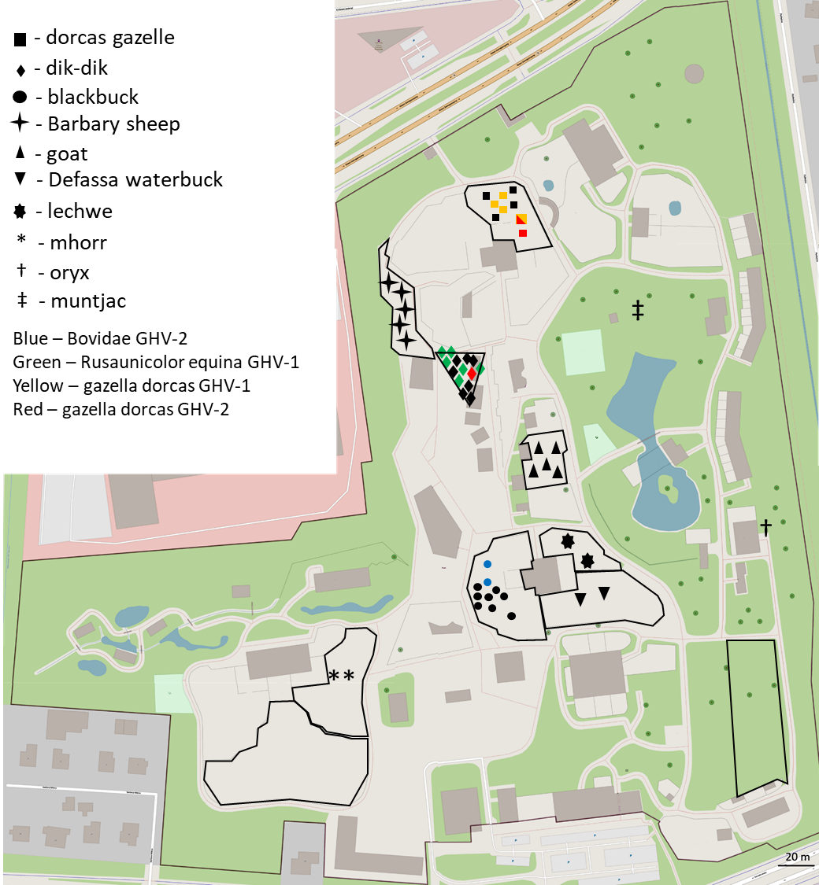
Figure S1. Map of Zamość Zoological Garden showing distribution of animals tested in the study. Different shapes as listed at the legend, while colours were used to mark animals infected with specific gammaherpesvirus strains. Black frames indicate enclosures of dorcas, Babary sheep, dik-diks, domestic goats, blackbucks, Defassa waterbuck, mhorr/giraffe, Javan rusa/lechwe and Thorold's deer from which environmental samples were collected. Plan was drawn based on data from Geoportal.gov.pl (mapy.geoportal.gov.pl, accession date 8.09.2025)

