Supplemental Information
Glossary of terms
Aitchison distance: A distance metric specifically designed for compositional data, that is, datasets where values represent parts of a whole (such as relative abundances in microbiome sequencing). The standard Euclidean distance can be misleading in microbiome studies because the data is closed (constrained to sum to 1 or 100). A change in one microbe’s abundance mathematically forces others to change, creating spurious correlations. Aitchison distance solves this by focusing on the log-ratios between taxa rather than their absolute proportions.

Alpha diversity: A measure of microbial diversity within a single sample or a specific site. It describes the complexity of a community by accounting for both the number of different types of microbes present and how they are distributed.

Beta diversity: A measure of the similarity or dissimilarity between microbial communities. Unlike alpha diversity, which describes a single sample, beta diversity compares how different two or more samples are from one another (between-sample diversity).

BH-corrected (Benjamini-Hochberg) P-value: A multiple-testing adjusted p-value calculated using the Benjamini-Hochberg procedure, which controls the false discovery rate (FDR), or the expected proportion of statistically significant results that are false positives when many hypotheses are tested simultaneously (e.g., across thousands of genes or pathways).

Bray-Curtis distance: A non-phylogenetic metric used to quantify the difference in microbial composition between two samples. It is one of the most widely used measures of Beta diversity in microbiome research because it accounts for both the presence of taxa and their relative abundances.

Chao1 index: A non-parametric estimator used to predict the total species richness (alpha diversity) of a sample. Unlike a simple count of observed taxa, Chao1 accounts for unseen species: those that are present in the environment but were missed during sequencing due to low abundance.

Hub genes: Genes which are most central to a WGCNA module, typically defined as having the highest intramodular connectivity (i.e., strongest overall co-expression with other genes within the same module) and/or high module membership (strong correlation with the module eigengene). Hub genes are often interpreted as key genes in representing a module’s overall biology.

Interconnectivity: The degree to which a gene (node) is connected to other genes in a network, as quantified within WGCNA as connectivity (e.g., the sum of connection strengths/edge weights to other genes). Higher interconnectivity indicates a more central position in the co-expression structure and is used to help identify hub genes.

Jaccard distance: A qualitative metric used to measure the dissimilarity between two microbial communities based solely on the presence or absence of taxa. It ignores the relative abundance of the microbes, focusing instead on how many species (or ASVs/OTUs) the samples share.

Kendall's Tau correlation coefficient: A nonparametric, rank-based measure of association between two variables, ranging from -1 to +1. Positive values indicate that higher ranks of one variable tend to occur with higher ranks of the other; negative values indicate the opposite effect. Kendall’s Tau coefficients are often preferred when relationships may be monotonic but not strictly linear or when data are not normally distributed.

K-means cluster: An unsupervised clustering method that partitions observations into k-number of groups, then iteratively assigns each observation to the nearest cluster centroid. In bioinformatics, k-means can be used to group samples or features based on similarity in multivariate profiles.

LRT: Lower respiratory tract tissues including lung parenchyma and respiratory-associated lymph nodes.

Overlapping hub genes: Genes which are identified as hub genes in more than one context, such as those shared between two networks, those which appear across multiple modules and/or traits, or those that meet hub gene criteria in multiple comparisons. This term is used to highlight genes that may represent shared or convergent biological signals across conditions.
Shannon index: A common measure of Alpha diversity that quantifies the uncertainty in predicting the identity of an individual picked at random from a sample. In microbiome research, it is the standard middle-ground metric because it accounts for both richness (the number of taxa) and evenness (how equally distributed those taxa are).

WGCNA (Weighted Gene Co-expression Network Analysis): A network-based approach for analyzing transcriptome data through constructing a weighted network, identifying clusters of highly co-expressed genes (modules), summarizing each module via eigengenes (the first principal component of the module’s expression), and correlating modules to external traits. WGCNA is often used to detect clinical trait-associated gene modules and prioritize biologically important genes (e.g., hub genes) within those modules.
Methodological Appendix
Microbiome Analyses
DNA Extraction
In a biosafety cabinet, a portion of a swab or a piece of tissue was cut with sterilized scissors and placed within a PowerBead Pro tube (Qiagen, Hilden, Germany). DNA was extracted using the PowerSoil Pro kit (Qiagen, Hilden, Germany) according to the manufacturer’s instructions, with mechanical homogenization performed by a Mini-Beadbeater-24 (BioSpec, Bartlesville, Oklahoma, USA) using a regime of 5 cycles of 1 minute of beating per cycle. The extraction was performed in a QiaCube Connect (Qiagen, Hilden, Germany). Sample DNA concentration was measured using the Qubit dsDNA HS Assay Kit (Thermo Fisher, Waltham, Massachusetts, USA) on the Qubit Flex Fluorometer (Thermo Fisher, Waltham, Massachusetts, USA).
Full Length 16S rRNA gene Sequencing
Amplification of the full length bacterial 16S ribosomal gene was performed using the 16S Barcoding Kit 1-24 (SQK-16S024, Oxford Nanopore Technologies, Oxford, United Kingdom) with the following DNA input and PCR cycles: for tonsillar swabs, 10 ng of DNA was used as input for the PCR reaction, and the thermocycler was run for 25 cycles; for tissue pieces, 200 ng of DNA was used as input for the PCR reaction, and the thermocycler was run for 30 cycles. Barcoded samples were pooled and sequenced for 24 hours on a MinION sequencer (Oxford Nanopore Technologies, Oxford, United Kingdom) using an R9.4.1 flow cell, the Fast Model (MinKNOW version 22.10.7, Guppy version 6.3.9), and a minimum length and quality score of 1,000 base pairs and 8, respectively. After the sequencing run, the FAST5 files were base called again with the High Accuracy Model (standalone Guppy version 6.5.7) on a dedicated workstation for downstream analysis.
Bioinformatics Processing for full Length 16S rRNA gene
Reads were classified with Centrifuger (version 1.0.11)¹ using the indexes for GTDB r226 (updated 05/20/2025, https://github.com/mourisl/centrifuger). The rest of the bioinformatics processing was performed using R version 4.3.1. A count table was generated from the Centrifuge output via Pavian (https://github.com/fbreitwieser/pavian) ².The count table and the metadata were incorporated in a phyloseq object (phyloseq version 1.46.0). Samples with less than 5,000 reads were not included in the analysis.³ Reads classified as Archaea were removed (no reads were classified as Eukarya, chloroplasts, or mitochondria)⁴. Additionally, bacterial genera present in less than 3 samples or with maximum abundance < 100 reads were removed^{5,6}. Rarefaction curves by species and sample type were created with the ampvis2 package version 2.8.9 (https://kasperskytte.github.io/ampvis2/index.html).
Microbiome Analysis
All microbiome analyses were performed using R version 4.3.1. Chao1(estimator of richness, that is, how many bacterial genera are present in a sample) and Shannon (capturing both how many bacterial genera are present in a sample and how homogenously distributed they are) indices were calculated using the estimate_richness() function of the phyloseq package (1.52.0). Unconditional linear regression models regressing the Chao1 and Shannon indices on species, treatment groups, sex, age (as a continuous variable), and the presence of relevant respiratory bacteria (M. ovipneumoniae, M. haemolytica, P. multocida, B. trehalosi, and T. pyogenes)^{7–10} were built separately for tonsillar swabs and lower respiratory tract (LRT) tissue samples.
Three beta-diversity distances (Bray-Curtis, Jaccard, and Aitchison) were evaluated in this study to provide a broader understanding of differences among microbial populations in the samples. Bray-Curtis dissimilarity distance (difference between the microbiome of two samples in terms of presence/absence and relative abundance of bacteria) was calculated using the vegan package (2.6-10), Jaccard dissimilarity distance (difference between the microbiome of two samples in terms of presence/absence of bacteria) with the phyloseq package, and Aitchison dissimilarity distance was computed as the Euclidean distance of the centered log ratio-transformed count matrices. PERMANOVA models on the three dissimilarity distances using species, treatment groups, sex, age (as a continuous variable), and the presence of relevant respiratory bacteria (M. ovipneumoniae, M. haemolytica, P. multocida, B. trehalosi, and T. pyogenes) as main effects (one PERMANOVA model per dissimilarity distance and covariate) were run using the adonis2 function from the vegan package. The multivariate homogeneity of the group-level dispersion was tested using betadisper (vegan package) in those instances where a main effect was statistically significant in PERMANOVA.
ALDEx2 (1.34.0) ¹¹ was used to detect differentially abundant genera between species, treatment groups, sex, age (as a continuous variable), and the presence of relevant/clinically significant respiratory bacteria (M. ovipneumoniae, M. haemolytica, P. multocida, B. trehalosi, and T. pyogenes). Specifically, Wilcoxon rank sum tests were used for sex, species, and bacterial presence/absence while Kruskal-Wallis tests were utilized for treatment and age. Benjamini-Hochberg correction was employed to control false discovery rates, a priori set at 0.05.
Transcriptomic Analyses
Tissue RNA isolation, sequencing, and bioinformatic processing
Approximately 20 mg of frozen lung (canioventral and dorsocaudal) and tracheobronchiole lymph node tissue were sterilely dissected and independently utilized for total RNA extraction via the RNeasy Plus Mini Kit (Qiagen). Samples were first aseptically placed into PowerBead Pro Tubes (Qiagen), followed by the pipetting of 350 μL of Buffer RLT Plus containing 14.3 M β-mercaptoethanol at a volumetric ratio of 100:1; all samples were handled and maintained at approximately 4°C until tissue homogenization. Samples were homogenized via a bead-beating centrifuge, where lysed supernatant from each sample was pipetted into sterile microcentrifuge tubes and automatically processed via a QIAcube Connect device (Qiagen, Germantown, MD) according to manufacturer protocol. Following isolation, RNA quantity (total yield = 396.0 – 17,085.0 ng), purity (mean 260/280 nm = 2.08 ± 0.04, mean 260/230 nm = 1.92 ± 0.23), and integrity (mean RIN = 6.2 ± 0.7) were measured via a Qubit Flex Fluorometer (ThermoFisher Scientific, Waltham, MA), NanoDrop Eight Spectrophotometer (ThermoFisher Scientific, Waltham, MA), and TapeStation 4200 System (Agilent Technologies, Santa Clara, CA), respectively. Isolated RNA was prepared for high-throughput sequencing at Texas A&M Institute for Genome Sciences & Society (TIGSS; College Station, TX) via the Stranded mRNA Library Kit (Illumina, San Diego, CA), following manufacturer’s instruction. Specifically, 150 base pair paired-end sequencing (2×150) was performed on one flow cell lane of a NovaSeq 6000 S4 v1.7+ instrument (S4 reagent kit, v1.5; Illumina, San Diego, CA) at the North Texas Genome Center (NTGC, Arlington, TX); sequencing resulted in a mean of 28.6 M ± 8.4 paired-end reads per sample.
Following sample demultiplexing via bcl2fastq2 v2.20, raw sequenced reads were quality assessed with FastQC v0.11.9 ¹². Reads were subsequently trimmed for ambiguous base calling, retained Illumina adaptors, and minimum read lengths with Trimmomatic v0.39 ¹³ (mean retainment: 96.54% ± 0.94) using the following parameters: “ILLUMINACLIP:TruSeq3.fa:2:30:10:2:TRUE”, “SLIDINGWINDOW:4:20”, “MINLEN:28”, “LEADING:3”, and “TRAILING:3”. Following quality assessment and trimming, retained trimmed reads were mapped and indexed to the sheep reference genome assembly ARS-UI_Ramb_v3.0 (Ovis aries) with HISAT2 v2.2.1 ¹⁴ Notably, the AD and BHS genomes were not utilized for this study due to incomplete chromosome assembly, deficient gene-level annotation records, and contaminated sequence segments at the time of bioinformatic processing (October 2023). Mean overall alignment rate was 74.41% ± 12.30; no differences were seen in concordant nor overall alignment rates between AD and BHS samples (Wilcoxon signed-rank test; p > 0.05). Prior to transcript assembly, Sequence Alignment Map (.sam) files generated from HISAT2 were converted to Binary Alignment Map (.bam) files via Samtools v1.14, utilizing default parameters ¹⁵. Transcript assembly and relative gene-level expression estimation was performed via StringTie2 v2.2.0, with default parameters ^{16,17}. Following merged Gene Transfer Format (.gtf) file generation of expression estimates for each sample, post-processing for the appending of ambiguous gene-level identifications (“MSTRG” tags) was performed with a custom Perl script (https://gist.github.com/gpertea/b83f1b32435e166afa92a2d388527f4b). All raw sequencing data and curated metadata produced by this study are available at the National Center for Biotechnology Information Gene Expression Omnibus (NCBI-GEO) under the accession number GSE295667.
Gene-level data processing and analysis
Gene-level count matrices produced from each sample were managed and analyzed in R v4.2.1. Raw count data were pre-processed with the filterByExpr toolkit ¹⁸ and count-per-million (CPM) filtering, specifically removing any genes having a minimum total count of less than 100 and those which failed to possess a row sum of greater than 1.0 in at least eight samples; filtering resulted in 15,024 genes for downstream analysis. All filtered libraries were normalized with the Relative Log Expression (RLE) method ^{19,20}, then converted into log2-counts-per-million values (log2CPM) for weighted correlation network analysis. Weighted correlation network analysis was performed with the Bioconductor package WGCNA v1.72-1 ^{21,22}. Metadata from all AD and BHS samples were aligned to each respective sample library. To evaluate potential outlier samples, canonical Euclidean distance-based network adjacency matrices were estimated and used to identify outliers based on standardized connectivity ^{23,24}. Samples with a standardized connectivity >-5.0 were considered outliers and to be removed; no samples were considered outliers for this study (S1 Fig). An adjacency matrix was constructed from calculated signed biweight midcorrelation coefficients between all genes across all samples. Soft thresholding allowed for the calculation of the power parameter (β) required to exponentially raise the adjacency matrix, targeting a scale-free topology fitting index (R²) of > 80%; β = 24 was selected for this study (S2 Fig). Gene-level co-expression modules were constructed with the automatic, one-step “blockwiseModules” function within WGCNA, utilizing the following parameters: power = 24, corType = “bicor,” TOMType = “signed,” networkType = “signed,” maxBlockSize = 15024, minModuleSize = 20, mergeCutHeight = 0.25, and pamRespectsDendro = FALSE; all other parameters were set to default. Constructed co-expression modules were assigned a color by the WGCNA R package, with all genes not assembling into a specific module placed in the “grey” module. Module-trait correlations were identified with independent Kendall’s Tau (a non-parametric measure of rank correlation that assesses the strength and direction of the monotonic relationship between two ranked variables) correlation matrices between module eigengenes (MEs). Modules were considered significantly correlated with each trait having a p-value ≤ 0.05 and |R| ≥ 0.4. Color scaling was performed with the Bioconductor package viridis v0.6.4 (10.5281/zenodo.4679423) to allow ease of visual interpretation for individuals with color blindness.

Functional enrichment analyses of trait-correlated gene expression modules
Functional enrichment analysis of genes found within modules which demonstrated significant correlation with metadata traits was performed with g:Profiler ve110_eg57_p18_4b54a898 (accessed December 1, 2023) ²⁵. Due to the lack of annotation in modeling sheep-specific genomic mechanism and pathways, we elected to utilize orthogonal annotations from human (Homo sapiens) databases ²⁶. Enrichment analyses performed with unordered gene lists, utilizing only annotated genes, selecting the biological pathways from KEGG, Reactome, and WikiPathways as the data source background, and applying the g:SCS multiple test correction technique with an adjusted p-value cutoff of 0.05 ^{27–29}.
Hub gene detection from bacteria detection-related modules
From the resulting module-trait correlation analysis, we selected those modules which displayed significant associations with the metadata concerning bacterial isolation for hub gene analysis (i.e., those genes within each module which may possess greater biological significance with respect to bacterial isolation/detection) ³⁰. Pearson correlation coefficients were calculated between individual gene expression values and module genes (kME) and between individual gene expression values and the bacteria isolation metadata component for which each module selected was significantly associated with (GS) for each gene; any gene possessing kME and GS values > 0.8 and > 0.5, respectively, was considered a hub gene within a module.
Protein-protein interaction network analysis of hub genes
Hub genes identified from modules with significant correlation with bacterial isolations and/or qPCR identification of M. ovipneumoniae were used for network construction of known and predicted protein-protein interactions with the Search Tool for the Retrieval of Interacting Genes (STRING) database v12.0 ³¹, utilizing DS annotations. Protein-protein interactions of gene products were predicted via the physical subnetwork setting, which display edges (i.e., associations between gene products) only if there is evidence of their specific binding or forming of a physical complex ^{31,32}. Overall, our approach and threshold selections were designed to balance node retention (connectivity) and biological interpretability, based on our previous work and recommendations for comparative network analyses of heterogeneous datasets ²⁴.Here, three independent analyses were performed. First, we combined all hub genes identified in modules with significant correlation to P. multocida isolation (n=1,056), selected a minimum interaction score of 0.900 (highest confidence), removed nodes (i.e., gene products) which were disconnected from the network, and employed a k-means clustering algorithm empirically set at k=8 based on the distance matrix acquired from combined interaction scores. This was done to minimize spurious or indirect edges that can dominate highly connected networks and obscure key biological substructures³¹. Next, we used hub genes identified in the module with significant correlation to M. haemolytica isolation (brown; n=231), selected a minimum interaction score of 0.400 (medium confidence), removed nodes (i.e., gene products) which were disconnected from the network, and employed a k-means clustering algorithm empirically set at k=6 based on the distance matrix acquired from combined interaction scores. While this threshold is less stringent than that of P. multocida, this level has been widely applied in moderate-scale STRING analyses where experimental validation coverage is limited but confidence weighting remains informative ^{31,33}. Lastly, we used hub genes from the purple module which shared hub genes identified from P. multocida isolation and M. ovipneumonaie qPCR identification (n=65), utilizing the same parameters as the aforementioned M. haemolytica -based analysis except for lowering the number of clusters to k=3.

References
1. Song, L. & Langmead, B. Centrifuger: lossless compression of microbial genomes for efficient and accurate metagenomic sequence classification. Genome Biol. 25, 03244–4 (2024).
2. Breitwieser, F. P. & Salzberg, S. L. Pavian: Interactive analysis of metagenomics data for microbiome studies and pathogen identification. Bioinformatics 36, 1303–1304 (2020).
3. Jonas, L. C., Youngs, C. R. & Schmitz-Esser, S. Combined analysis of 16S rRNA gene sequencing data reveals core vaginal bacteria across livestock species. Front. Microbiol. 16, (2025).
4. Nikodemova, M. et al. The effect of low-abundance OTU filtering methods on the reliability and variability of microbial composition assessed by 16S rRNA amplicon sequencing. Front. Cell. Infect. Microbiol. 13, 1165295 (2023).
5. Tommasi, N., Ferrari, A., Labra, M., Galimberti, A. & Biella, P. Harnessing the power of metabarcoding in the ecological interpretation of plant—pollinator DNA data: Strategies and consequences of filtering approaches. Diversity (Basel). 13, (2021).
6. Cao, Q. et al. Effects of Rare Microbiome Taxa Filtering on Statistical Analysis. Front. Microbiol. 11, 607325 (2021).
7. Kagueyama, F. C. et al. Bronchopneumonia in sheep associated with Providencia stuartii. Research, Society and Development 10, e117101623295 (2021).
8. Zhu, W. et al. Isolation and characterization of tick-borne Roseomonas haemaphysalidis sp. nov. and rodent-borne Roseomonas marmotae sp. nov. Journal of Microbiology 60, 137–146 (2022).
9. Dassanayake, R. P., Shanthalingam, S., Liu, W., Casas, E. & Srikumaran, S. Differential susceptibility of bighorn sheep (Ovis canadensis) and domestic sheep (Ovis aries) neutrophils to mannheimia haemolytica leukotoxin is not due to differential expression of cell surface CD18. J. Wildl. Dis. 53, 625–629 (2017).
10. Dassanayake, R. P. et al. Bibersteinia trehalosi Inhibits the growth of mannheimia haemolytica by a proximity-dependent mechanism. Appl. Environ. Microbiol. 76, 02086–09 (2010).
11. Fernandes, A. D. et al. Unifying the Analysis of High-Throughput Sequencing Datasets: Characterizing RNA-Seq, 16S RRNA Gene Sequencing and Selective Growth Experiments by Compositional Data Analysis. vol. 2 http://www.microbiomejournal.com/content/2/1/15http://www.microbiomejournal.com/content/2/1/15 (2014).
12. Andrews, S. FastQC: a quality control tool for high throughput sequence data. Preprint at (2010).
13. Bolger, A. M., Lohse, M. & Usadel, B. Trimmomatic: A flexible trimmer for Illumina sequence data. Bioinformatics 30, 2114–2120 (2014).
14. Kim, D., Paggi, J. M., Park, C., Bennett, C. & Salzberg, S. L. Graph-based genome alignment and genotyping with HISAT2 and HISAT-genotype. Nat. Biotechnol. 37, 907–915 (2019).
15. Li, H. et al. The Sequence Alignment/Map format and SAMtools. Bioinformatics 25, 2078–2079 (2009).
16. Kovaka, S. et al. Transcriptome assembly from long-read RNA-seq alignments with StringTie2. Genome Biol. 20, 1910–1 (2019).
17. Pertea, M., Kim, D., Pertea, G. M., Leek, J. T. & Salzberg, S. L. Transcript-level expression analysis of RNA-seq experiments with HISAT, StringTie and Ballgown. Nat. Protoc. 11, 1650–1667 (2016).
18. Chen, Y., Lun, A. T. L. & Smyth, G. K. From reads to genes to pathways: differential expression analysis of RNA-Seq experiments using Rsubread and the edgeR quasi-likelihood pipeline. F1000Res. 5, 1438 (2016).
19. Anders, S. & Huber, W. Differential Expression Analysis for Sequence Count Data. (2010).
20. Love, M. I., Huber, W. & Anders, S. Moderated estimation of fold change and dispersion for RNA-seq data with DESeq2. Genome Biol. 15, 550–8 (2014).
21. Langfelder, P. & Horvath, S. WGCNA: An R package for weighted correlation network analysis. BMC Bioinformatics 9, 559 (2008).
22. Zhang, B. & Horvath, S. A general framework for weighted gene co-expression network analysis. Stat. Appl. Genet. Mol. Biol. 4, 1128 (2005).
23. Horvath, S. Weighted Network Analysis: Applications in Genomics and Systems Biology. Vasa (Springer, New York, 2011).
24. Scott, M. A. et al. Hematological and gene co-expression network analyses of high-risk beef cattle defines immunological mechanisms and biological complexes involved in bovine respiratory disease and weight gain. PLoS One 17, e0277033 (2022).
25. Kolberg, L. et al. G:Profiler-interoperable web service for functional enrichment analysis and gene identifier mapping (2023 update). Nucleic Acids Res. 51, W207–W212 (2023).
26. Doncheva, N. T. et al. Human pathways in animal models: Possibilities and limitations. Nucleic Acids Res. 49, 1859–1871 (2021).
27. Kanehisa, M., Furumichi, M., Sato, Y., Kawashima, M. & Ishiguro-Watanabe, M. KEGG for taxonomy-based analysis of pathways and genomes. Nucleic Acids Res. 51, D587–D592 (2023).
28. Gillespie, M. et al. The reactome pathway knowledgebase 2022. Nucleic Acids Res. 50, D687–D692 (2022).
29. Agrawal, A. et al. WikiPathways 2024: next generation pathway database. Nucleic Acids Res. 52, D679–D689 (2024).
30. Langfelder, P. & Horvath, S. Eigengene networks for studying the relationships between co-expression modules. BMC Syst. Biol. 1, 54 (2007).
31. Szklarczyk, D. et al. The STRING database in 2023: protein-protein association networks and functional enrichment analyses for any sequenced genome of interest. Nucleic Acids Res. 51, D638–D646 (2023).
32. Szklarczyk, D. et al. The STRING database in 2021: Customizable protein-protein networks, and functional characterization of user-uploaded gene/measurement sets. Nucleic Acids Res. 49, D605–D612 (2021).
33. Barabási, A. L. & Oltvai, Z. N. Network biology: Understanding the cell’s functional organization. Nat. Rev. Genet. 5, 101–113 (2004).

Supplemental Results
Supplementary Table 1. Association of the Chao1 and Shannon indices with species, sex, age, treatment groups, and the presence of relevant respiratory bacteria in tonsillar swabs
Variable | Chao1 |  |  | Shannon
Variable | Coef | 95% CI | P value | Coef | 95% CI | P value
Species (BHS versus AD) | -22 | -91.2, 47.2 | 0.536 | -0.26 | -0.65, 0.13 | 0.191
Sex (Male versus Female) | 5 | -64, 74 | 0.889 | 0.17 | -0.23, 0.57 | 0.407
Age | 0.06 | -1.2, 1.4 | 0.926 | -0.0004 | -0.008, 0.007 | 0.925
Treatment (wash versus movi) | 46.9 | -27.8, 121.5 | 0.224 | 0.56 | 0.17, 0.96 | 0.00737
Treatment (control versus movi) | -1.95 | -97.5, 93.6 | 0.968 | -0.05 | -0.56, 0.46 | 0.85150
M. ovipneumoniae serological status | 108 | 15.5, 201.2 | 0.0261 | 0.38 | -0.18, 0.93 | 0.188
M. ovipneumoniae detection via qPCR (yes vs no) | 112 | 38, 187.6 | 0.00459 | 0.45 | 0.006, 0.9 | 0.0523
B. trehalosi detection (yes versus no) | -40.1 | -107.7, 27.5 | 0.25 | -0.39 | -0.77, -0.007 | 0.051
M. haemolytica detection (yes versus no) | 98 | -8.8, 204.9 | 0.0776 | 0.79 | 0.19, 1.39 | 0.0122
T. pyogenes detection (yes versus no) | -16.7 | -102.2, 68.8 | 0.703 | -0.25 | -0.74, 0.24 | 0.318
Coef: coefficient; 95% CI: 95% confidence interval calculated using the profile likelihood method.

Supplementary Table 2. Association of the Chao1 and Shannon indices with species, sex, age, treatment groups, and the presence of relevant respiratory bacteria in lower respiratory tract tissue samples
Variable | Chao1 |  |  | Shannon
Variable | Coef | 95% CI | P value | Coef | 95% CI | P value
Species (BHS versus AD) | -115.1 | -234, 4.58 | 0.0699 | -1.65 | -2.49, -0.81 | 0.000653
Sex (Male versus Female) | 105.2 | -14.2, 224 | 0.0952 | 0.02 | -1, 1 | 0.972
Age | 1.2 | -0.03, 2.45 | 0.06543 | 0.01 | 0.003, 0.02 | 0.0178
Treatment (wash versus movi) | 75.3 | -48.7, 199 | 0.244 | 0.22 | -0.82, 1.26 | 0.68
M. ovipneumoniae prevalence via PCR (yes vs no) | -40.4 | -180, 99.5 | 0.576 | 0.26 | -0.89, 1.4 | 0.666582
P. multocida detection (yes versus no) | -83.1 | -207, 40.9 | 0.2 | -0.34 | -1.4, 0.74 | 0.542
B. trehalosi detection (yes versus no) | -117.2 | -254, 20.1 | 0.106 | -1.13 | -2.28, 0.03 | 0.0663
M. haemolytica detection (yes versus no) | -68.6 | -205, 67.3 | 0.332 | -0.69 | -1.84, 0.46 | 0.252
T. pyogenes detection (yes versus no) | -88.8 | -229, 51.6 | 0.226 | -1.4 | -2.51, -0.29 | 0.0201
Coef: coefficient; 95% CI: 95% confidence interval calculated using the profile likelihood method.

Supplementary Table 3. Association between the beta diversity of the tonsillar microbiome with species, sex, age, treatment groups, and the presence of relevant respiratory bacteria in tonsillar swabs
Variable | Beta diversity distance
Variable | Bray-Curtis | Jaccard | Aitchison
Species | R²=0.06  P value=0.001  Dispersion homogeneity P value=0.2931 | R²=0.05  P value=0.001  Dispersion homogeneity P value=0.3736 | R²=0.09  P value=0.002  Dispersion homogeneity P value=0.00003
Sex | R²=0.03  P value=0.102 | R²=0.02  P value=0.151 | R²=0.01  P value=0.534
Age | R²=0.08  P value=0.001 | R²=0.07  P value=0.001 | R²=0.12  P value=0.001
Treatment Groups | R²=0.04  P value=0.207 | R²=0.04  P value=0.19 | R²=0.05  P value=0.194
M. ovipneumoniae serological status | R²=0.09  P value=0.002  Dispersion homogeneity P value=0.1265 | R²=0.07  P value=0.001  Dispersion homogeneity P value=0.18 | R²=0.17  P value=0.001  Dispersion homogeneity P value=0.4595
M. ovipneumoniae detection via qPCR | R²=0.10  P value=0.001  Dispersion homogeneity P value=0.01558 | R²=0.07  P value=0.001  Dispersion homogeneity P value=0.01615 | R²=0.18  P value=0.001  Dispersion homogeneity P value=0.05418
B. trehalosi detection | R²=0.04  P value=0.024  Dispersion homogeneity P value=0.4089 | R²=0.04  P value=0.008  Dispersion homogeneity P value=0.4793 | R²=0.03  P value=0.086
M. haemolytica detection | R²=0.01  P value=0.606 | R²=0.01  P value=0.65 | R²=0.02  P value=0.43
T. pyogenes detection | R²=0.02  P value=0.343 | R²=0.02  P value=0.23 | R²=0.02  P value=0.503

Supplementary Table 4. Association between the beta diversity of the lower respiratory tract with species, sex, age, treatment groups, and the presence of relevant respiratory bacteria in lower respiratory tract tissue samples
Variable | Beta diversity distance
Variable | Bray-Curtis | Jaccard | Aitchison
Species | R²=0.06  P value=0.057 | R²=0.06  P value=0.033  Dispersion homogeneity P value=0.663 | R²=0.10  P value=0.002  Dispersion homogeneity P value=0.0002318
Sex | R²=0.06  P value=0.057 | R²=0.06  P value=0.037  Dispersion homogeneity P value=0.03585 | R²=0.07  P value=0.019  Dispersion homogeneity P value=0.2414
Age | R²=0.06  P value=0.026 | R²=0.06  P value=0.023 | R²=0.09  P value=0.004
Treatment Groups | R²=0.11  P value=0.002  Dispersion homogeneity P value=0.8592 | R²=0.08  P value=0.001  Dispersion homogeneity P value=0.8805 | R²=0.04  P value=0.234
M. ovipneumoniae prevalence via PCR | R²=0.06  P value=0.025  Dispersion homogeneity P value=0.1012 | R²=0.06  P value=0.019  Dispersion homogeneity P value=0.06437 | R²=0.03  P value=0.493
P. multocida prevalence | R²=0.15  P value=0.001  Dispersion homogeneity P value=0.8779 | R²=0.11  P value=0.001  Dispersion homogeneity P value=0.8706 | R²=0.06  P value=0.059
B. trehalosi prevalence | R²=0.04  P value=0.445 | R²=0.03  P value=0.573 | R²=0.05  P value=0.194
M. haemolytica prevalence | R²=0.14  P value=0.001  Dispersion homogeneity P value=0.001413 | R²=0.11  P value=0.001  Dispersion homogeneity P value=0.0007563 | R²=0.07  P value=0.022  Dispersion homogeneity P value=0.003214
T. pyogenes prevalence | R²=0.05  P value=0.126 | R²=0.05  P value=0.17 | R²=0.04  P value=0.257

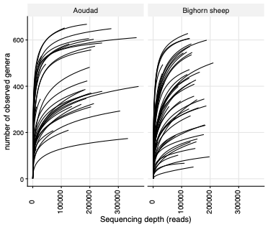
Figure S1: Rarefaction curves for full-length 16S rRNA gene. Each line represents a single sample. The number of observed genera is represented in the y axis and the sequencing depth in the x-axis. The rarefaction curves are stratified by species; aoudad (Ammotragus lervia), and bighorn sheep (Ovis canadensis; sheep).

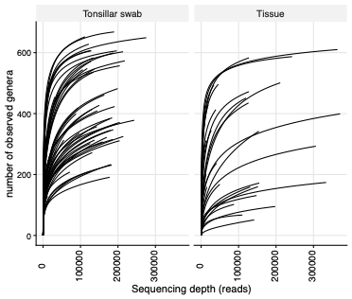
Figure S2: Rarefaction curves for full-length 16S rRNA gene. Each line represents a single sample. The number of observed genera is represented in the y axis and the sequencing depth in the x-axis. The rarefaction curves are stratified by sample type; tissue from the lower respiratory tract (lung parenchyma and respiratory-associated lymph nodes) and tonsillar swabs (swab).

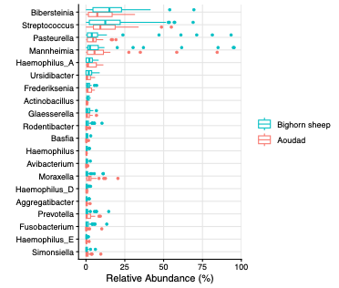
Figure S3: Boxplot of the relative abundance of the 20 most abundant bacterial genera (in descending order) in samples collected from aoudad (Ammotragus lervia), and bighorn sheep (Ovis canadensis; sheep). Boxes indicate the interquartile range (IQR, the middle 50% of the data), with a line within the box to identify the median relative abundance. Whiskers represent ± 1.5 times the IQR. Individual points represent outliers.

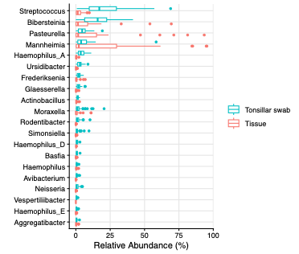
Figure S4: Boxplot of the relative abundance of the 20 most abundant bacterial genera (in descending order) in samples from two locations; tissue from the lower respiratory tract (lung parenchyma and respiratory-associated lymph nodes) and tonsillar swabs (swab). Boxes indicate the interquartile range (IQR, the middle 50% of the data), with a line within the box to identify the median relative abundance. Whiskers represent ± 1.5 times the IQR. Individual points represent outliers.

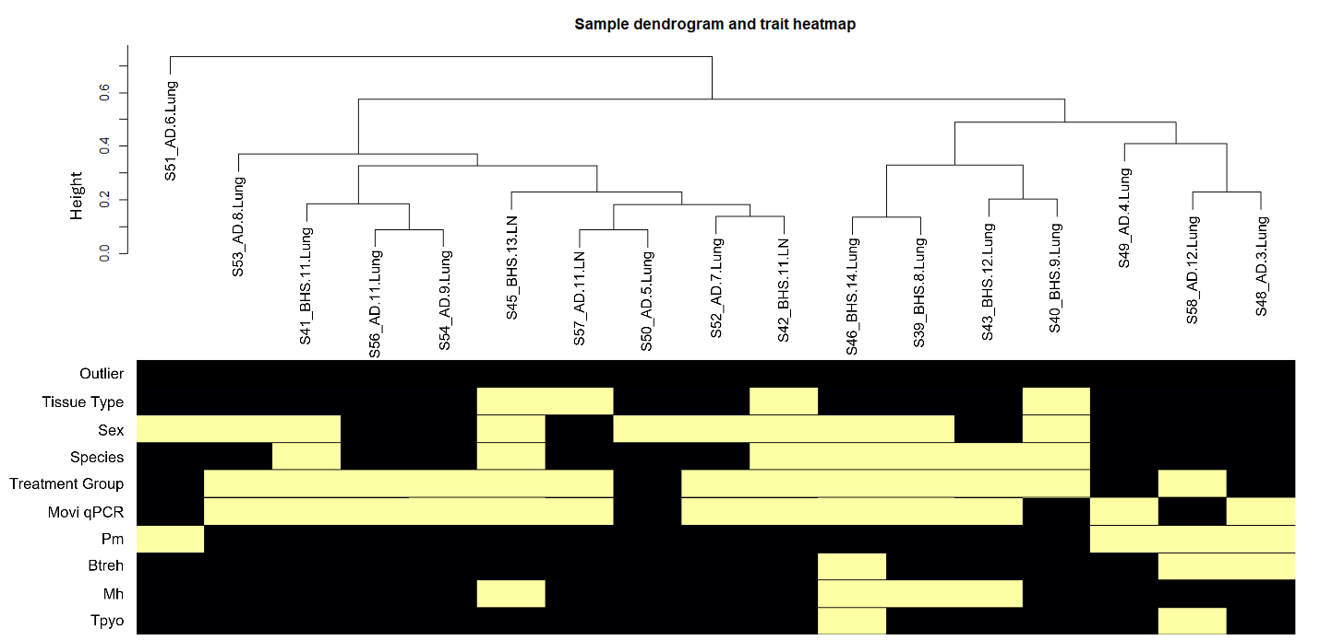
Figure S5. Hierarchical clustering of clinical metadata across all sheep samples utilized for transcriptome gene expression network analysis. Standardized connectivity was calculated from network adjacency matrices and used to classify potential outliers (Z.k < -5); no sample was identified as an outlier for downstream analyses (Outlier; No=0, 1=Yes). Colors indicate an increase (yellow/white) or decreased (purple/black) value for each trait. Binary metadata variables were utilized for outlier identification (Tissue Type (lung = 0, lymph node = 1), Sex (Female=0, Male=1), Species (AD = 0, BHS = 1), Treatment Group (Movi=0, Wash=1), Movi qPCR (Mycoplasma ovipneumoniae qPCR results; negative = 0, positive = 1), Pm (Pasteurella multocida culture results; negative = 0, positive = 1), Btreh (P Bibersteinia trehalosi culture results; negative = 0, positive = 1), Mh (Mannheimia haemolytica culture results; negative = 0, positive = 1), Tpyo (Trueperella pyogenes culture results; negative = 0, positive = 1).
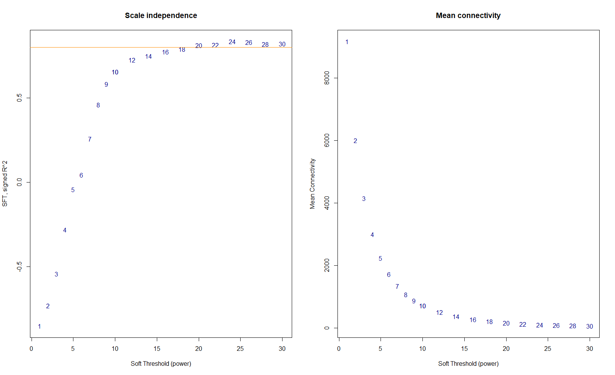
Figure S6. Soft thresholding (β) selection for signed weighed correlation network construction of all sheep samples via scale free topology analysis. A) Scale free topology indices (R²; y-axis) at increasing soft threshold powers (β; x-axis). The value β = 24 was selected, seen where the saturation curve is above 0.8 (orange horizontal line). B) Increasing soft threshold powers (β; x-axis) with respect to decreasing mean connectivity (y-axis).

