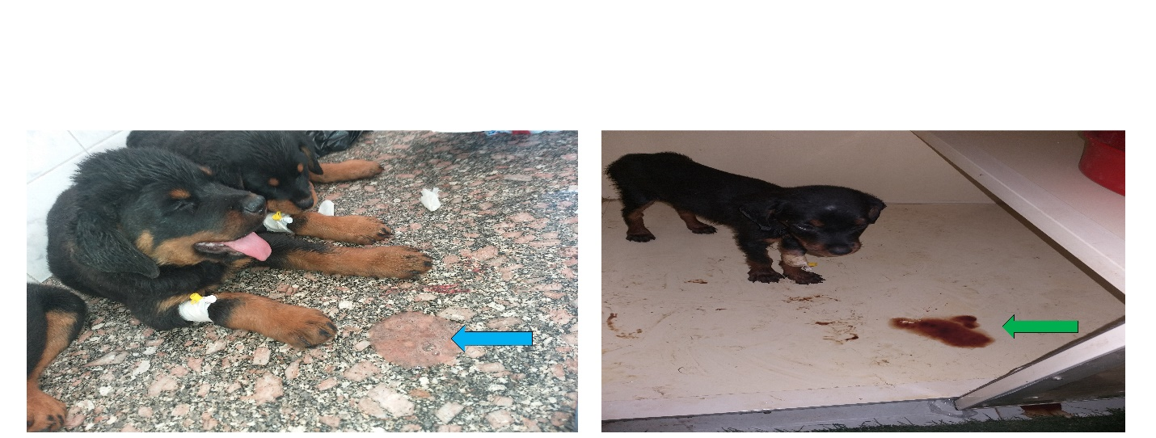Supplementary Figure 1. Two puppies exhibiting clinical signs consistent with canine parvoviral enteritis. The puppy on the left shows bloody vomitus (blue arrow), whereas the puppy on the right presents with bloody diarrhea (green arrow). Both animals appear dull and severely dehydrated.

