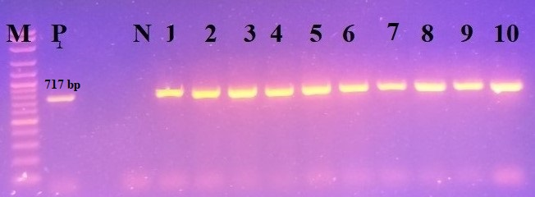
Supplementary Figure 3. Conventional PCR using primer pair CPV3381-F / CPV4116-R. A positive reaction is indicated by an amplicon of 717 bp. Lane M: 100 bp DNA ladder; P: positive control (CPV-2c strain VetCU-14/2019, GenBank accession number MT636872); N: negative control (PCR-grade water); lanes 1–10: positive samples from this study.

