Supplementary data
Table S1. Summary of Atypical porcine pestivirus (APPV) viral load in semen from boars positive at the initial screening, expressed as genome copies/mL semen.
Boar ID | Arrival group | APPV load in semen (GC/mL)
B1 | C | 4138737
B2 | C | 1240488.8
B3 | A | 1106756.3
B4 | B | 135096.2
B5 | A | 113849.7
B6 | C | 37705.5
B7 | B | 17963.4
B8 | A | 16373.4
B9 | C | 13897.1
B10 | A | 10905.6
B11 | C | 8996
B12 | C | 5122
B13 | C | 3363.2
B14 | C | 4441.3
B15 | B | 3485.3
B16 | C | 1284.6
B17 | A | 1106
B18 | B | <LoQ*
B19 | C | <LoQ*
B20 | B | 721562.4
B21 | C | 277568.1
B22 | B | 91926.9
B23 | A | 71626.2
B24 | A | 68139.4
B25 | C | 67655.3
B26 | B | 66223.6
B27 | B | 30445.0
B28 | C | 17583.3
B29 | A | 13603.0
B30 | C | 10083.0
B31 | A | 5991.8
B32 | B | 5782.0
B33 | A | 5345.9
B34 | C | 5345.9
B35 | B | 5049.5
B36 | A | 3485.3
B37 | A | 2388.6
B38 | A | 1266.4
B39 | B | <LoQ*
B40 | C | <LoQ*
B41 | B | <LoQ*
B42 | B | <LoQ*
B43 | C | <LoQ*
B44 | C | <LoQ*
B45 | C | <LoQ*
B46 | B | <LoQ*
B47 | A | <LoQ*
B48 | B | <LoQ*
B49 | C | <LoQ*
B50 | C | <LoQ*
B52 | A | <LoQ*
B53 | B | <LoQ*
B54 | A | <LoQ*
B55 | A | <LoQ*
B56 | B | <LoQ*
*LoQ = Limit of quantification (Cq = 35.1; 1060 GC/mL).

Boar ID | Age at first positive test (days) | Age at last positive test (days) | No. of virus-positive days | Viral load in semen (GC/mL) at initial test
B1 | 248 | 374 | 126 | 4138737
B2 | 254 | 382 | 128 | 1240488.8
B3 | 227 | 227 | 1 | 1106756.3
B4* | 239 | 455 | 216 | 135096.2
B5 | 255 | 255 | 1 | 113849.7
B6 | 252 | 305 | 53 | 37705.5
B7 | 247 | 247 | 1 | 17963.4
B8 | 209 | 209 | 1 | 16373.4
B9 | 231 | 231 | 1 | 13897.1
B10 | 286 | 286 | 1 | 10905.6
B11 | 232 | 288 | 56 | 8996
B12 | 244 | 300 | 56 | 5122
B13 | 265 | 323 | 58 | 3363.2
B14 | 232 | 323 | 1 | 4441.3
B15 | 214 | 353 | 139 | 3485.3
B16 | 246 | 246 | 1 | 1284.6
B17 | 241 | 241 | 1 | 1106
B18 | 291 | 291 | 1 | <LoQ**
B19 | 252 | 252 | 1 | <LoQ
Table S2. Age, viral load (GC/mL) and duration of APPV-positivity in semen for the 19 boars included in both the initial screening and the longitudinal sampling.
* Boar number B4 had negative semen samples at day 383 and 411 but was positive again at day 427 and 455. ** LoQ = Limit of quantification.

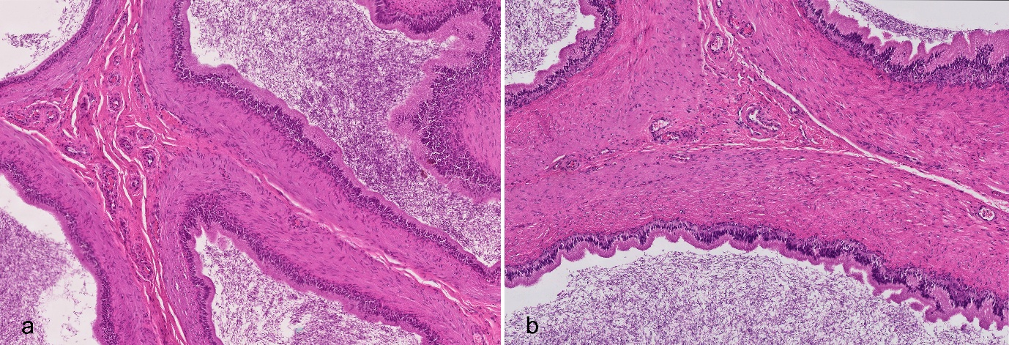
Figure S1. Epididymal histology in an APPV-positive and an APPV-negative boar. a) Representative section from boar B17, which tested APPV-positive in epididymis by RT-qPCR before slaughter. b) Section from boar B58, which tested APPV negative at the initial screening. No histopathological lesions were observed in either case. H&E-stain. 5x magnification.

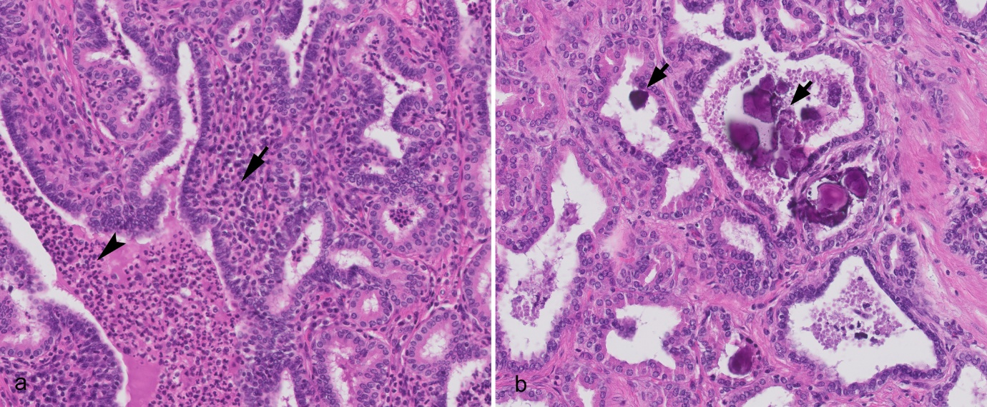
Figure S2. Lesions in accessory glands from slaughtered breeding boars. a) Seminal vesiculitis, moderate and multifocal, with infiltrates of lymphocytes (arrow) and neutrophil granulocytes (arrowhead) in glands and interstitium. b) Multifocal intraglandular and intraductal concretions (arrows) in the prostate gland. H&E-stain. 50x magnification.

