Full uncropped alfa-toxin pcr gel corresponding to Figure 1.

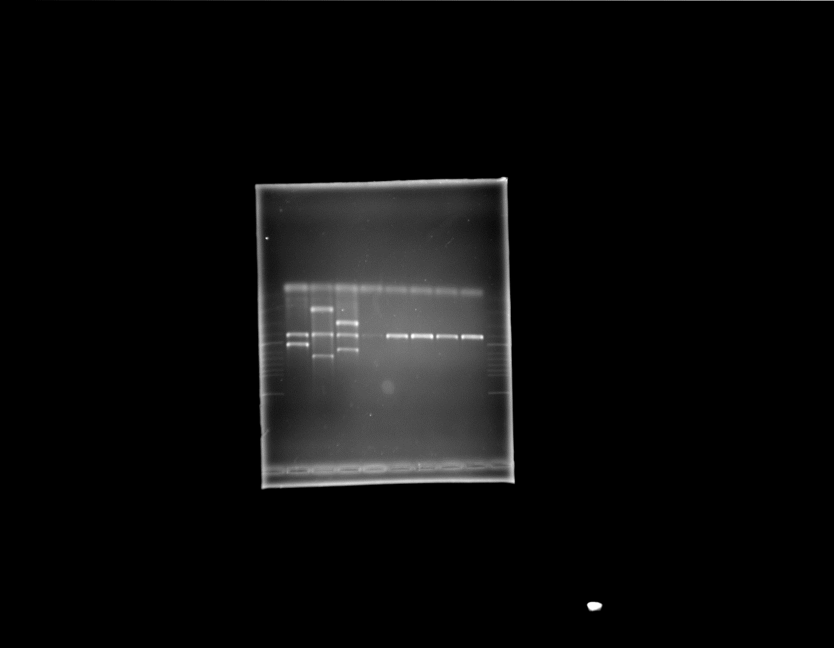

Full uncropped multiplex pcr gel corresponding to Figure 2.

Full uncropped PFGE gel corresponding to Figure 3A and 3B.

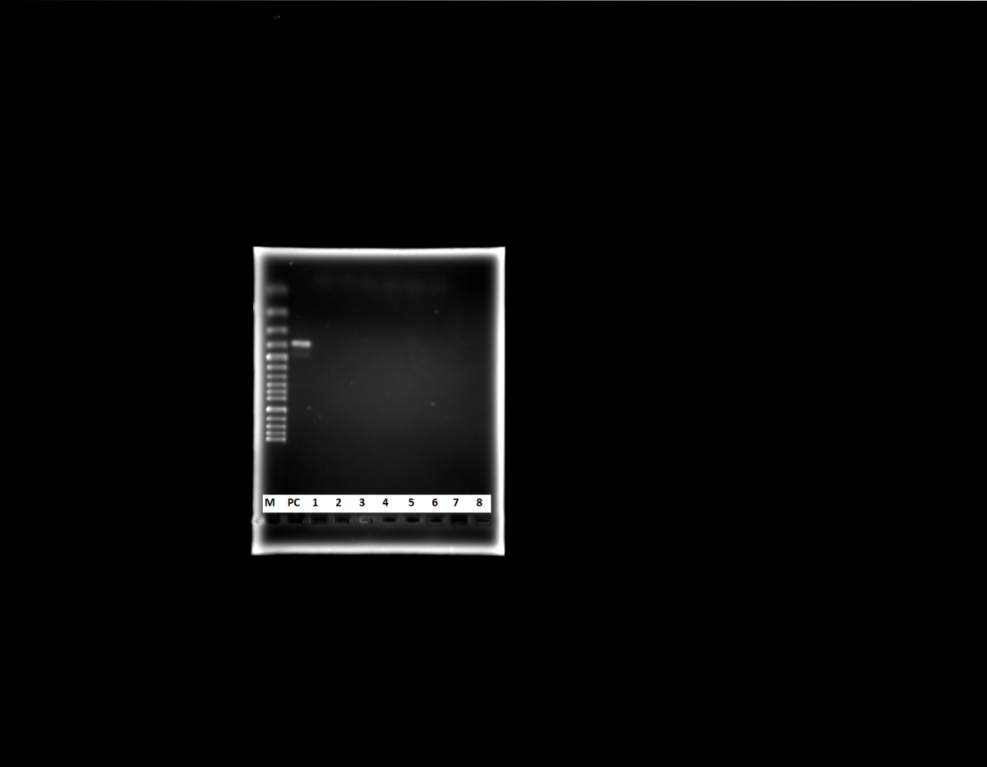

Netb Toxin positive control uncropped gel image. Since none of the isolates tested positive for Netb, the PCR gel image was not included as a figure when uploading the article. It can be added to the maintext upon request.

