Dear Editor,
Regarding the request for uncropped versions of all images, I would like to clarify that I have uncropped originals for all figures except one. For the image showing the agarose gel, the uncropped version includes lanes from another experiment that are not related to the work presented in the manuscript. Therefore, I am unable to provide the full uncropped image for that specific figure.
All photographs were taken using a Samsung A33 mobile phone, and I apologize for the relatively low image quality. If possible, I kindly request that the cropped versions already included in the manuscript be accepted and used for publication, should the article be accepted.
Thank you for your understanding.

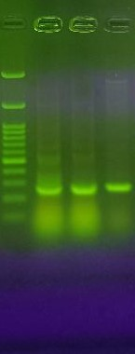
rpro-CuHep

Figure 1. PCR colony. Line 1, DNA molecular weight marker (Cinnacholon, SL7030); line 2-4, two recombinant bacterial colony.

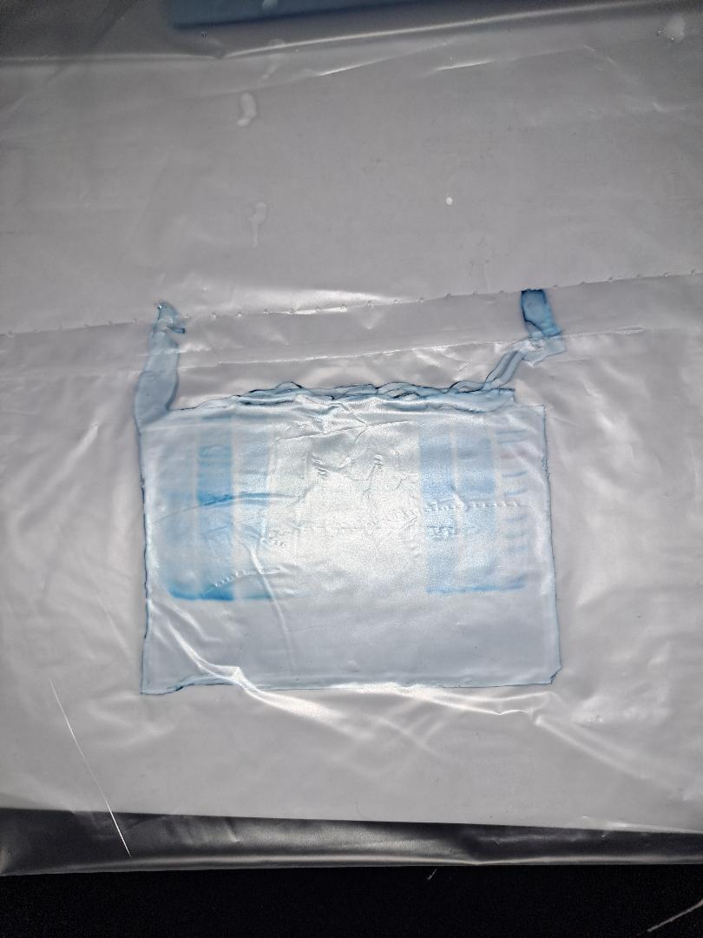

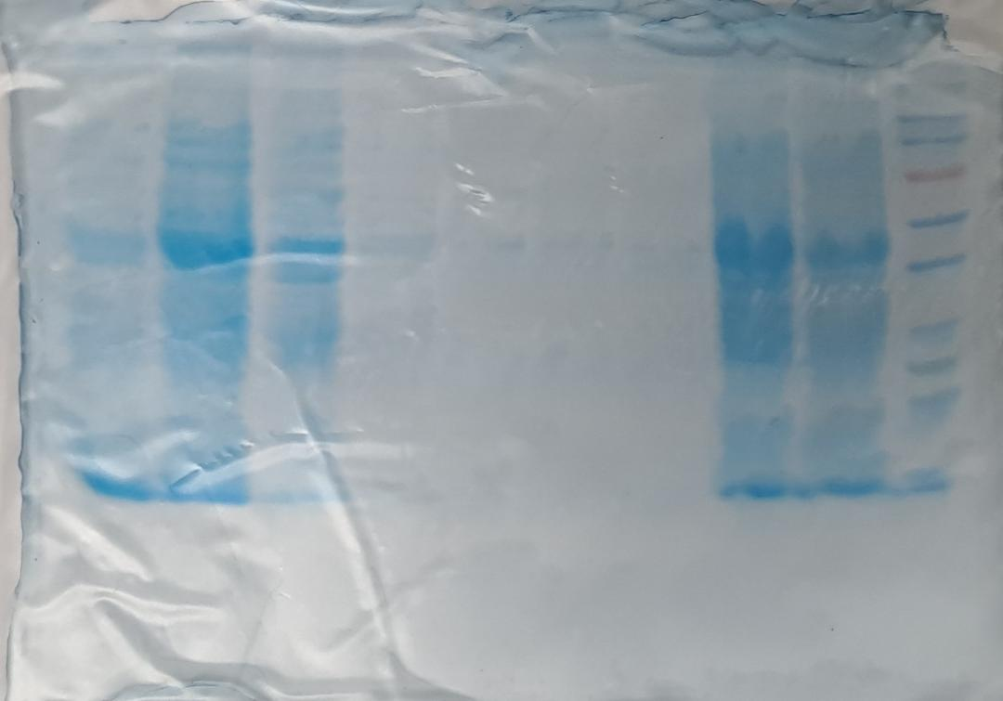

Figure 2. SDS-PAGE gel electrophoresis of the rpro-CuHep.

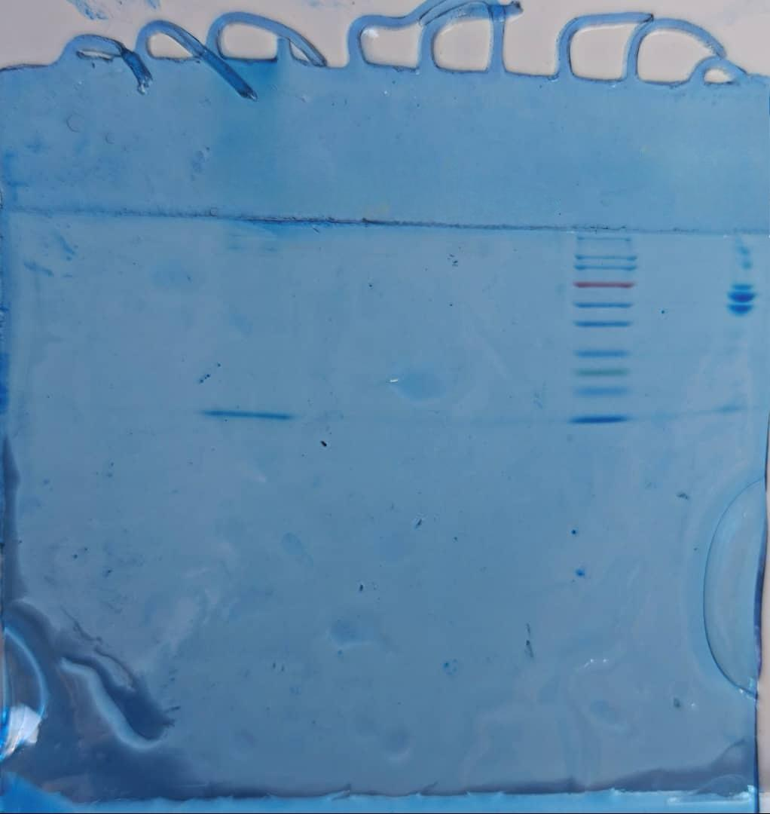

Figure 3. SDS-PAGE gel electrophoresis of the purified recombinant peptide.

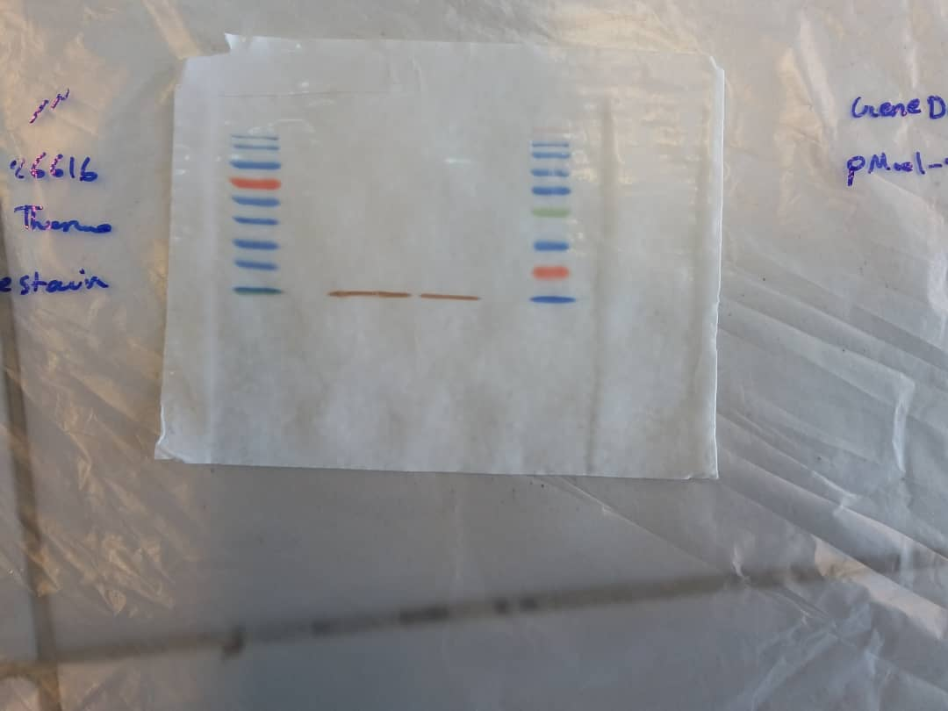

Figure 4. Western blot analysis of rpro-CuHep. Line1 and 4 protein molecular weight marker (GeneDirex, PM001-0500), Line 2 and 3, rpro-CuHep.

