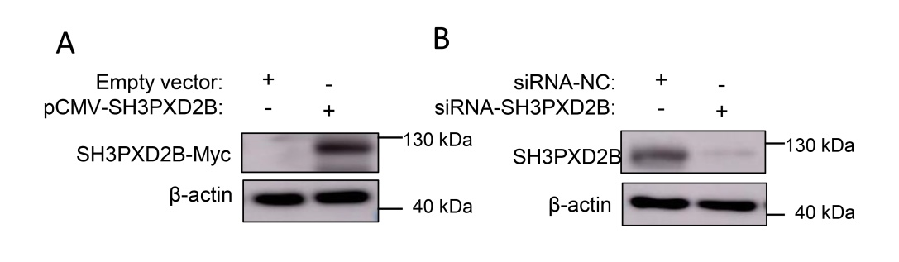
Fig.S1 The validation of expression plasmid and siRNA. A: Overexpression of SH3PXD2B; B: Knockdown of SH3PXD2B.

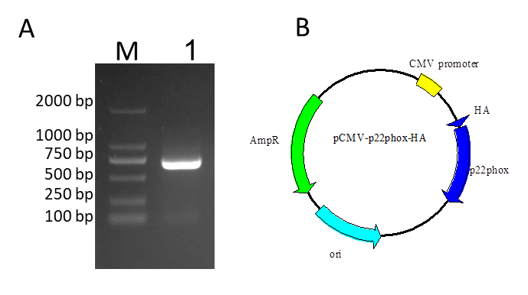
Fig.S2 Construction of plasmid pCMV-p22phox-HA. A: Amplify the gene encoding bovine p22phox protein (CYBA) (M: DL2000 Marker; 1: PCR amplification product). B: The map of plasmid pCMV-p22phox-HA.

