- CACNA2D1 ---Figure 6C
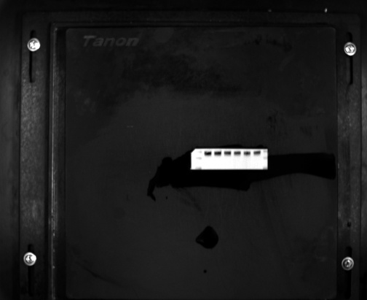  CACNA2D1 | 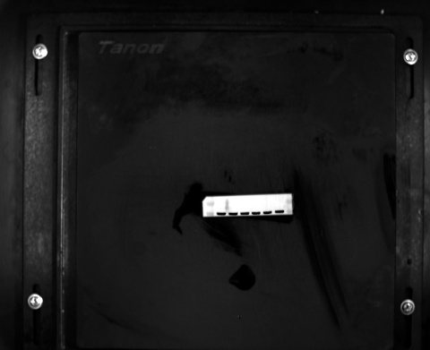  TUBULIN
The left three lanes are for the Si-NC group, and the right three lanes are for the Si-CACNA2D1 group.

- CamkⅡ and P-CamkⅡ--- Figure 6D
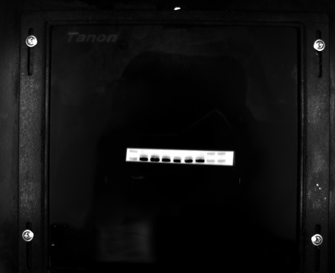  CamkⅡ |  | 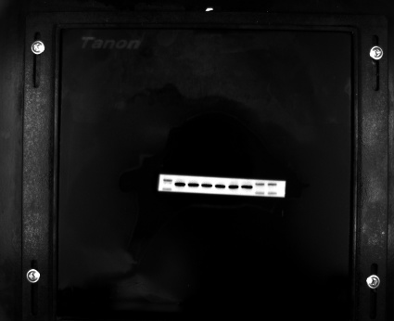  GAPDH
The left three lanes are for the Si-NC group, and the right three lanes are for the Si-CACNA2D1 group.
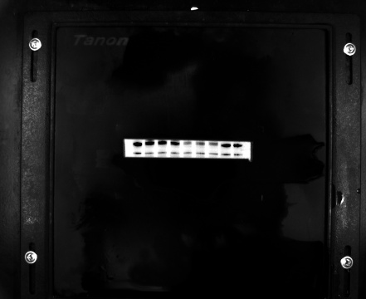  P-CamkⅡ | 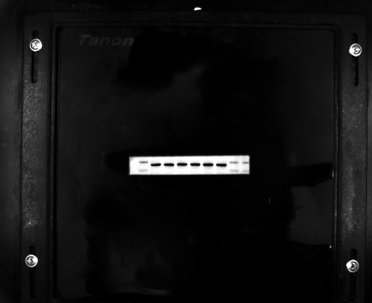  GAPDH
The left three lanes are for the Si-NC group, and the right three lanes are for the Si-CACNA2D1 group.

3. P65 and p- P65---- Figure S3A
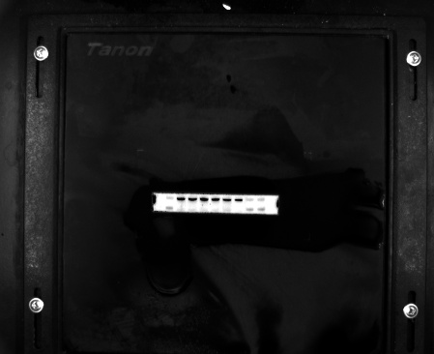  P65 | 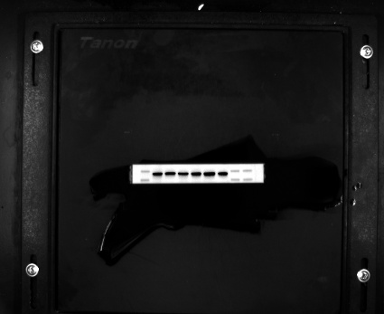  GAPDH
The left three lanes are for the Si-NC group, and the right three lanes are for the Si-CACNA2D1 group.
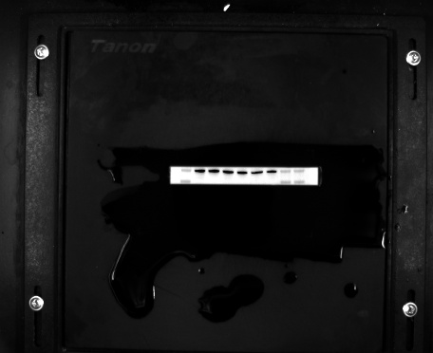  P-P65 | 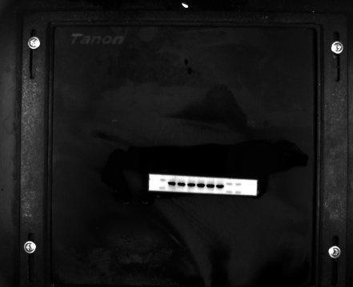  GAPDH
The left three lanes are for the Si-NC group, and the right three lanes are for the Si-CACNA2D1 group.

4. P- STAT3 and STAT3--- Figure S3B
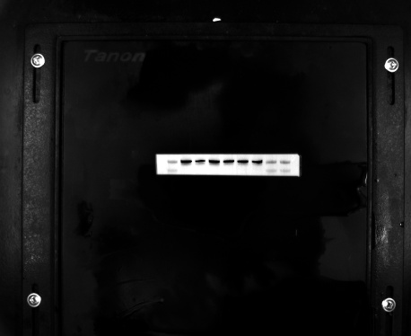  STAT3 | 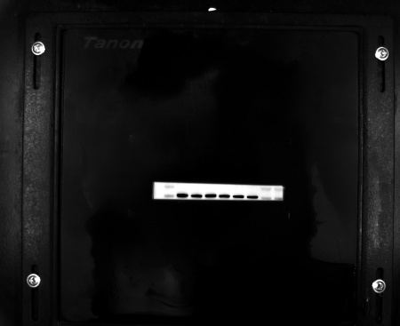  TUBULIN
The left three lanes are for the Si-NC group, and the right three lanes are for the Si-CACNA2D1 group.
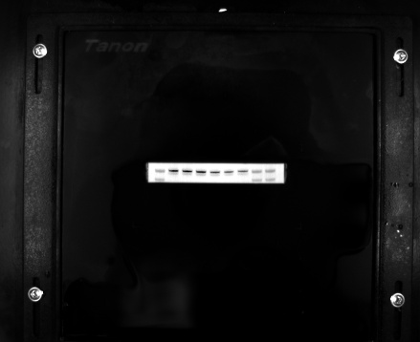  P-STAT3 | 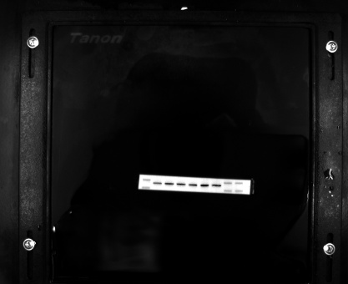  GAPDH
The left three lanes are for the Si-NC group, and the right three lanes are for the Si-CACNA2D1 group.

