Appendix and Supplementary Items
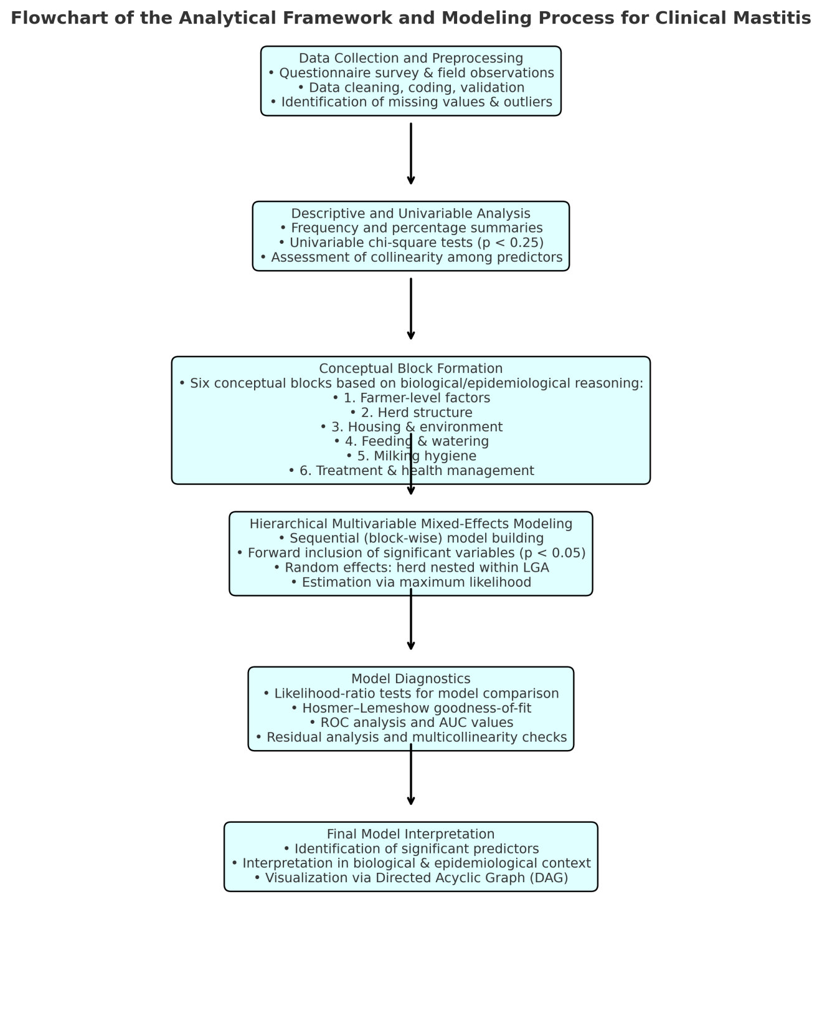
Appendix Figure 1. Flowchart of the Analytical Framework and Modeling Process for Clinical Mastitis
This flowchart illustrates the sequential analytical framework and modelling process adopted in the study to identify risk factors associated with clinical mastitis in dairy cows. It visually outlines the major steps from data collection to final model interpretation.

Appendix Table 1: Variable inclusion criteria for multivariable mixed-effects logistic regression among cows for clinical mastitis, Plateau State, Nigeria
Variable | P-value (lowest per variable) | Inclusion Decision | Reason for Inclusion/Exclusion
Block 1 – (farmer & farm-level demographics)
Number of employees | 0.15 | Include | 11+ employees showed a strong association (OR: 4.80, p = 0.15); consider for adjusted model due to plausible biological relevance.
Years in dairy farming | 0.163 | Include | Moderate association seen in category 31–45 years (OR: 1.87, p = 0.163); include for confounding control and time-in-farming effects.
Education | 0.208 | Include | Primary school (OR: 0.50, p = 0.208) shows potential association with lower odds; variable is important for socio-demographic context.
Age group | 0.238 | Include | Age 50–59 showed a potential risk association (OR: 2.03); biologically plausible relationship with management decisions.
Block 2 – (animal demographics/structure)
Female calves <1 year | 0.059 | Include | "Few (1–3)" category showed an association with lower odds; p-value < 0.25 and biologically plausible.
Heifers served awaiting confirmation | 0.069 | Include | "Moderate (4–6)" category showed risk association; close to significance, keep for model development.
Heifers >2 yrs never calved | 0.094 | Include | "High (11–20)" showed an elevated OR with p = 0.094; important for herd structure and dynamics.
Milking cows | 0.158 | Include | "Large (20–49)" showed increasing association (OR = 1.96); biologically important; p < 0.25.
Dry cows awaiting calving | 0.27 | Consider | No strong evidence; may keep if other variables are removed or to control for herd size balance.
Milking cows pregnant | 0.15 | Include | "None (0)" showed an association with lower odds; potential indicator of reproductive health.
Milking cows not pregnant | 0.417 | Exclude | No category showed significant effect; limited discriminatory value.
Block 3 – (housing & management practices)
Production system | 0.028 | Include | Intensive system significantly associated with lower odds of mastitis (OR = 0.155, p = 0.028).
Herd size (total cattle) | 0.058 | Include | Large herds had doubled odds (OR = 2.21), borderline significance, biologically relevant.
Working bulls | 0.118 | Include | Moderate (3–5) category showed potential association (p < 0.25); keep for confounding control.
Production system | 0.131 | Consider | Smallholder showed association toward lower odds; biologically plausible, but borderline significance.
Herd size (total animals) | 0.142 | Include | Small herds showed lower odds (OR = 0.23), biologically important herd indicator.
Housing design | 0.163 | Include | Indoor housing had increased odds; possibly confounded, but warrants inclusion for context.
Animals move out for grazing | 0.159 | Include | Movement restriction showed increased odds (OR = 5.22); biologically meaningful exposure factor.
Working bulls | 0.215 | Consider | Very many category showed low odds but non-significant; may drop if not improving model fit.
Cow accommodation | 0.476 | Exclude | No meaningful association observed; low OR and high p-value.
Herd size (total cattle) | 0.904 | Exclude | Small herds had no significant effect; not biologically or statistically compelling.
Block 4 – (water & feed practices)
Feed cows after milking? | 0.083 | Include | Borderline significance (p < 0.1); biologically plausible lower odds.
Type of feed | 0.141 | Include | Grazing showed borderline p-value; nutrition-related relevance.
Supplement to lactating cows? | 0.136 | Include | "None" category showed borderline effect; important feeding management factor.
Supplement to lactating cows? | 0.194 | Consider | "Other" category borderline; may be retained based on subject-matter judgment.
Water source | 0.201 | Exclude | No category showed significant association; estimates unstable or wide CI.
Individual or group feeding? | 0.53 | Exclude | Weak evidence of association.
Feed supplements? | 0.766 | Exclude | Very weak statistical evidence; not retained.
Water ad libitum? | 0.969 | Exclude | Effect not observed; null association.
Block 5 – (milking hygiene practices)
Clean teats as preparation for milking? | 0.011 | Include | Statistically significant; strong association with lower odds effect observed with "Only dirty teats" category.
Teat dip/spraying after milking? | 0.011 | Include | Statistically significant; clear evidence of association with lower odds effect.
Teat dip/spraying before milking? | 0.012 | Include | Statistically significant; associated with lower odds of mastitis.
Frequency of washing milking equipment | 0.086 | Include | Borderline significance; biologically plausible; needs testing in multivariable model.
Servicing milking equipment | 0.098 | Include | Borderline significance; maintenance is relevant to hygiene and mastitis risk.
Clean teats – All cows | 0.08 | Include | Borderline significance; preventive hygiene behavior.
Milking method | 0.29 | Consider | Wide CI; include if theory supports mechanical method being associated with lower odds or risky.
Handwash/glove use | 0.339 | Exclude | Not statistically significant; weak association.
Use separate cloth | 0.75 | Exclude | No evidence of effect; exclude.
Pre-strip before milking | 0.788 | Exclude | Not significant; low effect size.
Milker | 0.499 | Exclude | No strong statistical or theoretical reason for inclusion.
Dry teat before milking | 0.721 | Exclude | No significant association with mastitis.
Block 6 – (mastitis management)
Treat mastitis? | 0.003 | Include | Statistically significant; strong association with lower mastitis odds.
Recurrence of mastitis treatment? | 0.004 | Include | Significant predictor; indicates herd-level mastitis status persistence and management gap.
Challenges in mastitis treatment – None | 0.049 | Include | Borderline significance; absence of treatment challenge associated with lower risk.
Heifers & cows same calving paddock? | 0.06 | Include | Borderline p-value; biologically plausible risk factor.
Mastitis main reason for culling? | 0.065 | Include | Borderline p-value; theoretically relevant; include for contextual significance.
How mastitis diagnosed – Bacterial culture | 0.071 | Include | Not statistically significant; valuable diagnostic practice to retain in the model.
Frequency of mastitis – Thrice | 0.15 | Consider | May indicate severity; borderline and could be tested in stepwise selection.
Drug – Herbs | 0.119 | Consider | Alternative treatment; borderline significance.
Challenges – Medicine expensive | 0.136 | Consider | May affect treatment access; borderline p-value.
Dry cow therapy | 0.236 | Exclude | Not significant; weak evidence of association.
Calving paddock separation | 0.606 | Exclude | Not significant; wide CI.
Udder health checking freq. | 0.388–0.701 | Exclude | All comparisons are not statistically significant.
Record mastitis treatment | 0.93 | Exclude | Not significant; no effect.
Prescriber | 0.793–0.978 | Exclude | Not statistically significant; wide CI.
Drug – Sulphonamides | 0.323 | Exclude | Not significant; small sample size limits inference.
Buy replacement heifers? | 0.985 | Exclude | No statistical evidence of association.

Appendix Table 2: Likelihood ratio tests for model comparisons among cows for clinical mastitis, Plateau State, Nigeria
Comparison | DF | LR Chi² | p-value | Interpretation
Block 1: Farmer & farm-level demographics
Model 1 vs. Model 2: Added Age group | 4 | 5.76 | 0.218 | Not significant; adding Age group did not improve model fit.
Model 2 vs. Model 3: Removed observations not in e(sample) | 3 | 6.42 | 0.093 | Suggestive (p < 0.10); dropping non-sample observations may improve the model.
Model 2 vs. Model 4: Removed age group | 4 | 6.94 | 0.139 | Not significant; removing Age group did not significantly worsen the fit.
Model 4 vs. Model 5: Removed Number of employee | 4 | 2.01 | 0.734 | No improvement; Number of employee may not contribute meaningfully to the model.
Block 2: Animal demographics/structure
Model 1 vs. Model 2: Removed Milking cows served but not pregnant | 4 | 0.51 | 0.973 | No improvement; Milking cows served but not pregnant does not improve model fit.
Model 2 vs. Model 3: Removed Milking cows pregnant | 4 | 5.07 | 0.28 | Not significant; removing Milking cows pregnant does not reduce model fit.
Model 3 vs. Model 4: Removed Dry cows awaiting calving | 4 | 2.01 | 0.734 | No improvement; Dry cows awaiting calving not contributing significantly.
Model 4 vs. Model 5: Removed Milking cows | 3 | 1.33 | 0.722 | Not significant; Milking cows not improving the model.
Model 5 vs. Model 6: Removed Heifers >2 yrs never calved | 4 | 7.59 | 0.108 | Suggestive (p < 0.11); Heifers >2 yrs never calved may improve the model.
Model 6 vs. Model 7: Removed Heifers served awaiting confirmation | 4 | 8.82 | 0.066 | Borderline significant (p < 0.07); keeping Heifers served awaiting confirmation may help.
Block 3: Housing & Management Practices
Model 1 vs. Model 2_restricted: Removed Cow accommodation | 1 | 0.47 | 0.495 | Not significant; removing Cow accommodation does not worsen the model.
Model 2_restricted vs. Model 3: Removed Animals move out for grazing | 1 | 2.38 | 0.123 | Suggestive improvement; Animals move out for grazing may improve fit.
Model 3 vs. Model 4: Removed Housing design | 2 | 3.69 | 0.158 | Not significant; Housing design does not significantly improve model.
Model 4 vs. Model 5: Removed Herd size (total cattle) | 1 | 4.04 | 0.044 | Significant; Herd size (total cattle) improves model fit.
Model 4 vs. Model 6: Replaced Working bulls with Herd size (total animals), (excluded total cattle) | 3 | 7.37 | 0.061 | Borderline significance; model fit possibly improved.
Model 4 vs. Model 7: Replaced Total cattle with Working bulls and Herd size (total animals) | 2 | 12.03 | 0.002 | Highly significant; strong model improvement with revised variables.
Model 4 vs. Model 8: Replaced Production system with Herd size (Total cattle), Working bulls, Herd size (Total animals) | 3 | 4.53 | 0.21 | Not significant; Model 8 does not improve fit over Model 4.
Block 4: Water & Feed
Model 1 vs. Model 2 | 1 | 0.72 | 0.397 | Not significant; removing Water adlib does not worsen model fit.
Model 2 vs. Model 3 | 1 | 3.79 | 0.052 | Borderline significant; Feed supplements may improve fit.
Model 2 vs. Model 4 | 1 | 2.68 | 0.102 | Suggestive; Individual or group feeding may contribute to the model.
Model 4 vs. Model 5 | 3 | 7.92 | 0.048 | Significant (p < 0.05); model including Supplement to lactating cows improves over Model 4.
Model 4 vs. Model 6 | 3 | 1.92 | 0.588 | Not significant; model c6 without Supplement to lactating cows does not improve over Model 4.
Model 6 vs. Model 7 | 2 | 3.63 | 0.163 | Not significant; excluding Type of feed does not significantly worsen model fit.
Model 7 vs. Model 8 | 1 | 1.37 | 0.243 | Not significant; removing Feed cows after milking does not meaningfully impact model fit.
Block 5: Milking Hygiene Practices
Model 1 vs. d Model 2 | 1 | 1.02 | 0.314 | Not significant; removing Dry teat before milking? does not worsen model fit.
Model 2 vs. Model 3 | 1 | 0.28 | 0.594 | Not significant; removing Milker does not significantly reduce model fit.
Model 3 vs. Model 4 | 1 | 2.22 | 0.136 | Suggestive (p < 0.15); Pre-strip before milking? may contribute to the model.
Model 4 vs. Model 5 | 1 | 4.43 | 0.035 | Significant (p < 0.05); Handwash/wear glove during milking? improves model fit.
Model 4 vs. Model 6 | 1 | 0.06 | 0.814 | Not significant; Pre-strip before milking? may not be essential.
Model 6 vs. Model 7 | 1 | 3.39 | 0.066 | Borderline significant (p < 0.07); consider retaining Teat dip/spraying before milking?
Model 6 vs. Model 8 | 2 | 0.66 | 0.718 | Not significant; Servicing milking equipment and Frequency of washing milking equipment do not improve fit.
Model 8 vs. Model 9 | 1 | 0.03 | 0.869 | Not significant; removing Servicing milking equipment has little effect.
Model 9 vs. Model 10 | 1 | 0.54 | 0.464 | Not significant; Clean teats as preparation to milking? has no strong impact here.
Model 10 vs. Model 11 | 1 | 10.05 | 0.002 | Highly significant; Teat dip/spraying after milking? greatly improves model fit.
Model 9 vs. Model 12 | 3 | 10.7 | 0.014 | Significant (p < 0.05); Clean teats as preparation to milking? Teat dip/spraying before milking? and Teat dip/spraying after milking? are jointly important.
Block 6: Mastitis Management
Model 1 vs. Model 2 | 2 | 3.72 | 0.156 | Not significant; removing How was mastitis diagnosed? did not worsen model fit.
Model 2 vs. Model 3 | 1 | 2.18 | 0.14 | Suggestive improvement (p < 0.15); dropping Mastitis main reason for culling? may help.
Model 3 vs. Model 4 | 1 | 4.42 | 0.036 | Significant (p < 0.05); removing Heifers & cows same calving paddock? improves fit.
Model 3 vs. Model 5 | 5 | 2.06 | 0.841 | Not significant; replacing Challenges in mastitis treatment with Heifers & cows same calving paddock? does not improve the model.
Model 5 vs. Model 6 | 1 | 4.37 | 0.037 | Significant (p < 0.05); excluding Recurrence of mastitis treatment? improves model fit.
Model 5 vs. Model 7 | 1 | 3.58 | 0.059 | Borderline significant (p < 0.06); removing Treat mastitis? may help.


Sdedd
Veterinary dies

Supplementary material S1: Sample Questionnaire

Personal Data Privacy Policy

- Thank you for taking part in this questionnaire.

- We want to reduce mastitis in your region and to do that we want to carry out trials for approximately three months. We would like to ask you questions about your household and farm practices before and after the trials.
- We will also collect some personal information about you, such as your name and address so that we can interview you again following the completion of the trials.

- We will store your personal information securely at the University of Edinburgh and the National Veterinary Research Institute (NVRI) until the research period is over.

- We respect your trust and protect your privacy, and therefore will never share or sell your personal data with any third parties.

- If you have any questions or change your mind about us”coIIecting personal data, please ask the interviewer or Dr. Muhammed-Bashir Bolajoko, at the NVRI. Contact number: 708 051 0017

the interviewee understands and agrees with the privacy policy Et The interviewee agrees to taking part in this trial



Farmer Signature:


Farmers Questionnaire

- General Information

  - Respondent's Name: !'" “ / */** “ “ Farm ID: t " Address: ** District/LGA: - *"* ** ”
  - Gender: I*!’*
  - Age (in years):
  - Education: not able to read and write (b) Read and write or Primary school (grade 1-8)
(c) High school (grade 9-12) (d) Vocational/college diploma (e) University
S. How many years is your dairy farming experience (in years)? /
6. How many employees (full-/part time or paid and not paid) including family members work in the farm? /

For the next set of questions, please circle the answer (i.e. s No)

- Housing design, feeding and watering of farm animals.

7. | What is the housing design of the dairy farm? | Indoor/Outdoor/Semi-  indoor/other:
8. | Is the cow accommodation...? | IndividuaI/f oup¿
9. | Do animals allowed to rriove out of the farm for  grazing? | e/No
10. | What is the production system of the farm* | Intensive/Semi-  intensive/Extensive/4maIIholde¿
11. | How many animals are in the farm?’ | 1-5/S-10/10-1S/>15  Specify: 1W
12. | What is the source of water? | Pipeline/water well ake a en  Other:
13. | Is water available ad-libitum to your animals? | Yes//T9
14. | Do you fed your dairy animals with supplements? | Yes/job
15. | What are the types of feed you use? | Concentrate/Blocks/  Other:




Interventions

Veterinary Studies

- Milking and hygiene measures

16. | Who is milking the cows? | Farmer I  tube/others (Specify:
 | Do you wash hands and/or wear gloves during    milking? | e
 | Do you clean the teats as part of your preparation  before milking? | over I the co wi di ty  tea all cows
19. | Do you dry the teats before milking? | Yes/fiQ}
20. | Do you use separate clothes for cleaning and drying  for each cow? | yes/
21. | Do you pre strip as part of your preparation before  the cows are milked? | Yes/NQ
22. | Do you use teat dipping/spraying before milking? | Yes
23. | Do you use teat dipping/spraying after milking* | Yes/Jul
24. | What do you use to milk a cow? | nd i in Machine  milking/Both
25. | How regularly are your well milking equipment  washed? |   /weekIy/monthly
26. | How regularly are your milking equipment  replaced? | y/annually eqn is  MFoket
27. | Which of the following options describe your dry cow therapy best? | _/Np dry cow therap used Selective in the cows which I used dry cow therapy on/ I use dry cow therapy on each cows which is dried off
28. | Do you have a separate calving paddock for your  COWS? | Ye/N
29. | Do heifers and cows have the same calving  paddock? | 
30. | Do you buy replacement heifers? | \Ye4/No
31. | Do you feed your cows after milking? | Yes o
32. | If yes, are they fed individual or grups? | Individual/Grups
33. | Do you feed additional supplement to your ,‘  lactating cows, choose one of the following option: | 6oJFlac d_dr    nly lactating cows/only dry cows/other options like
34. | Is mastitis a primary reason for you to cull a cow? | Yes o
35. | When do you check the udder health of individual  cow? | bSyaei ore ilking/weekly  /Never other:
36. | Do you record treatments of clinical cases of  mastitis? | \/No




, TDEITNIYER5IT’Y@EDQIBURGH Su00ortlng
ool of Evfdence-baaed

- Mastitis Management in the farm

37. | Have you had problems of mastitis cases in this  year? | /esNo
38. | If Yes, how frequent was mastitis per cow per  lactation period? | Always/ At least 2 times/ At  least 3 timed More an 3 ti es?‘
39. | Who is responsible to diagnose mastitis' |   Veterinarian LEO/Other:
40. | t  How was the mastitis case diagnosed? | Visual observation for change3  Jn contents nd c our o ’ milk/CMT/bacteriological culture
 | Do you treat (medicines) animals with mastitis?  What product do you use? | /\Á@No  Name: l•’*** - *-' '+
42. | Who prescribed the medicine? | Vet/historical effectiveness/  •Other farmer recommendation
43. | Have you had any recurrences or difficulties  treating mastitis? | YesN
44. | What main challenges do you face in treating mastitis? | No animal health provider-, nearby/no mect ci-nes available/medicines are expensive/medicines are not  working/other:

- HERD STRUCTURE
46. | Number of cows currently milking | 
 | Dairy cows dry "
47. | Number of cows dry awáiting calving
48. | Number of milking cows confirmed pregnant
49. | Number of cows served but not pregnant
50. | Number of heifers old than 2 years and never  calved
51. | Numbers of heifers are In-calf or been served  awaiting confirmation | 
51. | Number of female calves tess than 1 year
52. | Number of working bulls or do you use Al? | 

