uncropped Gels
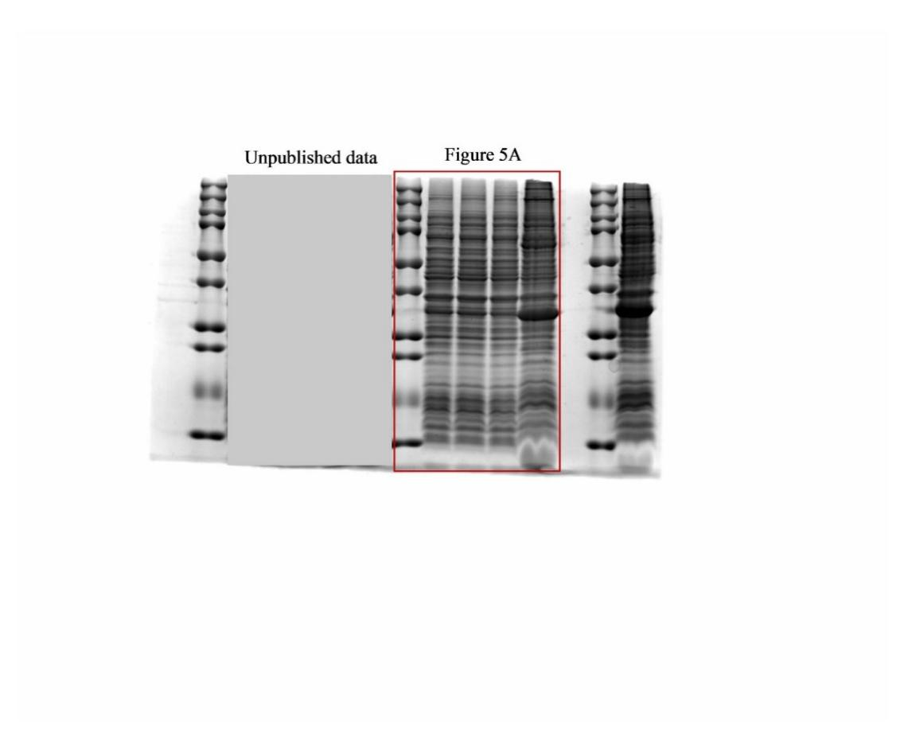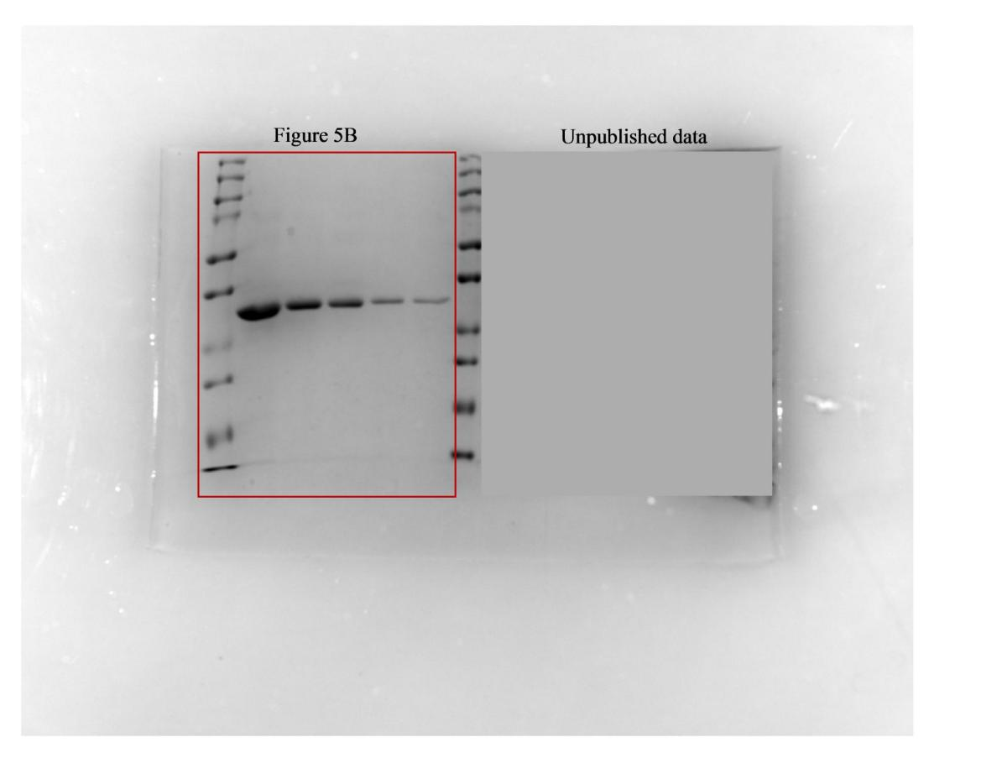
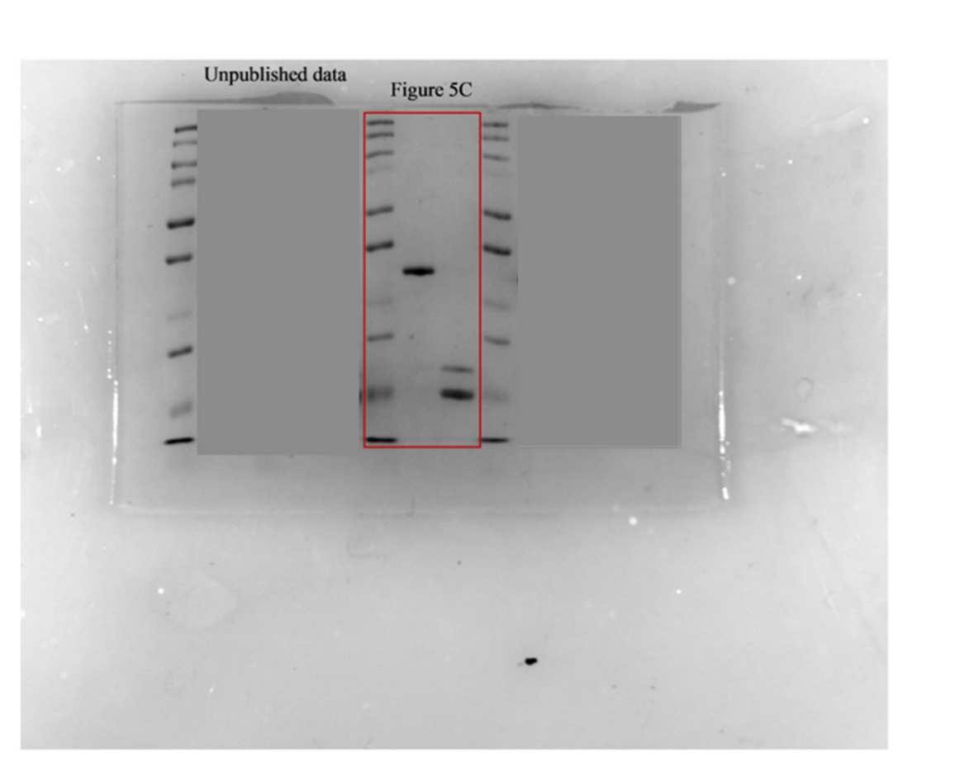
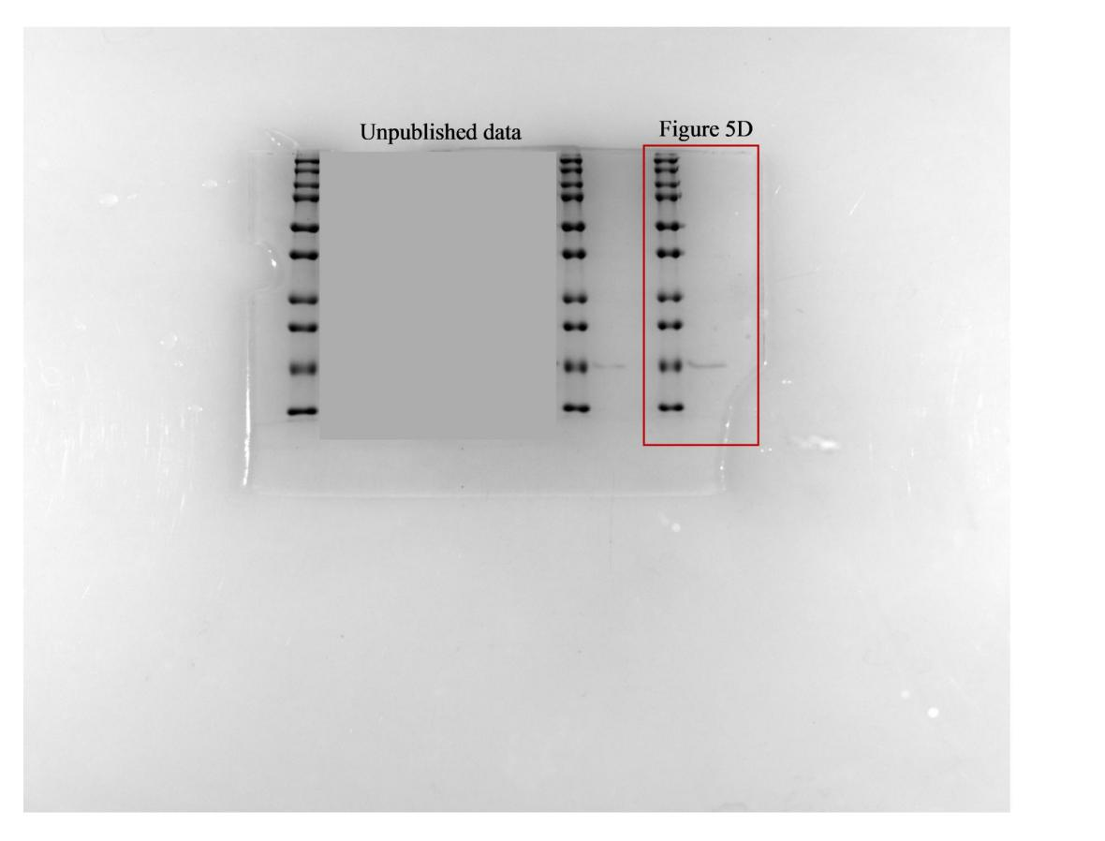
We would like to explain the obscuration in some gel diagrams: this was done to protect certain unpublished data contained within, and we sincerely hope this arrangement is understandable to you.

