Supplement table 1 The reference strains used for constructing the phylogenetic tree in this study
No | Strain | Species | Serotype | Accession Number | Base pair | Country collected
1 | OTE | FAdV-A | FAdV-1 | MK572847 | 43,816 | Japan
2 | Phelps | FAdV-A | FAdV-1 | NC_001720 | 43,804 | -
3 | SR48 | FAdV-D | FAdV-2 | NC_075462 | 43,632 | Japan
4 | 685 | FAdV-D | FAdV-2 | KT862805 | 44,336 | UK
5 | SR49 | FAdV-D | FAdV-3 | NC_075461 | 43,337 | Japan
6 | KR5 | FAdV-C | FAdV-4 | NC_075488 | 45,810 | -
7 | ON1 | FAdV-C | FAdV-4 | NC_015323 | 45,667 | Canada
8 | 340 | FAdV-B | FAdV-5 | NC_021221 | 45,781 | Ireland
9 | WHRS | FAdV-B | FAdV-5 | OM836676 | 45,734 | China
10 | CR119 | FAdV-E | FAdV-6 | NC_038332 | 43,810 | Japan
11 | YR36 | FAdV-E | FAdV-7 | NC_075460 | 43,525 | Japan
12 | JL/170408 | FAdV-E | FAdV-8a | MN417117 | 44,209 | China
13 | TR59 | FAdV-E | FAdV-8a | NC_075459 | 43,287 | Japan
14 | HUNG6 | FAdV-E | FAdV-8b | MK572853 | 44,037 | Hungary
15 | HN1472 | FAdV-E | FAdV-8b | OR975470 | 44,253 | China
16 | SD2009 | FAdV-E | FAdV-8b | OL456208 | 44,475 | China
17 | HeB20 | FAdV-E | FAdV-8b | OK188966 | 43,843 | China
18 | SD1356 | FAdV-E | FAdV-8b | MG712775 | 44,454 | China
19 | QD2016 | FAdV-E | FAdV-8b | MF577036 | 43,632 | China
20 | 764 | FAdV-E | FAdV-8b | NC_075458 | 43,666 | UK
21 | UPM04217 | FAdV-E | FAdV-8b | KU517714 | 44,072 | Malaysia
22 | A-2A | FAdV-D | FAdV-9 | NC_000899 | 45,063 | -
23 | C2-B-FAdV-10 | FAdV-C | FAdV-10 | NC_075970 | 45,554 | USA
24 | AHFY19 | FAdV-C | FAdV-10 | MN542422 | 45,757 | China
25 | ON P2 | FAdV-D | FAdV-11 | KU310942 | 44,377 | Canada
26 | 380 | FAdV-D | FAdV-11 | NC_075457 | 43,347 | UK
27 | GR | DAdV | DAdV-2 | NC_024486 | 43,734 | France

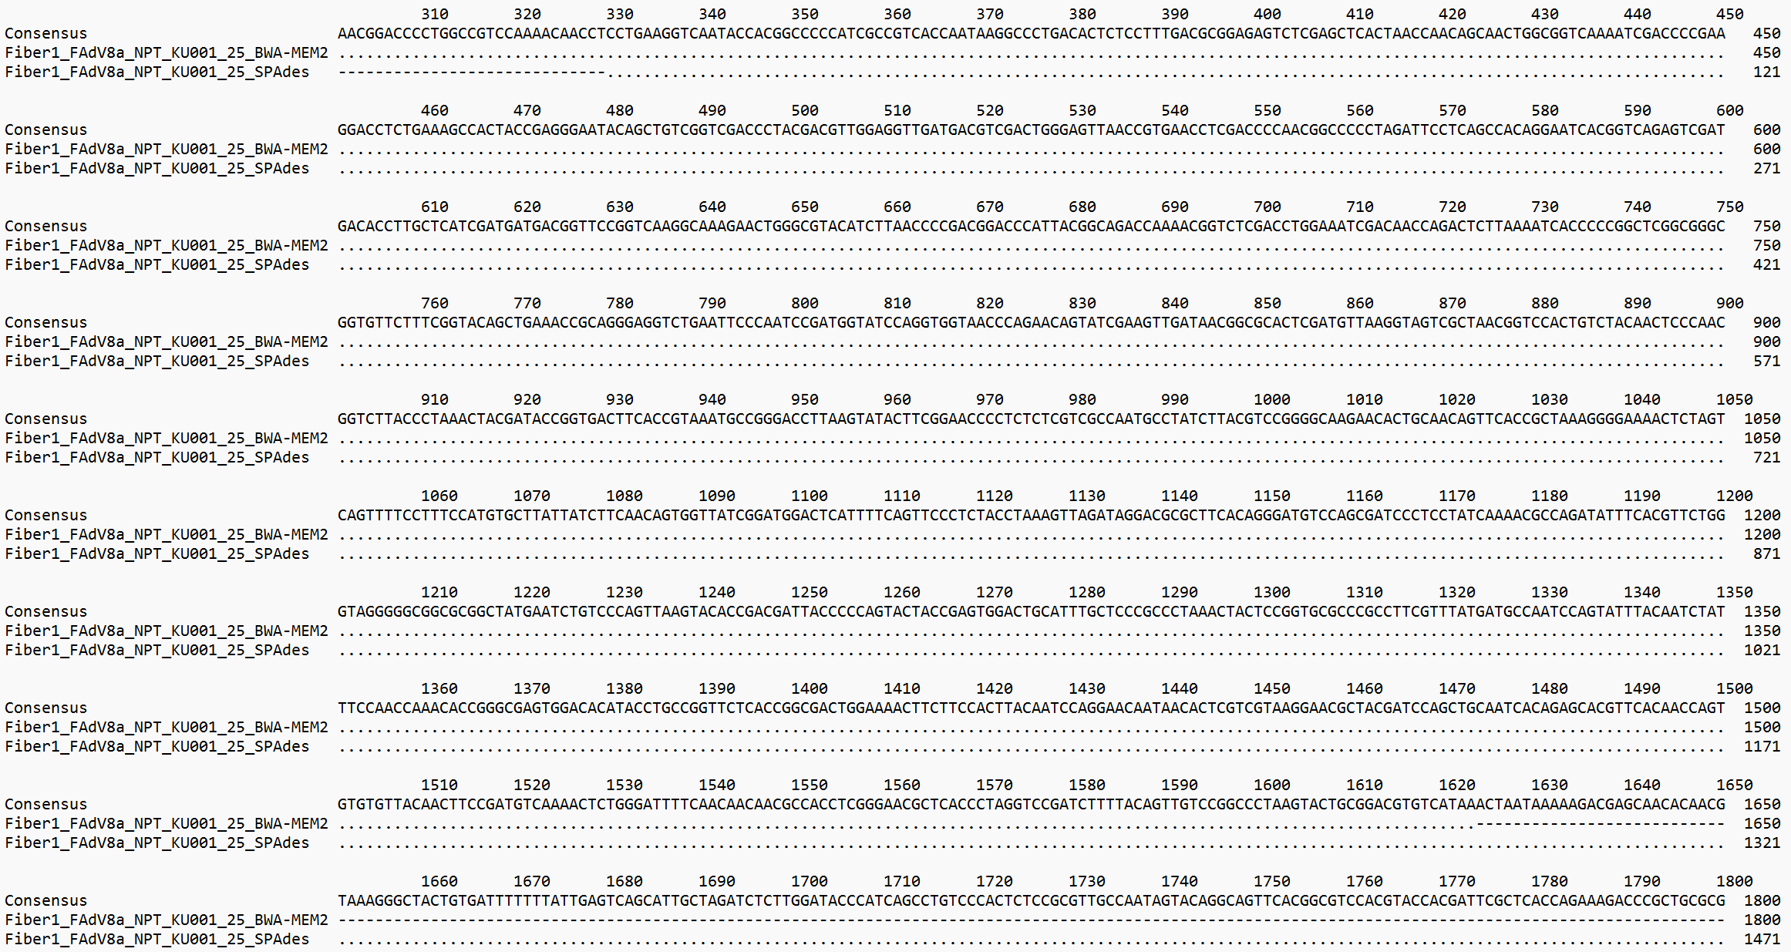
Supplement figure 1. This figure illustrated the pairwise alignment between the fiber gene of the FAdV8a_NPT_KU001_25 strain obtained from BWA-MEM2 mapping and fiber obtained from de novo assembly using SPAdes. The sequence lengths for these two approaches were 1,623 and 7,303 bp, respectively. In the alignment, the topmost line represented the consensus sequence, followed by the fiber sequence from the FAdV8a_NPT_KU001_25 strain obtained through mapping, and finally, the fiber sequence from the FAdV8a_NPT_KU001_25 strain obtained through de novo assembly. This comparison identified discrepancies between the two methods and ensured the accuracy of the assembled sequence, particularly in highly variable regions.

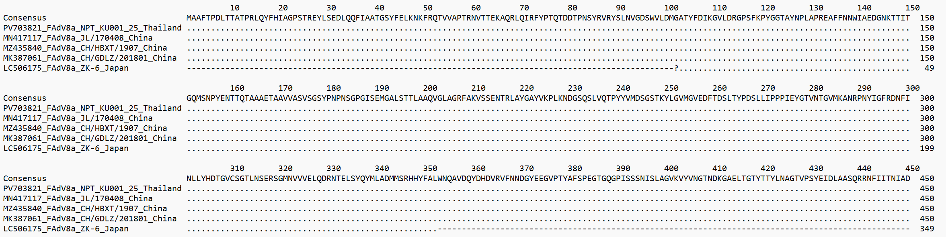
Supplement figure 2. This figure showed the amino acid alignment of the Hexon protein from non-GE-associated and GE-associated FAdV-8a strains. The amino acid alignment presented no variations between GE-associated strains (ZK-6/Japan) and the non-GE-associated strains (JL/170408/China, CH/HBXT/1907/China, CH/GDLZ/201801/China). The question-mark symbol represented a nucleotide gap that does not form a complete codon and therefore cannot be translated into an amino acid residue.

