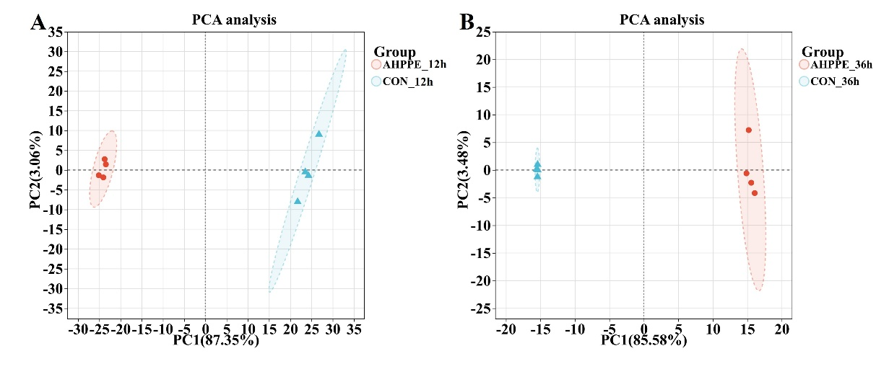
Figure S2. Principal component analysis (PCA) of transcriptomic profiles. PCA plots showing separation between untreated control (CON) and AHPPE-treated moDCs at (A) 12 hours and (B) 36 hours post-stimulation. Each dot represents an individual biological replicate (n = 4 per group per time point).

