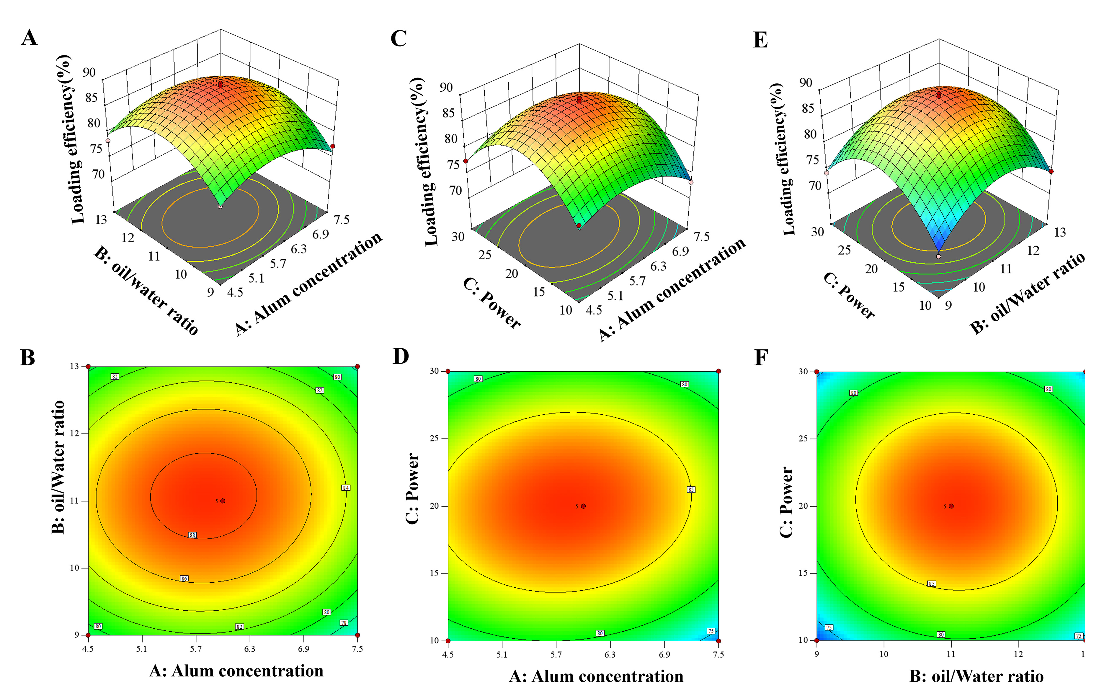
Figure S1. Response surface and contour plots for AHPPE preparation optimization. Response surface (A, C, E) and corresponding contour (B, D, F) plots showing the effect of independent variables on antigen loading efficiency (Y). Variables include Alum concentration (A), oil-to-water ratio (B), and ultrasonic power (C). Each plot illustrates the interaction between two variables while the third is held at its central level.

