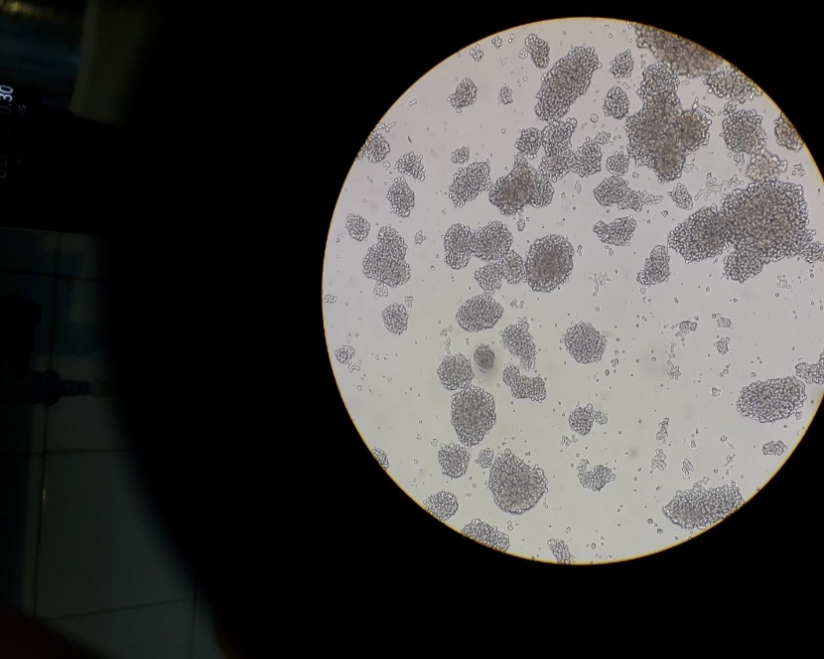
Figure S1: 48-hour culture of H1H9 lymphoblastoid cells (4 X)

