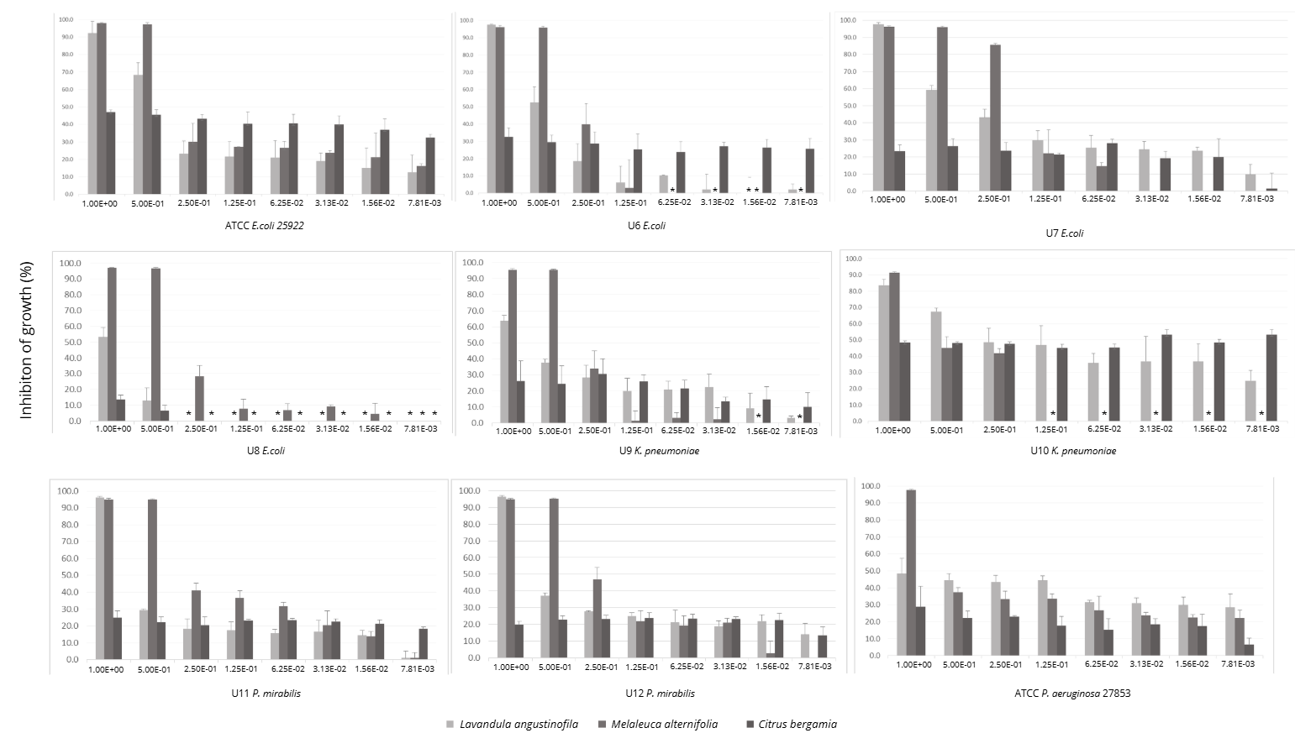
Supplementary figure 11 – Mean percentage of bacterial growth inhibition for Gram-positive isolates, for Lavandula angustifolia (lavender), Melaleuca alternifolia (tea tree) and Citrus bergamia (bergamot) essential oils. Legend: (*) - no inhibition in comparison with control.

