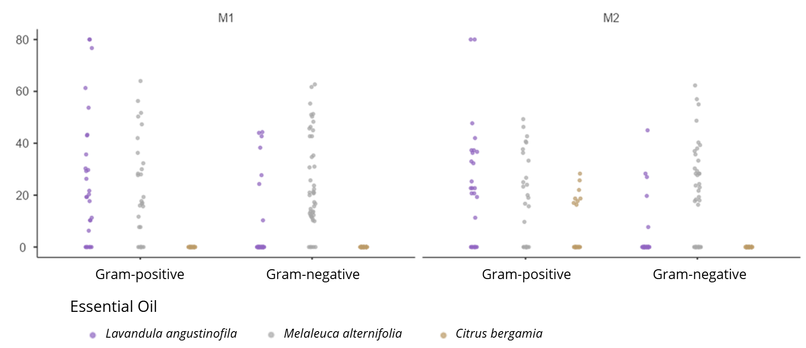
Supplementary figure 4 – Volatile exposure methods (M1 and M2) – Mean zone inhibition values for each volume used (10µL, 20µL, 40µL, 80µL and 160µL) divided by bacterial group for Lavandula angustifolia (lavender), Melaleuca alternifolia (tea tree) and Citrus bergamia (bergamot) essential oils. Results are expressed in millimeters (mm).

