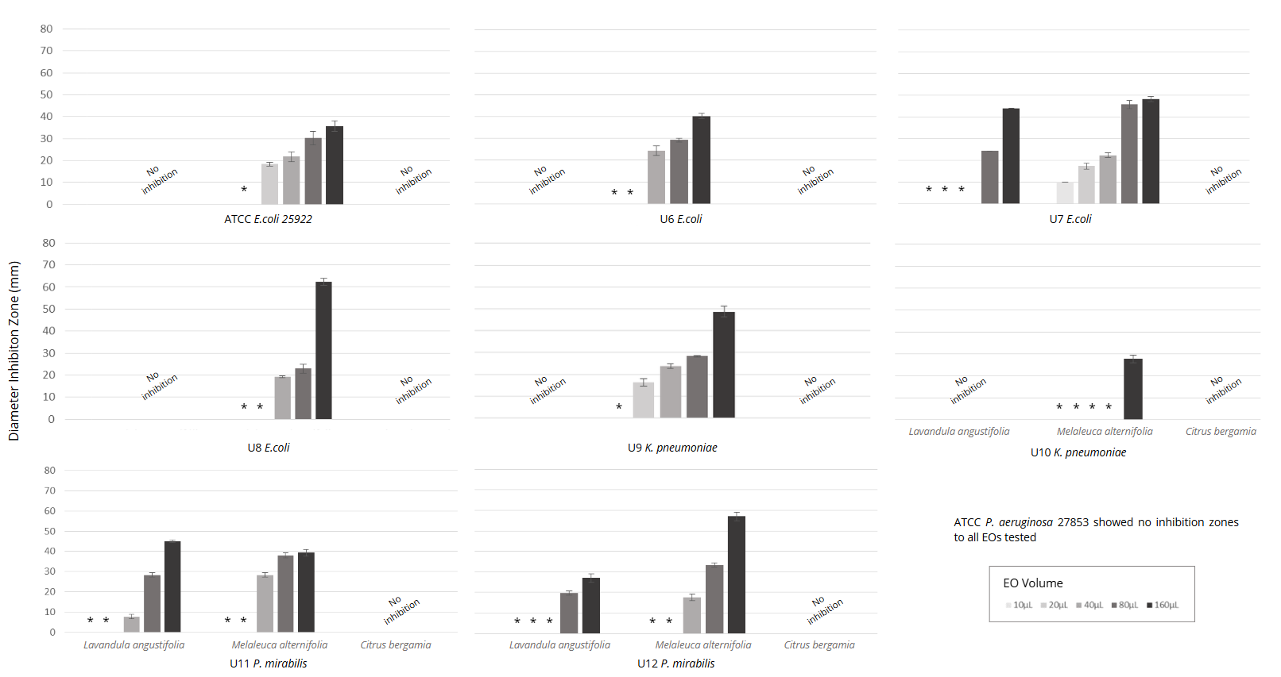
Supplementary figure 8 – Volatile exposure method (M2) for Gram-negative isolates, for Lavandula angustifolia (lavender), Melaleuca alternifolia (tea tree) and Citrus bergamia (bergamot) essential oils at 10µL, 20µL, 40µL, 80µL and 160µL. Results are expressed in millimeters (mm) Legend: (*) - Diameter ≤ 6mm; EO: Essential oil.

