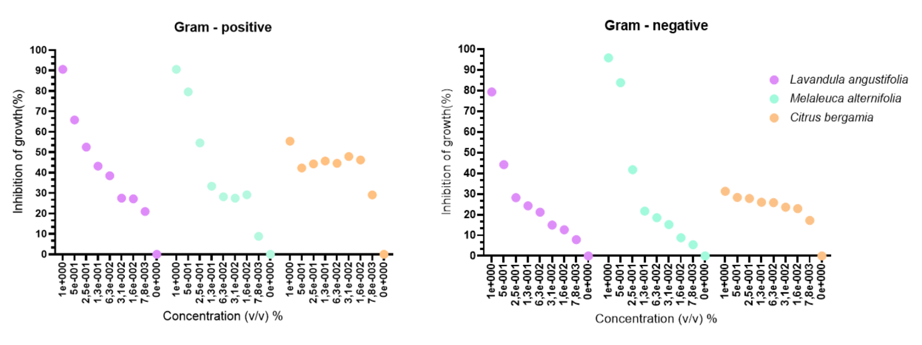
Supplementary figure 9 – Mean percentage of bacterial growth inhibition for Gram-positive and Gram-negative isolates, for Lavandula angustifolia (lavender), Melaleuca alternifolia (tea tree) and Citrus bergamia (bergamot) essential oils.

