Short-term acceptance of botanical feed additives by horses: a multidimensional behavioural and consumption analysis

E. Tkaczyk, J. Kita, W. Janicka, A. J. Łuszczyński, I. Janczarek

Supplementary Material

Supplementary Table S1. Full primary three-component model-adjusted ranking of all herbs.
Rank | Name | Low-acceptance score | 95% CrI | P(score > 0) | P(score < 0)
Clearly unfavourable
1 | Zingiber officinale | 3.682 | 2.540 to 4.830 | 1.000 | 0.000
2 | Pimpinella anisum | 3.007 | 1.810 to 4.170 | 1.000 | 0.000
3 | Ascophyllum nodosum | 2.804 | 1.650 to 3.960 | 1.000 | 0.000
4 | Cistus ladaniferus | 2.634 | 1.370 to 3.840 | 1.000 | 0.000
5 | Allium sativum | 2.557 | 1.380 to 3.720 | 1.000 | 0.000
6 | Cinnamomum verum | 2.514 | 1.380 to 3.660 | 1.000 | 0.000
7 | Nigella sativa | 2.293 | 1.120 to 3.470 | 1.000 | 0.001
8 | Curcuma longa | 1.727 | 0.538 to 2.910 | 0.996 | 0.004
9 | Valeriana officinalis | 1.666 | 0.469 to 2.850 | 0.995 | 0.005
10 | Glycyrrhiza glabra | 1.359 | 0.173 to 2.540 | 0.986 | 0.014
Intermediate
11 | Salvia officinalis | 1.182 | -0.087 to 2.360 | 0.968 | 0.032
12 | Althaea officinalis | 1.152 | -0.115 to 2.370 | 0.966 | 0.034
13 | Origanum majorana | 0.997 | -0.260 to 2.200 | 0.938 | 0.062
14 | Cetraria islandica | 0.724 | -0.976 to 2.160 | 0.812 | 0.188
15 | Foeniculum vulgare | 0.365 | -1.120 to 1.660 | 0.684 | 0.316
16 | Urtica dioica | 0.179 | -1.530 to 1.650 | 0.596 | 0.404
17 | Origanum vulgare | 0.026 | -1.460 to 1.360 | 0.517 | 0.483
18 | Vitex agnus-castus | 0.021 | -1.510 to 1.430 | 0.511 | 0.488
19 | Equisetum arvense | -0.182 | -2.020 to 1.290 | 0.416 | 0.584
20 | Tussilago farfara | -0.242 | -1.970 to 1.220 | 0.374 | 0.626
21 | Verbena officinalis | -0.260 | -1.680 to 1.120 | 0.368 | 0.632
22 | Filipendula ulmaria | -0.292 | -1.700 to 1.020 | 0.334 | 0.666
23 | Leonurus cardiaca | -0.321 | -1.970 to 1.150 | 0.345 | 0.655
24 | Borago officinalis | -0.380 | -1.890 to 1.010 | 0.306 | 0.694
25 | Calendula officinalis | -0.427 | -2.140 to 1.020 | 0.301 | 0.699
26 | Rubus idaeus | -0.468 | -2.140 to 1.050 | 0.280 | 0.720
27 | Trigonella foenum-graecum | -0.523 | -1.970 to 0.823 | 0.225 | 0.775
28 | Rosa canina | -0.551 | -2.310 to 0.997 | 0.249 | 0.751
29 | Arctium lappa | -0.587 | -2.350 to 0.883 | 0.227 | 0.773
30 | Rosmarinus officinalis | -0.613 | -2.300 to 0.818 | 0.204 | 0.796
31 | Echinacea purpurea | -0.631 | -2.550 to 1.050 | 0.244 | 0.756
32 | Symphytum officinale | -0.682 | -2.430 to 0.897 | 0.198 | 0.802
33 | Camellia sinensis | -0.822 | -2.560 to 0.650 | 0.130 | 0.870
34 | Fagopyrum esculentum | -0.825 | -2.450 to 0.619 | 0.135 | 0.865
35 | Matricaria chamomilla | -0.867 | -2.650 to 0.566 | 0.122 | 0.878
36 | Galium aparine | -0.946 | -2.760 to 0.555 | 0.103 | 0.897
37 | Aronia melanocarpa | -0.977 | -2.800 to 0.652 | 0.126 | 0.874
38 | Hypericum perforatum | -0.985 | -2.710 to 0.538 | 0.112 | 0.888
39 | Plantago lanceolata | -1.109 | -2.690 to 0.291 | 0.062 | 0.938
40 | Thymus vulgaris | -1.249 | -3.190 to 0.354 | 0.070 | 0.930
41 | Mentha × piperita | -1.268 | -3.260 to 0.370 | 0.061 | 0.939
42 | Carum carvi | -1.322 | -3.130 to 0.183 | 0.042 | 0.958
43 | Silybum marianum | -1.334 | -3.310 to 0.267 | 0.053 | 0.947
44 | Harpagophytum procumbens | -1.611 | -3.700 to 0.012 | 0.027 | 0.974
Clearly favourable
45 | Taraxacum officinale | -1.651 | -3.570 to -0.045 | 0.022 | 0.978
46 | Crataegus spp. | -1.694 | -3.620 to -0.013 | 0.024 | 0.976
47 | Coriandrum sativum | -1.763 | -3.700 to -0.042 | 0.022 | 0.978
48 | Achillea millefolium | -1.796 | -3.540 to -0.296 | 0.010 | 0.990
49 | Melissa officinalis | -1.798 | -3.750 to -0.153 | 0.017 | 0.984
50 | Lavandula angustifolia | -2.261 | -4.060 to -0.702 | 0.001 | 0.999
Ranks are ordered from highest to lowest low-acceptance score. Latin names should be checked against the final study dictionary before submission.

Supplementary Table S2. Summary of validation, diagnostic and robustness analyses.
Analysis | Result | Interpretation
Posterior PCA stability | PC1 variance: median 62.9%, 95% CrI 56.7–68.5%; P(all PC1 loadings > 0) = 1.000 | PC1 had stable interpretation as low-acceptance gradient.
Joint model PPC | 100% of herb-, horse- and trial-level groups within 95% posterior predictive intervals | Joint model reproduced group-level response patterns.
Posterior predictive herb-level correlations | Observed herb-level correlations within posterior predictive intervals for all response pairs | Joint model reproduced response co-variation.
LOHO stability | Clearly unfavourable group: median overlap 10/10, minimum 9/10 | Unfavourable group was not driven by any single horse.
Prior sensitivity | Spearman ≥ 0.999; median rank shift = 0; top 10 overlap = 10/10 | Ranking was practically insensitive to prior specification.
Censored-time sensitivity | Four-component vs primary three-component PCA: Spearman = 0.983, Kendall = 0.915; extreme group retained | Censored time was retained only as sensitivity because PPC underestimated non-completion rates.
Expected leftover burden | Spearman = 0.848, Kendall = 0.693; median absolute rank shift = 3 | Practical leftover-burden indicator supported the unfavourable end.

Supplementary Figure S1. Leave-one-horse-out stability of posterior-defined herb groups.
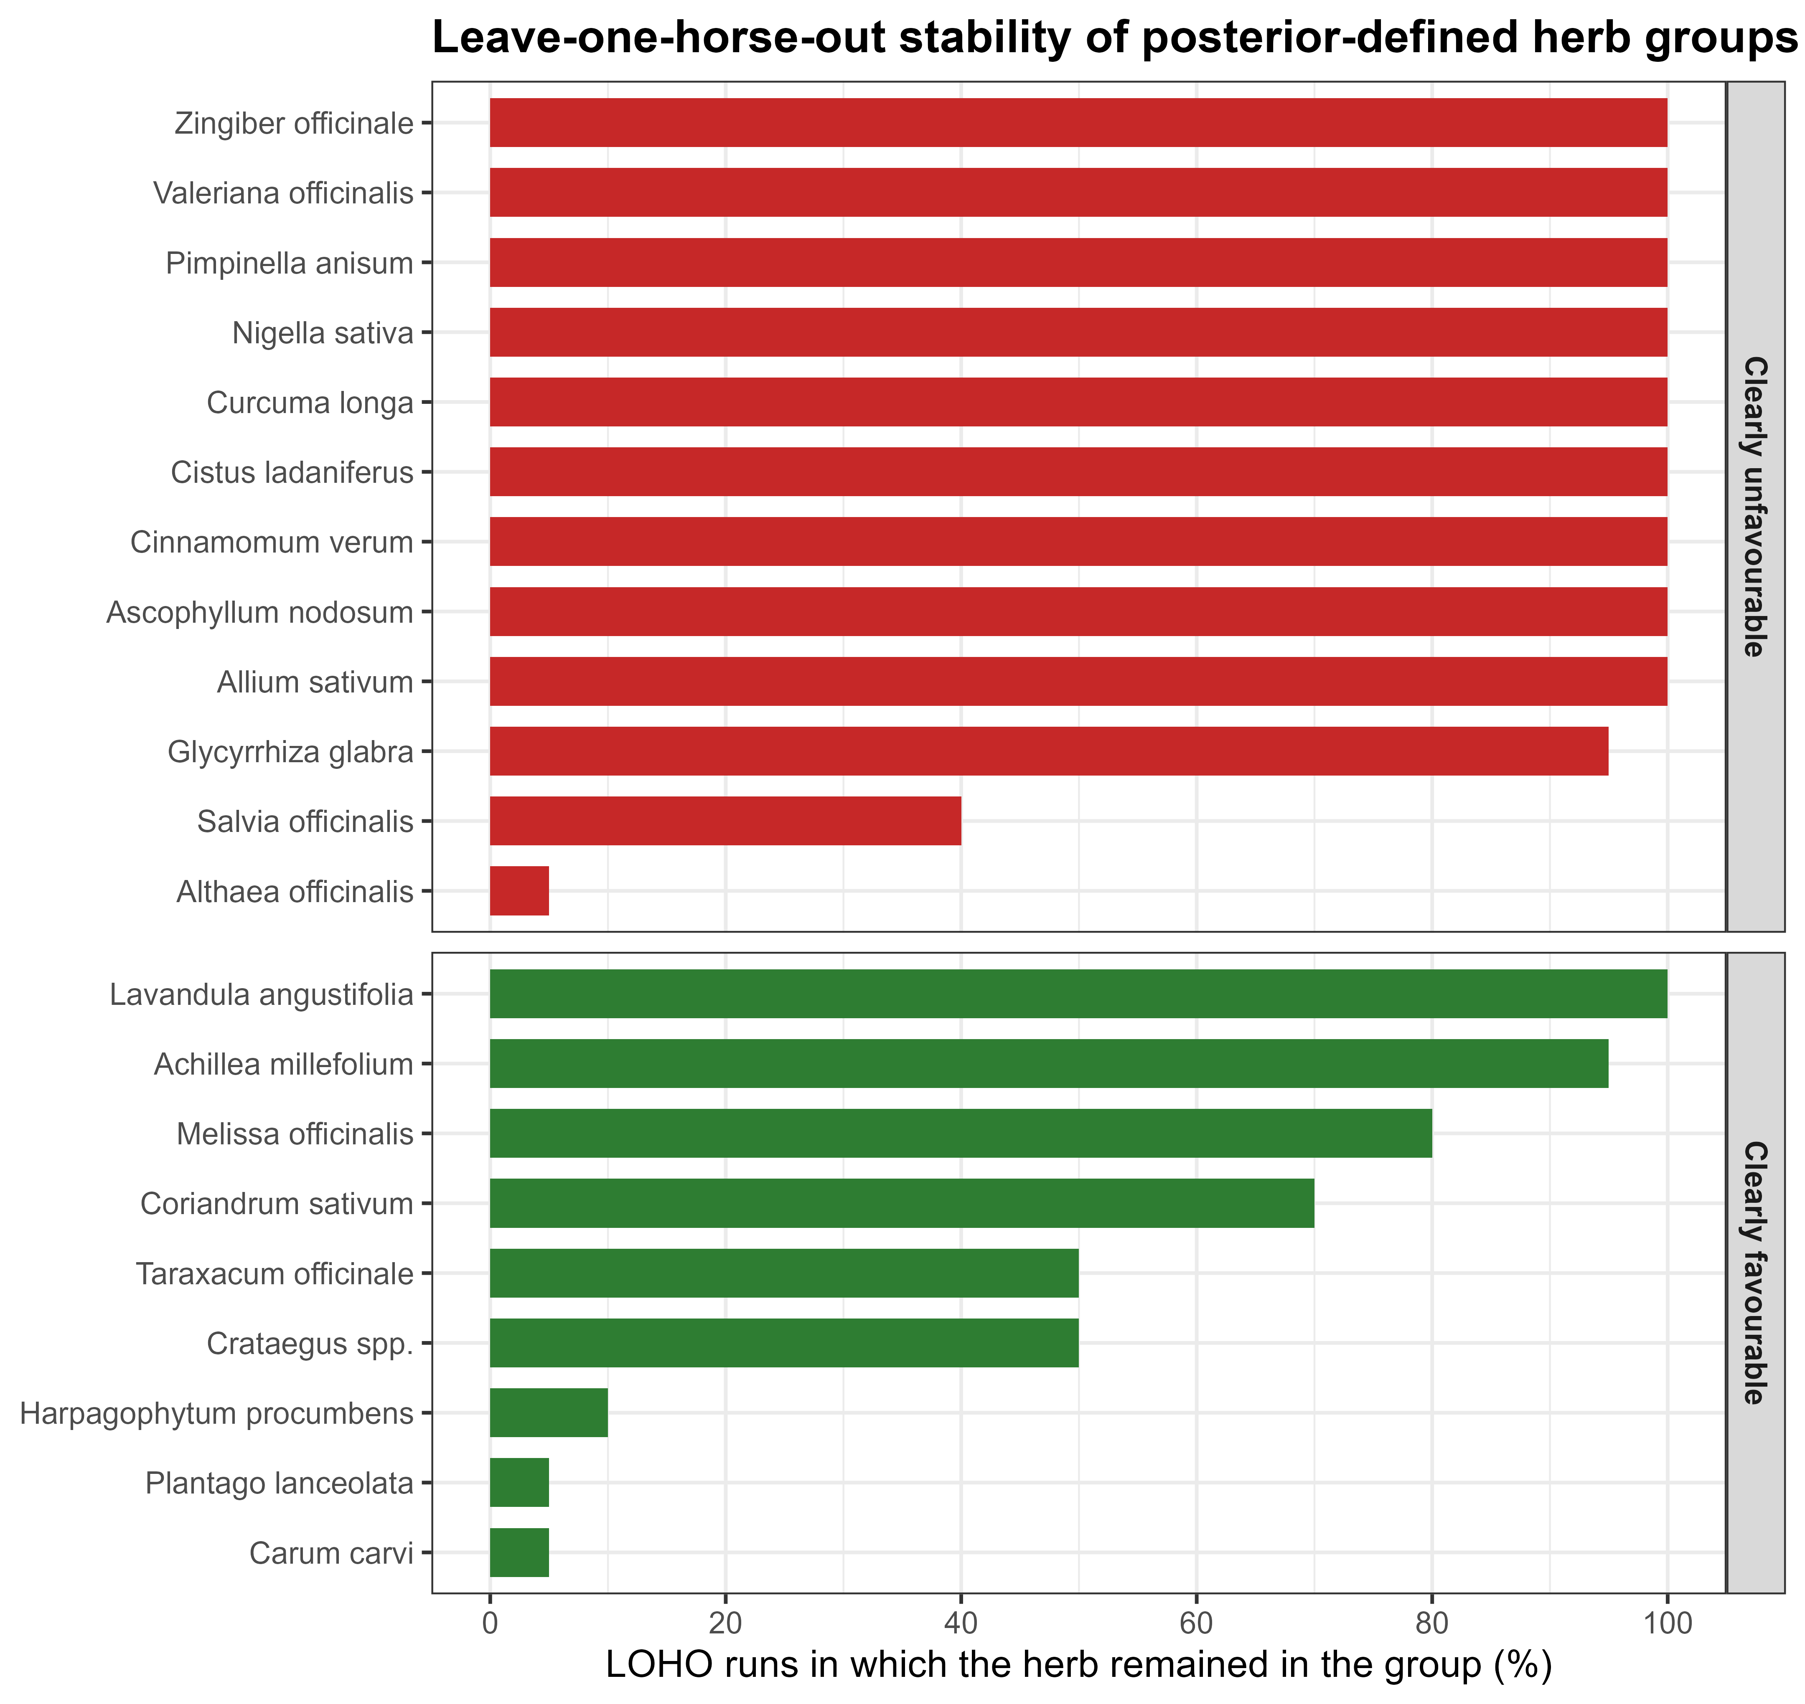

Supplementary Figure S2. Prior sensitivity of posterior-defined herb groups.
