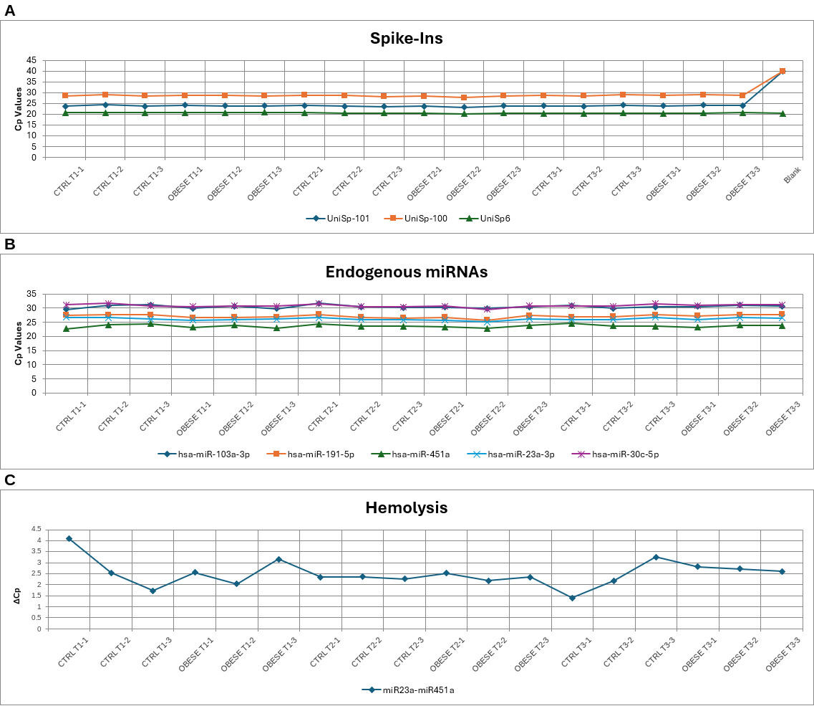
Supplementary Figure S1. RNA quality assessment of plasma samples prior to library preparation. (A) Cp values of three synthetic spike-in controls (UniSp-101, UniSp-100, UniSp6) across all 18 samples and a no-template blank, confirming absence of reverse transcription or amplification inhibition. (B) Cp values of five endogenous plasma miRNAs across all 18 samples, confirming expression within the expected range. (C) ΔCp values across all 18 samples, calculated as Cp(miR-23a-3p) − Cp(miR-451a). Because miR-451a is erythrocyte-enriched, hemolysis lowers its Cp and thereby increases ΔCp; values below 5 indicate no hemolysis and values approaching or exceeding 7 indicate an increased risk. All samples fell below this threshold, indicating absence of significant hemolysis. Samples are labelled by group, timepoint and animal.

