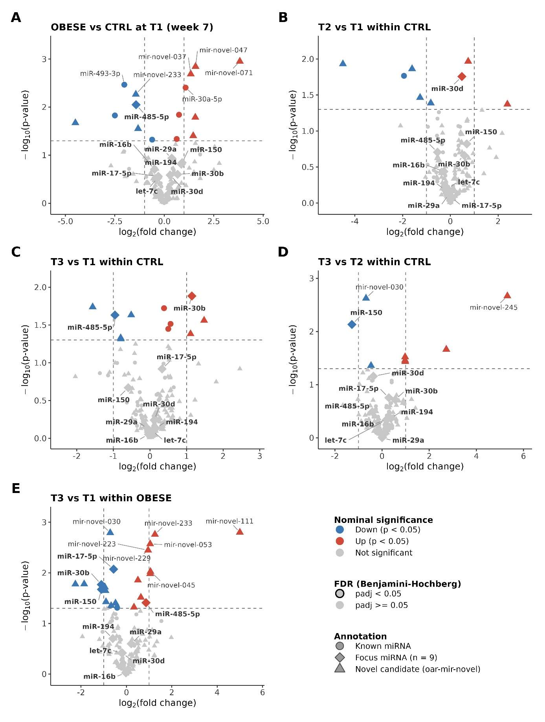
Supplementary Figure S2. Volcano plots of differential miRNA expression for remaining pairwise comparisons. (A) OBESE vs CTRL at T1 (week 7); (B) T2 vs T1 within the CTRL group; (C) T3 vs T1 within the CTRL group; (D) T3 vs T2 within the CTRL group; (E) T3 vs T1 within the OBESE group. Analyses are based on n = 3 animals per group at each timepoint and were performed with DESeq2 using a paired design with animal identity as a blocking factor; significance was assessed by Wald test with Benjamini-Hochberg correction across all 181 tested miRNAs within each comparison. x-axis, log2 fold change; y-axis, −log10(nominal p-value); dashed lines indicate nominal p = 0.05 and |log2FC| = 1. Colour indicates the direction of change and nominal significance only; adjusted significance (padj < 0.05) is shown by a black outline, not by colour or vertical position. Point shape indicates annotation class (circle, previously annotated ovine miRNA; diamond, one of the nine focus miRNAs; triangle, de novo candidate). Selected miRNAs are labelled; for clarity, labels omit the oar- prefix. oar-miR-3957-5p, which reached padj < 0.05 in the CTRL T2 vs T1 and T3 vs T1 comparisons, was identified as a technical artefact (baseMean ≈ 7, log2FC > 16), excluded from biological interpretation and is not shown. Apart from this artefact, no miRNA reached statistical significance (padj < 0.05) in any CTRL temporal comparison or in the OBESE vs CTRL comparison at T1.

