Additional file 1
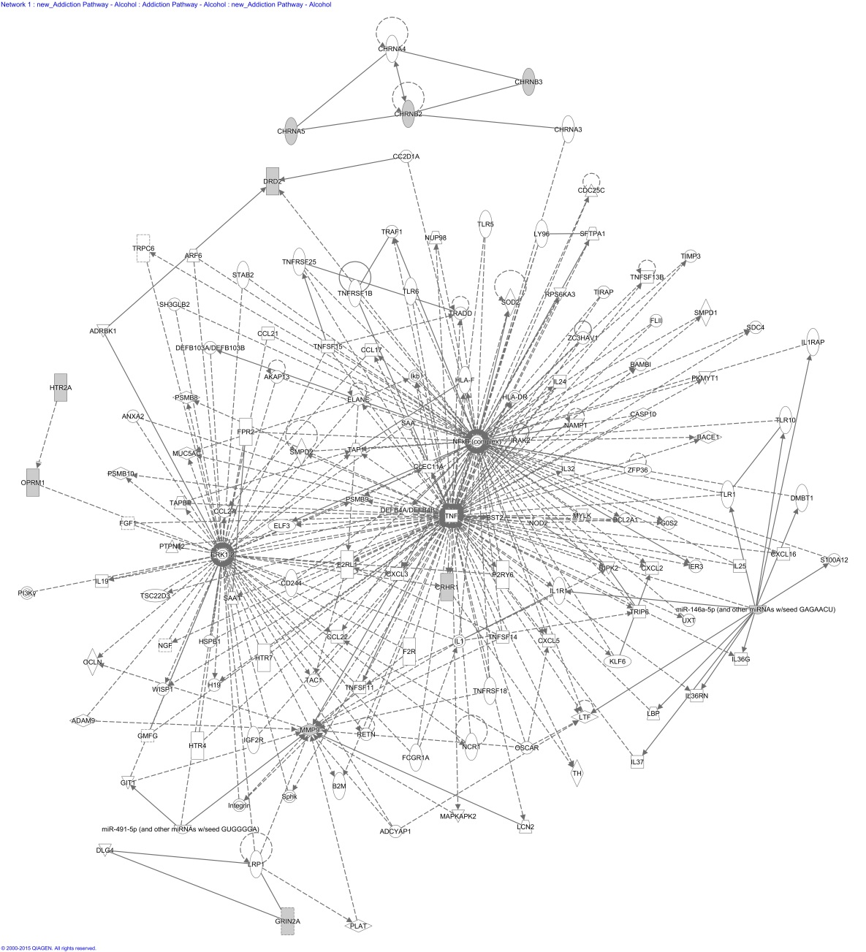
Figure S1: Network generated using 25 focus genes for alcohol addiction (p-score = 16)
Focus genes associated with alcohol addiction

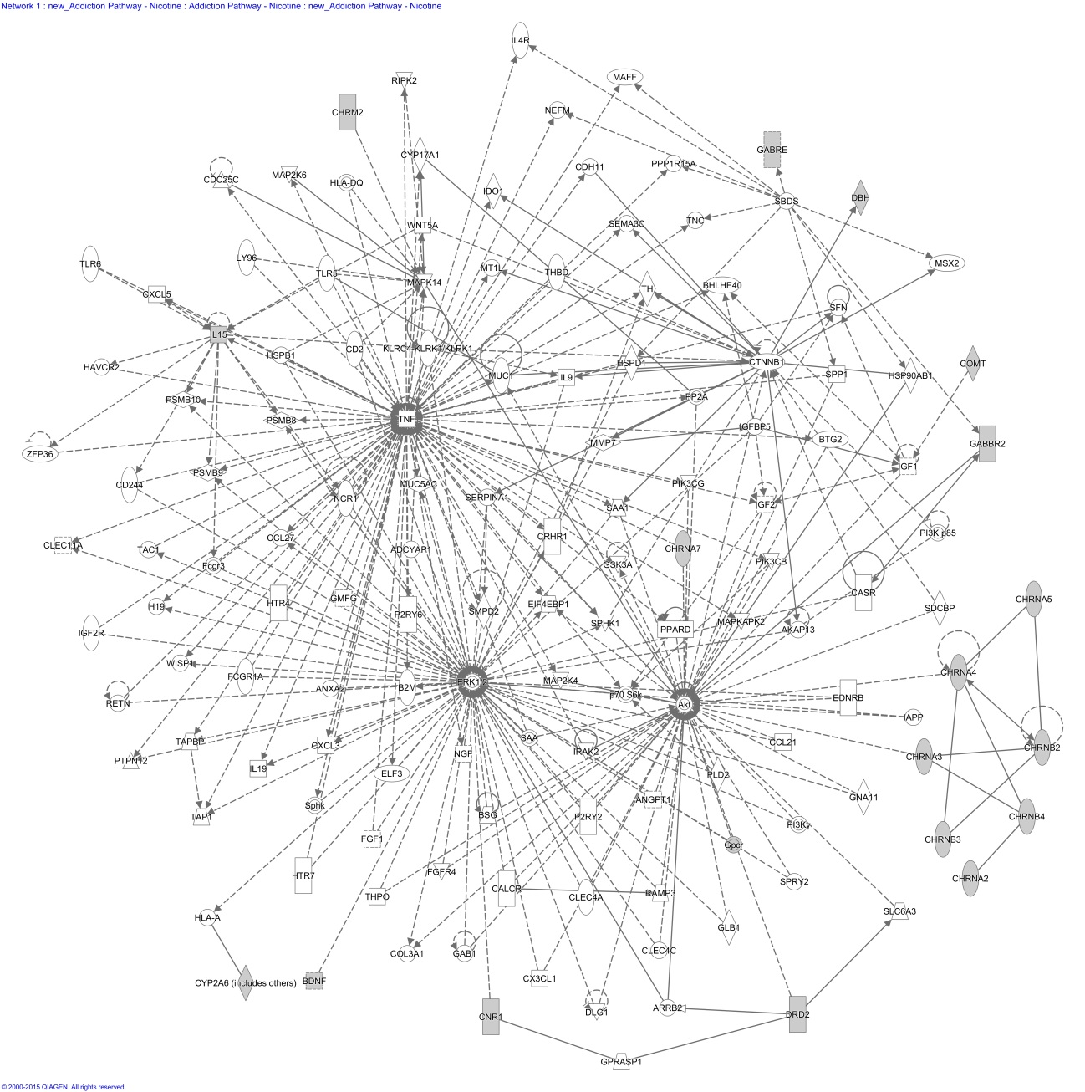
Figure S2: Network generated using 27 focus genes for nicotine addiction (p-score = 31)
Focus genes associated with nicotine addiction

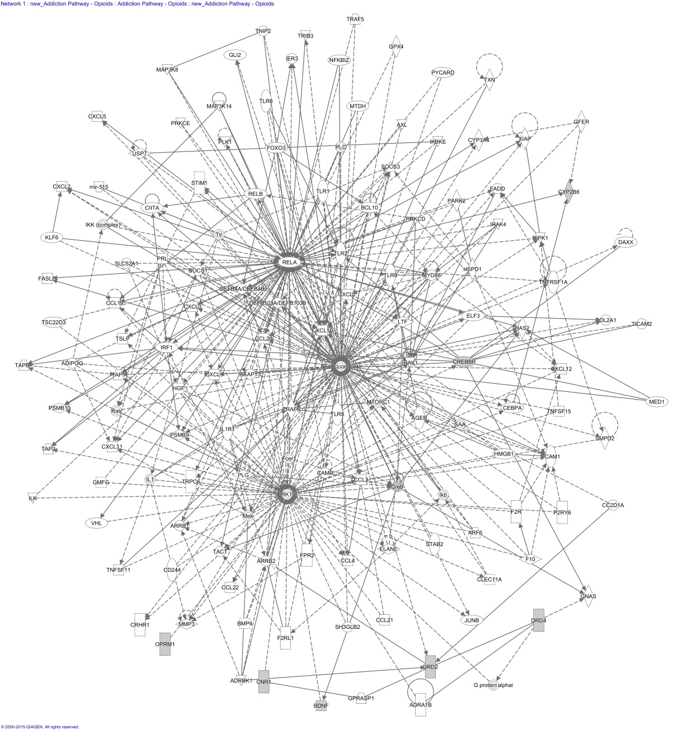
Figure S3: Network generated using 15 focus genes for opioid addiction (p-score = 10)
Focus genes associated with opioid addiction

