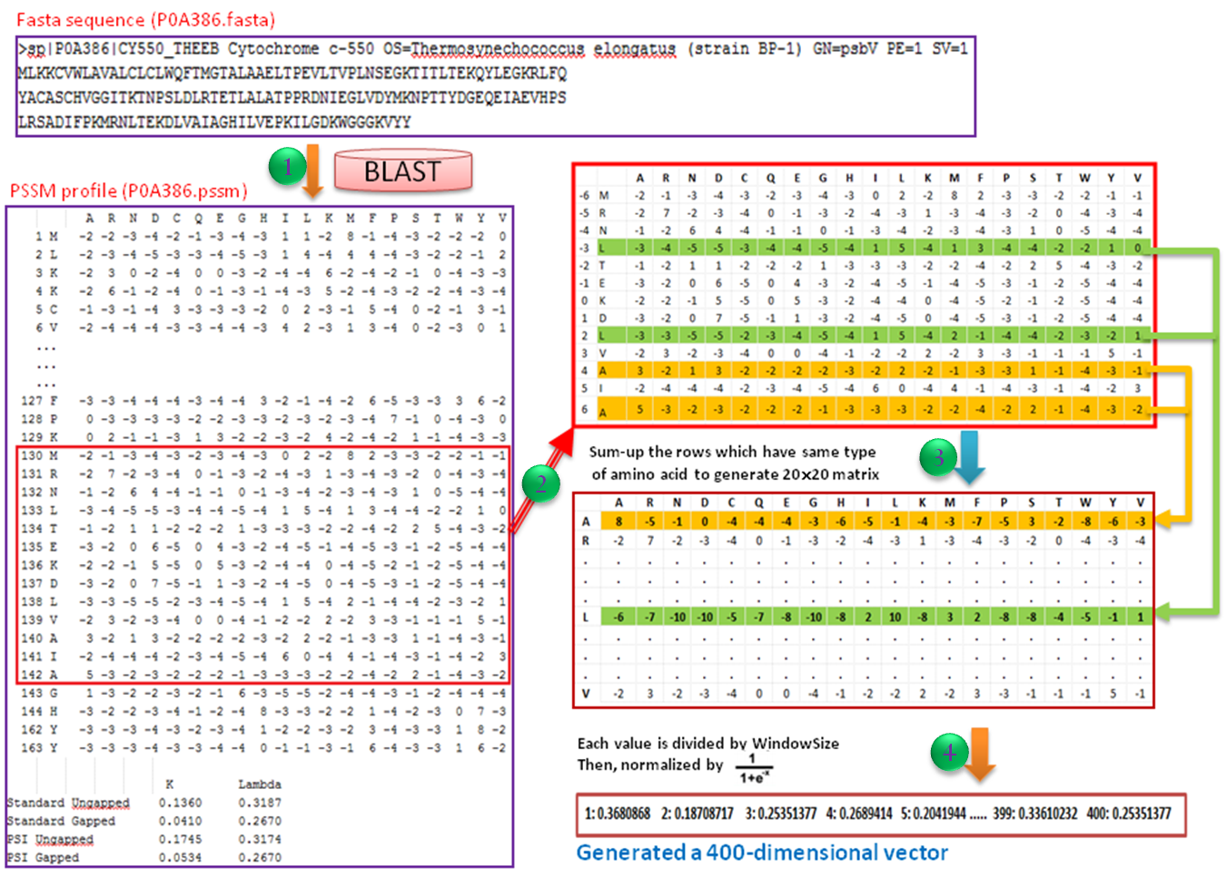
Figure S2. Detailed steps for obtaining the PSSM vector in this study.

