Additional file 2 – Figure S1

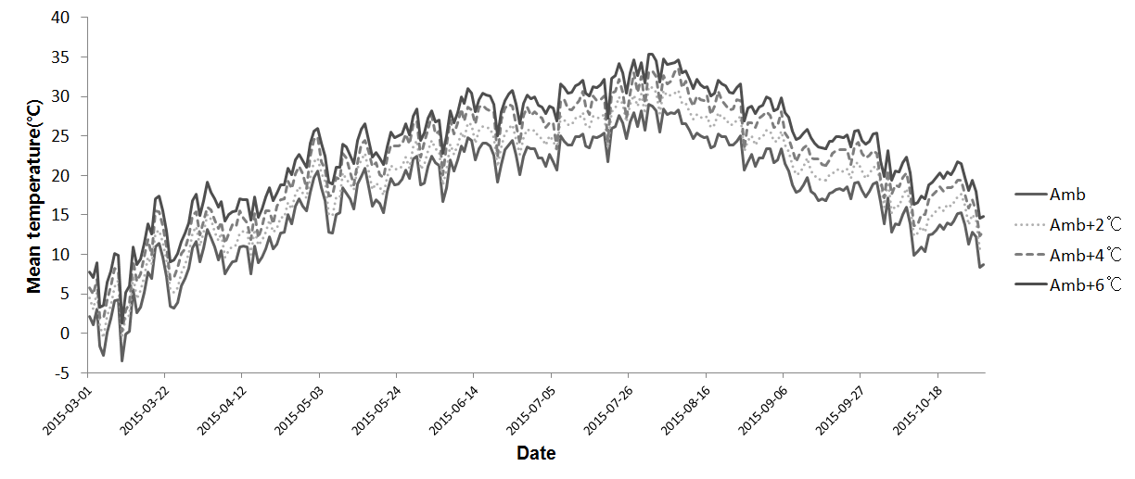
Figure S1. Changes in daily average air temperature in the Temperature Gradient Greenhouse where Korean ginseng, Yunpoong, grown. Each label represents a location within the temperature-gradient green house (TGG), which have different temperature measures. Amb, Ambient Temperature; Amb+2℃, Ambient Temperature +2

