Supplementary Information

Table S1. Significant epigenetic interactions between miRNA and methylation associated with target genes.

Gene | Methylation | miRNA | LRT p-value | Bonferroni corrected p-value
BCL3 | cg11459773 | hsa.mir.3936 | 1.65E-15 | 1.19E-09
USP40 | cg05689415 | hsa.mir.484 | 3.86E-15 | 2.79E-09
E2F3 | cg21803390 | hsa.mir.765 | 1.28E-14 | 9.24E-09
NCAN | cg04314308 | hsa.mir.1286 | 1.31E-14 | 9.49E-09
SLC7A1 | cg03937082 | hsa.mir.3919 | 3.09E-14 | 2.23E-08
BCL11B | cg07015803 | hsa.mir.944 | 5.24E-14 | 3.79E-08
C8orf33 | cg01040181 | hsa.mir.3159 | 1.02E-13 | 7.39E-08
E2F3 | cg21803390 | hsa.mir.217 | 1.15E-13 | 8.31E-08
BCL3 | cg01220257 | hsa.mir.3936 | 1.54E-13 | 1.12E-07
TXNL1 | cg18319916 | hsa.mir.320e | 2.77E-13 | 2.0E-07
CDADC1 | cg18587973 | hsa.mir.107 | 9.90E-13 | 7.16E-07
ECH1 | cg07662676 | hsa.mir.320a | 1.11E-12 | 8.02E-07
SLC35E3 | cg02006977 | hsa.mir.3929 | 1.16E-12 | 8.35E-07
NCAN | cg06952310 | hsa.mir.1286 | 1.33E-12 | 9.60E-07
TXNL1 | cg23374762 | hsa.mir.320e | 1.37E-12 | 9.90E-07
PFKP | cg10710457 | hsa.mir.3609 | 2.15E-12 | 1.56E-06
PFKP | cg14068301 | hsa.mir.520b | 3.96E-12 | 2.86E-06
CDKAL1 | cg19926519 | hsa.mir.1276 | 4.92E-12 | 3.55E-06
SLC35E3 | cg02006977 | hsa.mir.3176 | 8.64E-12 | 6.24E-06
SLC12A7 | cg02350636 | hsa.mir.1291 | 8.77E-12 | 6.34E-06
ELAVL4 | cg18242139 | hsa.mir.375 | 1.00E-11 | 7.26E-06
C8orf33 | cg11270233 | hsa.mir.3159 | 1.24E-11 | 8.94E-06
MYO1C | cg05843943 | hsa.mir.3170 | 1.24E-11 | 8.96E-06
ZNF669 | cg06545762 | hsa.mir.1976 | 2.70E-11 | 1.95E-05
C2orf82 | cg13047596 | hsa.mir.3195 | 3.49E-11 | 2.52E-05
MYO1C | cg20929407 | hsa.mir.3170 | 3.97E-11 | 2.87E-05
HIC2 | cg02209075 | hsa.mir.577 | 4.05E-11 | 2.93E-05
UNC5A | cg08322194 | hsa.mir.320a | 4.42E-11 | 3.20E-05
CCND1 | cg03040489 | hsa.mir.944 | 5.28E-11 | 3.81E-05
TXNL1 | cg18319916 | hsa.mir.588 | 5.83E-11 | 4.21E-05
SLC7A1 | cg26117398 | hsa.mir.3919 | 1.04E-10 | 7.54E-05
BCL11B | cg16452866 | hsa.mir.944 | 1.12E-10 | 8.09E-05
MDM2 | cg08547457 | hsa.mir.3662 | 1.71E-10 | 0.000123
MYO1C | cg13588265 | hsa.mir.3198 | 1.74E-10 | 0.000126
BCL3 | cg21606696 | hsa.mir.3936 | 1.77E-10 | 0.000128
SLC12A7 | cg18196463 | hsa.mir.1291 | 1.85E-10 | 0.000134
SLC12A7 | cg22673380 | hsa.mir.1291 | 2.01E-10 | 0.000145
SLC35E3 | cg02006977 | hsa.mir.3652 | 2.12E-10 | 0.000153
METTL6 | cg26710055 | hsa.mir.765 | 2.51E-10 | 0.000181
NIPBL | cg08374525 | hsa.mir.3936 | 2.71E-10 | 0.000196
PFKP | cg02579140 | hsa.mir.520b | 2.88E-10 | 0.000208
GATA6 | cg16204205 | hsa.mir.944 | 2.96E-10 | 0.000214
UTP6 | cg13453082 | hsa.mir.1254 | 3.38E-10 | 0.000244
ANP32E | cg13458596 | hsa.mir.3929 | 3.50E-10 | 0.000253
ZNF154 | cg01268824 | hsa.mir.548y | 3.58E-10 | 0.000259
ZNF555 | cg23671719 | hsa.mir.3929 | 3.63E-10 | 0.000262
SLC35E3 | cg02006977 | hsa.mir.665 | 3.66E-10 | 0.000265
TACR2 | cg23339629 | hsa.mir.1976 | 4.43E-10 | 0.00032
ECH1 | cg02012442 | hsa.mir.320a | 5.25E-10 | 0.000379
TRIM68 | cg23532985 | hsa.mir.1256 | 7.86E-10 | 0.000568
DDHD1 | cg13654573 | hsa.mir.934 | 8.28E-10 | 0.000598
RNASEH2B | cg01060358 | hsa.mir.940 | 8.35E-10 | 0.000603
ERLIN2 | cg09056309 | hsa.mir.326 | 8.78E-10 | 0.000635
HIC2 | cg02209075 | hsa.mir.4310 | 1E-09 | 0.000698
PFKP | cg09875661 | hsa.mir.520b | 1E-09 | 0.000701
CDADC1 | cg17226947 | hsa.mir.107 | 1E-09 | 0.000737
LONRF2 | cg26150922 | hsa.mir.484 | 1.06E-09 | 0.000768
ESPNL | cg02290684 | hsa.mir.375 | 1.15E-09 | 0.000833
ZNF555 | cg23100979 | hsa.mir.3929 | 1.22E-09 | 0.000883
DCTN6 | cg03746590 | hsa.mir.3929 | 1.24E-09 | 0.000894
LRIG1 | cg04560545 | hsa.mir.588 | 1.30E-09 | 0.000942
TRIP10 | cg25510018 | hsa.mir.3609 | 1.34E-09 | 0.000968
SLC25A15 | cg06026880 | hsa.mir.375 | 1.37E-09 | 0.000993
HOXB3 | cg10585948 | hsa.mir.375 | 1.38E-09 | 0.000998
IGF1R | cg15375596 | hsa.mir.1294 | 1.41E-09 | 0.001016
MAPKAPK2 | cg25748647 | hsa.mir.1231 | 1.49E-09 | 0.001074
SLC35E3 | cg02006977 | hsa.mir.940 | 1.50E-09 | 0.001084
TLE3 | cg12349571 | hsa.mir.765 | 1.51E-09 | 0.001091
ERBB2 | cg22018815 | hsa.mir.375 | 1.62E-09 | 0.001169
TES | cg01574564 | hsa.mir.641 | 1.64E-09 | 0.001188
RNASEH2B | cg12175143 | hsa.mir.940 | 1.75E-09 | 0.001263
ZNF555 | cg23100979 | hsa.mir.665 | 1.79E-09 | 0.001294
SHPK | cg21817720 | hsa.mir.943 | 1.84E-09 | 0.001328
HOXB3 | cg13280788 | hsa.mir.375 | 1.91E-09 | 0.001382
MYPN | cg13609017 | hsa.mir.520e | 1.93E-09 | 0.001393
CDKAL1 | cg07905141 | hsa.mir.940 | 1.95E-09 | 0.001407
BCL3 | cg19587318 | hsa.mir.3936 | 2E-09 | 0.001414
BCL3 | cg01220257 | hsa.mir.3115 | 2E-09 | 0.001456
VGLL4 | cg23193320 | hsa.mir.3662 | 2E-09 | 0.001472
METRNL | cg01502876 | hsa.mir.107 | 2.06E-09 | 0.001487
ZNF48 | cg01304182 | hsa.mir.484 | 2.08E-09 | 0.001506
TPCN2 | cg10490196 | hsa.mir.1976 | 2.33E-09 | 0.001686
RIMS4 | cg15207742 | hsa.mir.4254 | 2.64E-09 | 0.001908
NACC2 | cg13979562 | hsa.mir.107 | 2.65E-09 | 0.001916
SLC12A7 | cg01551729 | hsa.mir.527 | 2.71E-09 | 0.001962
RAB11FIP3 | cg07740599 | hsa.mir.484 | 3.08E-09 | 0.002224
KCTD10 | cg09412069 | hsa.mir.375 | 3.20E-09 | 0.00231
ESPNL | cg05099493 | hsa.mir.375 | 3.21E-09 | 0.002322
EHMT1 | cg14156842 | hsa.mir.484 | 3.33E-09 | 0.002409
SLC7A1 | cg02756849 | hsa.mir.3919 | 3.46E-09 | 0.002499
ECHDC1 | cg13817182 | hsa.mir.3174 | 3.51E-09 | 0.002536
PFKP | cg09875661 | hsa.mir.3609 | 3.67E-09 | 0.002653
CDKAL1 | cg07905141 | hsa.mir.1276 | 3.77E-09 | 0.002723
TXNL1 | cg09130402 | hsa.mir.588 | 3.78E-09 | 0.002733
DYRK2 | cg19968199 | hsa.mir.147b | 3.90E-09 | 0.002818
CDK6 | cg07266431 | hsa.mir.449a | 3.93E-09 | 0.002842
NHLRC3 | cg12415720 | hsa.mir.1258 | 4E-09 | 0.002904
STARD3 | cg00871133 | hsa.mir.940 | 4.17E-09 | 0.003011
ANP32E | cg13458596 | hsa.mir.665 | 4.48E-09 | 0.003236
HS6ST1 | cg00221357 | hsa.mir.3658 | 4.50E-09 | 0.003256
ZNF555 | cg23671719 | hsa.mir.665 | 4.90E-09 | 0.003539
SSBP4 | cg07527607 | hsa.mir.3662 | 5.07E-09 | 0.003668
TBX3 | cg13930596 | hsa.mir.137 | 5.23E-09 | 0.003778
DYRK2 | cg19968199 | hsa.mir.3662 | 5.72E-09 | 0.004134
CDADC1 | cg24523585 | hsa.mir.107 | 5.77E-09 | 0.004174
ZBTB38 | cg27288595 | hsa.mir.559 | 6E-09 | 0.004327
MYO1C | cg10431512 | hsa.mir.3198 | 6E-09 | 0.004338
DPY19L1 | cg25557260 | hsa.mir.375 | 6.14E-09 | 0.004437
CACNA1C | cg12046677 | hsa.mir.2110 | 6.28E-09 | 0.004539
PFKP | cg02345060 | hsa.mir.3609 | 6.61E-09 | 0.004781
SLC12A7 | cg07567497 | hsa.mir.1291 | 6.65E-09 | 0.004807
THBS2 | cg05969567 | hsa.mir.3170 | 6.89E-09 | 0.004977
SLC35E3 | cg15993521 | hsa.mir.665 | 7.10E-09 | 0.005129
TNRC6A | cg27078729 | hsa.mir.23c | 7.13E-09 | 0.005154
LRPAP1 | cg25296745 | hsa.mir.3609 | 7.23E-09 | 0.005229
NACC2 | cg02493986 | hsa.mir.107 | 7.27E-09 | 0.005253
ERBB2 | cg05512684 | hsa.mir.375 | 7.42E-09 | 0.005361
RNF185 | cg24245352 | hsa.mir.3185 | 7.48E-09 | 0.005406
CCDC6 | cg08096168 | hsa.mir.3646 | 7.68E-09 | 0.005554
E2F3 | cg21803390 | hsa.mir.607 | 8.08E-09 | 0.00584
SLC35E3 | cg16615842 | hsa.mir.665 | 8.25E-09 | 0.005965
BCL3 | cg21606696 | hsa.mir.3115 | 8.75E-09 | 0.006325
ZNF154 | cg26465391 | hsa.mir.548y | 9.44E-09 | 0.006821
PFKP | cg14068301 | hsa.mir.520e | 1.04E-08 | 0.0075
POLR3D | cg08316073 | hsa.mir.3183 | 1.07E-08 | 0.007756
INTU | cg22357337 | hsa.mir.3941 | 1.08E-08 | 0.007809
FAM83G | cg11281396 | hsa.mir.548s | 1.12E-08 | 0.008063
PITX1 | cg02037307 | hsa.mir.320a | 1.14E-08 | 0.00823
STX1B | cg25033993 | hsa.mir.4254 | 1.25E-08 | 0.009058
HOXB3 | cg24761525 | hsa.mir.375 | 1.26E-08 | 0.009139
DOCK7 | cg01097102 | hsa.mir.612 | 1.26E-08 | 0.009141
CLEC16A | cg04434701 | hsa.mir.484 | 1.28E-08 | 0.009266
ZNF154 | cg12506930 | hsa.mir.548y | 1.29E-08 | 0.009358
CACNB2 | cg07372450 | hsa.mir.2110 | 1.31E-08 | 0.009463
CDKAL1 | cg07914385 | hsa.mir.4284 | 1.34E-08 | 0.009712
VGLL4 | cg25619837 | hsa.mir.3662 | 1.35E-08 | 0.009724
SEC16A | cg01275932 | hsa.mir.484 | 1.37E-08 | 0.009886
ERBB2 | cg26615017 | hsa.mir.375 | 1.39E-08 | 0.010039
PFKP | cg20133200 | hsa.mir.520e | 1.46E-08 | 0.010524
AKT2 | cg26862316 | hsa.mir.137 | 1.5E-08 | 0.010858
ZNF555 | cg08069425 | hsa.mir.3929 | 1.53E-08 | 0.011078
SLC35E3 | cg16615842 | hsa.mir.3652 | 1.56E-08 | 0.011289
TXNL1 | cg06765434 | hsa.mir.320e | 1.57E-08 | 0.011383
DIP2C | cg07236840 | hsa.mir.375 | 1.59E-08 | 0.01146
METRNL | cg03155999 | hsa.mir.107 | 1.59E-08 | 0.011514
RNF185 | cg12504284 | hsa.mir.3185 | 1.6E-08 | 0.011564
WRN | cg18996590 | hsa.mir.592 | 1.62E-08 | 0.011695
PFKP | cg20133200 | hsa.mir.520b | 1.65E-08 | 0.011939
HOXB3 | cg21474786 | hsa.mir.375 | 1.69E-08 | 0.01218
E2F3 | cg23167585 | hsa.mir.1260b | 1.69E-08 | 0.012251
PFKP | cg15319824 | hsa.mir.520b | 1.76E-08 | 0.012711
RIMS3 | cg24517738 | hsa.mir.375 | 1.77E-08 | 0.012797
SLC12A7 | cg17733824 | hsa.mir.527 | 1.79E-08 | 0.01293
SLC12A7 | cg25528709 | hsa.mir.1291 | 1.8E-08 | 0.013008
CAMKK2 | cg04615865 | hsa.mir.3198 | 1.83E-08 | 0.013214
MYO1C | cg12989085 | hsa.mir.3198 | 1.85E-08 | 0.013403
ZNF555 | cg21355100 | hsa.mir.665 | 1.89E-08 | 0.013687
CDKAL1 | cg18868372 | hsa.mir.940 | 1.9E-08 | 0.013699
HOXB3 | cg04800503 | hsa.mir.375 | 1.97E-08 | 0.014275
POLR3D | cg06021753 | hsa.mir.3651 | 1.99E-08 | 0.014413
DYRK2 | cg19968199 | hsa.mir.3941 | 2.07E-08 | 0.014934
RGS19 | cg00759427 | hsa.mir.3175 | 2.09E-08 | 0.015084
ELAVL4 | cg26301690 | hsa.mir.375 | 2.12E-08 | 0.015294
AZIN1 | cg16998490 | hsa.mir.643 | 2.16E-08 | 0.015649
BCL3 | cg25644380 | hsa.mir.3936 | 2.23E-08 | 0.016098
PFKP | cg02579140 | hsa.mir.520e | 2.23E-08 | 0.01612
ZNRF2 | cg07003744 | hsa.mir.507 | 2.25E-08 | 0.016275
PLXNA3 | cg09673331 | hsa.mir.612 | 2.32E-08 | 0.016739
GATA6 | cg20921890 | hsa.mir.944 | 2.33E-08 | 0.016835
QRSL1 | cg21190634 | hsa.mir.4284 | 2.33E-08 | 0.016851
SLC7A1 | cg00953201 | hsa.mir.3919 | 2.34E-08 | 0.016911
BCL2 | cg14544831 | hsa.mir.375 | 2.45E-08 | 0.01774
ZNF48 | cg00711896 | hsa.mir.484 | 2.49E-08 | 0.01801
BCL3 | cg17883035 | hsa.mir.3936 | 2.58E-08 | 0.018667
KLF2 | cg18473733 | hsa.mir.940 | 2.63E-08 | 0.019042
E2F3 | cg15585670 | hsa.mir.577 | 2.65E-08 | 0.019188
SEMA7A | cg27157619 | hsa.mir.577 | 2.69E-08 | 0.01942
DIP2C | cg27081107 | hsa.mir.375 | 2.72E-08 | 0.019696
RIMS4 | cg12343182 | hsa.mir.4254 | 2.77E-08 | 0.020011
QSOX2 | cg14249808 | hsa.mir.602 | 2.8E-08 | 0.020256
SLC12A7 | cg24059022 | hsa.mir.1291 | 2.82E-08 | 0.020374
SLC12A7 | cg18756954 | hsa.mir.1291 | 2.87E-08 | 0.020722
IGF1R | cg20388729 | hsa.mir.940 | 3.03E-08 | 0.021904
MAP2K4 | cg18156845 | hsa.mir.559 | 3.11E-08 | 0.022463
NCAN | cg25814383 | hsa.mir.1286 | 3.11E-08 | 0.022491
NFIX | cg08616111 | hsa.mir.3648 | 3.12E-08 | 0.022521
STEAP2 | cg27367526 | hsa.mir.940 | 3.13E-08 | 0.022641
NEK9 | cg08310116 | hsa.mir.940 | 3.14E-08 | 0.022675
CDKAL1 | cg23560765 | hsa.mir.1276 | 3.26E-08 | 0.023583
E2F3 | cg27250759 | hsa.mir.1260b | 3.31E-08 | 0.023957
DLEU1 | cg17004212 | hsa.mir.940 | 3.51E-08 | 0.025399
DIP2C | cg10796899 | hsa.mir.375 | 3.51E-08 | 0.025404
BCL3 | cg11459773 | hsa.mir.3115 | 3.53E-08 | 0.025511
HOXA3 | cg24360871 | hsa.mir.577 | 3.75E-08 | 0.027081
ITPKB | cg05306109 | hsa.mir.133b | 3.76E-08 | 0.027168
STRADB | cg04842541 | hsa.mir.1197 | 3.79E-08 | 0.027372
FHIT | cg00506250 | hsa.mir.217 | 3.86E-08 | 0.027917
HOXB3 | cg21399057 | hsa.mir.375 | 3.88E-08 | 0.028011
RIN2 | cg26396492 | hsa.mir.429 | 3.92E-08 | 0.02833
STRADB | cg24749970 | hsa.mir.1197 | 4E-08 | 0.028941
FBXO46 | cg18429235 | hsa.mir.3115 | 4.05E-08 | 0.029295
RASSF2 | cg16385758 | hsa.mir.429 | 4.56E-08 | 0.032995
BASP1 | cg08771731 | hsa.mir.1255a | 4.58E-08 | 0.033114
PTEN | cg16686761 | hsa.mir.492 | 4.69E-08 | 0.03393
APP | cg23269692 | hsa.mir.1276 | 4.92E-08 | 0.035597
TMED8 | cg14875498 | hsa.mir.375 | 4.93E-08 | 0.035654
PARK2 | cg27630180 | hsa.mir.548s | 4.93E-08 | 0.035667
ATP1A2 | cg05808709 | hsa.mir.484 | 5E-08 | 0.036137
HOXB3 | cg12570134 | hsa.mir.520b | 5.03E-08 | 0.036344
MLH1 | cg12790037 | hsa.mir.658 | 5.07E-08 | 0.036615
STEAP2 | cg02206373 | hsa.mir.940 | 5.14E-08 | 0.03718
BCL2L13 | cg23077364 | hsa.mir.449a | 5.29E-08 | 0.038247
TCF7L2 | cg00831931 | hsa.mir.1305 | 5.42E-08 | 0.039205
MYO1C | cg20929407 | hsa.mir.3198 | 5.53E-08 | 0.039971
HNRNPD | cg01942445 | hsa.mir.2110 | 5.55E-08 | 0.040097
SLC12A7 | cg16017429 | hsa.mir.1291 | 5.63E-08 | 0.040674
ECHDC1 | cg00886812 | hsa.mir.3174 | 5.71E-08 | 0.041244
PTEN | cg16686761 | hsa.mir.543 | 5.75E-08 | 0.041556
MYO1C | cg13588265 | hsa.mir.3170 | 5.89E-08 | 0.042564
HOXB3 | cg13293524 | hsa.mir.375 | 6.28E-08 | 0.045404
SLC35E3 | cg02006977 | hsa.mir.466 | 6.31E-08 | 0.045611
ITPKB | cg03199014 | hsa.mir.133b | 6.37E-08 | 0.046038
C8orf33 | cg06443863 | hsa.mir.3159 | 6.49E-08 | 0.046919
E2F3 | cg21803390 | hsa.mir.1260b | 6.57E-08 | 0.047454
AAK1 | cg04694389 | hsa.mir.612 | 6.68E-08 | 0.048264
XIAP | cg02877744 | hsa.mir.466 | 6.69E-08 | 0.048335
TBX3 | cg25058261 | hsa.mir.137 | 6.88E-08 | 0.04975

Table S2. Significant epigenetic interactions between miRNA and methylation associated with target genes for papillary subtype.

Gene | Methylation | miRNA | LRT p-value | Bonferroni corrected p-value
ZNF669 | cg07945013 | hsa.mir.548s | 6.86E-13 | 4.96E-07
PFKP | cg19416623 | hsa.mir.3609 | 1.11E-12 | 8.01E-07
ZNF669 | cg07945013 | hsa.mir.600 | 1.27E-12 | 9.19E-07
COL19A1* | cg15080430 | hsa.mir.581 | 1.91E-12 | 1.38E-06
SLC7A1 | cg02756849 | hsa.mir.375 | 1.24E-11 | 9.00E-06
ZNF669 | cg07945013 | hsa.mir.940 | 1.39E-11 | 1.00E-05
BAHD1* | cg21127508 | hsa.mir.3125 | 1.56E-11 | 1.13E-05
SLC7A1 | cg02756849 | hsa.mir.3916 | 5.81E-11 | 4.20E-05
HS6ST1 | cg15920655 | hsa.mir.3658 | 7.60E-11 | 5.49E-05
SLC12A7 | cg18848012 | hsa.mir.1291 | 8.02E-11 | 5.80E-05
CCDC6 | cg15232971 | hsa.mir.3646 | 1.54E-10 | 0.000111
ZNF669 | cg07945013 | hsa.mir.588 | 1.65E-10 | 0.000119
CCDC6 | cg10515953 | hsa.mir.520e | 1.95E-10 | 0.000141
HS6ST1 | cg05729804 | hsa.mir.3658 | 2.59E-10 | 0.000187
HS6ST1 | cg02886528 | hsa.mir.3658 | 2.60E-10 | 0.000188
TMCO1* | cg26272983 | hsa.mir.3945 | 3.46E-10 | 0.00025
HS6ST1 | cg09375299 | hsa.mir.3658 | 5.97E-10 | 0.000431
TMCO1* | cg24106943 | hsa.mir.940 | 6.47E-10 | 0.000468
CCDC6 | cg10515953 | hsa.mir.3646 | 7.94E-10 | 0.000574
SLC7A1 | cg02756849 | hsa.mir.3919 | 1.24E-09 | 0.000896
CCDC6 | cg14316118 | hsa.mir.3646 | 1.28E-09 | 0.000923
SLC1A5* | cg00782174 | hsa.mir.520e | 1.29E-09 | 0.000931
HS6ST1 | cg08867399 | hsa.mir.3658 | 1.33E-09 | 0.000961
TMCO1* | cg24409356 | hsa.mir.3945 | 1.33E-09 | 0.000963
SLC1A5* | cg00782174 | hsa.mir.520b | 1.39E-09 | 0.001003
PFKP | cg02579140 | hsa.mir.520b | 1.56E-09 | 0.001126
TMCO1* | cg18174222 | hsa.mir.3652 | 1.74E-09 | 0.001261
CCDC6 | cg07312556 | hsa.mir.520e | 2.62E-09 | 0.001897
HS6ST1 | cg23429047 | hsa.mir.3658 | 2.79E-09 | 0.002017
RPH3AL* | cg01760178 | hsa.mir.3170 | 2.92E-09 | 0.002111
HNF1A* | cg14101638 | hsa.mir.320a | 3.08E-09 | 0.002226
TMCO1* | cg24409356 | hsa.mir.940 | 3.25E-09 | 0.002351
KRAS* | cg20199655 | hsa.mir.3125 | 3.78E-09 | 0.002733
SLC12A7 | cg13299707 | hsa.mir.1291 | 3.84E-09 | 0.002776
PRKACB* | cg23052793 | hsa.mir.520b | 4.02E-09 | 0.002908
BAHD1* | cg02726739 | hsa.mir.3125 | 4.85E-09 | 0.003503
RNASEH2B | cg08146111 | hsa.mir.3929 | 5.27E-09 | 0.003806
TRIM13* | cg04603834 | hsa.mir.137 | 7.34E-09 | 0.005304
PFKP | cg14068301 | hsa.mir.520b | 7.95E-09 | 0.005749
ZNF415* | cg10332700 | hsa.mir.3941 | 8.42E-09 | 0.006089
E2F3 | cg05617744 | hsa.mir.577 | 9.27E-09 | 0.006697
TMCO1* | cg24106943 | hsa.mir.3945 | 9.49E-09 | 0.006862
CCDC6 | cg10515953 | hsa.mir.520b | 9.78E-09 | 0.007072
LIMCH1* | cg11076306 | hsa.mir.137 | 1.30E-08 | 0.00937
HS6ST1 | cg07892413 | hsa.mir.3658 | 1.47E-08 | 0.010631
SLC1A5* | cg00782174 | hsa.mir.498 | 1.67E-08 | 0.012076
TMCO1* | cg19769164 | hsa.mir.3945 | 1.79E-08 | 0.012964
HNRNPD | cg01942445 | hsa.mir.2110 | 1.84E-08 | 0.013292
BAHD1* | cg18073240 | hsa.mir.3125 | 1.94E-08 | 0.014006
CCDC6 | cg08096168 | hsa.mir.520b | 2.07E-08 | 0.014948
PFKP | cg15319824 | hsa.mir.520b | 2.20E-08 | 0.015903
FANCF | cg08082142 | hsa.mir.548s | 2.88E-08 | 0.020849
CCDC6 | cg08096168 | hsa.mir.520e | 3.13E-08 | 0.022655
HOXA3 | cg02000808 | hsa.mir.3131 | 3.20E-08 | 0.023155
PFKP | cg09875661 | hsa.mir.3609 | 3.77E-08 | 0.027253
TMCO1* | cg19769164 | hsa.mir.940 | 4.33E-08 | 0.031274
CCDC6 | cg07312556 | hsa.mir.520b | 4.34E-08 | 0.031382
KCNK12* | cg04431946 | hsa.mir.3650 | 4.71E-08 | 0.034021
HNF1A* | cg01341572 | hsa.mir.320a | 5.31E-08 | 0.038405
ARMCX6* | cg08464305 | hsa.mir.1262 | 5.45E-08 | 0.039364
CCDC6 | cg15232971 | hsa.mir.520e | 5.58E-08 | 0.0403
HOXA3 | cg24272697 | hsa.mir.3131 | 6.34E-08 | 0.045803
RNASEH2B | cg22221131 | hsa.mir.3929 | 6.83E-08 | 0.04934
* Papillary subtype-specific genes compared to the non-papillary and all patient groups

Table S3. Significant epigenetic interactions between miRNA and methylation associated with target genes for non-papillary subtype.

Gene | Methylation | miRNA | LRT p-value | Bonferroni corrected p-value
BCL3 | cg11459773 | hsa.mir.3936 | 2.97E-15 | 2.15E-09
USP40 | cg05689415 | hsa.mir.484 | 3.50E-14 | 2.53E-08
C8orf33 | cg11270233 | hsa.mir.3159 | 3.77E-14 | 2.73E-08
FAM83H* | cg08895928 | hsa.mir.3937 | 2.65E-13 | 1.92E-07
BCL3 | cg01220257 | hsa.mir.3936 | 4.32E-13 | 3.12E-07
NCAN | cg04314308 | hsa.mir.1286 | 7.52E-13 | 5.44E-07
C8orf33 | cg01040181 | hsa.mir.3159 | 1.48E-12 | 1.07E-06
TXNL1 | cg18319916 | hsa.mir.320e | 1.61E-12 | 1.17E-06
BCL3 | cg26157948 | hsa.mir.3115 | 3.04E-12 | 2.20E-06
TXNL1 | cg23374762 | hsa.mir.320e | 4.25E-12 | 3.07E-06
E2F3 | cg21803390 | hsa.mir.765 | 8.77E-12 | 6.34E-06
BCL3 | cg19587318 | hsa.mir.3115 | 2.69E-11 | 1.94E-05
SLC35E3 | cg16615842 | hsa.mir.665 | 3.23E-11 | 2.33E-05
ELAVL4 | cg18242139 | hsa.mir.375 | 3.38E-11 | 2.44E-05
TPCN2 | cg10490196 | hsa.mir.449a | 5.08E-11 | 3.67E-05
NCAN | cg06952310 | hsa.mir.1286 | 5.47E-11 | 3.95E-05
BCL11B | cg07015803 | hsa.mir.944 | 6.58E-11 | 4.76E-05
CDADC1 | cg17226947 | hsa.mir.107 | 8.92E-11 | 6.45E-05
GATA6 | cg16204205 | hsa.mir.944 | 9.17E-11 | 6.63E-05
BCL3 | cg19587318 | hsa.mir.3936 | 9.24E-11 | 6.68E-05
SEC16A | cg01275932 | hsa.mir.484 | 1.34E-10 | 9.65E-05
METTL6 | cg26710055 | hsa.mir.765 | 1.51E-10 | 0.000109
RNASEH2B | cg26847093 | hsa.mir.3929 | 1.70E-10 | 0.000123
C2orf82 | cg13047596 | hsa.mir.3195 | 1.72E-10 | 0.000124
BCL3 | cg11459773 | hsa.mir.3115 | 1.89E-10 | 0.000137
BCL3 | cg21606696 | hsa.mir.3936 | 2.09E-10 | 0.000151
SHPK | cg21817720 | hsa.mir.943 | 2.18E-10 | 0.000158
SHPK | cg12950012 | hsa.mir.943 | 2.87E-10 | 0.000207
CDKAL1 | cg07914385 | hsa.mir.1276 | 3.04E-10 | 0.000219
TRIM68 | cg23532985 | hsa.mir.1256 | 3.21E-10 | 0.000232
TXNL1 | cg18319916 | hsa.mir.588 | 3.23E-10 | 0.000233
KLHL26* | cg16705777 | hsa.mir.940 | 3.60E-10 | 0.00026
DPY19L1 | cg25557260 | hsa.mir.375 | 3.91E-10 | 0.000283
BCL3 | cg01220257 | hsa.mir.3115 | 4.16E-10 | 0.000301
SHPK | cg17745562 | hsa.mir.943 | 4.48E-10 | 0.000323
E2F3 | cg21803390 | hsa.mir.217 | 5.04E-10 | 0.000365
LONRF2 | cg26150922 | hsa.mir.484 | 8.62E-10 | 0.000623
BCL3 | cg21606696 | hsa.mir.3115 | 8.80E-10 | 0.000636
MAP2K4 | cg18156845 | hsa.mir.559 | 1.00E-09 | 0.000723
NEK9 | cg20071051 | hsa.mir.940 | 1.12E-09 | 0.00081
MYO1C | cg20929407 | hsa.mir.3170 | 1.26E-09 | 0.000907
RGS19 | cg00759427 | hsa.mir.3175 | 1.47E-09 | 0.001061
HOXA3 | cg24360871 | hsa.mir.577 | 1.61E-09 | 0.001164
CDKAL1 | cg19926519 | hsa.mir.1276 | 1.79E-09 | 0.001296
SLC35E3 | cg16615842 | hsa.mir.3652 | 2.04E-09 | 0.001477
TPCN2 | cg18053228 | hsa.mir.449a | 2.38E-09 | 0.001718
ELAVL4 | cg26301690 | hsa.mir.578 | 2.54E-09 | 0.001835
ERBB2 | cg22018815 | hsa.mir.375 | 2.95E-09 | 0.00213
SLC12A7 | cg01551729 | hsa.mir.527 | 3.22E-09 | 0.002326
F2* | cg26453360 | hsa.mir.3655 | 3.61E-09 | 0.002609
R3HDM1* | cg08333804 | hsa.mir.320a | 3.69E-09 | 0.002665
MYO1C | cg05843943 | hsa.mir.3170 | 3.80E-09 | 0.002745
SLC12A7 | cg23091824 | hsa.mir.1291 | 4.81E-09 | 0.003474
CDKAL1 | cg07914385 | hsa.mir.4284 | 4.87E-09 | 0.003522
NDUFS1* | cg24330485 | hsa.mir.1976 | 5.02E-09 | 0.003631
EHHADH* | cg19087039 | hsa.mir.1291 | 5.03E-09 | 0.003633
BCL11B | cg16452866 | hsa.mir.944 | 5.38E-09 | 0.003892
SLC12A7 | cg17733824 | hsa.mir.527 | 5.68E-09 | 0.004103
MAST3* | cg02720566 | hsa.mir.940 | 5.73E-09 | 0.004144
RIMS4 | cg15207742 | hsa.mir.4254 | 6.32E-09 | 0.004567
BCL3 | cg26157948 | hsa.mir.3936 | 6.98E-09 | 0.005045
HIC2 | cg02209075 | hsa.mir.577 | 7.44E-09 | 0.00538
FANCF | cg00146096 | hsa.mir.548s | 7.83E-09 | 0.005658
NEK9 | cg07098966 | hsa.mir.940 | 8.03E-09 | 0.005802
SEC16A | cg13407274 | hsa.mir.484 | 8.39E-09 | 0.006066
RNF185 | cg24245352 | hsa.mir.3185 | 8.63E-09 | 0.006241
FNDC3A* | cg06474453 | hsa.mir.1303 | 1.05E-08 | 0.007603
TXNRD1* | cg08065092 | hsa.mir.3611 | 1.06E-08 | 0.007673
CDKAL1 | cg07905141 | hsa.mir.3929 | 1.07E-08 | 0.00773
TXNL1 | cg09130402 | hsa.mir.588 | 1.08E-08 | 0.007814
TMED8 | cg14875498 | hsa.mir.375 | 1.09E-08 | 0.007883
ITPKB | cg20452738 | hsa.mir.133b | 1.12E-08 | 0.008073
ABL1* | cg10228162 | hsa.mir.484 | 1.15E-08 | 0.008339
ZNF48 | cg01304182 | hsa.mir.484 | 1.18E-08 | 0.00853
ECHDC1 | cg13817182 | hsa.mir.3174 | 1.20E-08 | 0.008674
TXNL1 | cg06765434 | hsa.mir.320e | 1.25E-08 | 0.009012
CTNS* | cg17745562 | hsa.mir.1976 | 1.43E-08 | 0.010342
NEK9 | cg09945151 | hsa.mir.940 | 1.55E-08 | 0.011233
NEK9 | cg09944325 | hsa.mir.940 | 1.69E-08 | 0.012234
SHPK | cg03861021 | hsa.mir.943 | 1.81E-08 | 0.013072
ELAVL4 | cg25217583 | hsa.mir.578 | 1.81E-08 | 0.013077
MYO1C | cg18594963 | hsa.mir.3170 | 1.88E-08 | 0.013593
FAM83H* | cg06465371 | hsa.mir.3937 | 1.91E-08 | 0.013772
CDKAL1 | cg00682125 | hsa.mir.3929 | 1.91E-08 | 0.013841
ZNF555 | cg21355100 | hsa.mir.665 | 1.93E-08 | 0.013948
ZNF48 | cg00711896 | hsa.mir.484 | 1.98E-08 | 0.014276
FNDC3A* | cg06481158 | hsa.mir.1303 | 2.03E-08 | 0.014685
E2F3 | cg21803390 | hsa.mir.607 | 2.10E-08 | 0.015188
RNASEH2B | cg07818646 | hsa.mir.3929 | 2.16E-08 | 0.015636
NEK9 | cg13494334 | hsa.mir.940 | 2.22E-08 | 0.016037
FRS2* | cg04913666 | hsa.mir.3646 | 2.23E-08 | 0.016147
ERBB2 | cg25582353 | hsa.mir.375 | 2.24E-08 | 0.016207
E2F3 | cg21803390 | hsa.mir.1260b | 2.48E-08 | 0.017919
SEC16A | cg00261144 | hsa.mir.484 | 2.54E-08 | 0.018378
CAMKK2 | cg04615865 | hsa.mir.3198 | 2.61E-08 | 0.018885
SLC35E3 | cg15993521 | hsa.mir.665 | 2.65E-08 | 0.019151
DGKE* | cg10654010 | hsa.mir.1267 | 2.65E-08 | 0.019185
MYO1C | cg13588265 | hsa.mir.3198 | 2.70E-08 | 0.01955
AKT2 | cg26862316 | hsa.mir.137 | 2.71E-08 | 0.019566
ERLIN2 | cg09056309 | hsa.mir.326 | 2.72E-08 | 0.019643
CDADC1 | cg18587973 | hsa.mir.107 | 2.72E-08 | 0.019675
TPCN2 | cg20256574 | hsa.mir.449a | 3.13E-08 | 0.022595
BCL3 | cg17883035 | hsa.mir.3115 | 3.19E-08 | 0.023071
BCL3 | cg26256192 | hsa.mir.3115 | 3.46E-08 | 0.024973
NEK9 | cg14426084 | hsa.mir.940 | 3.55E-08 | 0.025668
NIPBL | cg08374525 | hsa.mir.3936 | 3.69E-08 | 0.02664
CAMKK2 | cg22032709 | hsa.mir.3198 | 3.69E-08 | 0.026661
SRRM4* | cg11088135 | hsa.mir.3167 | 3.85E-08 | 0.027837
FAM83H* | cg26039042 | hsa.mir.3937 | 3.93E-08 | 0.028423
TACR2 | cg23339629 | hsa.mir.1976 | 4.16E-08 | 0.030084
RIMS4 | cg12343182 | hsa.mir.4254 | 4.42E-08 | 0.031977
PPM1K* | cg17127050 | hsa.mir.1976 | 4.85E-08 | 0.035042
MRPL36* | cg26009970 | hsa.mir.555 | 4.88E-08 | 0.035296
ELAVL4 | cg26301690 | hsa.mir.375 | 4.90E-08 | 0.03544
KLHL26* | cg16705777 | hsa.mir.484 | 5.03E-08 | 0.036338
TBCCD1* | cg13031679 | hsa.mir.564 | 5.10E-08 | 0.036898
RAB11FIP3 | cg10357909 | hsa.mir.484 | 5.15E-08 | 0.037254
CAND1* | cg02063925 | hsa.mir.548v | 5.42E-08 | 0.039154
RNF185 | cg12504284 | hsa.mir.3185 | 6.03E-08 | 0.0436
KLHDC8A* | cg13459217 | hsa.mir.640 | 6.13E-08 | 0.044284
MYO1C | cg08464498 | hsa.mir.3170 | 6.15E-08 | 0.044436
CHRNB2* | cg13393009 | hsa.mir.1291 | 6.20E-08 | 0.044826
ELAVL4 | cg25217583 | hsa.mir.375 | 6.21E-08 | 0.044866
SLC12A7 | cg02350636 | hsa.mir.1291 | 6.24E-08 | 0.04511
TBX3 | cg13930596 | hsa.mir.137 | 6.60E-08 | 0.047676
DDHD1 | cg13654573 | hsa.mir.934 | 6.72E-08 | 0.048585
USP42* | cg04734175 | hsa.mir.3686 | 6.91E-08 | 0.049966
* Non-papillary subtype-specific genes compared to the papillary and all patient groups

Table S4. Summary of overall survival analysis results.
Gene | Methylation | miRNA | Bonferroni-corrected LRT p-value | Permutation p-value
E2F3 | cg21803390 | hsa.mir.217 | 8.31E-08 | 0.001
CCND1 | cg03040489 | hsa.mir.944 | 3.81E-05 | 0.001
UTP6 | cg13453082 | hsa.mir.1254 | 2.44E-04 | 0.001
CDADC1 | cg17226947 | hsa.mir.107 | 7.37E-04 | 0.002
SLC35E3 | cg02006977 | hsa.mir.940 | 1.08E-03 | 0.001
METRNL | cg01502876 | hsa.mir.107 | 1.49E-03 | 0.001
TPCN2 | cg10490196 | hsa.mir.1976 | 1.69E-03 | 0.001
NACC2 | cg13979562 | hsa.mir.107 | 1.92E-03 | 0.001
VGLL4 | cg25619837 | hsa.mir.3662 | 9.72E-03 | 0.001
METRNL | cg03155999 | hsa.mir.107 | 1.15E-02 | 0.001
PTEN | cg166686761 | hsa.mir.543 | 4.97E-02 | 0.001
E2F3 | cg21803390 | hsa.mir.217 | 8.31E-08 | 0.001

Figure S1. Venn Diagram of Significant target genes for papillary, non-papillary subtypes.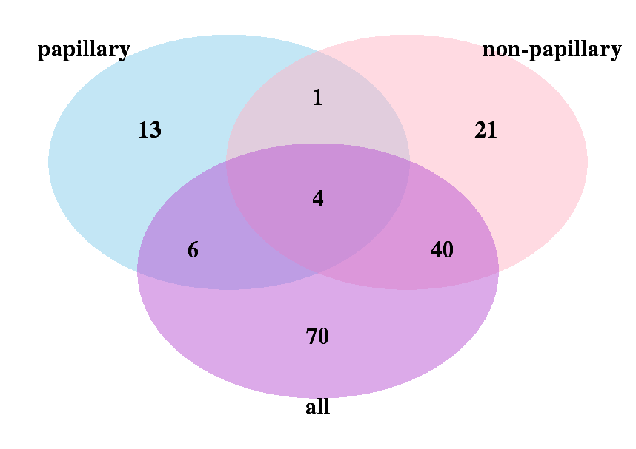

Figure S2. Survival analysis between two subgroups (LL and HH)

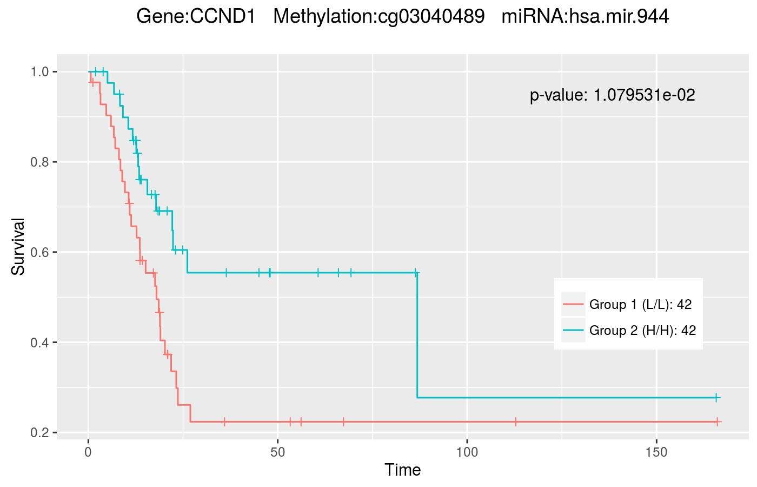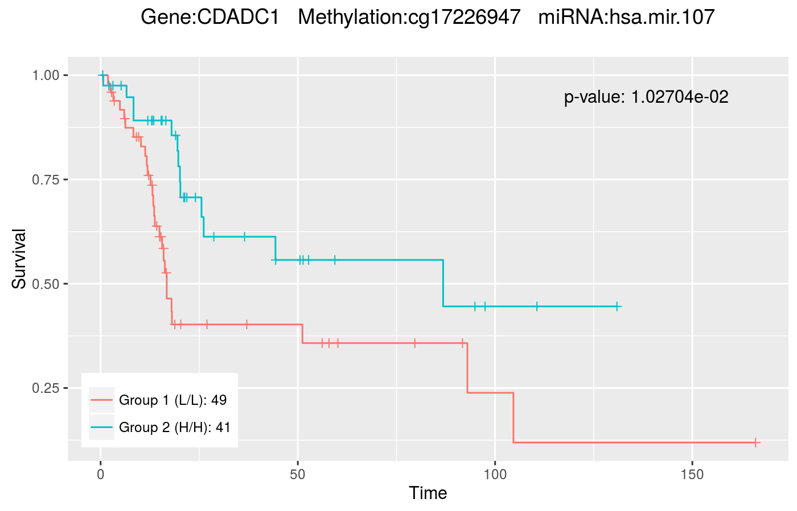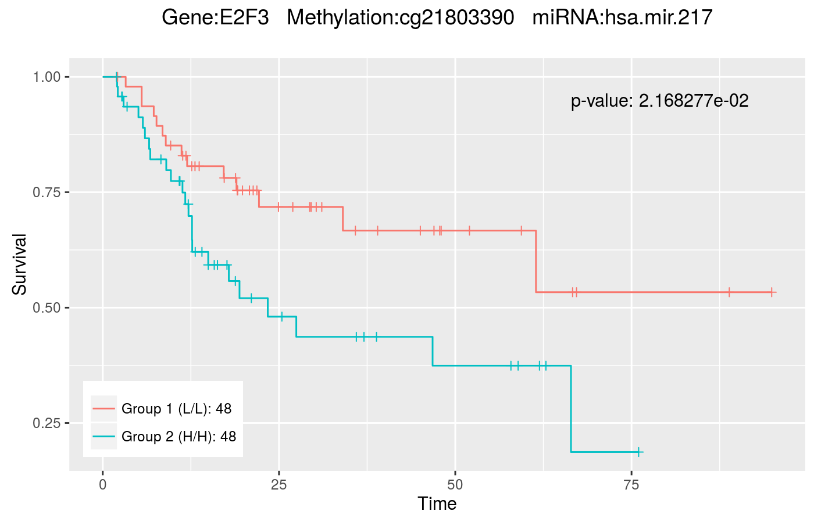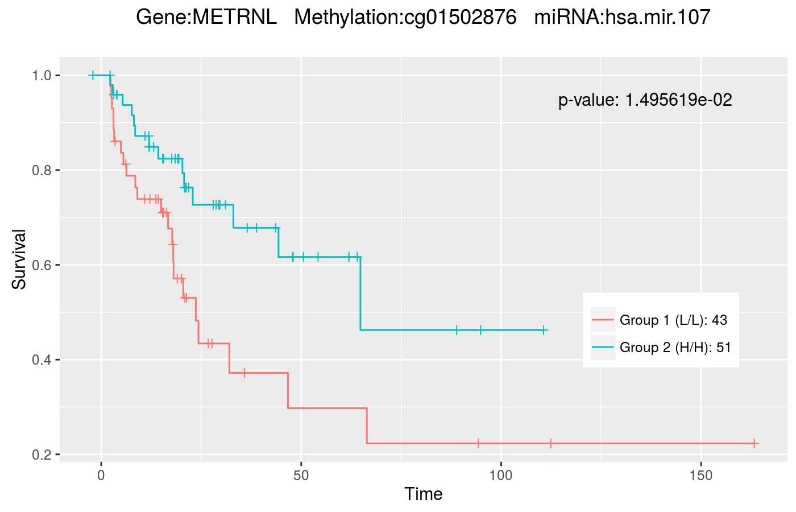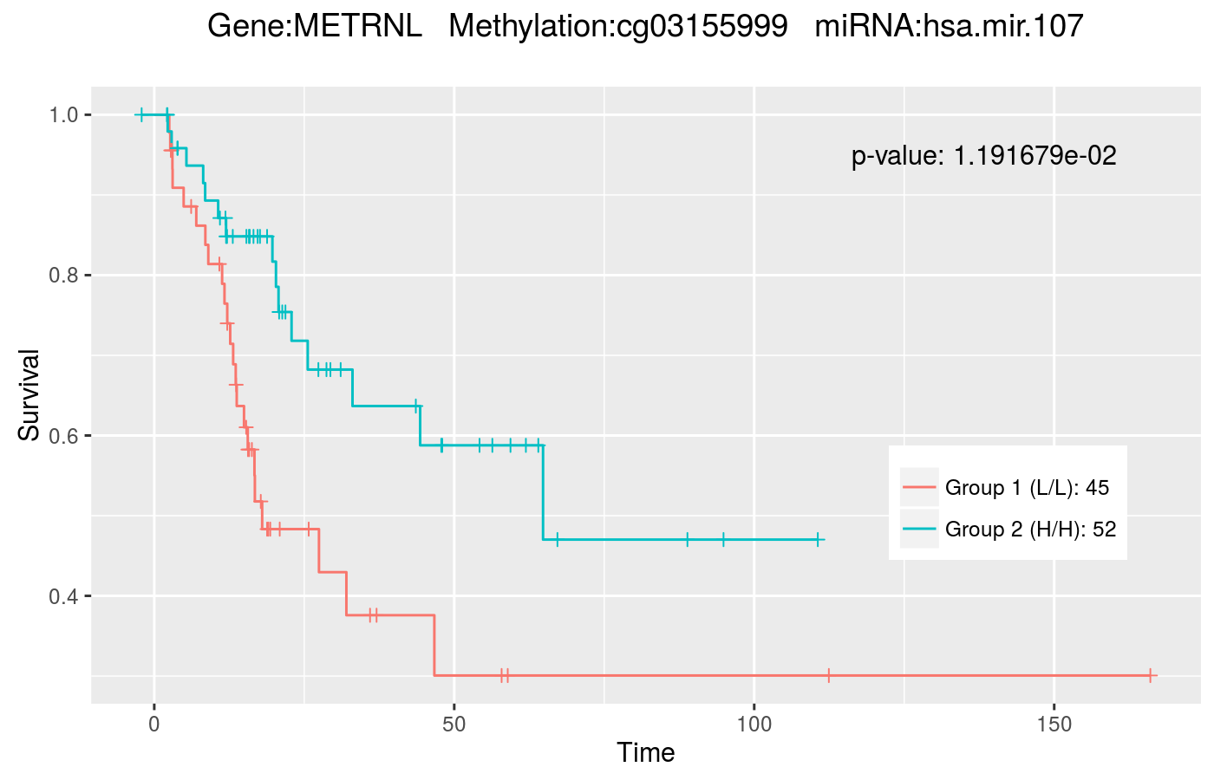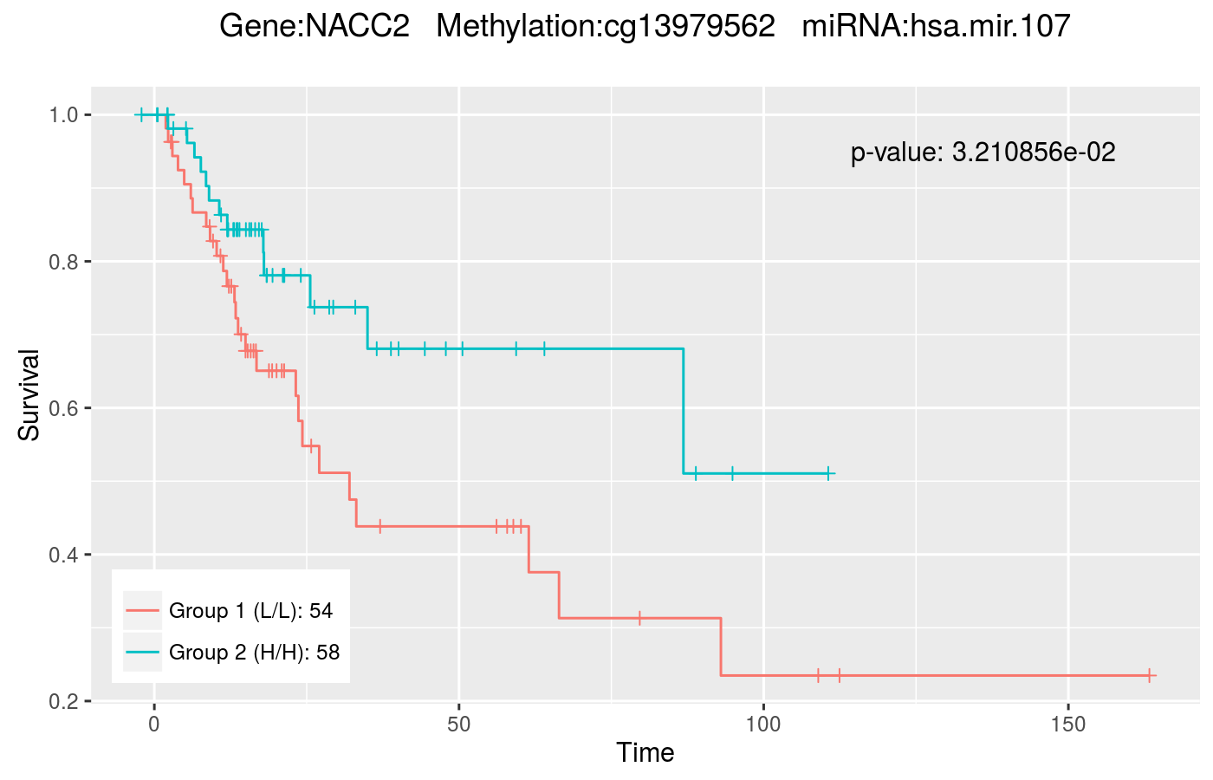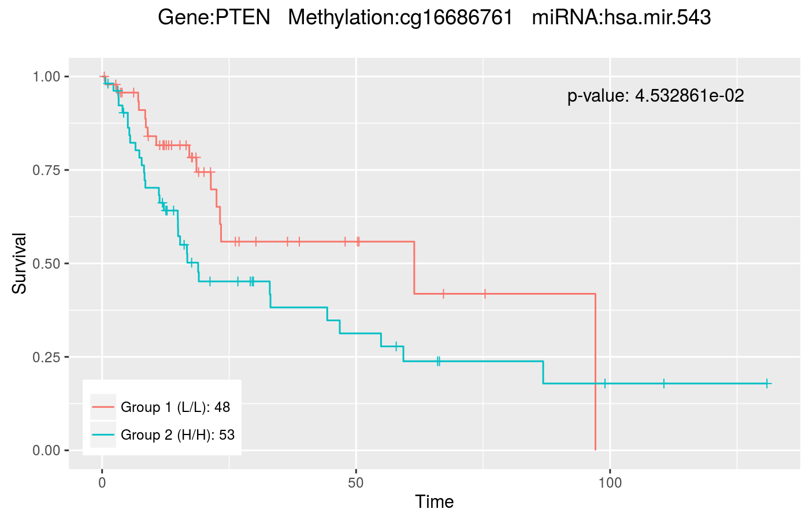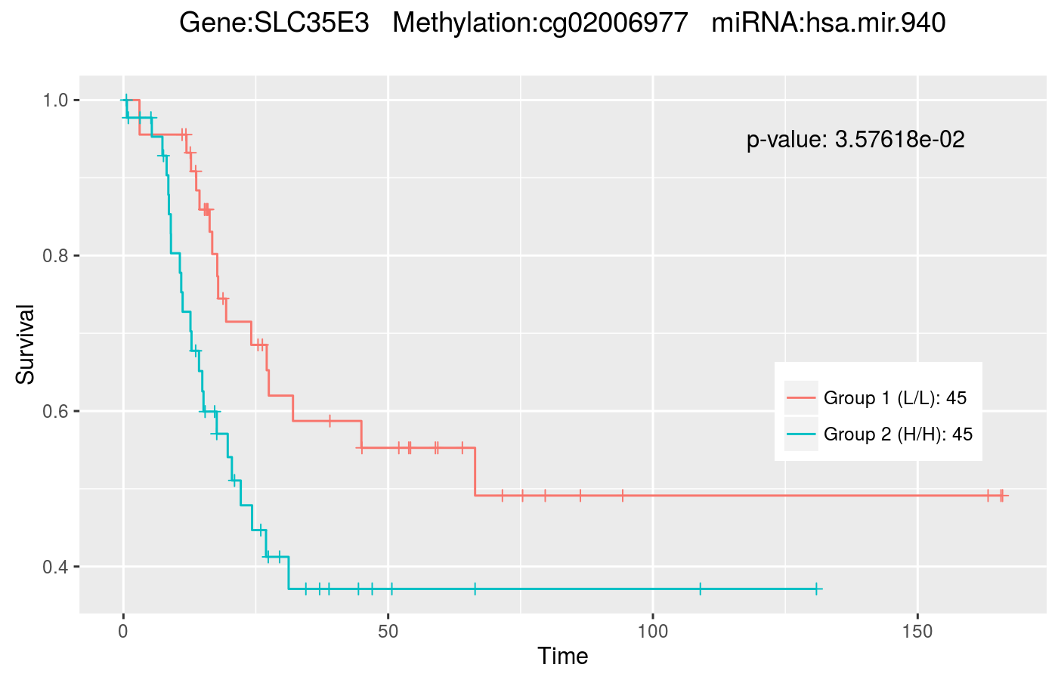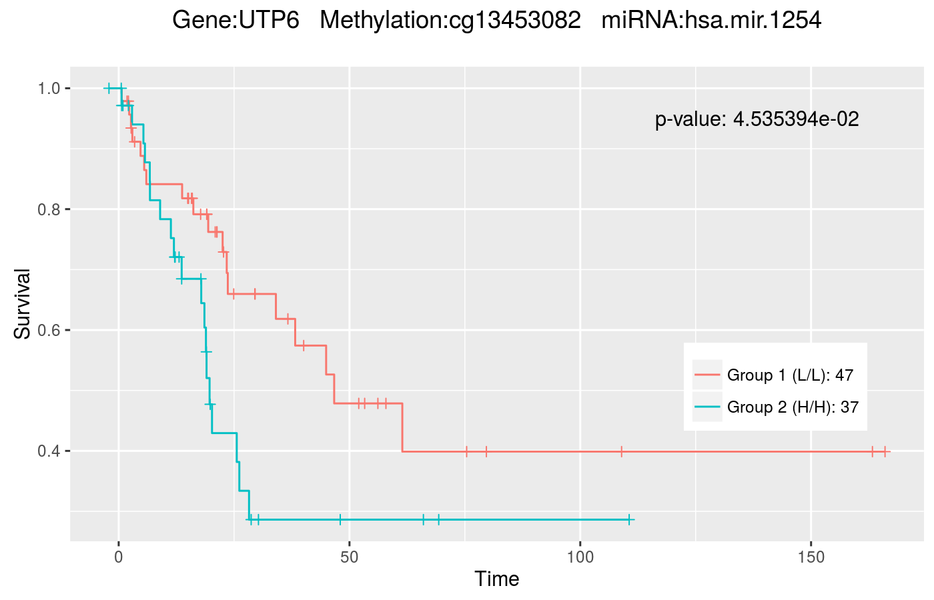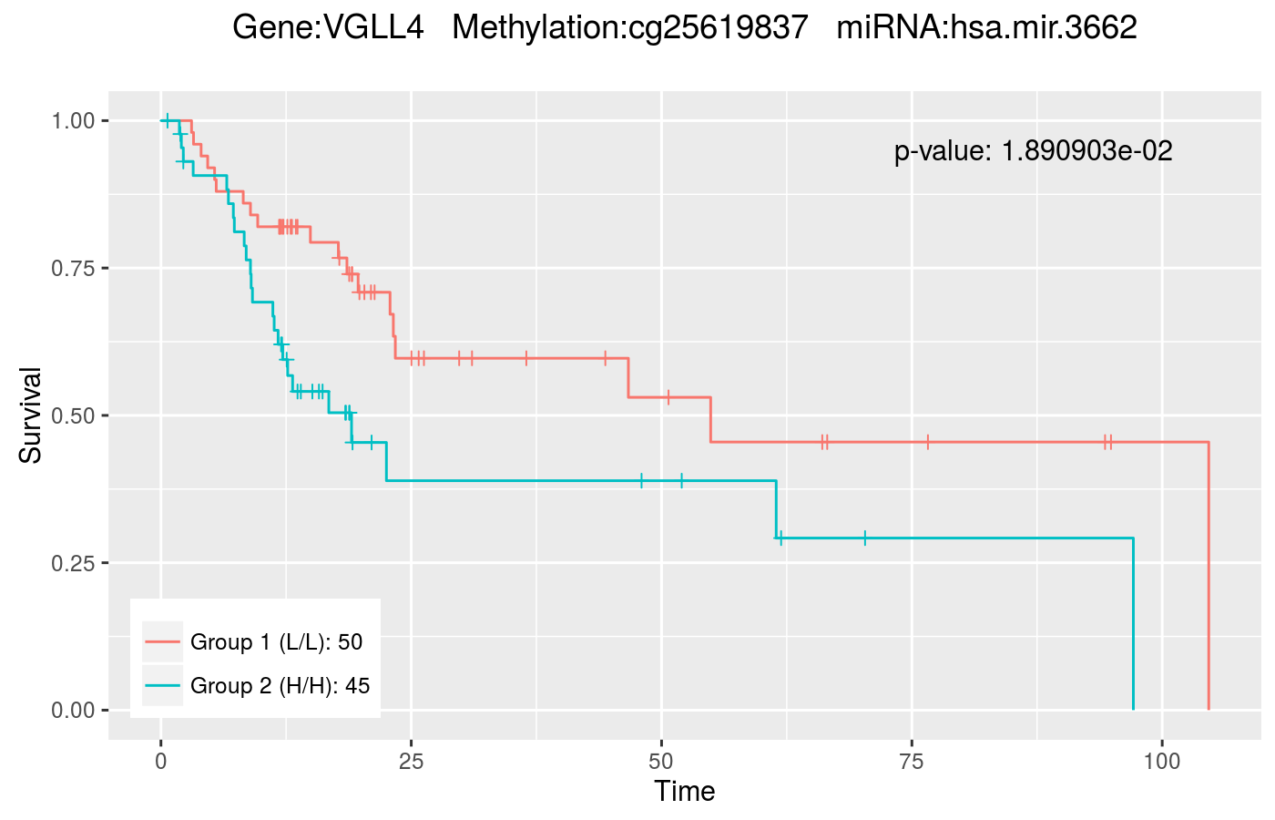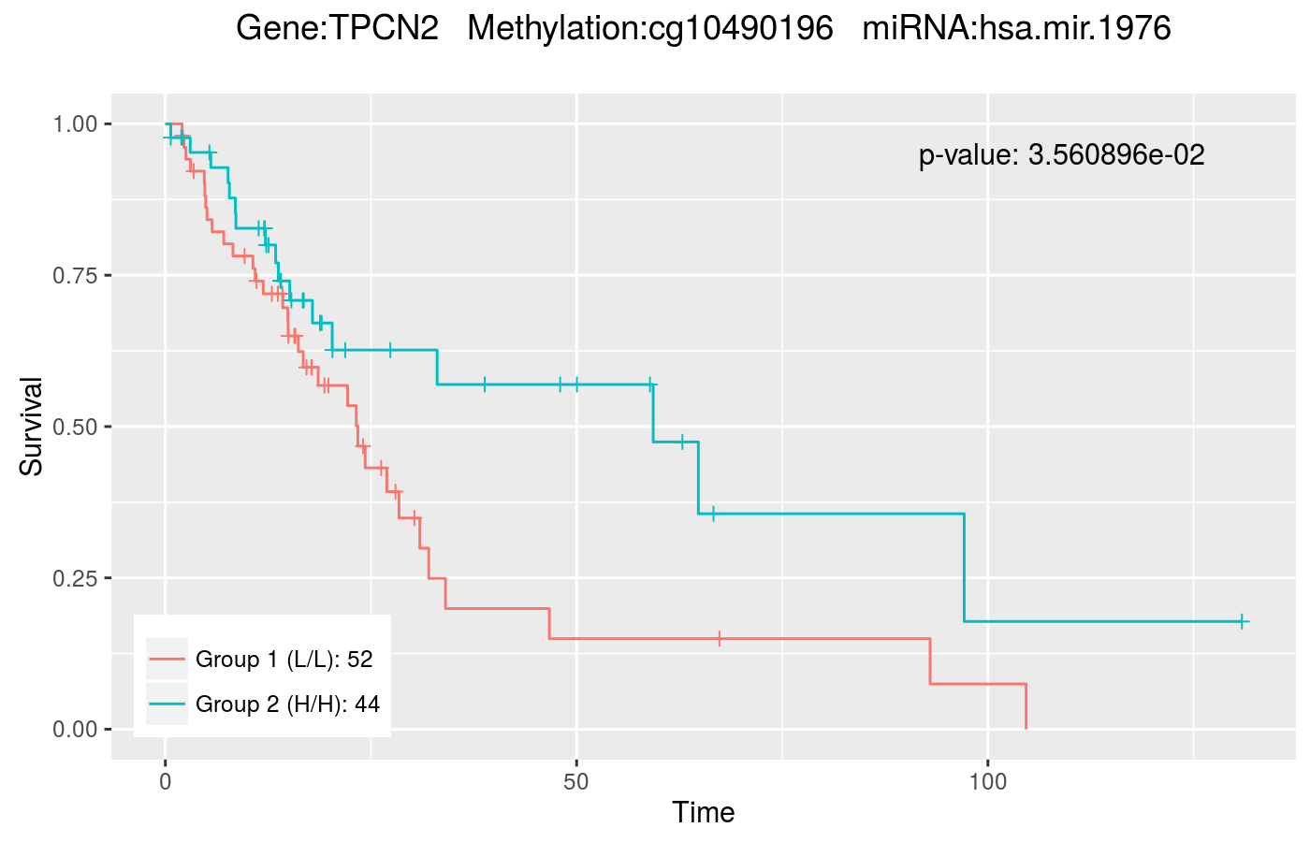

Figure S3. Gene expression boxplot for two subgroups (LL and HH)

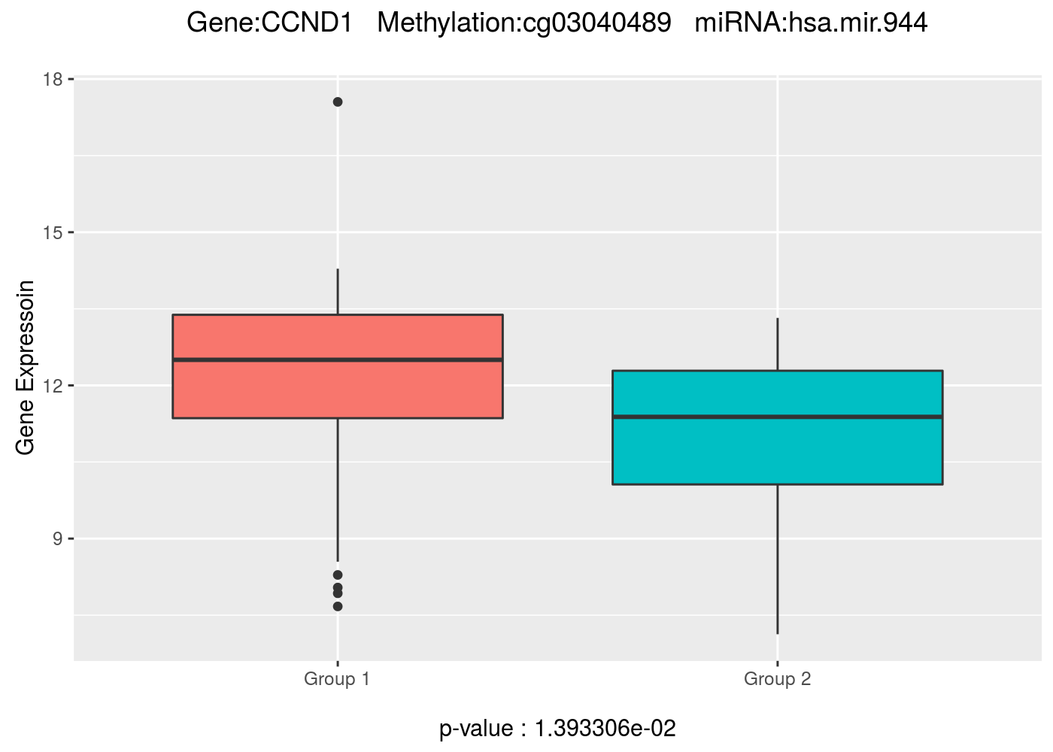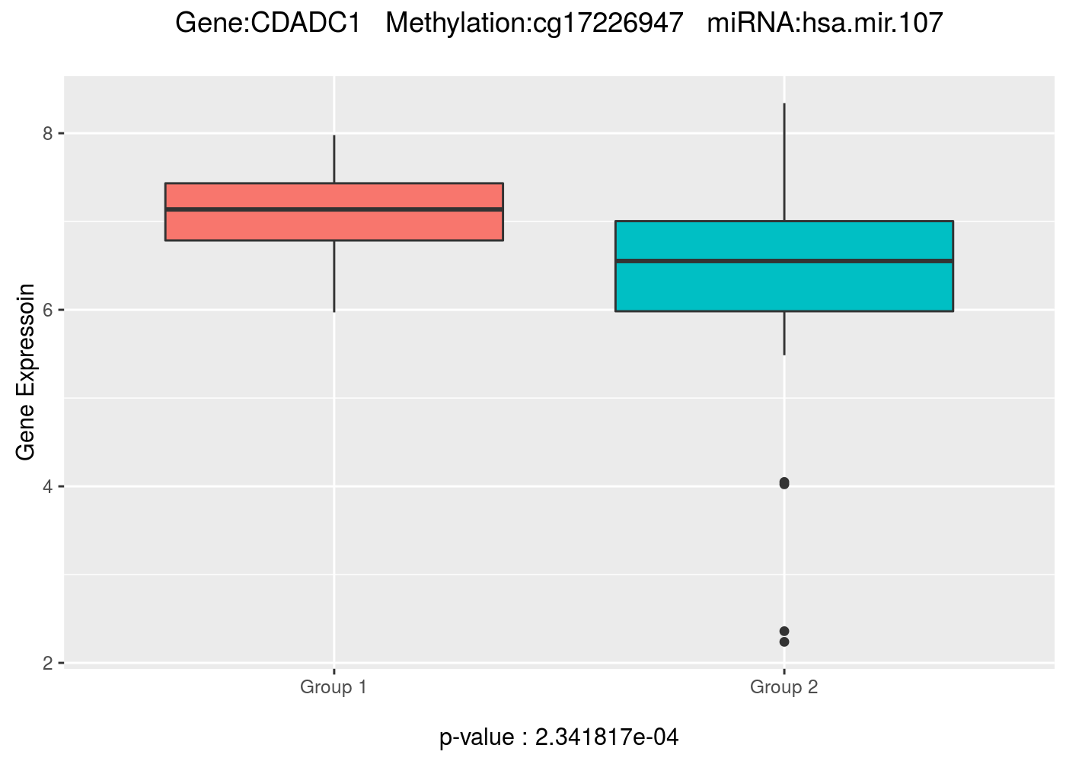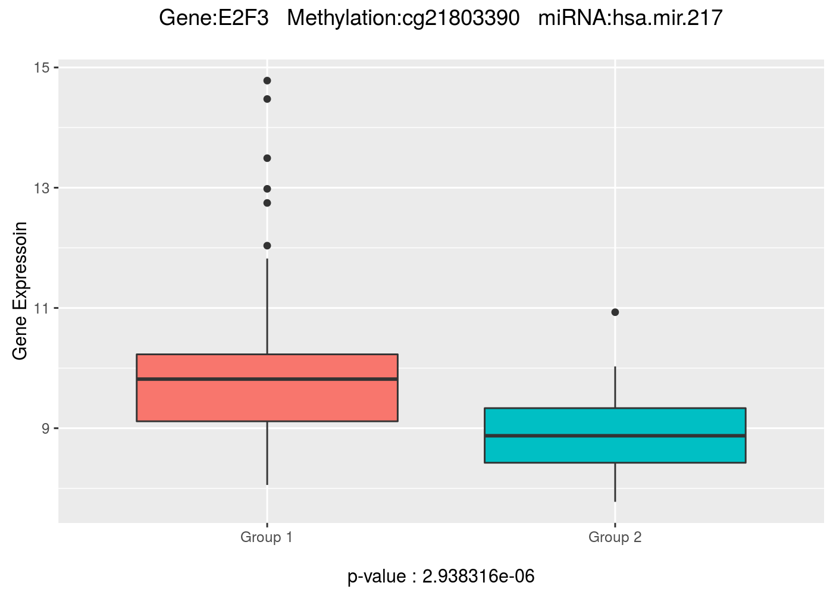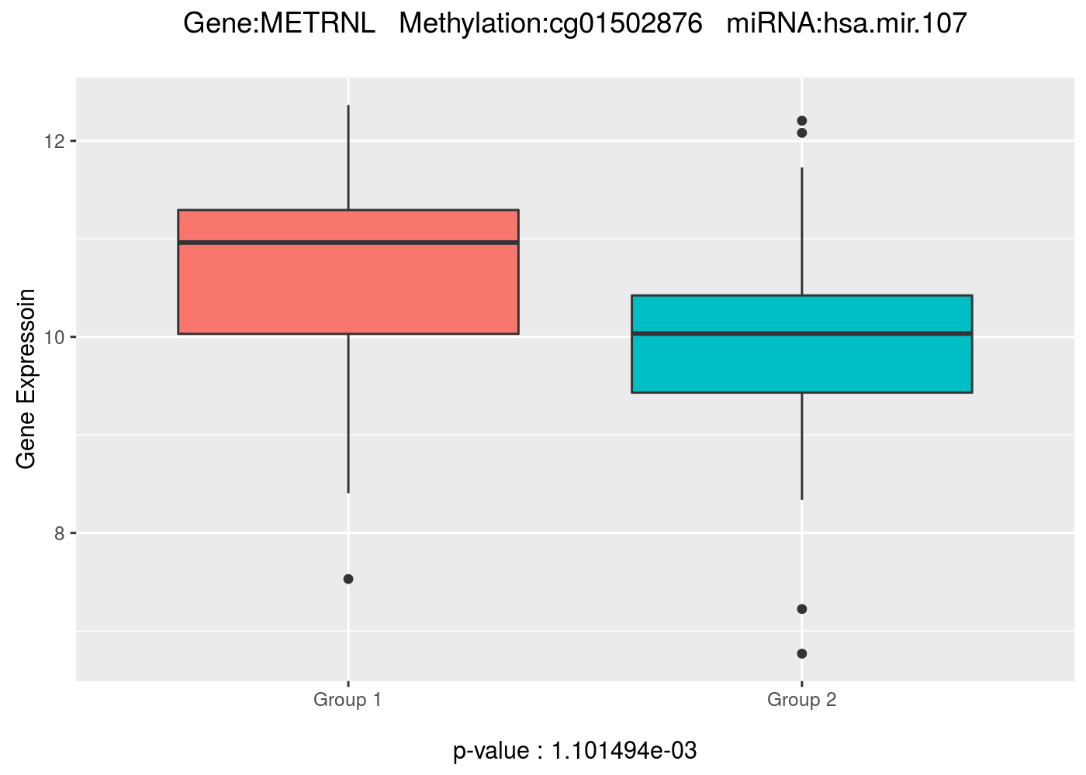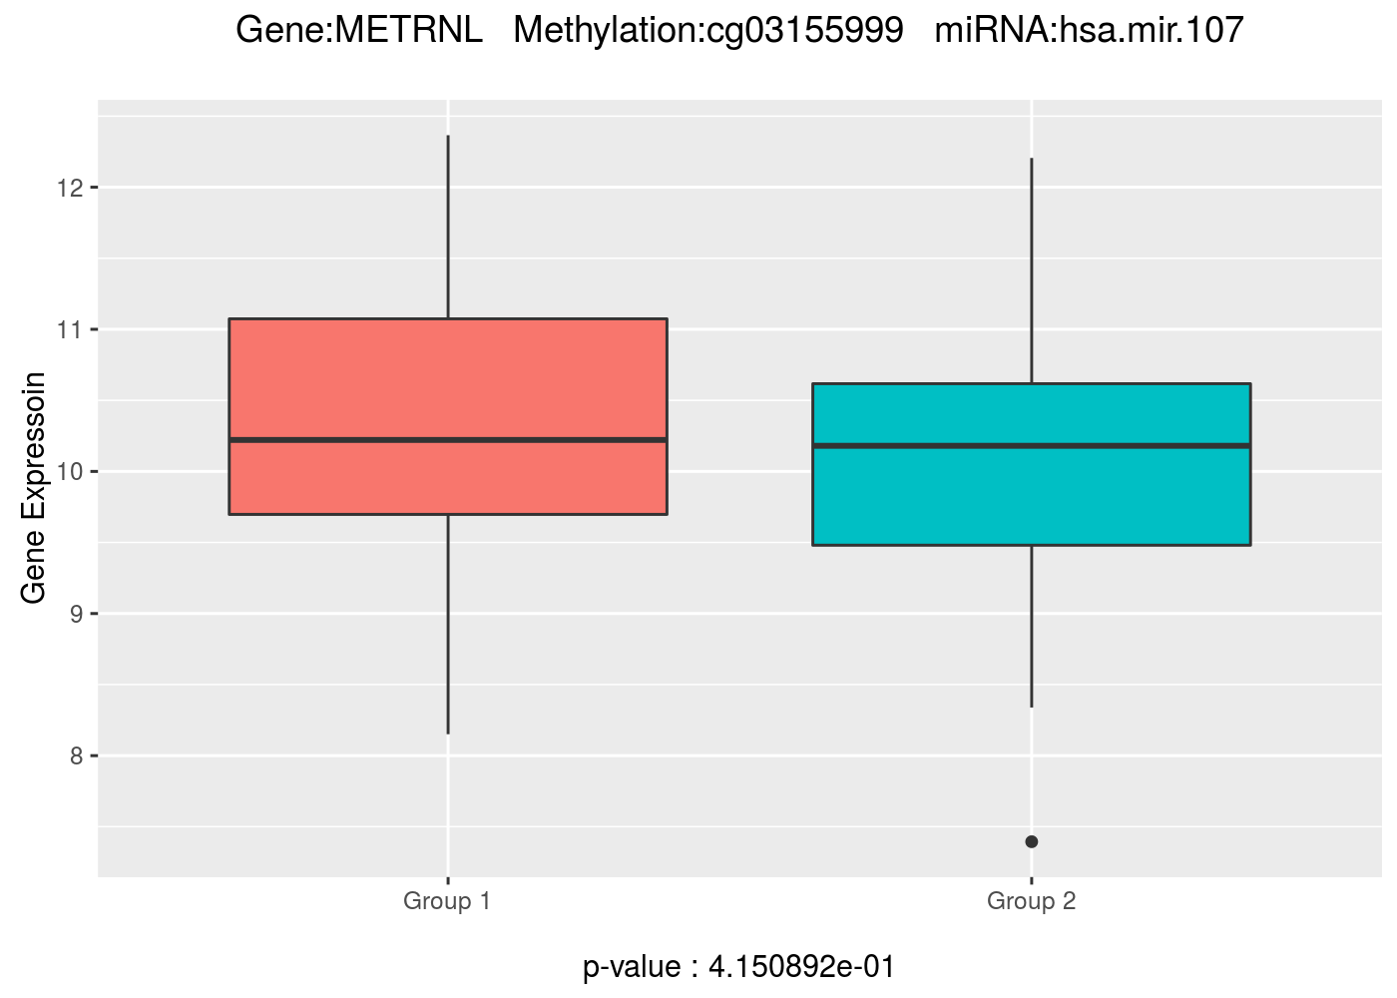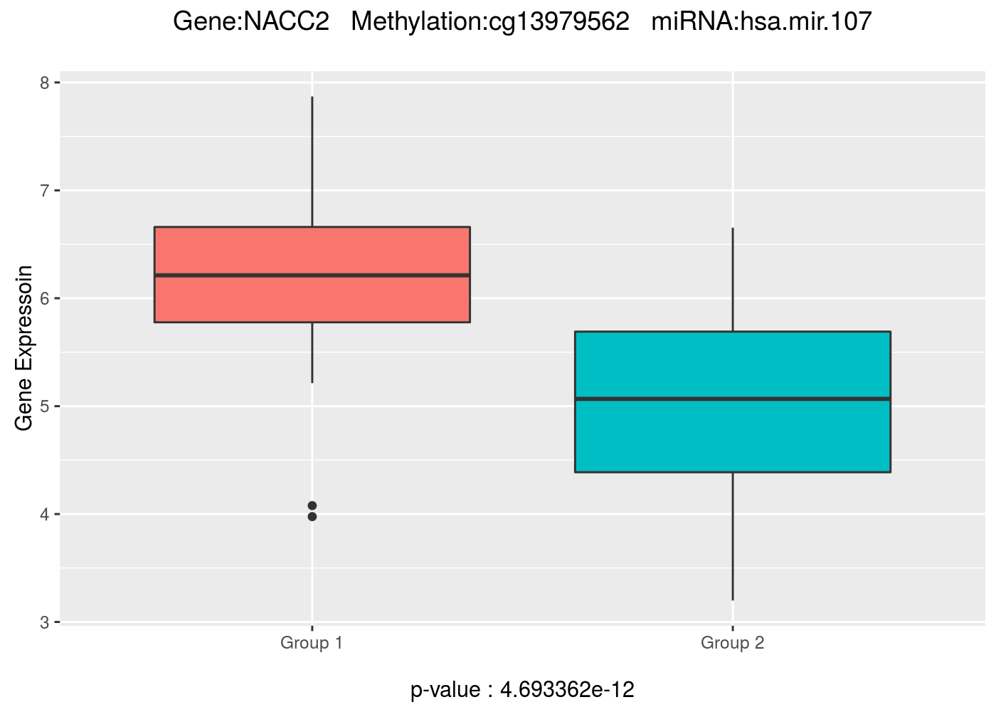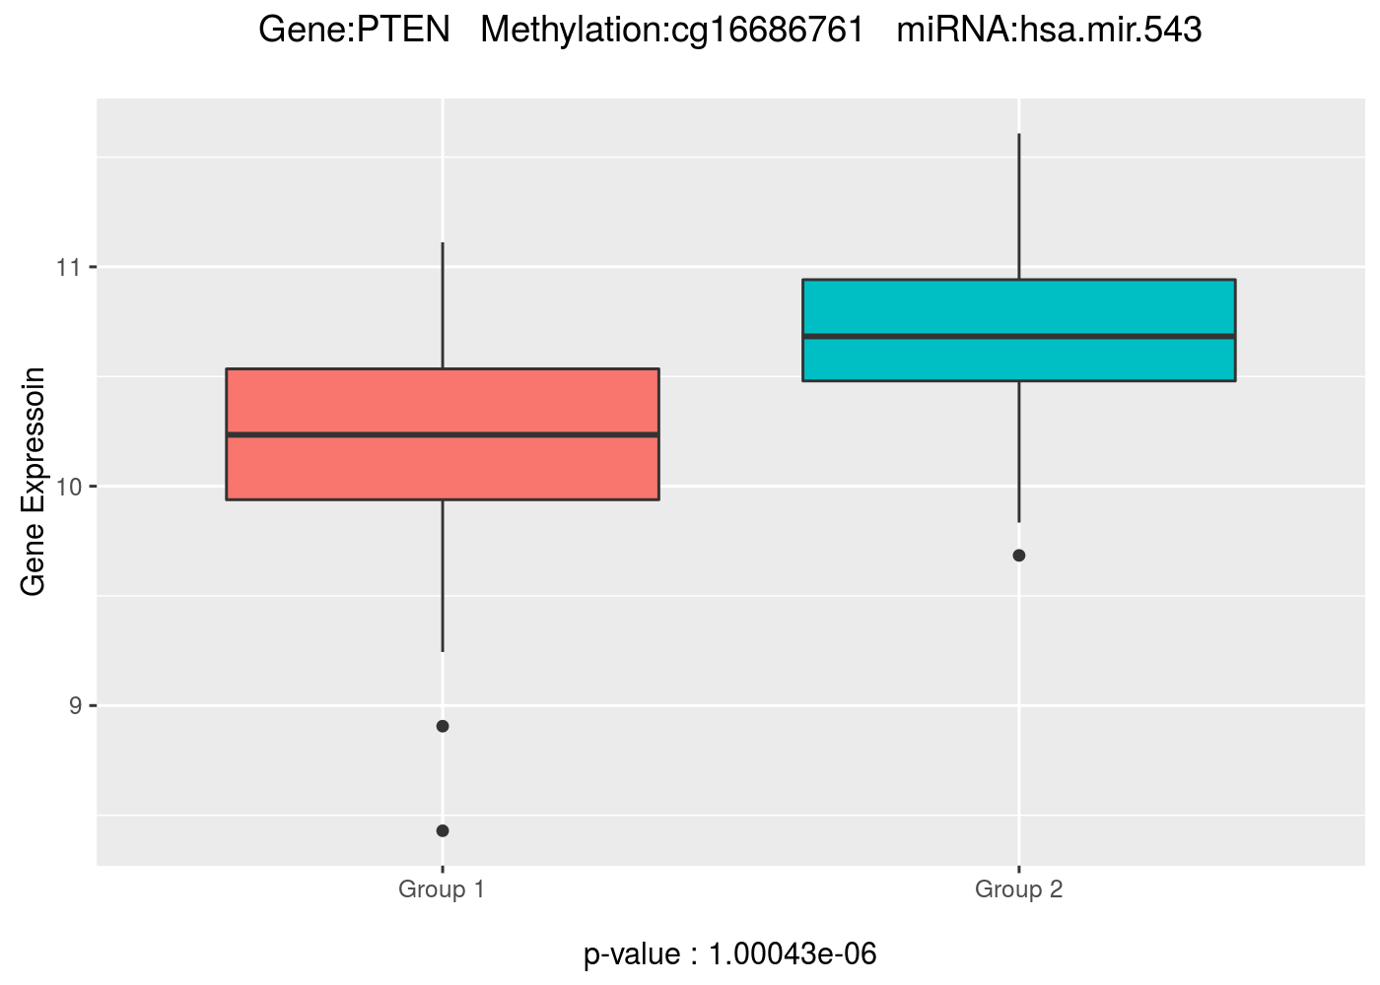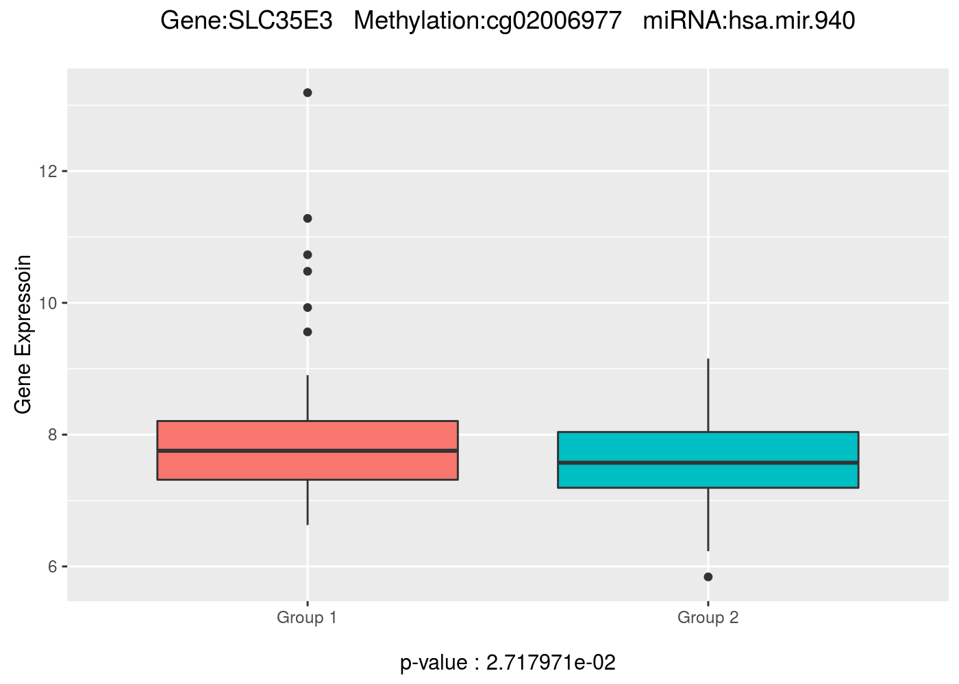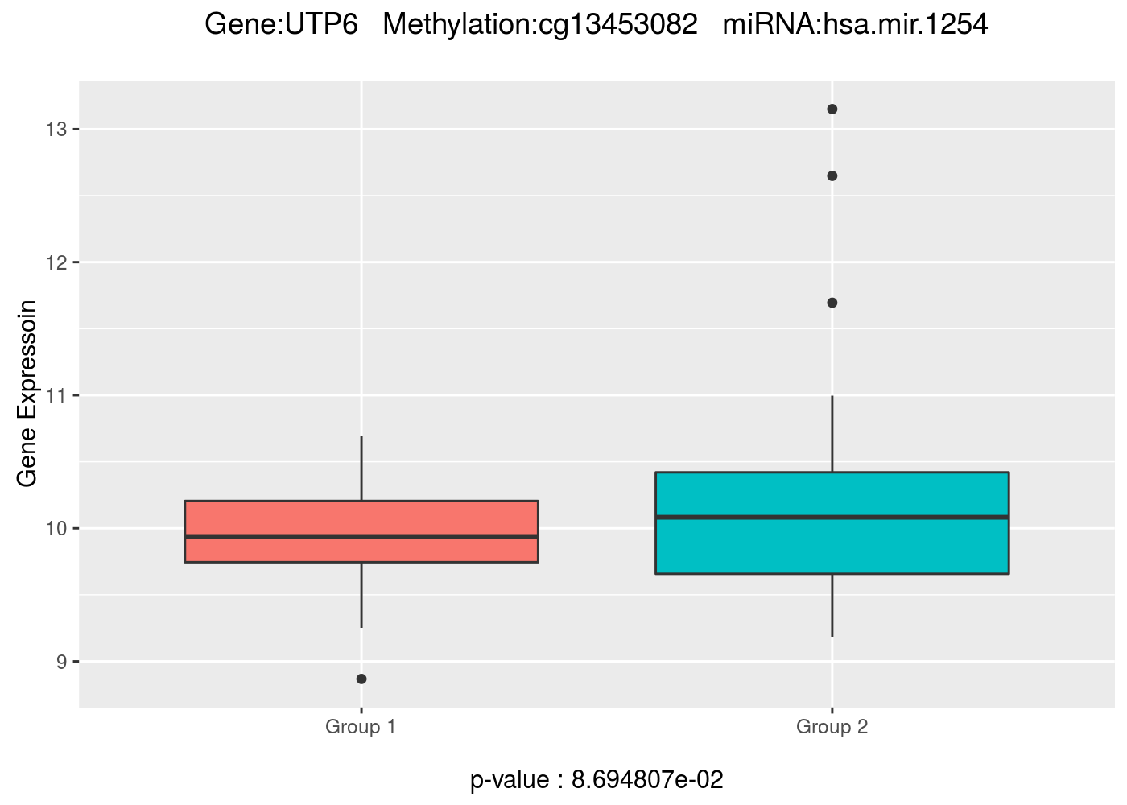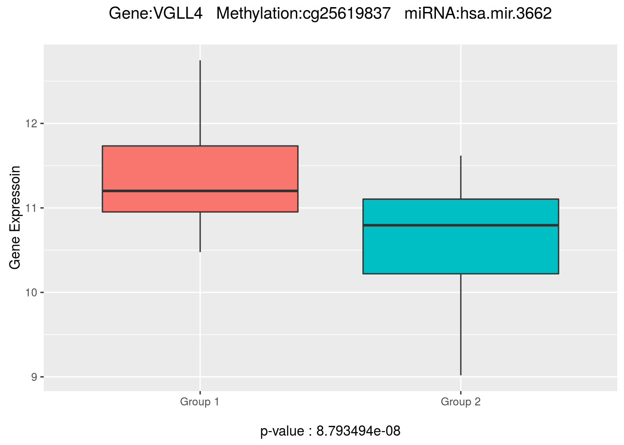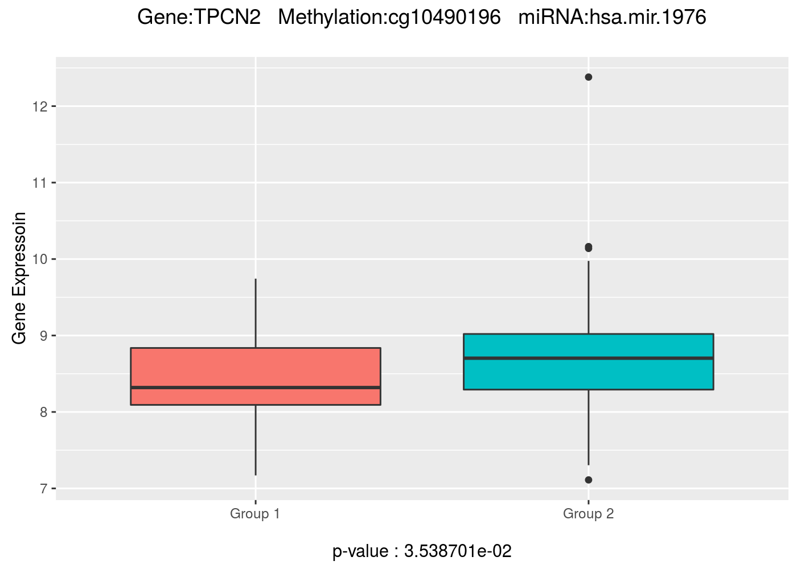

Figure S4. Gene expression boxplot for four subgroups (LL, LH, HL, and HH)
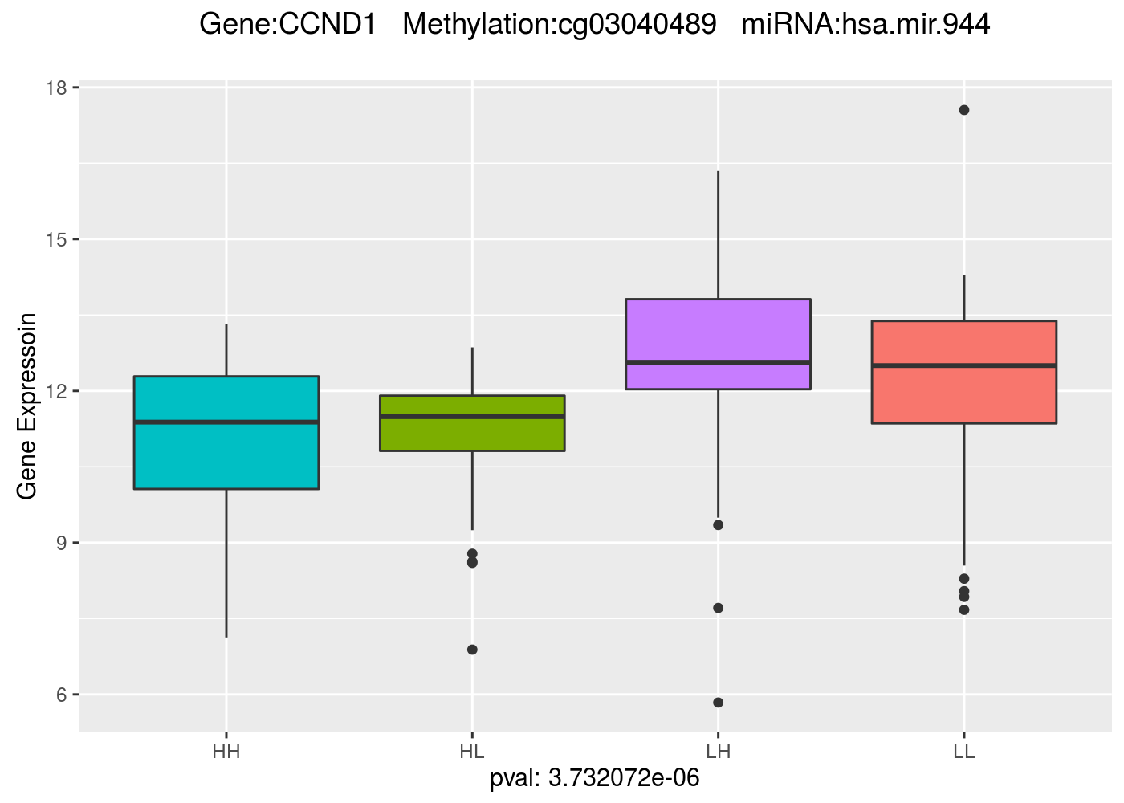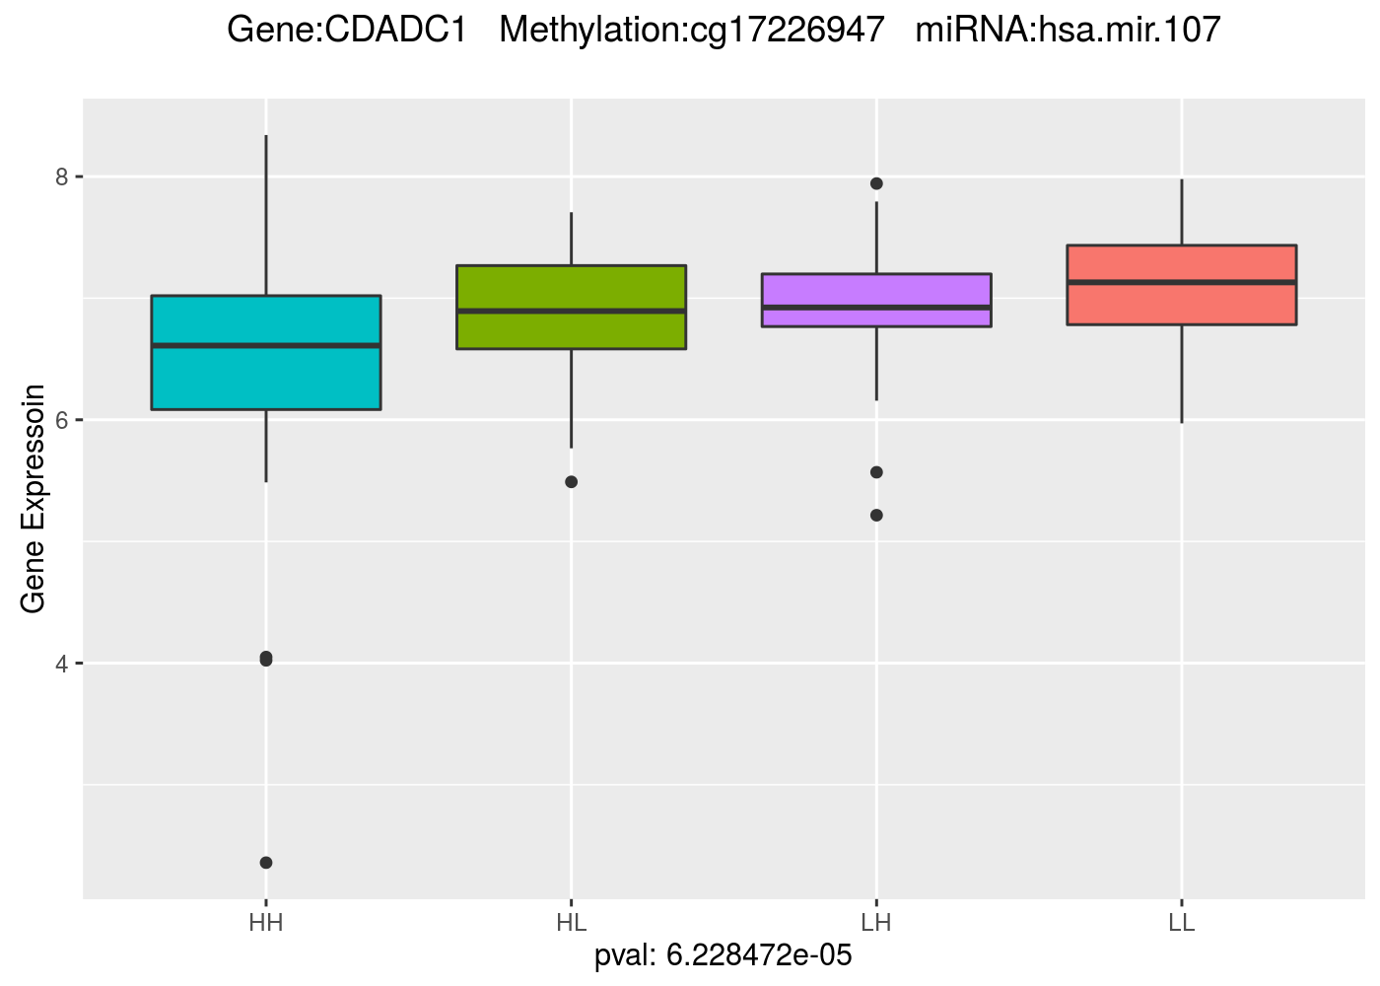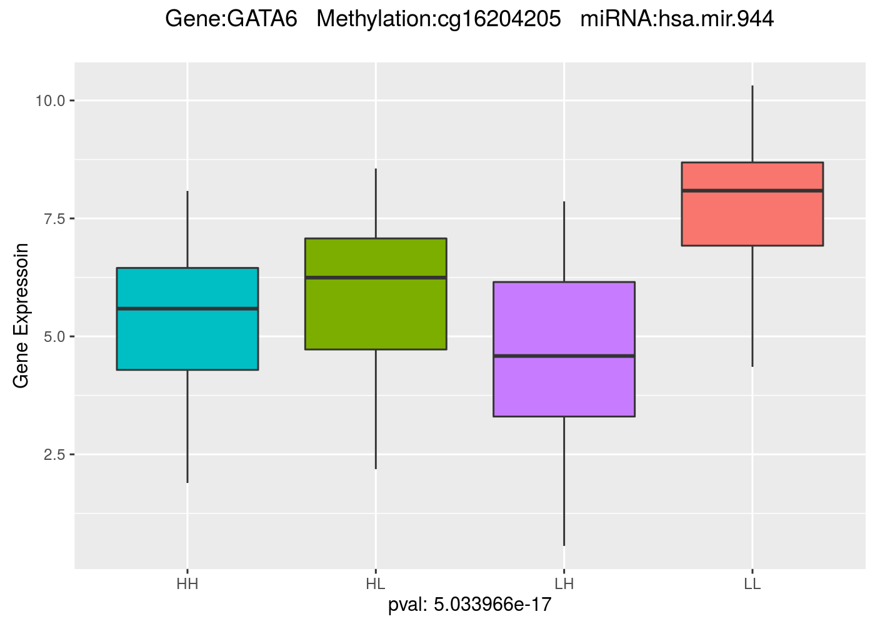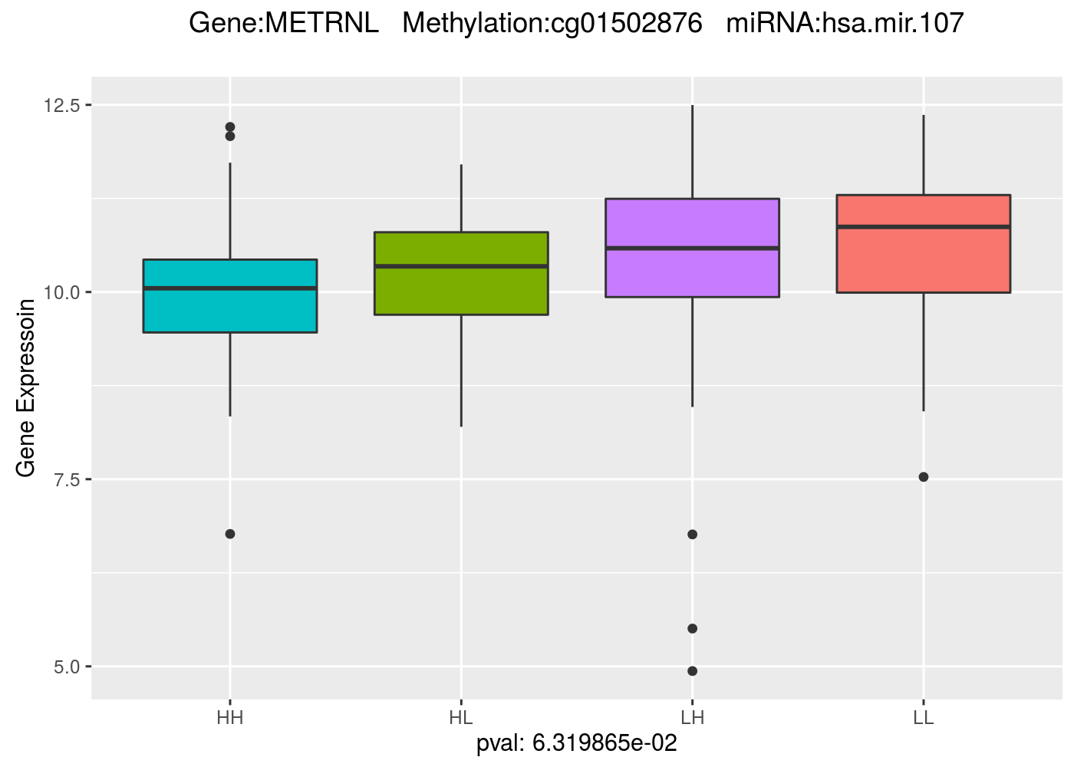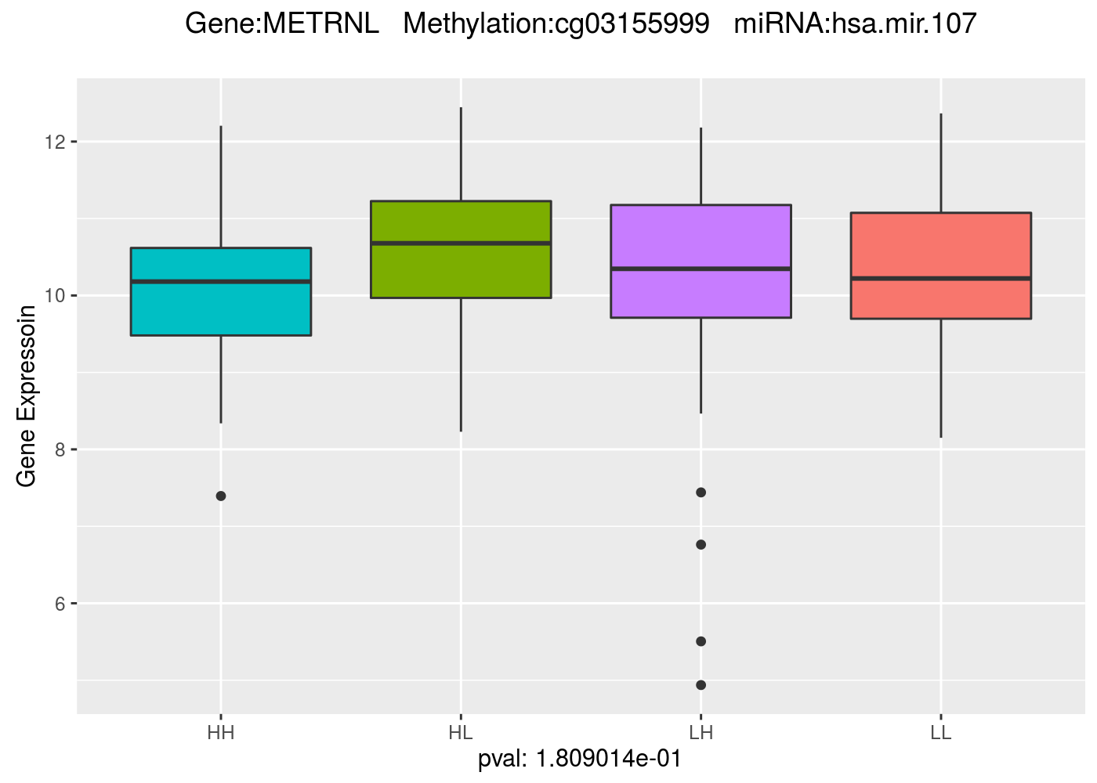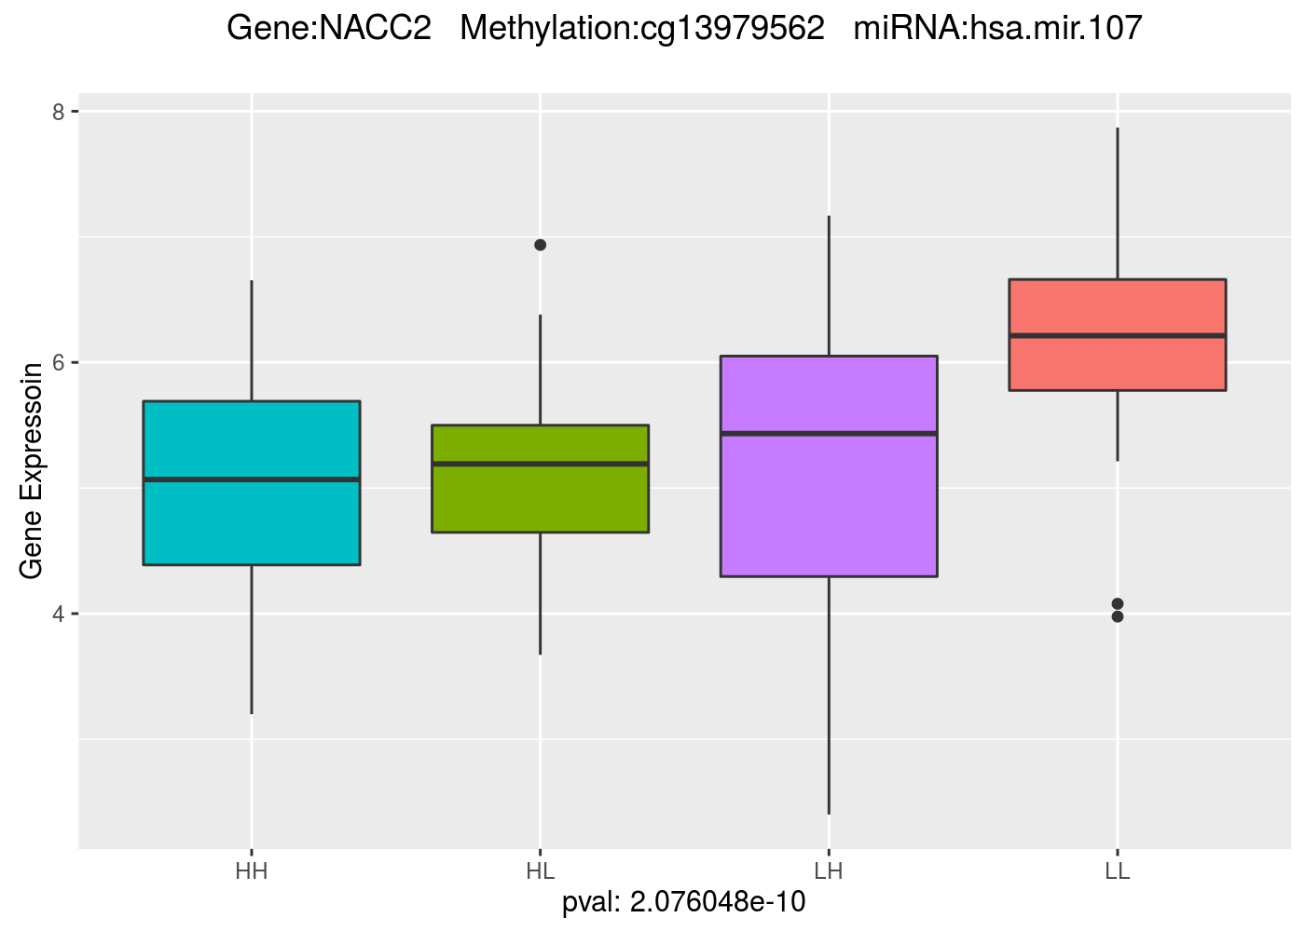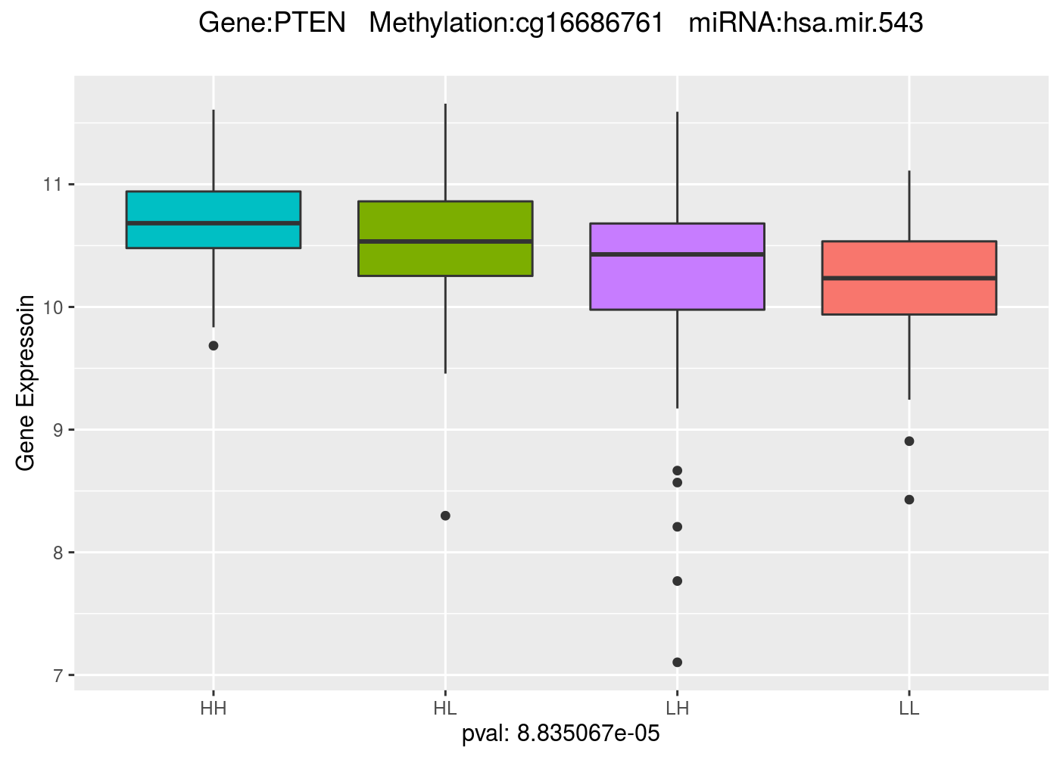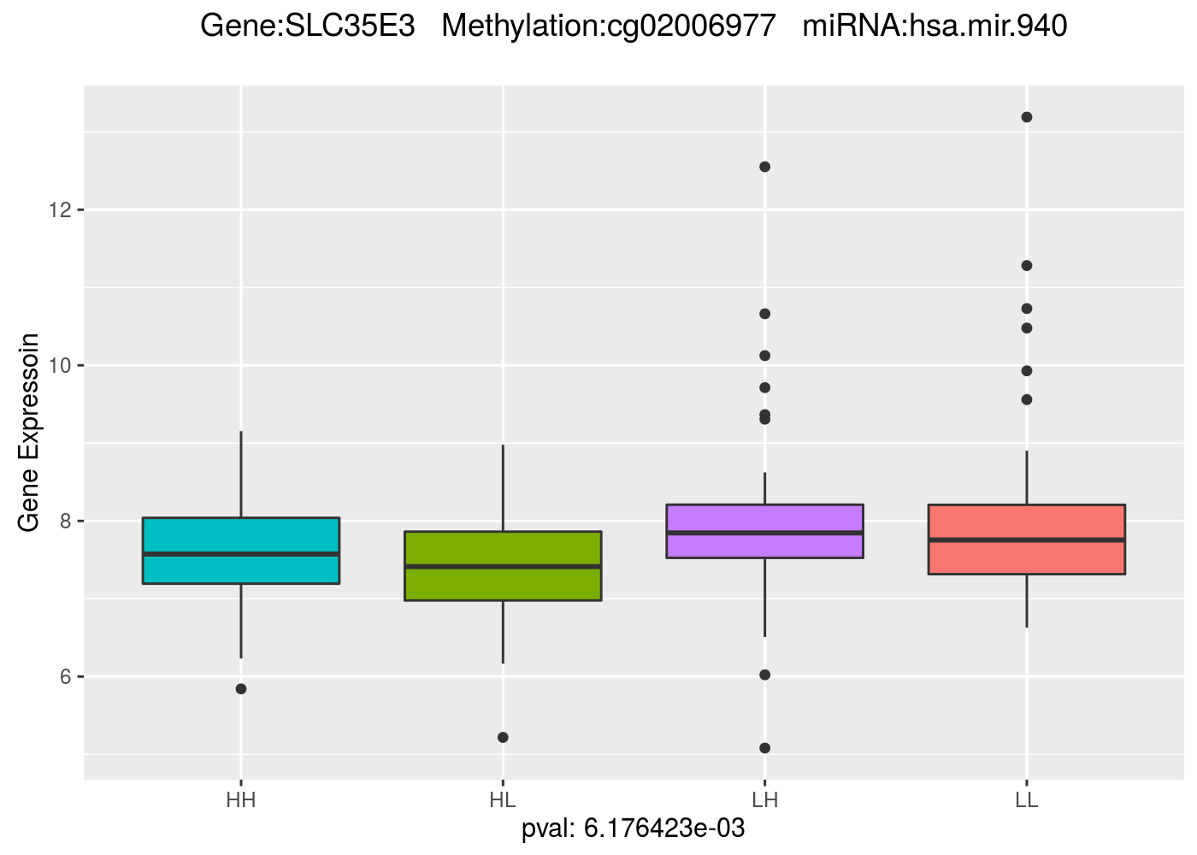
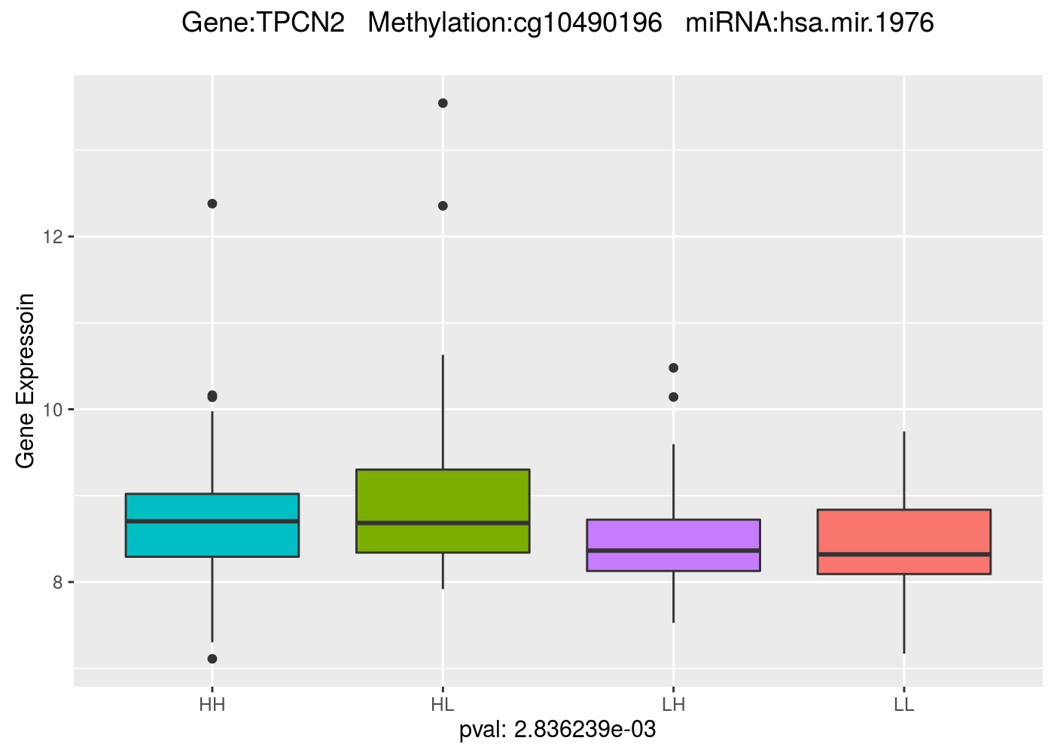
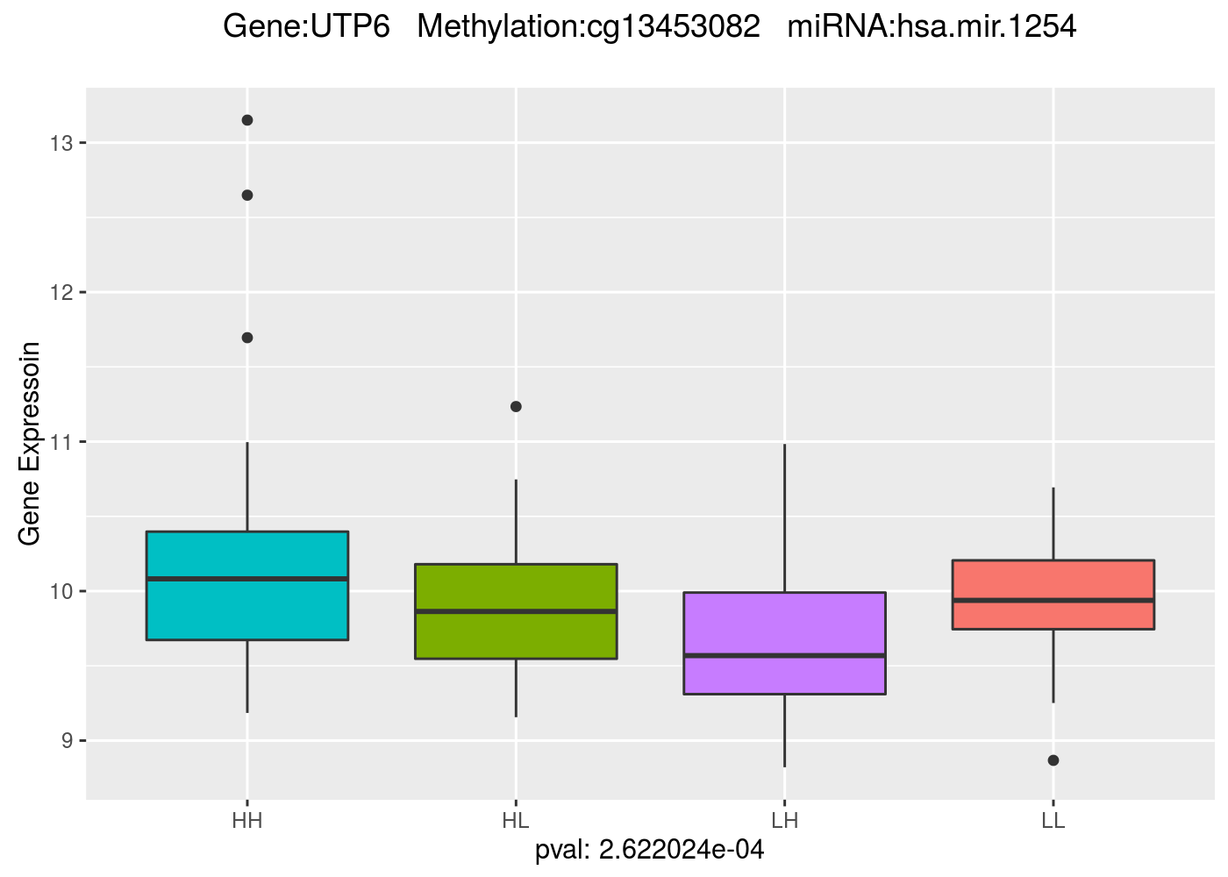

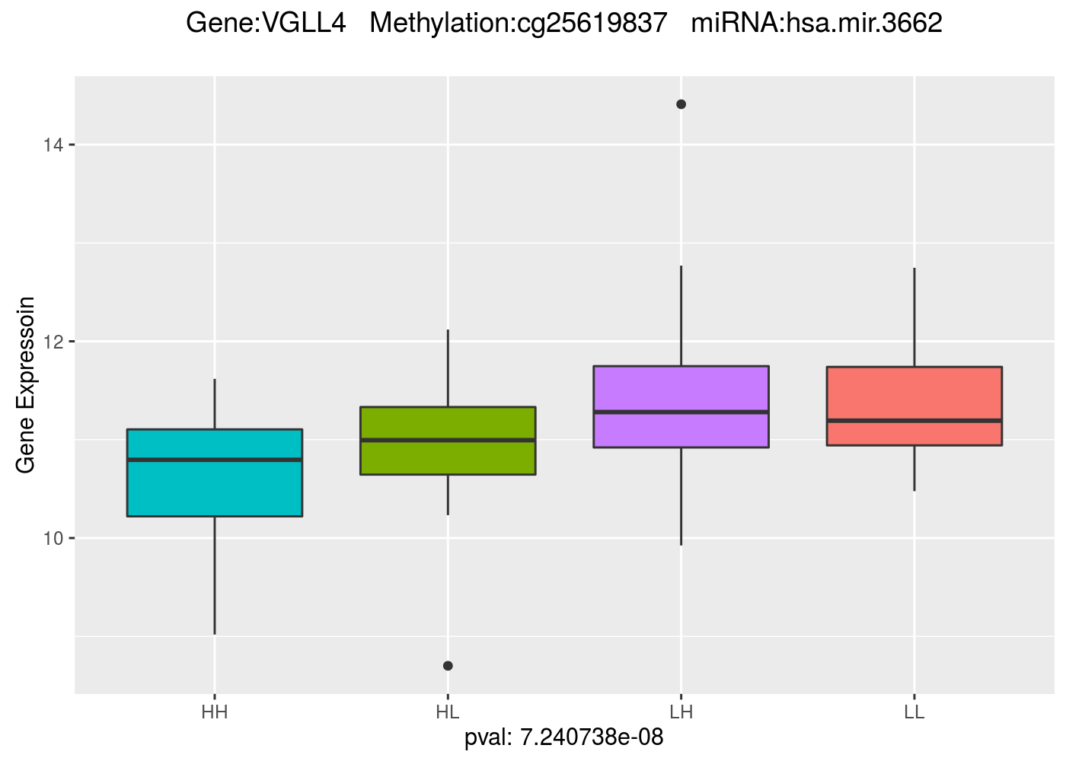

Figure S5. Survival analysis across four subgroups (LL, LH, HL, and HH)

