Integrated Metabolic Network corresponding with Model 3 of Table 8.

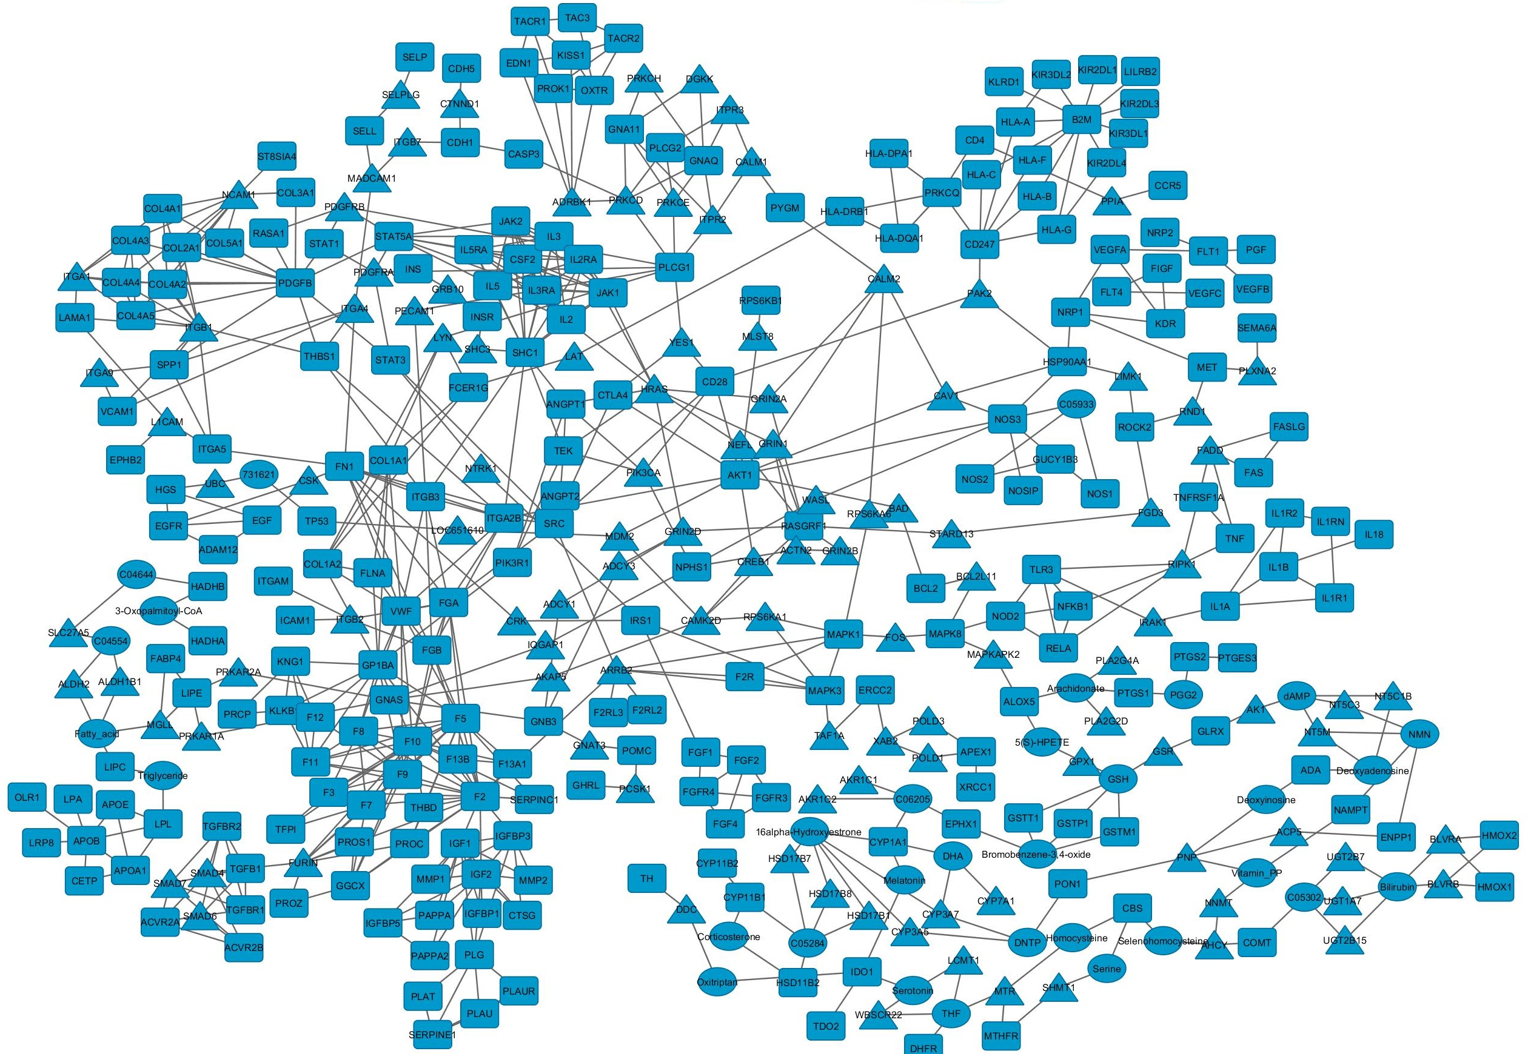
Descriptions
Ellipse: Compounds
Rectangles: input genes
Triangles: intermediate (missing) genes.

Compounds List
3-Oxopalmitoyl-CoA | C05259 | Deoxyadenosine | C00559
Corticosterone | C02140 | Deoxyinosine | C05512
Arachidonate | C00219 | Tetrahydrofolate (THF) | C00101
3alpha,7alpha-Dihydroxy-5beta-cholestanoyl-CoA | C04644 | Bromobenzene-3,4-oxide | C14839
11beta-Hydroxyandrost-4-ene-3,17-dione | C05284 | Parathion (DNTP) | C06604
3alpha,7alpha-Dihydroxy-5beta-cholestanate; | C04554 | Oxitriptan | C00643
2-Methoxy-17beta-estradiol | C05302 | Bilirubin | C00486
Triglyceride | C00422 | Docosahexaenoic acid (DHA) | C06429
5(S)-HPETE | C05356 | Nicotinamide mononucleotide (NMN) | C00455
16alpha-Hydroxyestrone | C05300 | dAMP | C00360
Prostaglandin G2 | C05956 | Melatonin | C01598
L-Homocysteine | C00155 | Nicotinamide | C00153
Glutathione (GSH) | C00051 | Serotonin | C00780
Serine | C00065 | N(omega)-Hydroxyarginine; | C05933

