Additional file 1

Hepatic molecular signatures of statin treatment are associated with impaired glucose homeostasis in severely obese patients
Daniel Margerie^{1 *}, Philippe Lefebvre^{2 *}, Violeta Raverdy^{3,5}, Uwe Schwahn¹, Hartmut Ruetten¹, Philip Larsen¹, Alain Duhamel⁴, Julien Labreuche⁴, Dorothée Thuillier³, Bruno Derudas², Céline Gheeraert², Hélène Dehondt², Quentin Dhalluin², Jérémy Alexandre², Robert Caiazzo^{3,5}, Pamela Nesslany⁵, Helene Verkindt⁵, Francois Pattou^{3,5} *, and Bart Staels² .
¹ Sanofi Aventis Deutschland GmbH, Research & Development, D-65926 Frankfurt, Germany
² Univ. Lille, INSERM, CHU Lille, Institut Pasteur de Lille, U1011 – EGID, F-59000 Lille, France
³ Univ. Lille, Inserm, CHU Lille, Institut Pasteur de Lille, U1011 – EGID, F-59000 Lille, France
⁴ CHU Lille, Department of Biostatistics, F-59000 Lille, France
⁵ CHU Lille, Department of General and Endocrine Surgery, F-59000 Lille, France

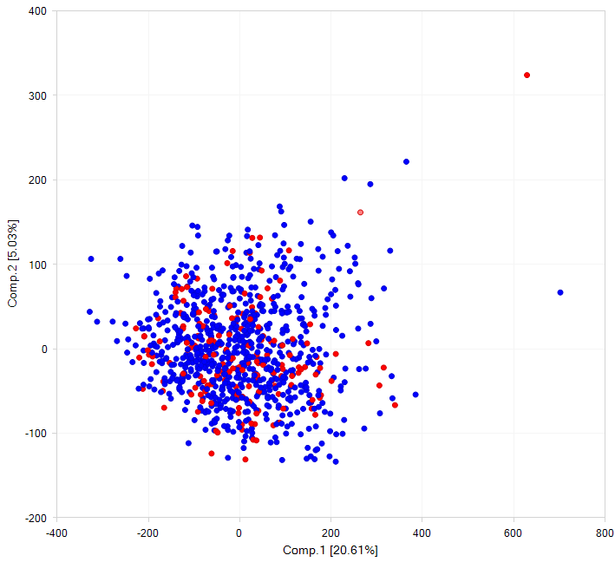
Figure S1: Principal component analysis (PCA) from 910 liver biopsies. The PCA is based on all 70,523 transcript IDs from the Affymetrix Human Transcriptome Array (HTA) 2.0. Data points marked in red represent liver samples from statin-treated patients (n=173), data points marked in blue represent samples from non-statin treated patients (n=737).

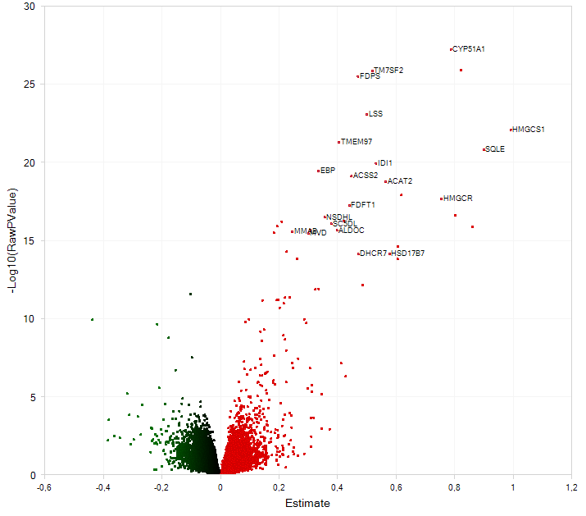
Figure S2: Differential gene expression in the propensity score-matched cohort . The volcano-plot is based on the pairwise comparison of statin-treated (n=157) vs non-statin-treated (n=157) patients of the matched patient cohort and shows the minus (-) log₁₀ adjusted P value on the Y-axis vs the fold-change estimate on the X-axis. The estimate is defined as the statistically adjusted difference between the means of the two compared groups (ANOVA). Top 20 differentially expressed genes with adjusted P values < 0.05 and log₂ fold-changes (FC) >1.2 are indicated (more details about these genes are given in Supplemental Table 2). Differentially expressed genes in green: downregulated by statins, red: upregulated by statins.

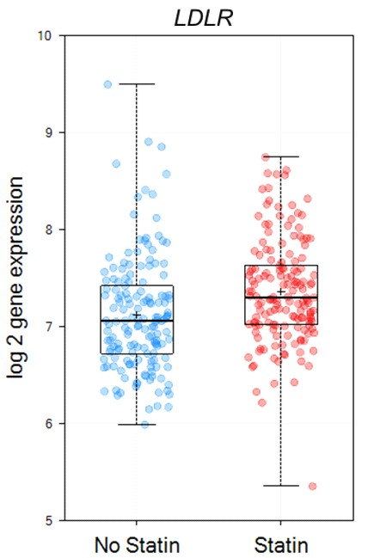
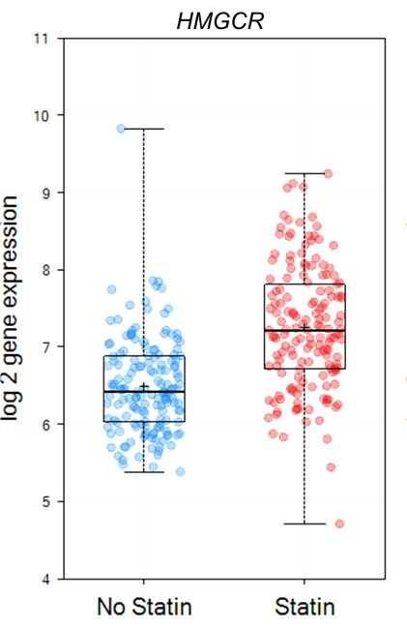
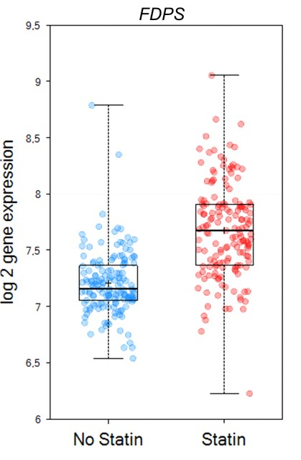

Figure S3: Gene expression values of representative genes. Boxplots with log₂ gene expression values of key metabolic genes in liver samples from the matched patient cohort are shown according to statin treatment. Genes are farnesyl-diphosphate synthase (FDPS: log₂FC=1.7, P=4.3x10⁻²³), 3-hydroxy-3-methylglutaryl-CoA reductase (HMGCR: log₂FC=1.7, P=1.1x10⁻¹⁴) and low density lipoprotein receptor (LDLR: log₂FC=1.2, P=2.0x10⁻⁰⁴). Liver samples from statin-treated group are marked red (n=157) and liver samples from the non-statin treated group are marked blue (n=157). Abbreviations: FC:fold change.

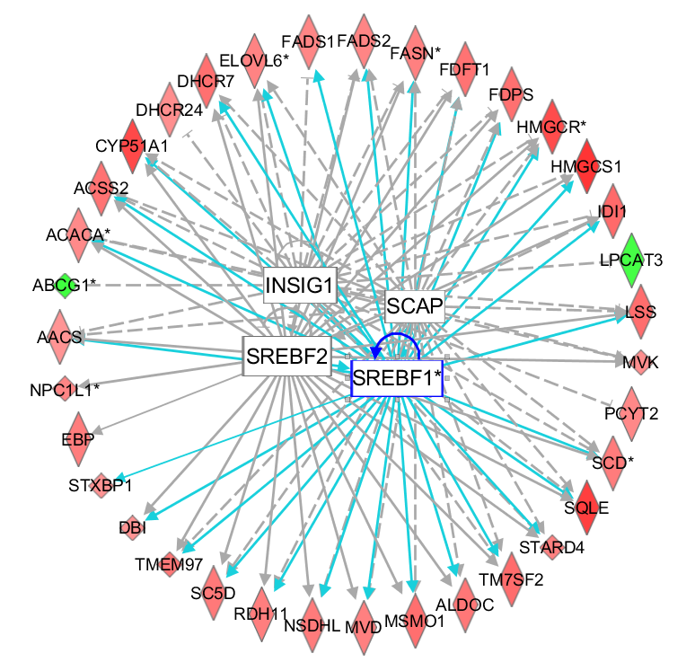
Figure S4: Gene network in statin-treated patients. The network illustrates statin-induced transcriptional upregulation (red) and downregulation (green) of 39 genes involved in cholesterol (e.g. HMGCR, HMGCS1, SQLE), fatty acid and triglyceride metabolism (e.g. ACACA, FASN, SCD) in the matched patient cohort, mediated by the predicted inhibition of INSIG1, activation of SCAP and subsequent activation of SREBP1 and SREBP2, encoded by the SREBF1 and SREBF2 genes. Lipid genes activated by SREBP1 are highlighted by interactions marked in blue. Genes marked with * are linked to hepatic steatosis according to literature findings reported by IPA.

Characteristics | Before Propensity Score-Matching* |  |  | After Propensity Score-Matching*
Characteristics | Statin group (n=173) | Non-statin group (n=737) | ASD, (%) | Statin group (n=157) | Non-statin group (n=157) | ASD, (%)
Age† [yr] | 52.1 ± 7.4 | 39.2 ± 11.1 | 136.1 | 51.4 ± 7.3 | 51.2 ± 8.3 | 2.6
Females† | 96 (55.5) | 562 (76.3) | 44.9 | 90 (57.5) | 96 (61.6) | 8.2
Diabetic father† | 41 (23.4) | 170 (23.1) | 0.7 | 37 (23.4) | 36 (23.1) | 0.8
Diabetic mother† | 67 (38.7) | 223 (30.2) | 18.0 | 57 (36.7) | 62 (39.9) | 6.6
Body mass index†* [kg/m²] | 46.1 ± 7.2 | 46.9 ± 9.0 | 9.7 | 46.2 ± 7.0 | 46.7 ± 9.2 | 6.3
Waist circumference† [cm] | 134.8 ± 16.0 | 129.2 ± 18.3 | 32.2 | 134.3 ± 15.1 | 134.9 ± 20.2 | 4.3
Systolic BP† [mmHg] | 137.4 ± 18.0 | 135.6 ± 18.8 | 10.0 | 138.0 ± 18.4 | 137.7 ± 22.6 | 2.2
Diastolic BP† [mmHg] | 76.0 ± 12.9 | 76.4 ± 14.5 | 2.7 | 76.7 ± 13.1 | 76.1 ± 16.8 | 4.6
Fasting plasma insulin [mUI/L] | 17.7 (11.0 to 31.6) | 13.8 (9.0 to 19.8) | 42.0 | 18.4 (11.1 to 31.5) | 15.5 (10.0 to 24.9) | 22.6
Fasting plasma C-peptide [ng/ml] | 4.0 (3.0 to 5.3) | 3.8 (3.0 to 4.8) | 12.7 | 4.1 (3.1 to 5.4) | 4.1 (3.2 to 5.4) | 2.6
2 hour plasma insulin [mUI/L] | 50.9 (28.4 to 103.2) | 58.0 (29.9 to 99.9) | 2.3 | 51.6 (27.9 to 99.4) | 59.8 (33.1 to 104.7) | 5.5
2 hour plasma C-peptide [ng/ml] | 9.2 (6.3 to 12.7) | 10.5 (7.6 to 13.0) | 24.4 | 9.4 (6.4 to 12.9) | 10.6 (7.6 to 13.0) | 19.6
HOMA2-B | 99.5(59.7 to 148.8) | 120.2 (88.2 to 165.4) | 27.0 | 101.8 (61.2 to 151.1) | 108.4 (77.2 to 153.7) | 9.0
HOMA2-IR | 2.9 (1.8 to 4.9) | 2.1 (1.4 to 3.0) | 49.5 | 2.9 (1.8 to 4.8) | 2.4 (1.6 to 4.0) | 25.7
Hypertension | 163 (94.2) | 565 (76.7) | 51.3 | 146 (93.6) | 147 (94.0) | 1.8
Patients on anti-hypertensive drugs† | 142 (82.1) | 244 (33.1) | 114.1 | 125 (80.1) | 127 (81.6) | 4.0
Total cholesterol [mmol/L] | 4.6 ± 1.1 | 5.0 ± 0.9 | 35.5 | 4.6 ± 1.1 | 5.1 ± 1.1 | 43.0
LDL cholesterol [mmol/L] | 2.6 ± 0.9 | 3.1 ± 0.8 | 56.9 | 2.6 ± 1.0 | 3.1 ± 0.9 | 50.8
HDL cholesterol [mmol/L] | 1.1 ± 0.3 | 1.2 ± 0.3 | 17.9 | 1.1 ± 0.3 | 1.2 ± 0.3 | 26.0
Triglycerides [mmol/L] | 2.0 ± 1.1 | 1.6 ± 1.5 | 30.4 | 2.0 ± 1.2 | 1.9 ± 2.5 | 11.9

Table S1: Patient characteristics in the statin and non-statin treatment groups before and after propensity score-matching. Values expressed as numbers (%), mean ± SD or median (IQR) as appropriate. * calculated after handling missing data using multiple imputation procedure. † factors included in the propensity score.
Abbreviations: ASD=absolute standardized difference, BP=blood pressure, HOMA2-B=homeostasis model assessment assessing β-cell function, HOMA2-IR=homeostasis model assessment assessing insulin resistance, HDL=high density lipoprotein, LDL=low density lipoprotein, IQR=interquartile range, SD=standard deviation.

Affymetrix Transcript ID | log₂ FC | Adjusted P value | Gene  Symbol | Pearson  correlation  HbA1c | P  value | Pearson  correlation  HOMA2-IR | P  value
TC01001299.hg.1 | 1.73 | 4.26E-23 | FDPS* | 2.50E-01 | 7.64E-06 | 8.00E-02 | 2.15E-01
TC07003361.hg.1 | 1.77 | 3.49E-22 | CYP51A1 | 1.92E-01 | 6.00E-04 | 9.84E-02 | 1.27E-01
TC11003460.hg.1 | 1.39 | 5.92E-22 | TM7SF2* | 2.64E-01 | 2.09E-06 | 1.38E-01 | 3.20E-02
TC21000554.hg.1 | 1.41 | 1.25E-19 | LSS* | 2.30E-01 | 3.97E-05 | 1.58E-02 | 8.07E-01
TC05001316.hg.1 | 1.99 | 9.70E-19 | HMGCS1 | 2.80E-01 | 4.58E-07 | 1.54E-01 | 1.64E-02
TC17000319.hg.1 | 1.32 | 5.43E-18 | TMEM97 | 2.40E-01 | 1.83E-05 | 3.88E-02 | 5.48E-01
TC08000729.hg.1 | 1.87 | 1.34E-17 | SQLE* | 2.96E-01 | 9.93E-08 | 1.42E-01 | 2.69E-02
TC10000967.hg.1 | 1.45 | 9.22E-17 | IDI1 | 2.50E-01 | 7.90E-06 | 8.25E-02 | 2.01E-01
TC0X000253.hg.1 | 1.26 | 2.61E-16 | EBP | 1.93E-01 | 6.00E-04 | 8.32E-02 | 1.97E-01
TC20000245.hg.1 | 1.36 | 5.06E-16 | ACSS2 | 2.53E-01 | 5.77E-06 | 5.18E-02 | 4.22E-01
TC06003166.hg.1 | 1.54 | 6.95E-15 | ACAT2 | 1.44E-01 | 1.06E-02 | 1.97E-02 | 7.61E-01
TC05000363.hg.1 | 1.69 | 1.11E-14 | HMGCR* | 2.51E-01 | 6.98E-06 | 7.56E-02 | 2.42E-01
TC08000093.hg.1 | 1.36 | 2.78E-14 | FDFT1 | 2.65E-01 | 1.93E-06 | 7.45E-02 | 2.48E-01
TC0X000743.hg.1 | 1.28 | 1.39E-13 | NSDHL | 2.72E-01 | 1.00E-06 | 1.53E-01 | 1.73E-02
TC14001324.hg.1 | 1.34 | 2.16E-13 | ERG28 | 2.08E-01 | 2.00E-04 | 3.14E-02 | 6.27E-01
TC17002830.hg.1 | 1.16 | 2.39E-13 | PCYT2 | 2.20E-01 | 8.97E-05 | -7.15E-02 | 2.68E-01
TC11001106.hg.1 | 1.30 | 3.13E-13 | SC5D | 1.74E-01 | 2.00E-03 | 2.70E-02 | 6.76E-01
TC07000627.hg.1 | 1.14 | 4.25E-13 | PCOLCE | 1.77E-01 | 1.70E-03 | -4.40E-02 | 4.96E-01
TC17001301.hg.1 | 1.32 | 6.86E-13 | ALDOC | 2.26E-01 | 5.57E-05 | -1.85E-02 | 7.74E-01
TC16001340.hg.1 | 1.23 | 9.62E-13 | MVD | 2.80E-01 | 4.95E-07 | 9.78E-02 | 1.29E-01
TC10000256.hg.1 | 1.52 | 6.40E-12 | HSD17B7P2 | 3.04E-01 | 4.18E-08 | 9.72E-02 | 1.32E-01
TC22000347.hg.1 | 1.17 | 1.31E-11 | SREBF2 | 2.44E-01 | 1.31E-05 | 4.22E-02 | 5.13E-01
TC11002038.hg.1 | 1.39 | 1.73E-11 | DHCR7 | 2.09E-01 | 2.00E-04 | 1.24E-01 | 5.33E-02
TC01001426.hg.1 | 1.49 | 1.73E-11 | HSD17B7 | 2.95E-01 | 1.10E-07 | 8.10E-02 | 2.09E-01
TC12003078.hg.1 | 1.20 | 3.31E-11 | MMAB | 2.41E-01 | 1.69E-05 | -2.90E-02 | 6.53E-01
TC04000828.hg.1 | 1.40 | 1.53E-09 | MSMO1 | 1.83E-01 | 1.10E-03 | 4.88E-02 | 4.50E-01
TC14002328.hg.1 | 1.25 | 2.70E-09 | RDH11 | 1.36E-01 | 1.62E-02 | 1.42E-01 | 2.77E-02
TC11003438.hg.1 | 1.18 | 8.01E-09 | FADS1 | 2.03E-01 | 3.00E-04 | 4.61E-02 | 4.76E-01
TC10000581.hg.1 | 1.15 | 1.07E-08 | FAM213A | 1.17E-01 | 3.90E-02 | 1.09E-01 | 9.18E-02
TC0X001506.hg.1 | 1.14 | 1.12E-08 | CETN2 | 1.95E-01 | 5.00E-04 | 1.55E-01 | 1.58E-02
TC14000604.hg.1 | 1.10 | 1.16E-08 | AK7 | 2.11E-01 | 2.00E-04 | 6.08E-02 | 3.46E-01
TC06004142.hg.1 | 1.16 | 1.76E-08 | SOD2 | 9.06E-02 | 1.10E-01 | 7.40E-03 | 9.09E-01
TC16000523.hg.1 | 1.15 | 3.33E-08 | PDP2 | 1.42E-01 | 1.20E-02 | 8.50E-03 | 8.96E-01
TC06000083.hg.1 | 1.07 | 1.72E-07 | TMEM170B | 5.35E-02 | 3.45E-01 | -4.75E-02 | 4.62E-01
TC06001182.hg.1 | -1.35 | 1.80E-07 | UNC93A | -1.01E-01 | 7.44E-02 | 6.46E-02 | 3.17E-01
TC07001334.hg.1 | 1.06 | 2.55E-07 | POLD2 | 1.78E-01 | 1.60E-03 | -3.00E-02 | 6.43E-01
TC05001673.hg.1 | 1.23 | 2.77E-07 | STARD4 | 1.75E-01 | 1.90E-03 | 6.55E-02 | 3.10E-01
TC21000200.hg.1 | -1.16 | 3.26E-07 | ABCG1 | -1.81E-01 | 1.30E-03 | -1.48E-01 | 2.09E-02
TC16001701.hg.1 | 1.11 | 7.13E-07 | SNAI3-AS1 | 1.73E-01 | 2.10E-03 | -4.60E-02 | 4.77E-01
TC12000849.hg.1 | 1.10 | 9.23E-07 | MVK | 3.55E-01 | 9.45E-11 | 1.29E-01 | 4.48E-02
TC11000367.hg.1 | 1.16 | 1.58E-06 | HSD17B12 | 4.69E-02 | 4.08E-01 | 2.85E-02 | 6.59E-01
TC19001502.hg.1 | 1.17 | 2.82E-06 | CAPN12 | 2.88E-01 | 2.07E-07 | 1.37E-01 | 3.29E-02
TC01000874.hg.1 | 1.17 | 1.36E-05 | LOC729970 | 1.41E-01 | 1.23E-02 | 1.30E-01 | 4.29E-02
TC17001406.hg.1 | 1.13 | 2.85E-05 | ACACA* | 1.99E-01 | 4.00E-04 | 1.33E-01 | 3.87E-02
TC07001184.hg.1 | -1.07 | 3.66E-05 | CDCA7L | -2.13E-01 | 1.00E-04 | -1.79E-01 | 5.20E-03
TC04001467.hg.1 | 1.20 | 4.25E-05 | ELOVL6* | 1.15E-01 | 4.26E-02 | -1.45E-02 | 8.22E-01
TC04002196.hg.1 | 1.10 | 4.29E-05 | LOC100507487 | 1.40E-01 | 1.30E-02 | 1.10E-01 | 8.82E-02
TC0X002327.hg.1 | 1.06 | 6.53E-05 | PIR | 2.25E-01 | 5.87E-05 | 8.71E-02 | 1.77E-01
TC11000542.hg.1 | 1.19 | 7.89E-05 | FADS2* | 1.85E-01 | 1.00E-03 | 6.64E-02 | 3.03E-01
TC06003966.hg.1 | 1.10 | 9.90E-05 | SOD2-OT1 | 2.02E-02 | 7.22E-01 | -8.80E-03 | 8.92E-01
TC17001192.hg.1 | -1.11 | 2.00E-04 | SREBF1 | -9.50E-03 | 8.67E-01 | -1.04E-01 | 1.05E-01
TC11003444.hg.1 | 1.06 | 2.00E-04 | DNHD1 | 1.17E-01 | 3.87E-02 | -6.87E-02 | 2.87E-01
TC01003229.hg.1 | 1.07 | 2.00E-04 | TDRKH | 1.89E-01 | 8.00E-04 | 1.27E-01 | 4.86E-02
TC11003443.hg.1 | 1.09 | 2.00E-04 | TIMM10B | 1.20E-01 | 3.43E-02 | -7.60E-03 | 9.06E-01
TC07001342.hg.1 | 1.19 | 2.00E-04 | NPC1L1 | 2.36E-01 | 2.55E-05 | 3.74E-02 | 5.63E-01
TC19000191.hg.1 | 1.18 | 2.00E-04 | LDLR | 2.50E-01 | 7.65E-06 | 2.80E-03 | 9.66E-01
TC01003314.hg.1 | 1.07 | 3.00E-04 | RUSC1-AS1 | 1.84E-01 | 1.00E-03 | 6.04E-02 | 3.50E-01
TC06002088.hg.1 | 1.11 | 3.00E-04 | ECHDC1 | 1.07E-01 | 5.98E-02 | -7.40E-03 | 9.09E-01
TC16000569.hg.1 | 1.11 | 3.00E-04 | CYB5B | 1.02E-01 | 7.21E-02 | 4.68E-02 | 4.69E-01
TC01000129.hg.1 | 1.10 | 4.00E-04 | PGD | 1.62E-01 | 4.00E-03 | 1.26E-01 | 5.05E-02
TC21000940.hg.1 | 1.13 | 8.00E-04 | KCNE1 | 1.10E-01 | 5.29E-02 | -4.62E-02 | 4.75E-01
TC14000454.hg.1 | 1.05 | 1.00E-03 | BBOF1 | 2.06E-01 | 2.00E-04 | -4.49E-02 | 4.87E-01
TC16002069.hg.1 | 1.09 | 1.00E-03 | QPRT | 7.06E-02 | 2.13E-01 | 8.48E-02 | 1.88E-01
TC05001674.hg.1 | 1.10 | 1.40E-03 | NREP | -5.48E-02 | 3.34E-01 | -9.80E-02 | 1.29E-01
TC06001692.hg.1 | 1.10 | 1.60E-03 | GLO1 | -3.40E-03 | 9.53E-01 | 7.20E-03 | 9.12E-01
TC01003565.hg.1 | -1.16 | 2.20E-03 | ANGPTL1 | -4.93E-02 | 3.85E-01 | -2.73E-01 | 1.64E-05
TC17001973.hg.1 | 1.23 | 2.40E-03 | FASN* | 2.62E-01 | 2.55E-06 | 1.32E-01 | 4.00E-02
TC15000305.hg.1 | 1.06 | 2.80E-03 | OIP5-AS1 | -3.19E-02 | 5.74E-01 | -7.20E-02 | 2.65E-01
TC02000751.hg.1 | 1.05 | 3.00E-03 | DBI | -4.00E-02 | 4.81E-01 | -4.73E-02 | 4.64E-01
TC19001505.hg.1 | 1.24 | 3.70E-03 | LGALS4 | 3.06E-01 | 3.19E-08 | 2.93E-01 | 3.63E-06
TC08001556.hg.1 | -1.25 | 4.70E-03 | ENPP2 | -7.49E-02 | 1.86E-01 | -4.76E-02 | 4.61E-01
TC10000721.hg.1 | 1.27 | 4.80E-03 | SCD* | 2.26E-01 | 5.42E-05 | 4.90E-02 | 4.48E-01
TC01004184.hg.1 | 1.07 | 7.90E-03 | NPPA-AS1 | 2.06E-01 | 2.00E-04 | -1.54E-01 | 1.69E-02
TC08000169.hg.1 | 1.04 | 8.70E-03 | PIWIL2 | 1.28E-01 | 2.33E-02 | -5.84E-02 | 3.65E-01
TC0X001092.hg.1 | 1.05 | 1.19E-02 | ARHGEF9 | -5.53E-02 | 3.30E-01 | -7.74E-02 | 2.31E-01
TC11003435.hg.1 | 1.03 | 1.21E-02 | SERGEF | 1.40E-01 | 1.29E-02 | -6.73E-02 | 2.97E-01
TC05001996.hg.1 | -1.05 | 1.38E-02 | RNF145 | -9.57E-02 | 9.08E-02 | 1.31E-01 | 4.23E-02
TC03002549.hg.1 | 1.07 | 1.50E-02 | NUDT16 | -1.05E-01 | 6.30E-02 | -7.06E-02 | 2.74E-01
TC03003123.hg.1 | 1.15 | 1.72E-02 | PCOLCE2 | -1.38E-01 | 1.49E-02 | -1.06E-01 | 1.01E-01
TC01003847.hg.1 | -1.14 | 1.89E-02 | DUSP10 | -6.60E-03 | 9.07E-01 | -3.04E-01 | 1.48E-06
TC02000280.hg.1 | -1.08 | 2.03E-02 | PRKCE | 6.80E-03 | 9.04E-01 | 2.45E-01 | 1.00E-04
TC01002307.hg.1 | -1.20 | 2.12E-02 | PLA2G2A | -1.69E-02 | 7.66E-01 | -8.70E-03 | 8.93E-01
TC03000773.hg.1 | 1.05 | 2.16E-02 | PAQR9-AS1 | -6.60E-03 | 9.07E-01 | 1.22E-02 | 8.50E-01
TC12001003.hg.1 | 1.04 | 2.30E-02 | AACS | 2.42E-01 | 1.49E-05 | 1.89E-01 | 3.20E-03
TC05002041.hg.1 | 1.10 | 2.47E-02 | PANK3 | 1.05E-01 | 6.29E-02 | -1.95E-02 | 7.63E-01
TC17002528.hg.1 | 1.06 | 2.49E-02 | SHMT1 | 4.25E-02 | 4.54E-01 | 6.05E-02 | 3.48E-01
TC17002142.hg.1 | -1.05 | 2.55E-02 | SLC13A2 | -5.20E-03 | 9.27E-01 | -5.67E-02 | 3.80E-01
TC01001781.hg.1 | 1.07 | 2.59E-02 | FLVCR1 | 2.58E-01 | 3.62E-06 | 9.61E-02 | 1.36E-01
TC21000257.hg.1 | 1.06 | 2.61E-02 | MCM3AP-AS1 | 1.95E-01 | 5.00E-04 | 8.28E-02 | 1.99E-01
TC03001466.hg.1 | 1.05 | 2.68E-02 | TKT | 2.82E-01 | 3.93E-07 | 8.78E-02 | 1.73E-01
TC14000401.hg.1 | 1.09 | 2.88E-02 | GPHN | -4.25E-02 | 4.53E-01 | -1.16E-01 | 7.18E-02
TC11003343.hg.1 | 1.05 | 3.28E-02 | TIMM8B | 9.14E-02 | 1.07E-01 | 1.62E-01 | 1.16E-02
TC06001072.hg.1 | 1.11 | 3.43E-02 | SAMD5 | 1.87E-02 | 7.42E-01 | -1.16E-01 | 7.26E-02
TC09000668.hg.1 | 1.05 | 3.95E-02 | STXBP1 | 3.02E-01 | 4.84E-08 | 1.03E-01 | 1.10E-01
TC01002694.hg.1 | 1.10 | 4.00E-02 | DHCR24 | 5.00E-04 | 9.93E-01 | -4.70E-03 | 9.42E-01
TC04000829.hg.1 | -1.10 | 4.33E-02 | CPE | 7.90E-02 | 1.63E-01 | 9.38E-02 | 1.46E-01
TC10000010.hg.1 | 1.03 | 4.41E-02 | WDR37 | -1.10E-03 | 9.84E-01 | -1.44E-01 | 2.52E-02
TC12001155.hg.1 | -1.12 | 4.51E-02 | LPCAT3 | -3.54E-02 | 5.33E-01 | -5.93E-02 | 3.59E-01

Table S2A: Differentially expressed genes between statin and non-statin treated patient groups from the matched patient cohort with Pearson correlation parameters to HbA1c and HOMA2-IR. Genes were ranked according to the corrected p value. *selected genes for validation in quantitative polymerase chain reaction (qPCR) assays (Supplemental Table 3). Abbreviations: FC=fold change. Red, bold characters: highest upregulated gene; green, bold characters: highest downregulated gene.

 | Without adjustment for diabetes status |  |  | With  adjustment for diabetes status
Affymetrix Transcript ID | log₂ FC | Adjusted P value | Gene  Symbol | log₂  FC | Adjusted  P value
TC01001299.hg.1 | 1.73 | 4.26E-23 | FDPS | 1.70 | 7.77E-21
TC07003361.hg.1 | 1.77 | 3.49E-22 | CYP51A1 | 1.38 | 8.93E-20
TC11003460.hg.1 | 1.39 | 5.92E-22 | TM7SF2 | 1.41 | 1.42E-19
TC21000554.hg.1 | 1.41 | 1.25E-19 | LSS | 1.40 | 9.82E-18
TC05001316.hg.1 | 1.99 | 9.70E-19 | HMGCS1 | 1.91 | 4.25E-16
TC17000319.hg.1 | 1.32 | 5.43E-18 | TMEM97 | 1.31 | 9.45E-16
TC08000729.hg.1 | 1.87 | 1.34E-17 | SQLE | 1.79 | 6.77E-15
TC10000967.hg.1 | 1.45 | 9.22E-17 | IDI1 | 1.41 | 1.63E-14
TC0X000253.hg.1 | 1.26 | 2.61E-16 | EBP | 1.26 | 1.15E-14
TC20000245.hg.1 | 1.36 | 5.06E-16 | ACSS2 | 1.35 | 3.28E-14

Table S2B: Top 10 differentially expressed genes between statin and non-statin treated patient groups from the matched patient cohort with and without adjustment for diabetes status. Genes were ranked according to the corrected p value. Abbreviations: FC=fold change. Red, bold characters: highest upregulated gene.

Affymetrix Transcript ID | Log₂FC (Affymetrix) | Adjusted P value (Affymetrix) | FC (qPCR) | P value (qPCR) | Gene Symbol
TC11003460.hg.1 | 1.4 | 5.94E-22 | 1.9 | <0.0001 | TM7SF2 *
TC01001299.hg.1 | 1.7 | 4.26E-23 | 1.9 | <0.0001 | FDPS *
TC21000554.hg.1 | 1.4 | 1.25E-19 | n.d. |  | LSS *
TC08000729.hg.1 | 1.9 | 1.34E-17 | 2.9 | <0.0001 | SQLE *
TC05000363.hg.1 | 1.7 | 1.11E-13 | 2.6 | <0.0001 | HMGCR *
TC04001467.hg.1 | 1.2 | 6.91E-09 | 1.6 | <0.0001 | ELOVL6 **
TC11000542.hg.1 | 1.2 | 6.89E-05 | 1.0 | n.s. | FADS2 **
TC10000721.hg.1 | 1.3 | 4.80E-03 | 1.6 | <0.0001 | SCD **
TC17001406.hg.1 | 1.1 | 2.85E-05 | 1.1 | n.s. | ACACA **
TC17001973.hg.1 | 1.2 | 2.40E-03 | 1.5 | <0.05 | FASN **

Table S3: Q-PCR validation of 10 statin-regulated genes identified from the Affymetrix microarray analysis. Selected genes are part of cholesterogenic (SREBP2- regulated *) and lipogenic (SREBP1-regulated **) pathways and were measured in liver samples from statin-treated (n=40) and non-statin treated (n=40) patients. Abbreviations: FC=fold change, n.d.=not detectable, n.s.=not significant.

Pathway or Disease | # Genes | Statin-regulated genes (Gene Symbols)
Superpathway of cholesterol biosynthesis | 19 | ACAT2,CYP51A1,DHCR7,DHCR24,EBP,FDFT1,FDPS,HMGCR,HMGCS1,HSD17B7,IDI1,LSS,MSMO1,MVD,MVK,NSDHL,SC5D,SQLE,TM7SF2
Fatty acid metabolism | 18 | AACS,ABCG1,ACACA,ACSS2,DBI,ELOVL6,FADS1,FADS2,FASN,LSS,MSMO1,NPC1L1,PCOLCE2,PLA2G2A,SC5D,SCD,SREBF1,STARD4
LXR/RXR signaling | 8 | ABCG1,ACACA,CYP51A1,FASN,FDFT1,HMGCR,SCD,SREBF1
AMPK signaling | 4 | ACACA,AK7,FASN,HMGCR
Metabolic disease | 31 | AACS,ABCG1,ACACA,ACAT2,CPE,CYP51A1,DHCR7,DHCR24,EBP,FADS2,FASN,FDFT1,FDPS,GPHN,HMGCR,KCNE1,LSS,MMAB,MSMO1,MVK,NPC1L1,PLA2G2A,PRKCE,QPRT,SC5D,SCD,SLC13A2,SOD2,SREBF1,SREBF2,STXBP1
Type 2 diabetes mellitus | 15 | AACS,ABCG1,ACACA,FADS2,FASN,FDFT1,HMGCR,KCNE1,NPC1L1,PRKCE,QPRT,SCD,SOD2,SREBF1,SREBF2
Insulin resistance | 10 | ACACA,ACAT2,CPE,FASN,HMGCR,NPC1L1,PRKCE,QPRT,SCD,SREBF1

Table S4: Pathway assignment to statin-dysregulated genes. The list of genes from Supplemental Table 2 were assigned to main metabolic and signaling pathways or disease processes using the Ingenuity Pathway Analysis (IPA). Abbreviations: LXR/RXR=liver X receptor/retinoid X receptor, AMPK=AMP-activated protein kinase.

