Figure S1: Metaphase of a stage I female breast cancer patient showing structural and numerical aberration. Karyotype: 45,XX,add(6)(pter→q27::?),-21

Figure S2: Metaphase of a stage II female breast cancer patient showing structural aberration. Karyotype: 46,XX,r(2)(::p25→q37::)

Figure S3: Metaphase of a stage II female breast cancer patient showing structural aberration.
Karyotype: 46,XX,del(2)(pter→q24:),t(2;13)(13pter→13q34::2q24→2qter)

Figure S4: Metaphase of a stage III female breast cancer patient showing structural aberration. Karyotype: 46,XX,inv(1)(p11→p36.3::q11→qter)

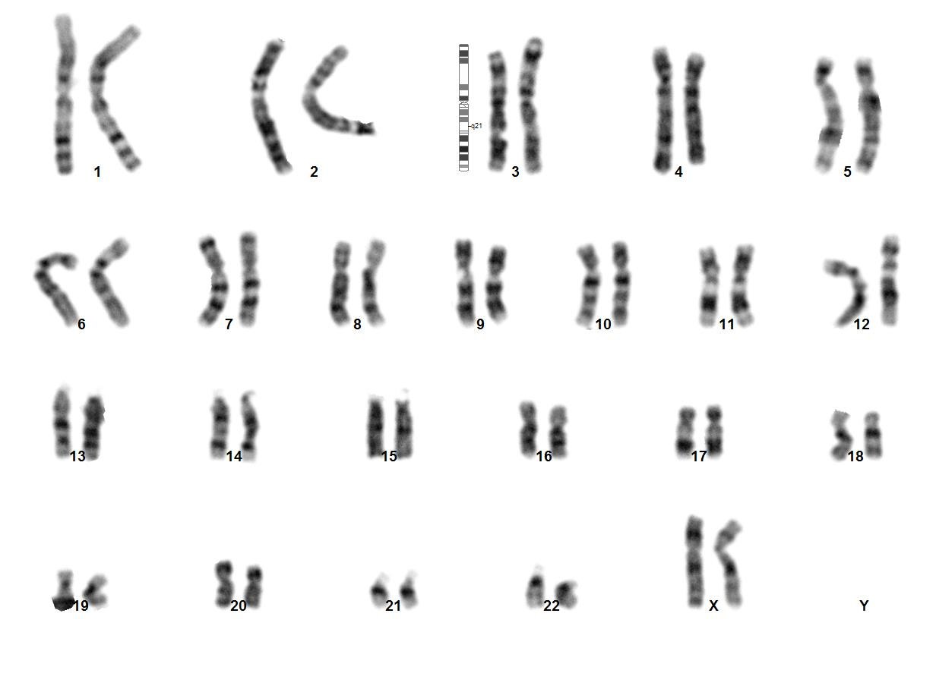
Figure S5: Metaphase of a stage IV female breast cancer patient showing structural aberration. Karyotype: 46,XX,chtb(3)(q21)

Figure S6: Metaphase of a male breast cancer patient showing structural aberration.
Karyotype: 46,XY,t(X;10)(Xpter→Xq13::10q21→10qter)(10pter→10q11.2::Xq21→Xqter)

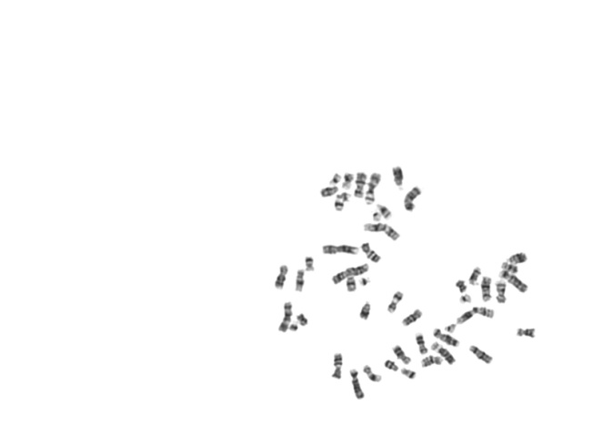
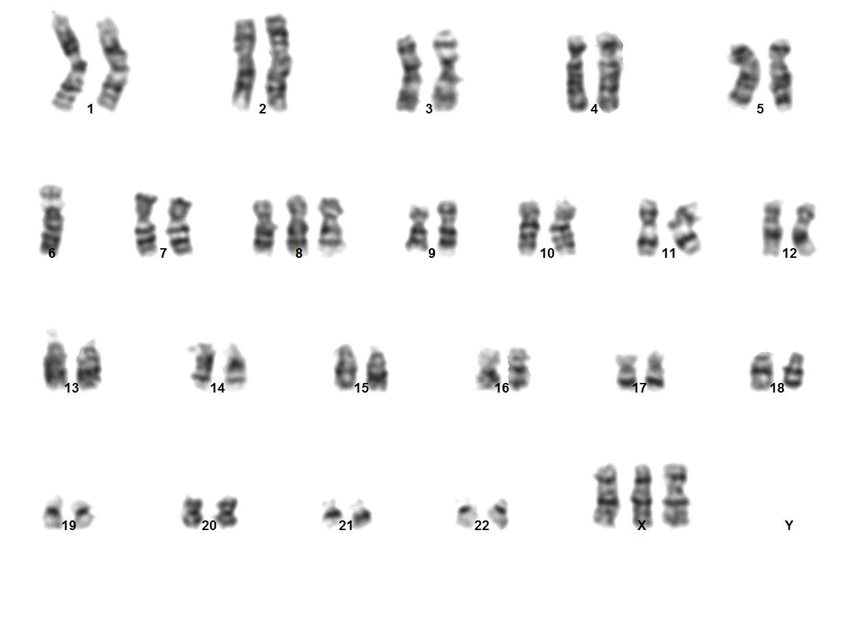 Figure S7: Metaphase of a stage IV female breast cancer patient showing numerical aberration. Karyotype: 47,XXX,-6,+8

Clonal Anomalies:

Figure S8: Interstitial deletion in chromosome 2 found in 13% of the scanned metaphases in a stage II female breast cancer patient [46,XX,del(2)(pter→q11.2::21.2→qter)]

Figure S9: Addition in chromosome 1q found in 4% of the scanned metaphases in a stage II female breast cancer patient [(46,XX,add(1)(pter→q21::?::q21→qter)]

