Additional files
Supplementary tables and figures
Series | No. Patient | Platform |  | Series | No. Patient | Platform
GSE1456 | 159 | Affymetrix Human Genome U133A Array |  | GSE9195 | 77 | Affymetrix Human Genome U133 Plus 2.0 Array
GSE2034 | 286 | Affymetrix Human Genome U133A Array |  | GSE19615 | 115 | Affymetrix Human Genome U133 Plus 2.0 Array
GSE5327 | 58 | Affymetrix Human Genome U133A Array |  | GSE21653 | 266 | Affymetrix Human Genome U133 Plus 2.0 Array
GSE2603 | 82 | Affymetrix Human Genome U133A Array |  | GSE42568 | 104 | Affymetrix Human Genome U133 Plus 2.0 Array
GSE2990 | 189 | Affymetrix Human Genome U133A Array |  | GSE48390 | 81 | Affymetrix Human Genome U133 Plus 2.0 Array
GSE3494 | 251 | Affymetrix Human Genome U133A Array |  | GSE58812 | 107 | Affymetrix Human Genome U133 Plus 2.0 Array
GSE6532 | 327 | Affymetrix Human Genome U133A Array |  | GSE17907 | 51 | Affymetrix Human Genome U133 Plus 2.0 Array
GSE7390 | 198 | Affymetrix Human Genome U133A Array |  | GSE20711 | 88 | Affymetrix Human Genome U133 Plus 2.0 Array
GSE11121 | 200 | Affymetrix Human Genome U133A Array |  | GSE20685 | 327 | Affymetrix Human Genome U133 Plus 2.0 Array
GSE12093 | 136 | Affymetrix Human Genome U133A Array |  | GSE61304 | 58 | Affymetrix Human Genome U133 Plus 2.0 Array
GSE17705 | 298 | Affymetrix Human Genome U133A Array |  | GSE58984 | 94 | Affymetrix Human Genome U133 Plus 2.0 Array
GSE25055 | 310 | Affymetrix Human Genome U133A Array |  | GSE6532 | 87 | Affymetrix Human Genome U133 Plus 2.0 Array
GSE25065 | 198 | Affymetrix Human Genome U133A Array |  | GSE53031 | 113 | Affymetrix Human Genome U219 Array
GSE25066 | 508 | Affymetrix Human Genome U133A Array |  | GSE86166 | 366 | Human RSTA Custom Affymetrix 2.0 microarray
GSE37181 | 123 | Illumina HumanWG-6 v3.0 beadchip
Table S1. GEO datasets used in this study
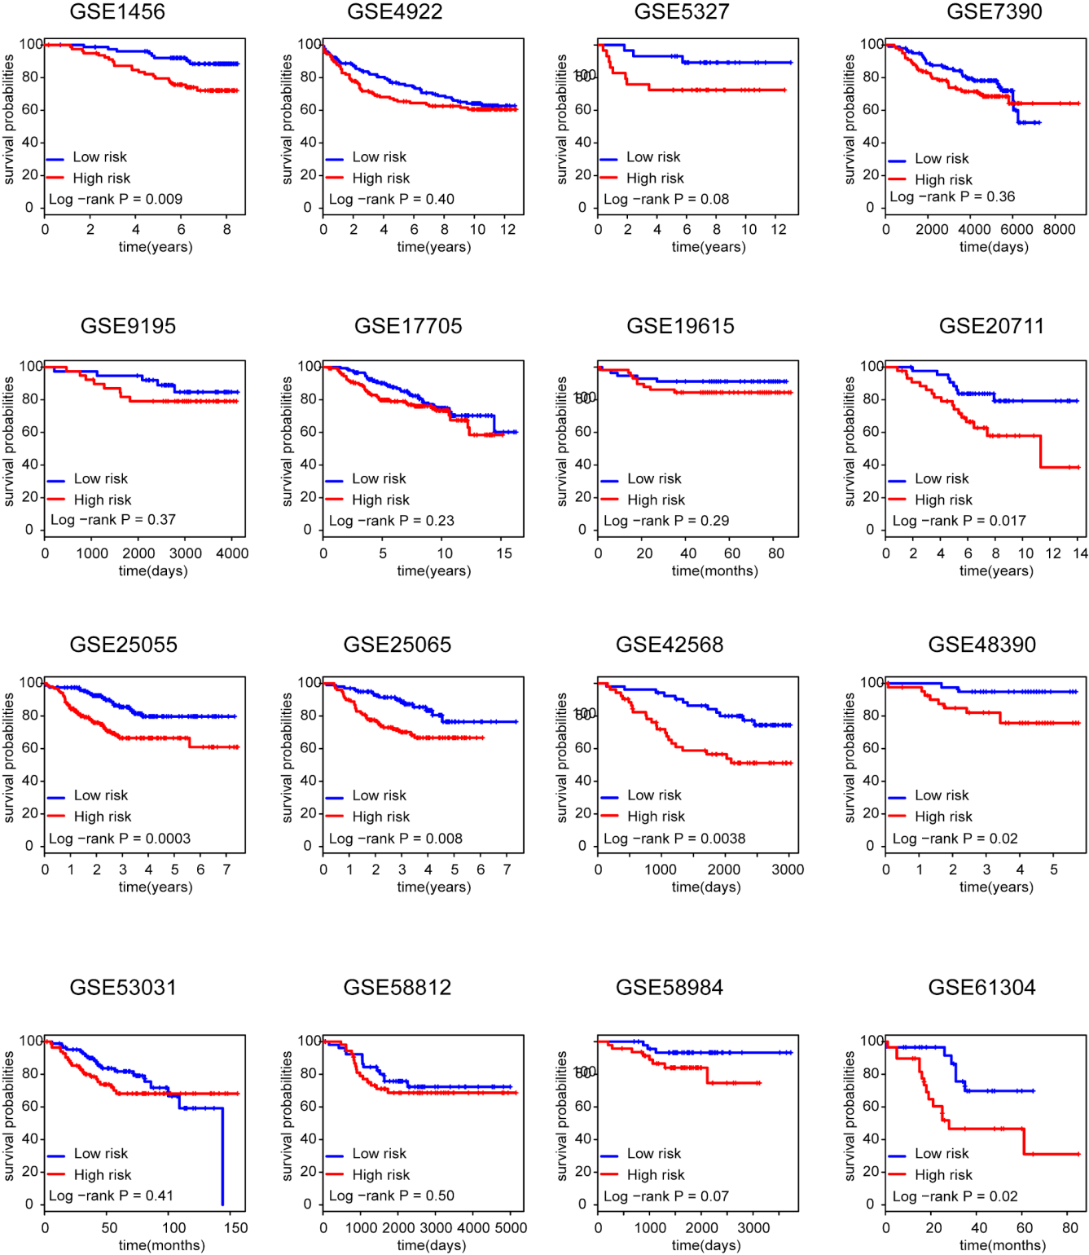
Figure S1. Transcriptional regulator model predicts survival in breast cancer datasets. Kaplan-Meier curves of overall survival for independent microarray data sets. The low-risk and high-risk groups of patients were determined on the basis of the median risk score for each validation dataset.

Figure S2. The regulator risk groups associated with average survival time. The high-risk group patients tend to have a shorter survival time compared with the low risk patients.

Figure S3. Comparison of the performance of the regulator model with MammaPrint. ROC curves of the regulator model and MammaPrint in predicting overall survival in two of the biggest validation sets GSE25066 (A) and GSE20685 (B).

