Supplementary Information

Additional file 1

Table of Contents

1 Samples and Infinium Global Screening Array (GSA) cluster file generation 2
2 Study sample selection rationale 8
3 Data, Datasets, and Data organization 8
3.1 WGS data 10
4 Principal Component Analysis (PCA) 12
4.1 Methods 12
4.1.1 Datasets 12
4.1.2 Principal Component Analysis 12
4.1.3 PCA analysis testing – randomization experiment 13
4.2 Results 13
4.3 R code 16
5 Sample DNA contamination estimation and detection 17
5.1 Regression-based method to detect sample contamination 17
6 GSA quality control analyses 20
6.1 Quality control for BeadChip Array 20
6.2 Quality control for GSA triplicate samples 21
6.3 Quality control of GSA triplicate VCF files 22
7 Transitions and transversions 23
7.1 Transitions and transversions with special focus on complementary transversions 24
8 Data submitted to NCBI 25
References 40

Samples and Infinium Global Screening Array (GSA) cluster file generation
List of 263 samples purchased from the Coriell Institute for GSA analysis are listed in Table S1 (details of sample selection in next section). A total of 7 plates containing Coriell samples across 14 diversity panels and 5 plates of Sanford Biobank samples were run in order to create a cluster file for the GSA with custom content (Sanford chip). Each plate was run 3 times (by 3 different technicians, on two different robots, using 2 lots of the Infinium HTS kit). Genotyping data was generated for 1,104 individuals in triplicate. The proportion of females to males was roughly 1:1 and the ethnic composition was as follows:

Of a total of 1,415 Coriell samples that were purchased from the Coriell Institute (Table S2), 644 Coriell samples covering major ethnic groups (46 individuals per each group) were used:
- Finns in Finland
- Han Chinese
- British in the United Kingdom
- Puerto Ricans in Puerto Rico
- Mexicans in Los Angeles, USA
- Japanese in Tokyo
- Iberians in Spain
- Peruvians in Lima
- Yoruba in Ibadan
- Kinh in Ho Chi Minh City
- African ancestry in Southwest US
- African Caribbean in Barbados
- Mende in Sierra Leone
- Indian Telugu in the UK
460 individuals semi-randomly selected from the local population (from the Sanford Biobank) including Native Americans (50) and trios (10) from internal research.

With the exception of the Native Americans and research trios, samples from the biobank were selected to assess two different methods of DNA extraction in the laboratory. To evaluate biases in cluster file generation at two physically different locations and from different input DNA samples, we compared a cluster file generated by Illumina to the one generated in-house. We found high correlation of p10GC values when the cluster files were compared indicating no major physical location specific or sample selection biases. Additionally, the utility of the GSA for assaying genotypes within the MAP59 genes was checked by overlaying MAP59 assays on all assays in the plot; this found no major differences between cluster files; minor off-diagonal differences were assays with different p10GC values relative to each other. The majority of the MAP59 assays had lower p10GC values in both the Illumina cluster file and the Imagenetics cluster file (Figure S1). Assessment of the reproducibility of cluster file curation between institutes was performed in collaboration with the bioinformatics staff at Illumina, Inc. (https://www.illumina.com, Ryan Kelly and Jeremy Pierce, unpublished data).

Table S1. List of 263 Coriell DNA samples purchased from the Coriell Institute and used for GSA analytical validity analyses.
HG00096 | HG00345 | HG02052 | HG03705 | NA18543 | NA19023 | NA19314 | NA19457 | NA20276 | NA20519
HG00099 | HG00366 | HG02271 | HG03713 | NA18544 | NA19024 | NA19319 | NA19466 | NA20278 | NA20520
HG00101 | HG00403 | HG02304 | HG03742 | NA18552 | NA19026 | NA19320 | NA19468 | NA20287 | NA20524
HG00102 | HG00419 | HG02360 | HG03788 | NA18559 | NA19031 | NA19321 | NA19471 | NA20289 | NA20525
HG00103 | HG00452 | HG02568 | HG03790 | NA18572 | NA19036 | NA19323 | NA19472 | NA20291 | NA20532
HG00106 | HG00759 | HG02628 | HG03848 | NA18606 | NA19037 | NA19324 | NA19473 | NA20294 | NA20763
HG00108 | HG01051 | HG02651 | HG03854 | NA18856 | NA19041 | NA19327 | NA19475 | NA20296 | NA20767
HG00110 | HG01083 | HG02684 | HG03871 | NA18861 | NA19042 | NA19347 | NA19625 | NA20299 | NA20812
HG00111 | HG01089 | HG02922 | HG03885 | NA18915 | NA19043 | NA19350 | NA19648 | NA20320 | NA20814
HG00116 | HG01112 | HG03006 | HG03896 | NA18916 | NA19056 | NA19355 | NA19658 | NA20321 | NA20822
HG00118 | HG01170 | HG03052 | HG03967 | NA18933 | NA19070 | NA19374 | NA19682 | NA20332 | NA20845
HG00120 | HG01398 | HG03267 | HG03974 | NA18939 | NA19072 | NA19376 | NA19700 | NA20339 | NA20846
HG00122 | HG01441 | HG03279 | HG04060 | NA18944 | NA19076 | NA19380 | NA19701 | NA20342 | NA20863
HG00126 | HG01455 | HG03366 | HG04094 | NA18948 | NA19102 | NA19390 | NA19704 | NA20346 | NA20864
HG00133 | HG01500 | HG03369 | HG04131 | NA18953 | NA19119 | NA19395 | NA19713 | NA20348 | NA20867
HG00174 | HG01530 | HG03401 | HG04219 | NA18959 | NA19130 | NA19399 | NA19764 | NA20351 | NA20887
HG00185 | HG01565 | HG03464 | NA06989 | NA18965 | NA19131 | NA19403 | NA19780 | NA20355 | NA20889
HG00188 | HG01583 | HG03472 | NA07045 | NA18966 | NA19147 | NA19429 | NA19789 | NA20356 | NA20890
HG00253 | HG01595 | HG03514 | NA12156 | NA18970 | NA19159 | NA19434 | NA19795 | NA20412 | NA20901
HG00257 | HG01605 | HG03575 | NA12878 | NA18971 | NA19160 | NA19435 | NA19834 | NA20502 | NA20904
HG00263 | HG01620 | HG03642 | NA17281 | NA18974 | NA19189 | NA19436 | NA19835 | NA20509 | NA21090
HG00265 | HG01879 | HG03681 | NA18486 | NA18983 | NA19209 | NA19437 | NA19909 | NA20510 | NA21093
HG00266 | HG01941 | HG03685 | NA18488 | NA18990 | NA19238 | NA19440 | NA19921 | NA20511 | NA21105
HG00268 | HG01944 | HG03686 | NA18508 | NA18994 | NA19239 | NA19443 | NA19984 | NA20513 | NA21118
HG00276 | HG02012 | HG03687 | NA18511 | NA19017 | NA19248 | NA19445 | NA20126 | NA20515 | NA21128
HG00332 | HG02032 | HG03694 | NA18525 | NA19019 | NA19308 | NA19452 | NA20274 | NA20516 | NA21135
NA24143 | NA24149 | NA24385

Table S2. List of 1,415 Coriell DNA samples purchased from the Coriell Institute for GSA for the purpose of cluster file generation.
HG00096 | HG02397 | HG03905 | NA18644 | NA19473 | HG01619 | HG03556 | NA11995 | NA19087 | NA20543
HG00099 | HG02398 | HG03907 | NA18645 | NA19474 | HG01620 | HG03558 | NA12003 | NA19088 | NA20544
HG00101 | HG02399 | HG03908 | NA18646 | NA19475 | HG01625 | HG03559 | NA12004 | NA19089 | NA20581
HG00102 | HG02401 | HG03910 | NA18647 | NA19625 | HG01630 | HG03563 | NA12006 | NA19090 | NA20586
HG00103 | HG02402 | HG03911 | NA18648 | NA19648 | HG01631 | HG03565 | NA12043 | NA19091 | NA20587
HG00106 | HG02406 | HG03913 | NA18740 | NA19649 | HG01669 | HG03567 | NA12044 | NA19092 | NA20588
HG00108 | HG02407 | HG03914 | NA18749 | NA19651 | HG01675 | HG03571 | NA12144 | NA19093 | NA20589
HG00110 | HG02408 | HG03916 | NA18853 | NA19652 | HG01686 | HG03572 | NA12154 | NA19095 | NA20752
HG00111 | HG02409 | HG03917 | NA18856 | NA19654 | HG01705 | HG03575 | NA12155 | NA19096 | NA20753
HG00116 | HG02410 | HG03919 | NA18858 | NA19655 | HG01756 | HG03577 | NA12156 | NA19098 | NA20754
HG00118 | HG02420 | HG03920 | NA18861 | NA19657 | HG01765 | HG03578 | NA12249 | NA19099 | NA20755
HG00120 | HG02429 | HG03922 | NA18864 | NA19658 | HG01777 | HG03583 | NA12273 | NA19102 | NA20758
HG00122 | HG02433 | HG03925 | NA18865 | NA19661 | HG01783 | HG03585 | NA12282 | NA19107 | NA20759
HG00126 | HG02439 | HG03926 | NA18867 | NA19664 | HG01791 | HG03589 | NA12283 | NA19108 | NA20760
HG00133 | HG02442 | HG03928 | NA18868 | NA19669 | HG01810 | HG03593 | NA12287 | NA19113 | NA20761
HG00148 | HG02449 | HG03931 | NA18870 | NA19670 | HG01811 | HG03594 | NA12340 | NA19114 | NA20762
HG00160 | HG02455 | HG03934 | NA18871 | NA19676 | HG01816 | HG03595 | NA12348 | NA19116 | NA20763
HG00174 | HG02461 | HG03937 | NA18873 | NA19678 | HG01840 | HG03598 | NA12383 | NA19117 | NA20765
HG00183 | HG02470 | HG03940 | NA18874 | NA19679 | HG01842 | HG03603 | NA12414 | NA19118 | NA20767
HG00185 | HG02484 | HG03943 | NA18876 | NA19681 | HG01844 | HG03604 | NA12489 | NA19119 | NA20770
HG00186 | HG02489 | HG03947 | NA18877 | NA19682 | HG01846 | HG03607 | NA12716 | NA19129 | NA20771
HG00187 | HG02490 | HG03949 | NA18878 | NA19684 | HG01849 | HG03611 | NA12717 | NA19130 | NA20775
HG00188 | HG02496 | HG03950 | NA18881 | NA19700 | HG01852 | HG03615 | NA12748 | NA19131 | NA20778
HG00244 | HG02512 | HG03951 | NA18907 | NA19701 | HG01860 | HG03616 | NA12749 | NA19137 | NA20783
HG00253 | HG02521 | HG03953 | NA18908 | NA19703 | HG01861 | HG03624 | NA12750 | NA19138 | NA20785
HG00257 | HG02536 | HG03963 | NA18909 | NA19704 | HG01864 | HG03629 | NA12751 | NA19141 | NA20786
HG00263 | HG02541 | HG03965 | NA18910 | NA19707 | HG01865 | HG03631 | NA12761 | NA19143 | NA20787
HG00264 | HG02545 | HG03967 | NA18912 | NA19711 | HG01866 | HG03634 | NA12763 | NA19144 | NA20792
HG00265 | HG02554 | HG03968 | NA18915 | NA19712 | HG01867 | HG03636 | NA12776 | NA19146 | NA20795
HG00266 | HG02557 | HG03969 | NA18916 | NA19713 | HG01872 | HG03640 | NA12812 | NA19147 | NA20796
HG00267 | HG02568 | HG03971 | NA18917 | NA19716 | HG01873 | HG03642 | NA12813 | NA19149 | NA20798
HG00268 | HG02585 | HG03973 | NA18923 | NA19717 | HG01879 | HG03643 | NA12815 | NA19152 | NA20801
HG00271 | HG02597 | HG03974 | NA18924 | NA19719 | HG01885 | HG03644 | NA12828 | NA19153 | NA20802
HG00276 | HG02600 | HG03976 | NA18933 | NA19720 | HG01914 | HG03645 | NA12829 | NA19159 | NA20803
HG00277 | HG02603 | HG03977 | NA18934 | NA19722 | HG01917 | HG03646 | NA12830 | NA19160 | NA20805
HG00278 | HG02610 | HG03978 | NA18939 | NA19723 | HG01941 | HG03649 | NA12872 | NA19171 | NA20806
HG00280 | HG02613 | HG03986 | NA18940 | NA19725 | HG01944 | HG03652 | NA12873 | NA19172 | NA20809
HG00284 | HG02620 | HG03989 | NA18942 | NA19729 | HG01947 | HG03653 | NA12878 | NA19175 | NA20810
HG00310 | HG02623 | HG03990 | NA18943 | NA19732 | HG01950 | HG03660 | NA12889 | NA19184 | NA20811
HG00311 | HG02628 | HG03995 | NA18944 | NA19735 | HG01953 | HG03668 | NA17281 | NA19185 | NA20812
HG00321 | HG02634 | HG03998 | NA18945 | NA19741 | HG01961 | HG03673 | NA18486 | NA19189 | NA20814
HG00329 | HG02651 | HG03999 | NA18946 | NA19747 | HG01970 | HG03680 | NA18488 | NA19190 | NA20815
HG00332 | HG02654 | HG04001 | NA18948 | NA19749 | HG01974 | HG03681 | NA18489 | NA19197 | NA20822
HG00335 | HG02657 | HG04002 | NA18949 | NA19750 | HG01977 | HG03684 | NA18498 | NA19198 | NA20827
HG00345 | HG02660 | HG04003 | NA18950 | NA19752 | HG01979 | HG03685 | NA18499 | NA19200 | NA20845
HG00351 | HG02681 | HG04006 | NA18951 | NA19756 | HG01982 | HG03686 | NA18501 | NA19201 | NA20846
HG00360 | HG02684 | HG04014 | NA18952 | NA19759 | HG01986 | HG03687 | NA18502 | NA19204 | NA20847
HG00366 | HG02727 | HG04015 | NA18953 | NA19761 | HG01988 | HG03691 | NA18504 | NA19206 | NA20849
HG00369 | HG02789 | HG04017 | NA18954 | NA19762 | HG01990 | HG03693 | NA18505 | NA19207 | NA20850
HG00372 | HG02813 | HG04018 | NA18956 | NA19764 | HG02002 | HG03694 | NA18507 | NA19209 | NA20851
HG00375 | HG02816 | HG04020 | NA18957 | NA19770 | HG02008 | HG03695 | NA18508 | NA19210 | NA20852
HG00382 | HG02819 | HG04022 | NA18959 | NA19771 | HG02009 | HG03697 | NA18510 | NA19213 | NA20853
HG00403 | HG02860 | HG04033 | NA18960 | NA19773 | HG02012 | HG03698 | NA18511 | NA19214 | NA20854
HG00419 | HG02881 | HG04035 | NA18961 | NA19774 | HG02013 | HG03702 | NA18516 | NA19222 | NA20856
HG00421 | HG02895 | HG04038 | NA18962 | NA19776 | HG02014 | HG03703 | NA18517 | NA19223 | NA20858
HG00442 | HG02922 | HG04039 | NA18963 | NA19777 | HG02017 | HG03705 | NA18519 | NA19225 | NA20859
HG00445 | HG02947 | HG04042 | NA18964 | NA19779 | HG02020 | HG03706 | NA18520 | NA19235 | NA20861
HG00448 | HG03006 | HG04047 | NA18965 | NA19780 | HG02023 | HG03708 | NA18522 | NA19236 | NA20862
HG00452 | HG03052 | HG04059 | NA18966 | NA19782 | HG02026 | HG03709 | NA18523 | NA19238 | NA20863
HG00457 | HG03120 | HG04060 | NA18967 | NA19783 | HG02029 | HG03711 | NA18525 | NA19239 | NA20864
HG00472 | HG03166 | HG04061 | NA18968 | NA19786 | HG02032 | HG03713 | NA18526 | NA19247 | NA20866
HG00475 | HG03202 | HG04062 | NA18970 | NA19788 | HG02035 | HG03714 | NA18528 | NA19248 | NA20867
HG00478 | HG03212 | HG04076 | NA18971 | NA19789 | HG02040 | HG03716 | NA18530 | NA19256 | NA20868
HG00500 | HG03224 | HG04080 | NA18972 | NA19792 | HG02047 | HG03720 | NA18531 | NA19257 | NA20869
HG00524 | HG03225 | HG04090 | NA18973 | NA19794 | HG02050 | HG03727 | NA18532 | NA19307 | NA20870
HG00530 | HG03234 | HG04093 | NA18974 | NA19795 | HG02051 | HG03729 | NA18533 | NA19308 | NA20872
HG00533 | HG03235 | HG04094 | NA18975 | NA19818 | HG02052 | HG03730 | NA18534 | NA19309 | NA20874
HG00556 | HG03237 | HG04098 | NA18976 | NA19819 | HG02053 | HG03731 | NA18535 | NA19310 | NA20875
HG00580 | HG03238 | HG04100 | NA18977 | NA19834 | HG02058 | HG03736 | NA18536 | NA19312 | NA20877
HG00595 | HG03240 | HG04107 | NA18978 | NA19835 | HG02061 | HG03742 | NA18537 | NA19314 | NA20881
HG00598 | HG03241 | HG04118 | NA18979 | NA19900 | HG02064 | HG03744 | NA18538 | NA19315 | NA20882
HG00607 | HG03246 | HG04131 | NA18980 | NA19901 | HG02067 | HG03746 | NA18539 | NA19316 | NA20884
HG00619 | HG03247 | HG04134 | NA18981 | NA19904 | HG02070 | HG03753 | NA18541 | NA19317 | NA20885
HG00625 | HG03258 | HG04140 | NA18982 | NA19908 | HG02073 | HG03754 | NA18542 | NA19318 | NA20887
HG00650 | HG03265 | HG04141 | NA18983 | NA19909 | HG02076 | HG03755 | NA18543 | NA19319 | NA20888
HG00653 | HG03267 | HG04144 | NA18984 | NA19913 | HG02079 | HG03757 | NA18544 | NA19320 | NA20889
HG00662 | HG03268 | HG04146 | NA18985 | NA19914 | HG02082 | HG03760 | NA18546 | NA19321 | NA20890
HG00674 | HG03270 | HG04152 | NA18986 | NA19916 | HG02085 | HG03762 | NA18547 | NA19323 | NA20891
HG00683 | HG03271 | HG04153 | NA18988 | NA19917 | HG02088 | HG03765 | NA18548 | NA19324 | NA20894
HG00689 | HG03279 | HG04155 | NA18989 | NA19920 | HG02090 | HG03770 | NA18549 | NA19327 | NA20895
HG00692 | HG03291 | HG04156 | NA18990 | NA19921 | HG02104 | HG03771 | NA18550 | NA19328 | NA20896
HG00701 | HG03294 | HG04158 | NA18991 | NA19922 | HG02107 | HG03774 | NA18552 | NA19331 | NA20897
HG00707 | HG03298 | HG04159 | NA18993 | NA19923 | HG02116 | HG03777 | NA18553 | NA19332 | NA20901
HG00759 | HG03300 | HG04161 | NA18994 | NA19982 | HG02122 | HG03778 | NA18555 | NA19334 | NA20902
HG00844 | HG03303 | HG04162 | NA18995 | NA19984 | HG02128 | HG03779 | NA18557 | NA19338 | NA20903
HG00881 | HG03311 | HG04164 | NA18997 | NA20126 | HG02131 | HG03780 | NA18558 | NA19346 | NA20904
HG00982 | HG03342 | HG04171 | NA18998 | NA20127 | HG02134 | HG03781 | NA18559 | NA19347 | NA20905
HG01028 | HG03343 | HG04173 | NA18999 | NA20274 | HG02137 | HG03782 | NA18560 | NA19350 | NA20906
HG01031 | HG03351 | HG04176 | NA19000 | NA20276 | HG02138 | HG03787 | NA18561 | NA19351 | NA20908
HG01051 | HG03366 | HG04177 | NA19001 | NA20278 | HG02141 | HG03788 | NA18562 | NA19355 | NA20910
HG01069 | HG03367 | HG04180 | NA19003 | NA20281 | HG02146 | HG03789 | NA18563 | NA19360 | NA20911
HG01082 | HG03369 | HG04182 | NA19004 | NA20282 | HG02150 | HG03790 | NA18564 | NA19372 | NA21086
HG01083 | HG03372 | HG04183 | NA19005 | NA20287 | HG02219 | HG03793 | NA18565 | NA19374 | NA21087
HG01089 | HG03376 | HG04185 | NA19006 | NA20289 | HG02221 | HG03796 | NA18566 | NA19375 | NA21089
HG01101 | HG03378 | HG04186 | NA19009 | NA20291 | HG02224 | HG03800 | NA18567 | NA19376 | NA21090
HG01112 | HG03380 | HG04188 | NA19010 | NA20294 | HG02233 | HG03802 | NA18570 | NA19377 | NA21091
HG01130 | HG03382 | HG04189 | NA19011 | NA20296 | HG02236 | HG03803 | NA18571 | NA19378 | NA21092
HG01170 | HG03388 | HG04194 | NA19012 | NA20298 | HG02250 | HG03805 | NA18572 | NA19379 | NA21093
HG01197 | HG03391 | HG04195 | NA19017 | NA20299 | HG02253 | HG03808 | NA18573 | NA19380 | NA21094
HG01250 | HG03394 | HG04198 | NA19019 | NA20317 | HG02255 | HG03809 | NA18574 | NA19383 | NA21095
HG01256 | HG03397 | HG04202 | NA19020 | NA20318 | HG02259 | HG03812 | NA18577 | NA19384 | NA21098
HG01259 | HG03401 | HG04206 | NA19023 | NA20320 | HG02262 | HG03814 | NA18579 | NA19385 | NA21099
HG01302 | HG03410 | HG04210 | NA19024 | NA20321 | HG02265 | HG03815 | NA18582 | NA19390 | NA21100
HG01308 | HG03419 | HG04211 | NA19025 | NA20332 | HG02271 | HG03817 | NA18591 | NA19391 | NA21101
HG01325 | HG03428 | HG04214 | NA19026 | NA20334 | HG02274 | HG03821 | NA18592 | NA19393 | NA21102
HG01350 | HG03432 | HG04216 | NA19027 | NA20339 | HG02277 | HG03823 | NA18593 | NA19394 | NA21103
HG01356 | HG03433 | HG04219 | NA19028 | NA20340 | HG02283 | HG03824 | NA18595 | NA19395 | NA21104
HG01362 | HG03436 | HG04222 | NA19030 | NA20342 | HG02285 | HG03826 | NA18596 | NA19397 | NA21105
HG01365 | HG03437 | HG04227 | NA19031 | NA20346 | HG02291 | HG03829 | NA18597 | NA19399 | NA21106
HG01374 | HG03439 | HG04229 | NA19035 | NA20348 | HG02299 | HG03830 | NA18599 | NA19401 | NA21107
HG01392 | HG03442 | HG04235 | NA19036 | NA20351 | HG02304 | HG03832 | NA18602 | NA19403 | NA21108
HG01395 | HG03445 | HG04238 | NA19037 | NA20355 | HG02307 | HG03833 | NA18603 | NA19404 | NA21109
HG01398 | HG03446 | HG04239 | NA19038 | NA20356 | HG02314 | HG03838 | NA18605 | NA19428 | NA21110
HG01412 | HG03449 | NA06984 | NA19041 | NA20357 | HG02317 | HG03844 | NA18606 | NA19429 | NA21111
HG01437 | HG03451 | NA06986 | NA19042 | NA20359 | HG02323 | HG03846 | NA18608 | NA19430 | NA21112
HG01440 | HG03452 | NA06989 | NA19043 | NA20362 | HG02330 | HG03848 | NA18609 | NA19431 | NA21113
HG01441 | HG03455 | NA06994 | NA19055 | NA20412 | HG02332 | HG03849 | NA18610 | NA19434 | NA21114
HG01443 | HG03457 | NA07000 | NA19056 | NA20502 | HG02334 | HG03850 | NA18612 | NA19435 | NA21115
HG01455 | HG03458 | NA07037 | NA19057 | NA20504 | HG02343 | HG03851 | NA18613 | NA19436 | NA21116
HG01461 | HG03460 | NA07045 | NA19058 | NA20509 | HG02353 | HG03854 | NA18614 | NA19437 | NA21117
HG01464 | HG03461 | NA07051 | NA19059 | NA20510 | HG02355 | HG03856 | NA18615 | NA19438 | NA21118
HG01479 | HG03464 | NA07347 | NA19060 | NA20511 | HG02356 | HG03857 | NA18616 | NA19439 | NA21119
HG01485 | HG03469 | NA07357 | NA19062 | NA20512 | HG02360 | HG03863 | NA18617 | NA19440 | NA21120
HG01491 | HG03470 | NA10847 | NA19063 | NA20513 | HG02367 | HG03868 | NA18618 | NA19443 | NA21122
HG01497 | HG03472 | NA10851 | NA19064 | NA20515 | HG02371 | HG03870 | NA18619 | NA19445 | NA21123
HG01500 | HG03473 | NA11829 | NA19065 | NA20516 | HG02373 | HG03871 | NA18621 | NA19446 | NA21124
HG01509 | HG03476 | NA11830 | NA19066 | NA20518 | HG02374 | HG03872 | NA18623 | NA19448 | NA21125
HG01515 | HG03479 | NA11831 | NA19067 | NA20519 | HG02375 | HG03873 | NA18624 | NA19449 | NA21126
HG01524 | HG03484 | NA11832 | NA19068 | NA20520 | HG02379 | HG03874 | NA18625 | NA19451 | NA21127
HG01527 | HG03485 | NA11840 | NA19070 | NA20521 | HG02380 | HG03875 | NA18626 | NA19452 | NA21128
HG01530 | HG03488 | NA11843 | NA19072 | NA20522 | HG02382 | HG03882 | NA18627 | NA19454 | NA21129
HG01556 | HG03491 | NA11881 | NA19075 | NA20524 | HG02383 | HG03885 | NA18628 | NA19455 | NA21130
HG01565 | HG03499 | NA11892 | NA19076 | NA20525 | HG02384 | HG03886 | NA18630 | NA19456 | NA21133
HG01571 | HG03511 | NA11894 | NA19079 | NA20527 | HG02385 | HG03887 | NA18632 | NA19457 | NA21135
HG01583 | HG03514 | NA11918 | NA19080 | NA20528 | HG02386 | HG03888 | NA18634 | NA19461 | NA21137
HG01589 | HG03517 | NA11919 | NA19081 | NA20529 | HG02389 | HG03890 | NA18635 | NA19462 | NA21141
HG01595 | HG03518 | NA11920 | NA19082 | NA20532 | HG02390 | HG03894 | NA18636 | NA19463 | NA21142
HG01596 | HG03520 | NA11931 | NA19083 | NA20534 | HG02391 | HG03895 | NA18637 | NA19466 | NA21143
HG01605 | HG03539 | NA11932 | NA19084 | NA20536 | HG02392 | HG03896 | NA18638 | NA19467 | NA21144
HG01606 | HG03547 | NA11992 | NA19085 | NA20538 | HG02394 | HG03897 | NA18640 | NA19468 | NA24143
HG01615 | HG03548 | NA11994 | NA19086 | NA20539 | HG02395 | HG03899 | NA18641 | NA19471 | NA24149
HG02396 | HG03902 | NA18642 | NA19472 | NA24385

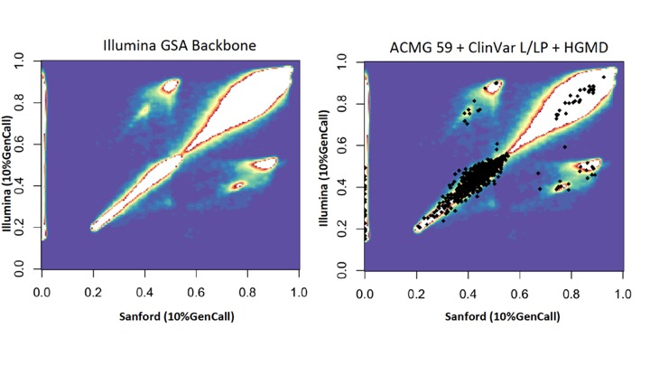
Figure S1. Comparison of p10GC between Illumina (y-axis) and Sanford GSA (x-axis) cluster files. Left panel shows all data and right panel shows ACMG59 ClinVar pathogenic / likely-pathogenic assays overlaid as black squares on top of all data-points.

Study sample selection rationale
Large-scale genotyping and sequencing studies select large sample sizes and typically target a sample size of over 1000 (1-4). To determine the validity of variation at a frequency >1% in the general population, Lee S et. al. proposed a framework to calculate a sample size given a target variation rate in the general population (Table S3) (5). With a finite sample size N, variants that are rare may not be observed. Supposing the population MAF for the j^{th} variant is m_{j} and $θ_{j}$ is the chance that the variant j is observed in the sample size N,

$θ_{j}=1-{(1-m_{j})}^{2N}$

then the sample size required to observe the variant j with at least $θ_{j}$ is

$$N=\frac{ln⁡(1-θ_{j})}{2ln⁡(1-m_{j})}$$

Table S3. Minimum number of samples required for a 99.9% chance to detect variation at a given minor allele frequency (MAF)
MAF | Minimum N
0.1 | 33
0.01 | 344
0.001 | 3,453
0.0001 | 34,537

To have a 99.9% chance of detecting variants with a MAF between ~1% and ~10%, a sample set of 263 samples from the Coriell Institute were selected to be genotyped in triplicate on the GSA as well as resequenced with Illumina WGS technology. The minor allele frequency for each GSA assay included in the 1000 Genomes Phase 3 data defined the number of needed samples, and this number was close to the theoretical number computed using the method of Lee S et al.

Data, Datasets, and Data organization
Dataset samples for analytical validation of Global Screening Array (GSA) data were selected from the 1000 Genomes project – Phase 3 (258) and the personal genomes project (5). The integrated genotype data from 1KG was downloaded and evaluated for coverage. 1KG genotype data covered 594,364 GSA assays. We also downloaded deep sequenced WGS from 1KG (pWGS; >51x) to evaluate rWGS, 1KG, and GSA data (ftp://ftp.1000genomes.ebi.ac.uk/vol1/ftp/phase3/data) (Table S4). We resequenced 263 samples on the Illumina HiSeqX to an average depth of 37x generating 731 million 150 bp paired-end reads (22.3 TB).

Table S4. Summary of number of samples in different datasets
Dataset | Total number of samples | Overlap with our dataset | Genotyping technology | Acronym
1000 Genomes Genotype Data – Phase 3 | 2,504 | 258 | WES, WGS, Array | 1KG
1000 Genomes WGS data* | 27 | 24 | WGS | pWGS
Resequenced WGS | 263 | 263 | WGS | rWGS
GSA | 789 (263 x 3) | 789 (263x3) | Array | GSA
*ftp://ftp.1000genomes.ebi.ac.uk/vol1/ftp/phase3/data

The data for resequenced WGS (rWGS) and public WGS (pWGS) were organized on AWS S3 bucket (Figure S2). All rWGS data files were mapped to canonical identifiers and file names were changed accordingly. Of the 1,104 samples used to generate the cluster file for GSA, 72 samples were included among the 263 samples in our primary validation dataset.
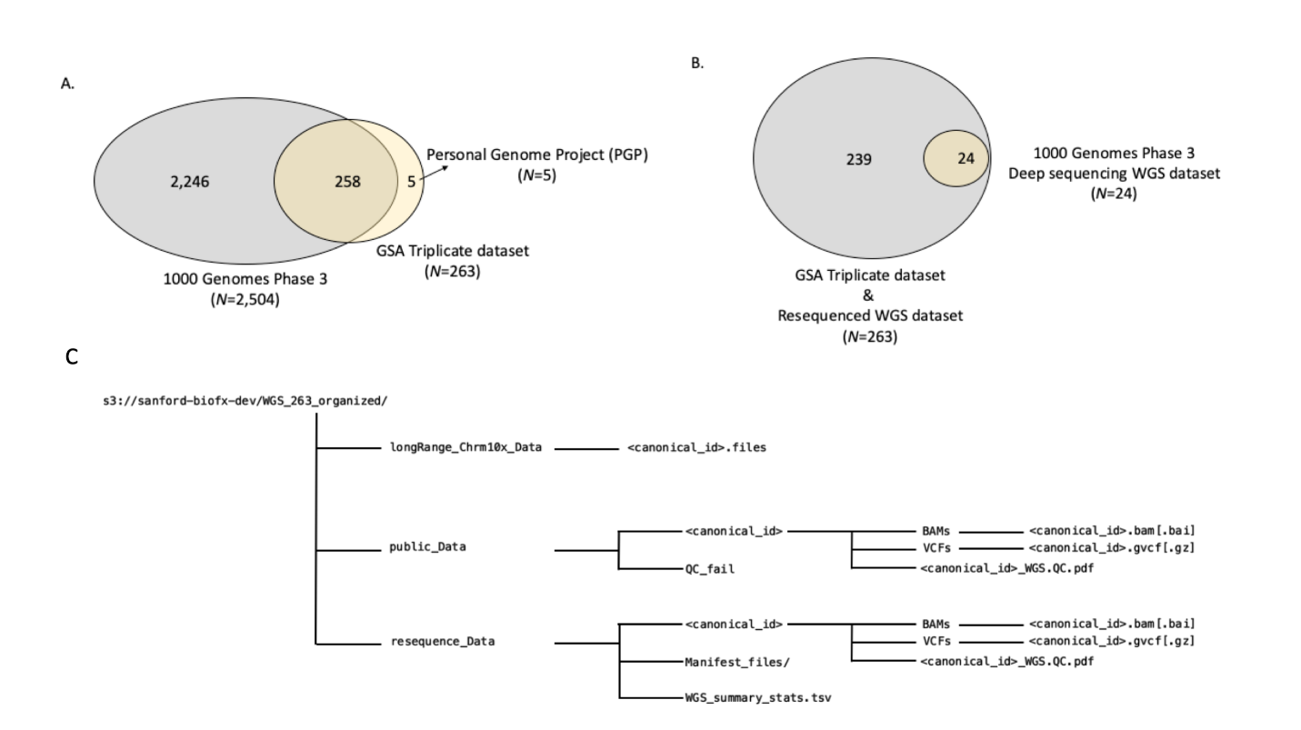

Figure S2. Datasets and their intersections with samples we selected from public benchmark databases. (A) Intersection of samples from 1000 Genomes Phase 3 benchmark dataset (2,504) and Personal Genomes Project (PGP; 5) with GSA validation samples (263; run in triplicate). (B) Intersection of 1000 Genomes Phase 3 deep sequencing WGS dataset (pWGS) relative to internally resequenced WGS dataset (rWGS) and GSA dataset. (C) The data-structure and organization of the WGS data archived on Sanford Imagenetics AWS S3 bucket (s3://sanford-biofx-dev).

WGS data
Whole Genome Sequence (WGS) data were either downloaded and reprocessed (pWGS) or resequenced (rWGS) and processed via GenomeNext and organized in an AWS S3 bucket (s3://sanford-biofx-dev). All WGS data and subsets are summarized in Table S4.

Table S5. WGS data subsets and summary
Datasets | Total samples | Pass QC | Fail QC | In_263 | Data size
1000 Genomes (public data – pWGS) | 27 | 24 | 3 | 24 | 3.9 TB
WGS resequenced data (rWGS) | 263 | 263 | 0 | 263 | 22.3 TB

Quality metrics were extracted from the quality control (QC) PDF files from GenomeNext for reprocessed public data (n=24) and resequenced data (n=263) (Tables S4 and S5, respectively). The average depth of sequencing was computed using mapped read information and read-lengths for the resequenced data (n=263) (Figure S3) and the reprocessed public data (n=24) (Table S6). We also plotted the correlation of reported total processed reads vs. mapped reads to see if the relationship were linear and found it to be true (Figure S3). To check for completeness of all the data downloaded from GenomeNext, we generated a matrix of samples and all files expected under a given sample folder (e.g., BAM files, VCF files, etc.).
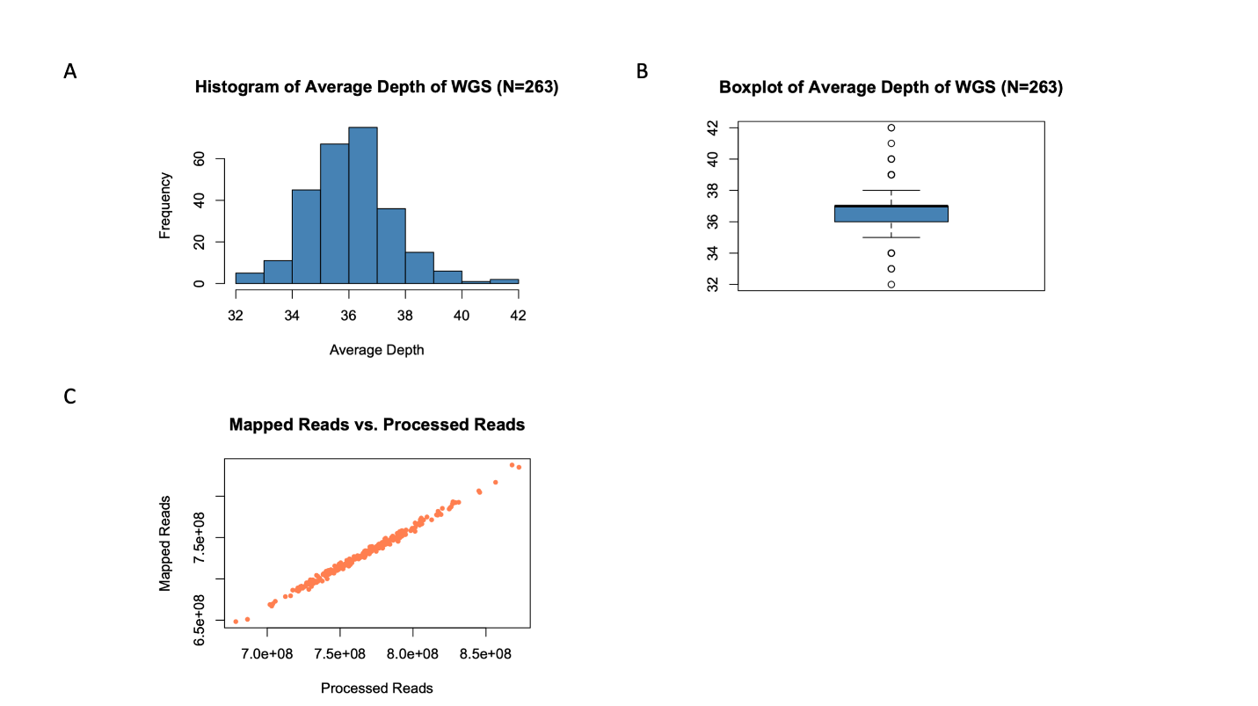
Figure S3. Quality control statistics of rWGS dataset (N=263). (A) A histogram of average read depth of coverage across HumanG1Kv37 for 263 resequenced WGS samples. (B) A box-plot of average read depth of coverage across HumanG1Kv37 for 263 resequenced WGS samples. (C) A scatter-plot of total number of reads mapped to reference sequence (HumanG1Kv37) as a function of total reads processed for alignment for each resequenced WGS sample.

Table S6. Public WGS (pWGS) from 1000 Genome Phase 3 downloaded and reprocessed data – summary statistics (QC pass samples)
Number | Samples | Processed | Discordant Reads | Mapq0 Reads | Unmapped Reads | Mapped | Average Depth
1 | HG02568 | 351,034,149 | 13,138,544 | 16,981,365 | 17,085,394 | 333,948,755 | 28
2 | HG03642 | 542,600,081 | 15,585,266 | 25,999,215 | 29,199,287 | 513,400,794 | 43
3 | HG01112 | 715,889,080 | 5,143,810 | 28,755,439 | 34,474,661 | 681,414,419 | 57
4 | HG00268 | 708,112,489 | 8,060,456 | 23,238,117 | 31,080,453 | 677,032,036 | 56
5 | HG03052 | 621,081,848 | 12,327,266 | 27,273,419 | 34,021,121 | 587,060,727 | 49
6 | NA18525 | 691,324,110 | 6,066,440 | 24,689,237 | 35,224,296 | 656,099,814 | 55
7 | NA20502 | 555,380,187 | 14,943,032 | 21,499,779 | 27,541,973 | 527,838,214 | 44
8 | NA18939 | 707,535,350 | 9,012,312 | 27,467,556 | 35,170,903 | 672,364,447 | 56
9 | HG01051 | 652,257,648 | 10,613,568 | 29,427,170 | 33,266,466 | 618,991,182 | 52
10 | HG00419 | 634,226,577 | 13,039,306 | 24,610,921 | 29,159,792 | 605,066,785 | 50
11 | HG03742 | 673,937,258 | 8,956,384 | 31,205,876 | 41,136,371 | 632,800,887 | 53
12 | NA19017 | 684,218,155 | 11,919,738 | 26,028,294 | 33,872,947 | 650,345,208 | 54
13 | HG01583 | 559,018,341 | 16,729,388 | 28,016,975 | 28,188,257 | 530,830,084 | 44
14 | HG00759 | 674,497,471 | 8,640,158 | 26,677,264 | 37,193,265 | 637,304,206 | 53
15 | NA19625 | 558,605,495 | 14,154,724 | 26,788,262 | 29,961,242 | 528,644,253 | 44
16 | HG01879 | 702,755,507 | 10,916,274 | 31,347,708 | 37,853,242 | 664,902,265 | 55
17 | HG01565 | 704,005,178 | 5,996,396 | 32,309,214 | 38,524,040 | 665,481,138 | 55
18 | HG01500 | 701,396,054 | 7,301,854 | 30,206,300 | 39,157,697 | 662,238,357 | 55
19 | HG01595 | 680,506,455 | 9,664,216 | 27,312,725 | 32,948,460 | 647,557,995 | 54
20 | HG00096 | 673,258,313 | 8,050,208 | 26,562,107 | 34,103,197 | 639,155,116 | 53
21 | NA19648 | 518,560,848 | 16,857,166 | 22,170,885 | 25,502,828 | 493,058,020 | 41
22 | NA20845 | 680,309,740 | 5,575,390 | 33,374,680 | 35,523,873 | 644,785,867 | 54
23 | HG02922 | 654,279,912 | 14,496,960 | 29,971,267 | 34,502,437 | 619,777,475 | 52
24 | HG03006 | 710,155,053 | 10,211,988 | 32,526,942 | 40,699,895 | 669,455,158 | 56
 | Average Statistics | 639,789,387 | 10,725,035 | 27,268,363 | 33,141,337 | 606,648,050 | 51
samples failed QC = (NA19238, NA19239 – single reads; not paired end);
HG00276 is not on the list for PCR-free WGS; only low-coverage – but was processed by Databricks (HumanG1Kv37, GRCh38)
Mapped = Processed – Unmapped
Genome length = 3x10⁹
Read length – 250 bp
Supplementary Information – Nature paper states additional 2 trios were sequenced by PCR-free WGS, however (1 CEPH: NA12878, NA12891, NA12892, 1 YRI: NA19238, NA19239, NA19240) – All these are missing PCR-free data in the portal

Table S7. GenomeNext resequenced rWGS summary (N=263)
Statistic | Processed | Discordant | Mapq0 | Unmapped | Mapped | Average Depth
Minimum | 678,435,694 | 1,382,636 | 26,482,204 | 29,491,105 | 648,242,190 | 32
1st Qu. | 746,809,500 | 2,343,146 | 30,216,560 | 34,461,232 | 711,046,138 | 36
Median | 766,996,302 | 3,191,934 | 31,927,018 | 36,287,654 | 730,666,603 | 37
Mean | 767,540,183 | 3,799,360 | 31,937,208 | 36,312,190 | 731,227,993 | 36.57
3rd Qu. | 786,304,491 | 4,793,391 | 33,625,400 | 38,189,484 | 748,822,998 | 37
Maximum | 872,634,555 | 11,171,256 | 39,221,563 | 44,400,703 | 837,856,118 | 42

Principal Component Analysis (PCA)
Principal component analysis (PCA) is a standard technique to synthesize and summarize the main structural components of a data table containing measurements of different variables. PCA and Multi-dimensional reduction (MDR) techniques are frequently used in genotyping analyses to detect population structure (6), batch effects (DNA source, genotyping centers, chip versions, etc.), etc. Batch effects are highly undesirable in large-scale genotyping but are realistically unavoidable. These are best identified and minimized prior to any large study analyses. Given this challenge, we hypothesized that the PCA signature for super-populations should remain unaltered between different datasets in the absence of major technical variables that interfere with genotyping processes across datasets. To test this hypothesis, we used publicly available 1000 Genomes (Phase 3) genotype data from 2,504 samples, performed PCA analysis, and generated the super-population structure as a positive control. We compared these results to PCA plots generated using GSA genotyping data generated in-house on two independent datasets - ~ 700 samples (dataset 1) and ~ 900 samples (dataset 2).

Methods

Datasets
Publicly available 1000 Genomes data, Phase 3 (positive control) and Imagenetics GSA data (test data) were used in the PCA analysis.

Principal Component Analysis
Principal Component Analysis (PCA) was performed on 1000 Genome subsets and Imagenetics GSA genotyping data subsets using a C VCF-parsing program to read variant data into a sparse matrix (Matrix) in R (credit – bwlewis.github.io). Using the R package – irlba, the sparse data matrix was operated on to detect principal components, and using threejs, the 3D principal components were visualized. Additionally, we used PLINK to process the merged 258 sample 1KG VCF file and generated PCA data utilizing just the autosomal GSA assays and the 1KG genotypes. PLINK generates eigenvalues (amount of variation explained by each principal component), and eigenvectors (data points along different principal components / dimensions for each sample). We plotted the first two principal components and colored them based on the super population codes in the 1KG (Figure S4).
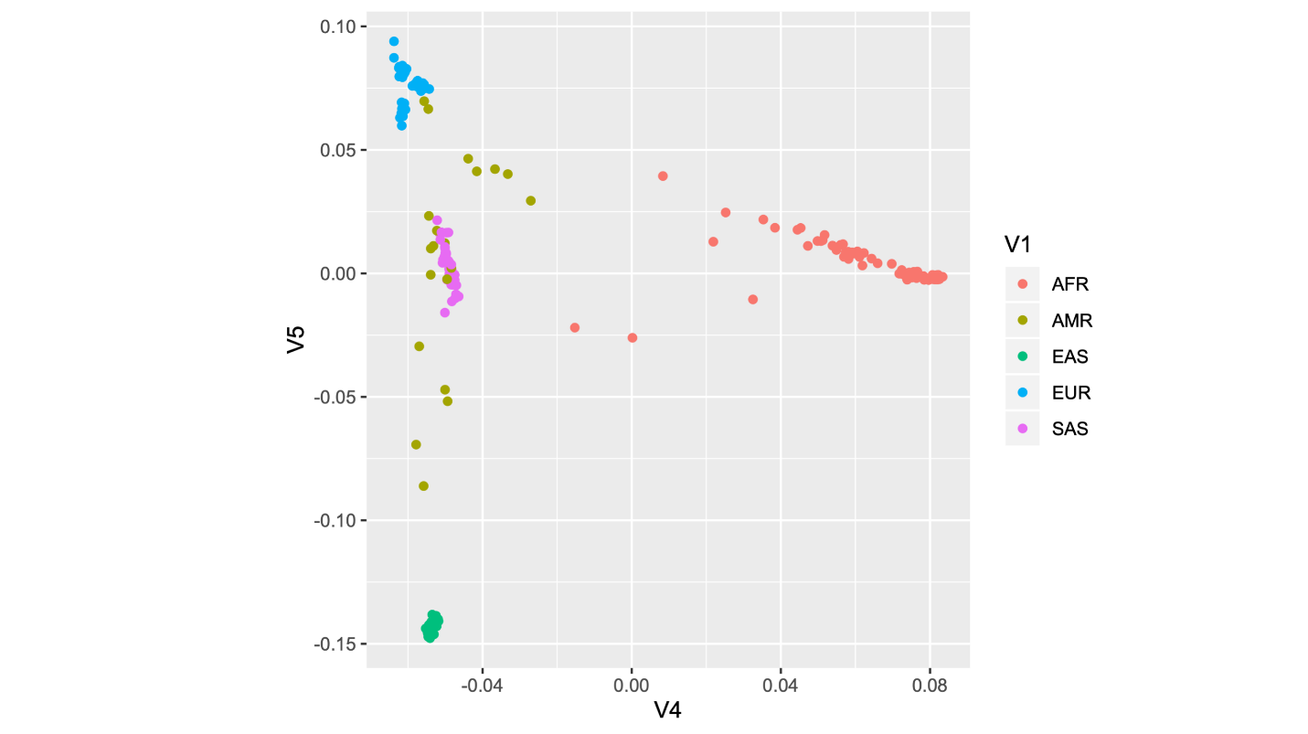

Figure S4. Principal component analysis (PCA) plotting the first two principle components generated using PLINK for 258 1000 Genomes Phase 3 genotype data using autosomal GSA assay loci.

PCA analysis testing – randomization experiment
To detect subtle systematic biases in GSA datasets, we randomly sub-sampled both the genomic loci (rows) and samples (columns) from Dataset 2. We synthetically created matrices with the following dimensions (rows x columns): (a) 10,000 x 500 (b) 10,000 x 900 (c) 600,000 x 900. Each matrix of a particular dimension was created independently three times, and PCA analysis was performed to check for deviation from the expected population structure observed in the 1KG.

Results
We analyzed the 1KG data by performing PCA on 2,504 individuals’ genotype data. These analyses were done on genotypes from all 1KG data, chromosome 1KG data, and 1KG data intersecting with GSA loci (all genotyped loci, chromosome 20, and GSA-specific loci). The super-population structure was reproducible and consistent across all three analyses of the 1KG and detected genotype differences between XX (females) and XY (males). We observed that 586,043 loci were sufficient to distinguish the 5 known major super-population groups. We considered these results to be our positive control for subsequent test analyses with GSA genotype data (Figure S5). To test the hypothesis that population structure would be reproducible if no other major variables distorted the expected structure, we applied PCA to the GSA data. Restricting GSA loci to autosomes (removal of sex chromosome and mitochondrial loci), our results were identical to those observed with the 1000 Genome Phase 3 genotype data (Figure S5). To validate this observation and ensure the absence of hidden, unobserved global variates, we performed a random sub-sampling experiment involving both genomic loci and samples (Figure S6). The results were consistently and reproducibly comparable to the positive control dataset and autosomal GSA datasets (Figure S7); this confirmed minimal technical artifacts in the GSA dataset.

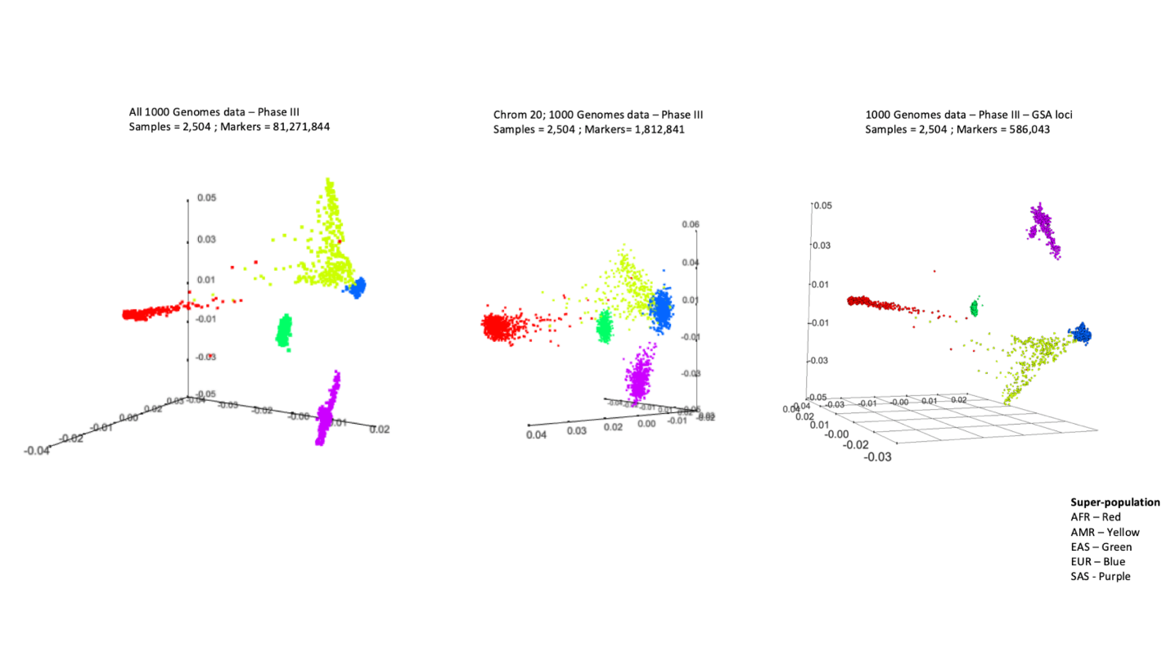
Figure S5. Principal component analysis (PCA) plotting the first three principal components and color coded by the five major super-population groups. Left panel plots the first 3 principal components for all 2,504 samples and all 1000 Genomes Phase 3 genotype data. Middle panel plots the first 3 principal components of chromosome 20 genotype data from 1000 Genomes Phase 3 for all 2,504 samples. Right panel plots the first 3 principal components of GSA assay loci genotype data from 1000 Genomes Phase 3 for all 2,504 samples.
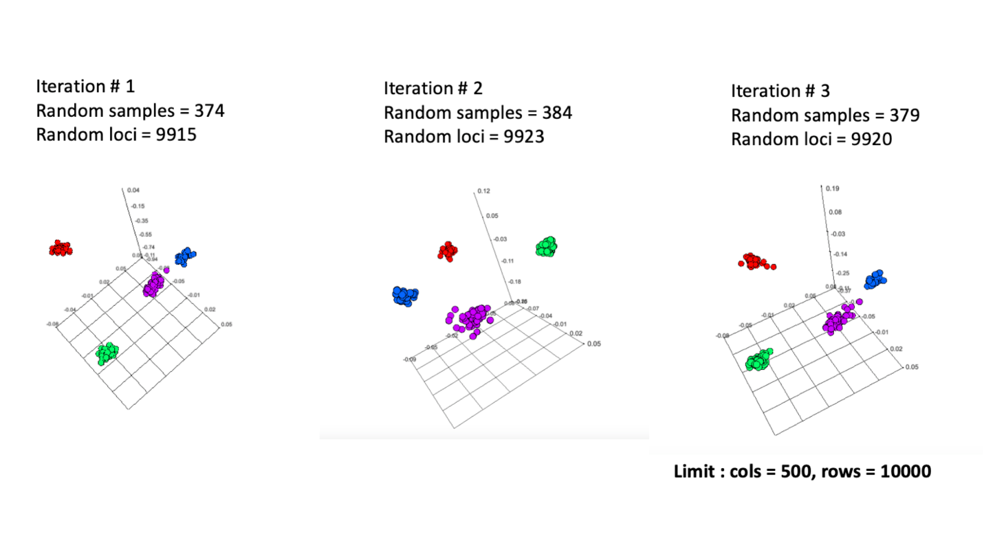
Figure S6. Principal component analysis (PCA) plotting the first three principal components of three random iterations of randomly selected samples and GSA loci with data from 1000 Genomes Phase 3 genotype data to show recapitulation of overall super-population grouping across iterations.

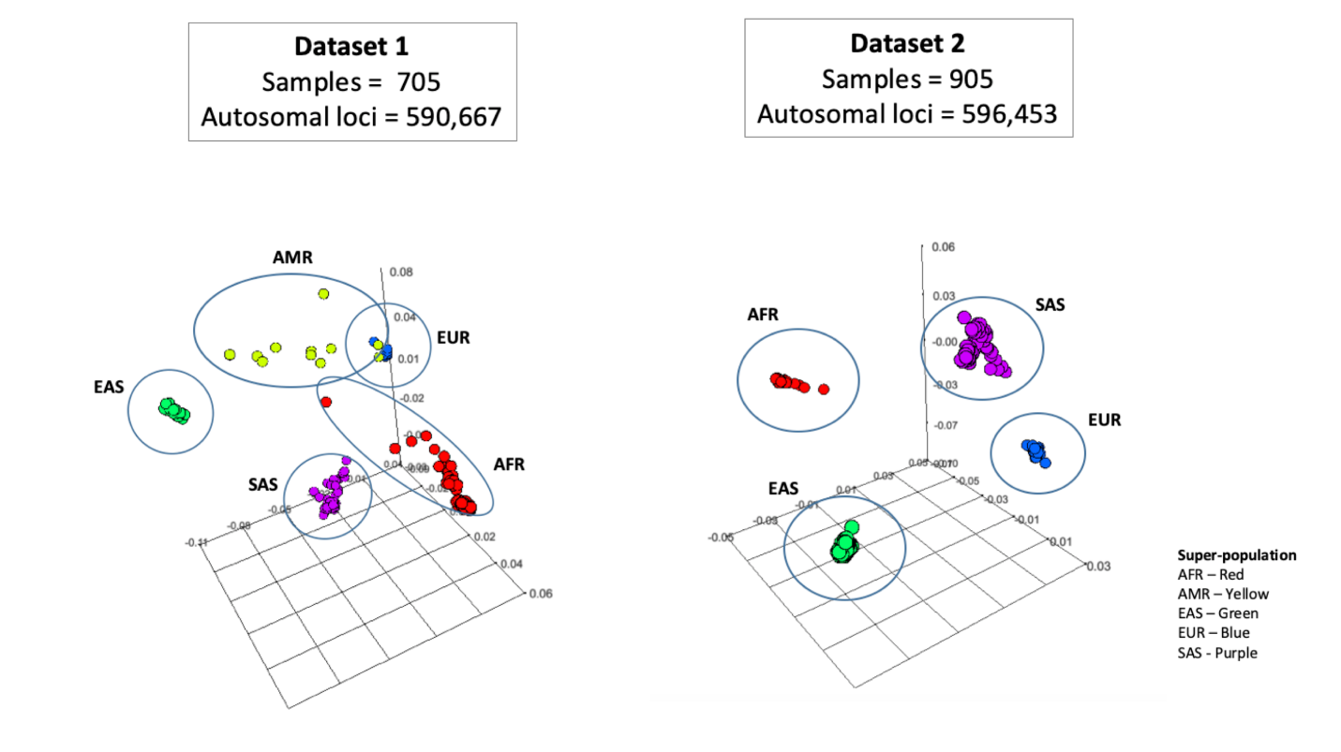
Figure S7. Principal component analysis (PCA) plotting the first three principal components of two GSA sample datasets – dataset 1 (n=705; left panel) and dataset 2 (n=905; right panel) using autosomal GSA loci; super-populations are grouped and color-coded.

R code
Code based on https://bwlewis.github.io/1000_genomes_examples/PCA.html
library(Matrix)
library(irlba)
library(threejs)

p = pipe("zcat /Users/703398698/Documents/Projects/GSA_Freq_validation/popln/mergedFile_batch1_genoCallRate_gt98_callRate_gt9975_mod.autosomes.VCF.Z | sed /^#/d | cut -f '10-' | /Users/703398698/Documents/Projects/GSA_Freq_validation/popln/parse_gsa | cut -f '1-2' ")
x = read.table(p, colClasses=c("integer","integer"), fill=TRUE, row.names=NULL)
gsa = sparseMatrix(i=x[,2], j=x[,1], x=1.0)
dim(gsa)
cm = colMeans(gsa)
p = irlba(gsa, nv=3, nu=3, tol=0.1, center=cm)
ids = readLines(pipe("zcat /Users/703398698/Documents/Projects/GSA_Freq_validation/popln/mergedFile_batch1_genoCallRate_gt98_callRate_gt9975_mod.autosomes.VCF.Z | sed -n /^#CHROM/p | tr '\t' '\n' | tail -n +10"))
ped = read.table(url("ftp://ftp.1000genomes.ebi.ac.uk/vol1/ftp/technical/working/20130606_sample_info/20130606_g1k.ped"),sep="\t",header=TRUE,row.names=2)[ids,6,drop=FALSE]
pop = read.table("ftp://ftp.1000genomes.ebi.ac.uk/vol1/ftp/phase3/20131219.populations.tsv",sep="\t",header=TRUE)
pop = pop[1:26,]
super = pop[,3]
names(super) = pop[,2]
super = factor(super)
ped$Superpopulation = super[as.character(ped$Population)]
N = length(levels(super))
scatterplot3js(p$u, col=rainbow(N)[ped$Superpopulation], size=0.5)
library(Matrix)
library(irlba)
library(threejs)

p = pipe("zcat /Users/703398698/Documents/Projects/GSA_Freq_validation/popln/mergedFile_batch2_mod_genoCallRate_gt98_callRate_gt9975_subNoCallwithRef.autosomes.VCF.Z | sed /^#/d | cut -f '10-' | /Users/703398698/Documents/Projects/GSA_Freq_validation/popln/parse_gsa | cut -f '1-2' ")

x = read.table(p, colClasses=c("integer","integer"), fill=TRUE, row.names=NULL)
gsa = sparseMatrix(i=x[,2], j=x[,1], x=1.0)
dim(gsa)
cm = colMeans(gsa)
p = irlba(gsa, nv=3, nu=3, tol=0.1, center=cm)

ids = readLines(pipe("zcat /Users/703398698/Documents/Projects/GSA_Freq_validation/popln/mergedFile_batch2_mod_genoCallRate_gt98_callRate_gt9975_subNoCallwithRef.autosomes.VCF.Z | sed -n /^#CHROM/p | tr '\t' '\n' | tail -n +10"))
ped = read.table(url("ftp://ftp.1000genomes.ebi.ac.uk/vol1/ftp/technical/working/20130606_sample_info/20130606_g1k.ped"),sep="\t",header=TRUE,row.names=2)[ids,6,drop=FALSE]
pop = read.table("ftp://ftp.1000genomes.ebi.ac.uk/vol1/ftp/phase3/20131219.populations.tsv",sep="\t",header=TRUE)
pop = pop[1:26,]
super = pop[,3]
names(super) = pop[,2]
super = factor(super)
ped$Superpopulation = super[as.character(ped$Population)]
N = length(levels(super))
scatterplot3js(p$u, col=rainbow(N)[ped$Superpopulation], size=0.5)

p = pipe("zcat /Users/703398698/Desktop/GSA/pca/gsa_b1_out_mod_auto.VCF.Z | sed /^#/d | cut -f '10-' | /Users/703398698/Documents/Projects/GSA_Freq_validation/popln/parse_gsa | cut -f '1-2' ")
x = read.table(p, colClasses=c("integer","integer"), fill=TRUE, row.names=NULL)
gsa = sparseMatrix(i=x[,2], j=x[,1], x=1.0)
dim(gsa)
cm = colMeans(gsa)
p = irlba(gsa, nv=3, nu=3, tol=0.1, center=cm)
ids = readLines(pipe("zcat /Users/703398698/Desktop/GSA/pca/gsa_b1_out_mod_auto.VCF.Z | sed -n /^#CHROM/p | tr '\t' '\n' | tail -n +10"))
ped = read.table(url("ftp://ftp.1000genomes.ebi.ac.uk/vol1/ftp/technical/working/20130606_sample_info/20130606_g1k.ped"),sep="\t",header=TRUE,row.names=2)[ids,6,drop=FALSE]
pop = read.table("ftp://ftp.1000genomes.ebi.ac.uk/vol1/ftp/phase3/20131219.populations.tsv",sep="\t",header=TRUE)
pop = pop[1:26,]
super = pop[,3]
names(super) = pop[,2]
super = factor(super)
ped$Superpopulation = super[as.character(ped$Population)]
N = length(levels(super))
scatterplot3js(p$u, col=rainbow(N)[ped$Superpopulation], size=0.5)

p = pipe("zcat /Users/703398698/Desktop/GSA/pca/gsa_b2_out_mod_auto.VCF.Z | sed /^#/d | cut -f '10-' | /Users/703398698/Documents/Projects/GSA_Freq_validation/popln/parse_gsa | cut -f '1-2' ")
x = read.table(p, colClasses=c("integer","integer"), fill=TRUE, row.names=NULL)
gsa = sparseMatrix(i=x[,2], j=x[,1], x=1.0)
dim(gsa)
cm = colMeans(gsa)
p = irlba(gsa, nv=3, nu=3, tol=0.1, center=cm)
ids = readLines(pipe("zcat /Users/703398698/Desktop/GSA/pca/gsa_b2_out_mod_auto.VCF.Z | sed -n /^#CHROM/p | tr '\t' '\n' | tail -n +10"))
ped = read.table(url("ftp://ftp.1000genomes.ebi.ac.uk/vol1/ftp/technical/working/20130606_sample_info/20130606_g1k.ped"),sep="\t",header=TRUE,row.names=2)[ids,6,drop=FALSE]
pop = read.table("ftp://ftp.1000genomes.ebi.ac.uk/vol1/ftp/phase3/20131219.populations.tsv",sep="\t",header=TRUE)
pop = pop[1:26,]
super = pop[,3]
names(super) = pop[,2]
super = factor(super)
ped$Superpopulation = super[as.character(ped$Population)]
N = length(levels(super))
scatterplot3js(p$u, col=rainbow(N)[ped$Superpopulation], size=0.5)

Sample DNA contamination estimation and detection
The GSA measures the relative intensity of fluorescently labeled probes associated with A and B alleles. After normalizing the intensities, the Illumina software assigns a genotype for each genomic locus assayed as AA (homozygous A, B-allele frequency (BAF) =~ 0; absence of B allele), or AB (heterozygous, BAF =~ 0.5; 50% B allele), or BB (homozygous B, BAF =~ 1; 100% B-allele). A missing genotype is assigned in positions with intensities outside the expected clusters. In addition, the output also contains the estimated abundance of the B allele called the B allele frequency (BAF) and the log-likelihood ratio (LLR) of observed signal intensity at a given locus relative to expected signal intensity.

Regression-based method to detect sample contamination
The regression-based method detects contamination by identifying shifts in signal between the expected and the B allele frequency in sites called as homozygous*. Consider a sample with the AA genotype at a particular genomic location whose DNA sample is contaminated. As the population frequency of the minor allele (B allele) increases, the sample is increasingly likely to be contaminated with the B allele (7). In absence of sample contamination, we expect BAF values close to 0, 0.5, and 1 for genotypes AA, AB and BB, respectively; however, in presence of contamination, the expected BAF scales with the level of contamination.

$$E\left[ BAF \right| g=AA; ∝, p_{B}]= ∝p_{B}$$
and, $E\left[ BAF \right| g=BB; ∝, p_{A}]= 1 - ∝p_{A}$

where $p_{A}$ and $p_{B}$ are the population frequencies of A and B, $∝$ is the contamination level (fraction; range 0 - 1).

This gives a linear regression model for BAF
$$BAF= γ+ αp+τI\left(g=AA\right)+ε$$

Where $γ$ is the intercept, $p=\left\{\begin{aligned}p_{B}, if g=AA \\ {-p}_{A}, if g=BB\end{aligned}\right.$ , $τ$ is the difference between expected BAF for AA and BB genotypes, and $ε$ is the normally distributed error term. The test for contamination can be evaluated by testing the null hypothesis that $α$=0 against the one-sided alternative that $α>0$.

In addition to using publicly available databases that record population frequency of the A and B alleles, allele frequencies can also be estimated from the Illumina genotyping cluster file that we generated from the 1,104 samples from diverse population groups. Using the cluster file, we estimated the minor allele frequency (MAF) $f$

$$f=\frac{\left(2*mC\right)+hC}{(2*T)}$$

Where $mC$ is the minor allele genotype count, $hC$ is the heterozygous genotype count, and $T$ is the total count of all genotypes at a particular genotyping locus. Following this derivation of the MAF and given the minor allele frequency and given that the genotype is AA, it is feasible (i) to calculate the probability that B is the minor allele and (ii) to compute the expected BAF.

$$\operatorname{Pr}\left(B is minor allele \right|g=AA and f)= \frac{Pr⁡(B is minor allele, g=AA and f)}{\operatorname{Pr}\left(B is minor allele, g=AA and f\right)+Pr⁡(A is minor allele, g=AA and f)}$$

$$\operatorname{Pr}\left(B is minor allele \right|g=AA and f)=\frac{{(1-f)}^{2}}{{(1-f)}^{2}+f^{2}}$$

$$E\left[BAF\right|g=AA; α, f]=α\frac{f(1-f)}{{(1-f)}^{2}+f^{2}}$$

where $α$ is level of contamination. The linear regression model can be updated to:

$$BAF= γ+ αf+τI\left(g=AA\right)+ε$$

Jun, G et. al. show that the linear regression model to calculate BAF using minor allele frequency is identical to population frequency-based computation; therefore, this method allows detection of contamination using genotypes encoded either as AA, AB or BB, and removes the necessity to decode the A and B alleles to their respective reference genome nucleotides (A, C, G, or T). This method also allows for implementation of sample contamination detection in early stages of data analysis and serves as a sample contamination detection quality control step. Using linear regression analysis of known and predicted DNA contamination, we generated a standard curve for a continuum of contamination between DNA samples from genetically unrelated individuals and between DNA samples from genetically related individuals (Figure S8). Additionally, we evaluated the relationship between sample contamination and GSA call-rate and heterozygous to homozygous call ratio (Figure S9).
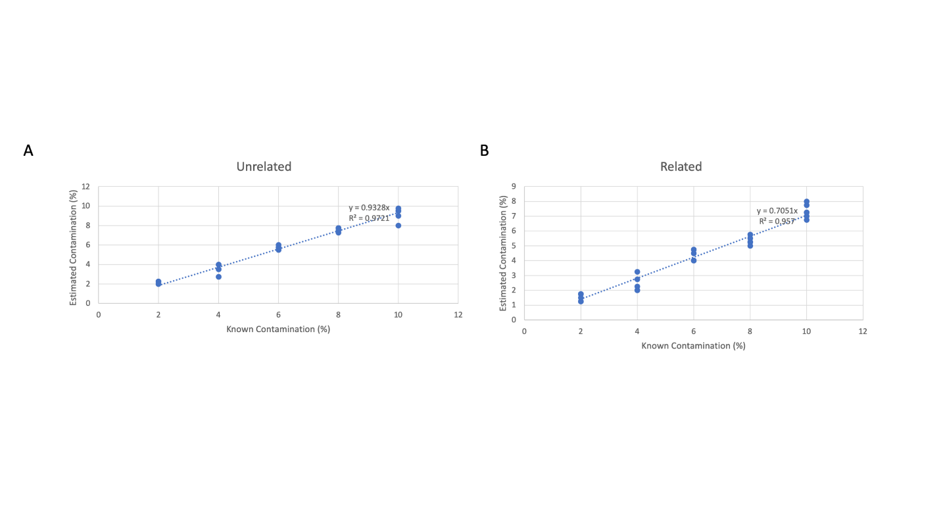
Figure S8. Standard linear regression analysis of estimated sample contamination (%) as a function of known sample contamination (%). Each known level of sample contamination (2% - 10%) data was generated in triplicate. (A) Estimation of sample contamination under the assumption that primary sample DNA and contaminant sample DNA are from unrelated individuals. (B) Estimation of sample contamination under the assumption that primary sample DNA and contaminant sample DNA are from related individuals.
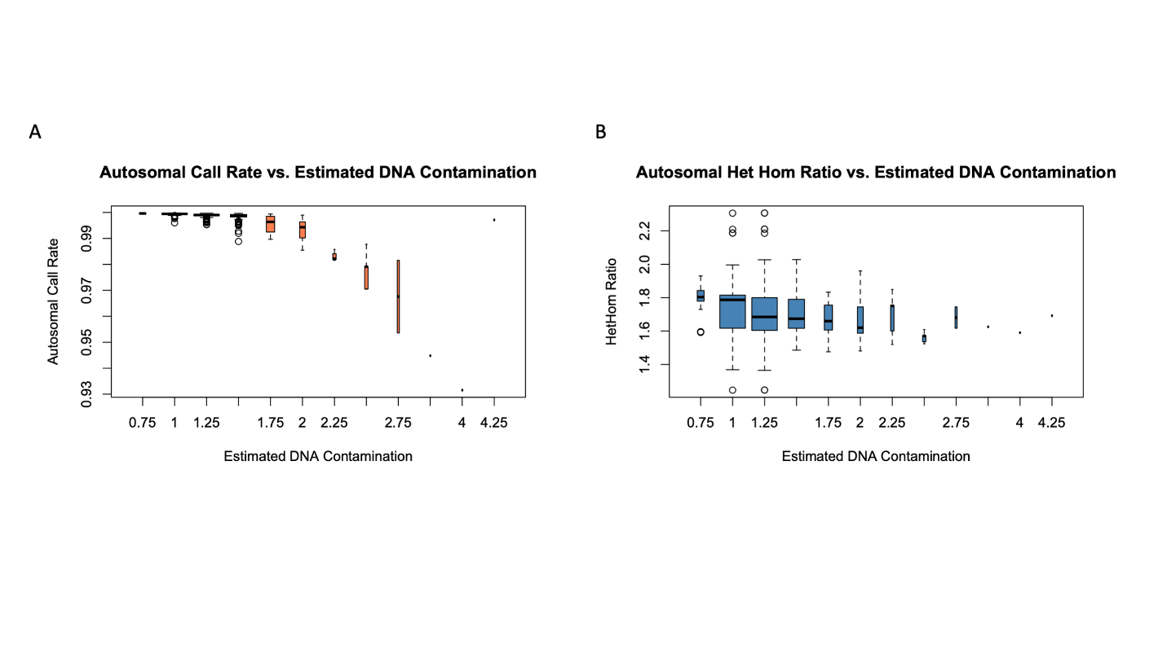
Figure S9. A box-plot analysis and comparison of autosomal call rate (panel A) and heterozygous calls / homozygous calls ratio (panel B) to estimated DNA sample contamination.

GSA quality control analyses
The quality control (QC) for the GSA was performed at multiple levels including (a) the BeadChip Array, (b) sample replicate, and (c) the VCF statistics.

Quality control for BeadChip Array
The QC for GSA data at the level of BeadChip was evaluated for (a) call rate, (b) p10GC, and (c) sample contamination. Each BeadChip was analyzed and the data was plotted using the R-code (below) to detect outlier samples (Figure S10).
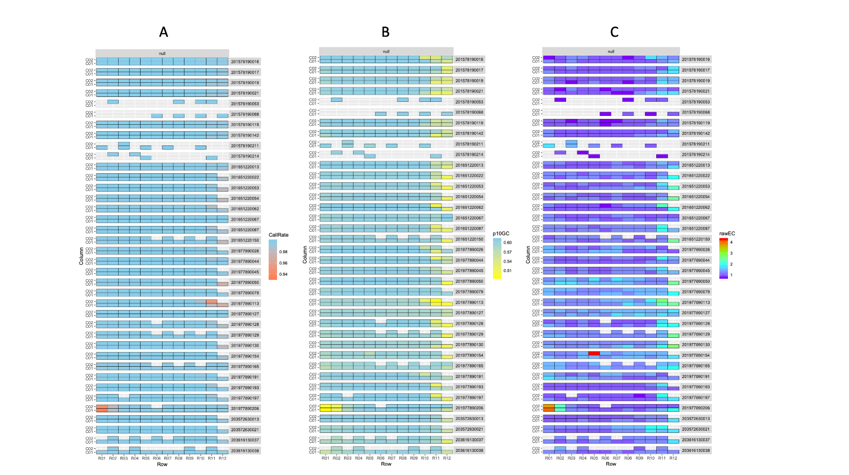
Figure S10. Heatmaps of BeadChip array quality control analysis of call-rate (left), p10GC (middle), and estimated DNA contamination (right). The color gradient scales for the three panels are as follows: call-rate (orange < 0.94 – blue > 0.99), p10GC (yellow < 0.50 – blue > 0.60) and estimated DNA contamination (rainbow gradient: purple ~ 1%, blue ~ 2%, green ~3%, orange / red ~ > 4%).

df<-read.table("/Users/703398698/Documents/Projects/GSA_replicates/GSA_WGS_263/dataset_263_master_QC.csv", sep="," , header=T)
ggplot(df, aes(Row, Column, fill=CallRate)) + geom_tile(colour="black") + facet_grid(BeadChip~Group) + scale_fill_gradient(low="coral", high="skyblue") + theme(strip.text.y=element_text(angle=360))

df<-read.table("/Users/703398698/Documents/Projects/GSA_replicates/GSA_WGS_263/dataset_263_master_QC.csv", sep="," , header=T)
ggplot(df, aes(Row, Column, fill=CallRate)) + geom_tile(colour="black") + facet_grid(BeadChip~Group) + scale_fill_gradient(low="yellow", high="skyblue") + theme(strip.text.y=element_text(angle=360))

df<-read.table("/Users/703398698/Documents/Projects/GSA_replicates/GSA_WGS_263/dataset_263_master_QC.csv", sep="," , header=T)
ggplot(df, aes(Row, Column, fill=rawEC)) + geom_tile(colour="black") + facet_grid(BeadChip~Group) + scale_fill_gradient(colours=rev(rainbow(4))) + theme(strip.text.y=element_text(angle=360))

Quality control for GSA triplicate samples
The QC for GSA triplicate samples were evaluated in tandem as R1, R2, and R3, respectively, across the quality control metrics of (a) call rate, (b) p10GC, (c) sample contamination, (d) no genotype calls, and (e) heterozygous genotype / homozygous genotype ratio (Figure S11). Additionally, replicate sample outliers were detected by applying a Z-score method to call rate data (Figure S12). The R-code used to generate these plots is shown below:
ds <- read.table("/Users/703398698/Desktop/GSA/Supplementary_Data/triplicate_VCF/merged_genomeStudio_VCFStats.csv", sep=",", header=T)

ggplot(ds, aes(Dataset, Sample, fill=withGenotypes/TotalGSAAssays)) + geom_tile(color="gray")+scale_fill_gradient(low="coral", high="skyblue") + labs(title="Call Rate \n", fill="Call Rate\n") + theme(axis.text.y=element_text(size=3))

ggplot(ds, aes(Dataset, Sample, fill=withGenotypes/TotalGSAAssays)) + geom_tile(color="gray")+scale_fill_gradientn(colours=rainbow(4))+ labs(title="Call Rate \n", fill="Call Rate\n") + theme(axis.text.y=element_text(size=3))

ggplot(ds, aes(Dataset, Sample, fill=p10GC)) + geom_tile(color="gray")+scale_fill_gradientn(colours=rainbow(4)) + labs(title="p10GC \n", fill="p10GC\n") + theme(axis.text.y=element_text(size=3))

ggplot(ds, aes(Dataset, Sample, fill=rawEC)) + geom_tile(color="gray")+scale_fill_gradientn(colours=rev(rainbow(4))) + labs(title="Estimated DNA Contamination \n", fill="Est Contam\n") + theme(axis.text.y=element_text(size=3))

ggplot(ds, aes(Dataset, Sample, fill=NoGenotypes)) + geom_tile(color="gray")+scale_fill_gradient(low="skyblue", high="coral") + labs(title="No Genotype Calls \n", fill="No Genotype Calls\n") + theme(axis.text.y=element_text(size=3))

ggplot(ds, aes(Dataset, Sample, fill=auto_het_SNV/auto_homalt_SNV)) + geom_tile(color="gray")+scale_fill_gradientn(colours=rainbow(4)) + labs(title="Het / Hom Ratio\n", fill="Het / Hom Ratio\n") + theme(axis.text.y=element_text(size=3))

tmp<-cbind(df,'Z_score'=(df$Autosome_data-599557)/sqrt(var(df$Autosome_data)))
plot(tmp$Z_score, pch=16, cex=1, col="steelblue", ylab="Z-Score")
abline(h=-4, lty=2)
abline(h=-2, lty=2)
abline(h=0, lty=1, col="red")

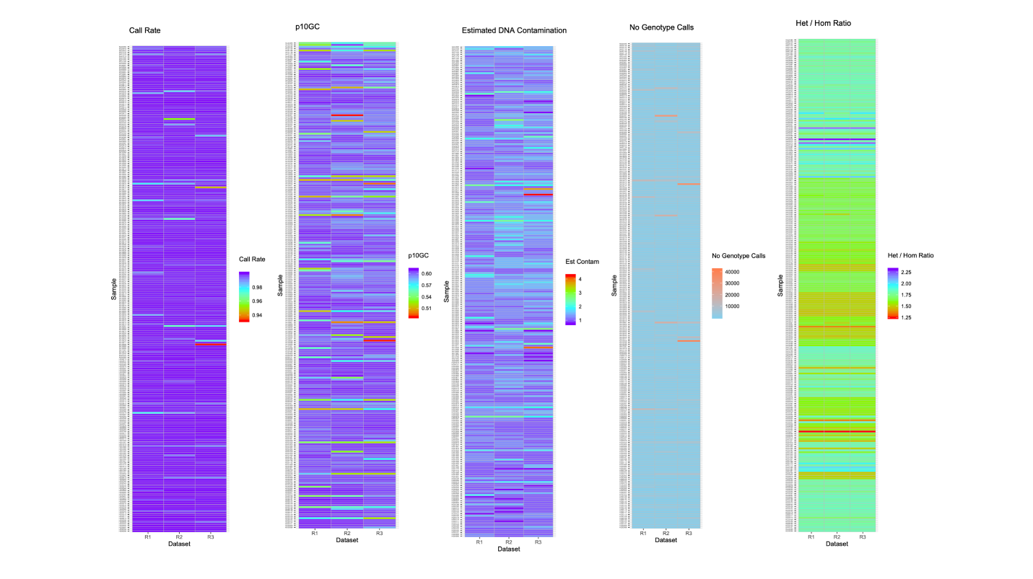

Figure S11. Heatmaps of reproducibility quality control analysis using replicate data as measured by call rate, p10GC, estimated DNA contamination, number of assays with no genotype calls, and heterozygote to homozygote ratio. The color gradient scales for these five heatmaps are as follows: rainbow gradient for call rate (purple > 0.99 – red < 0.94), rainbow gradient for p10GC (purple >0.60 – red < 0.5), estimated DNA contamination (purple < 1% – red > 4%), no genotype calls (blue < 166,000 – orange > 400,000), and heterozygote / homozygote ratio (purple > 2.25 – red < 1.25) respectively.
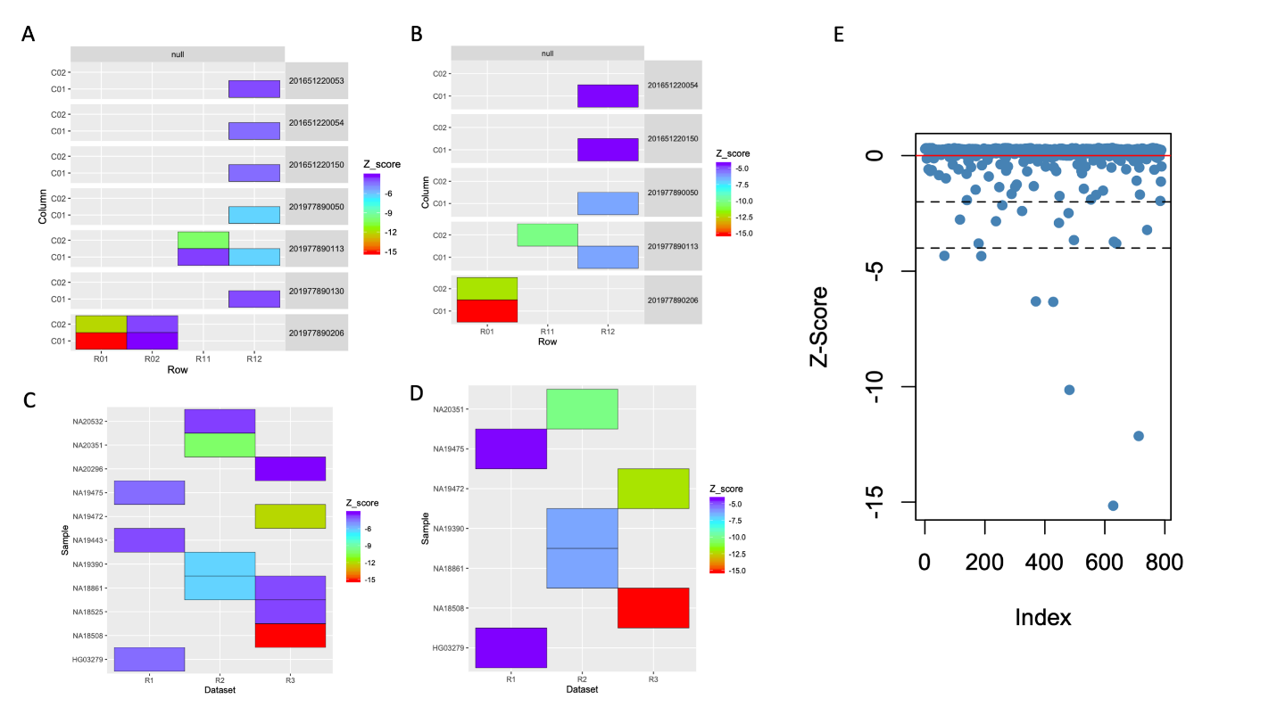
Figure S12. Quality control of GSA data by detecting triplicate samples with outlier call rates. Panels A and B: The outlier call rate detected along the edges of BeadChip array (rows 11 and 12); rows 01 and 02 samples were detected as samples with DNA contamination. Panel A uses a stringent Z-score threshold (< -3), whereas panel B uses a lenient Z-score threshold (< -4). Panels C and D show outlier detection across the three replicates; they parallel Panels A and B. Panel E plots Z-scores as a function of GSA triplicate sample data index. The dashed-lines depict lenient (<-4) and stringent (< -3) thresholds.

Quality control of GSA triplicate VCF files
We evaluated 236 samples’ triplicate VCF files for quality. Summary statistics for each replicate VCF file were generated using rtg (a program for VCF statistics) and plotted relative to each other to detect correlation (Figure S13). It was run as follows: rtg VCFstats [sampleid_replicate#.vcf.gz]. The summary of this analysis is the file GSA_236_triplicates_VCFSummary.xls.
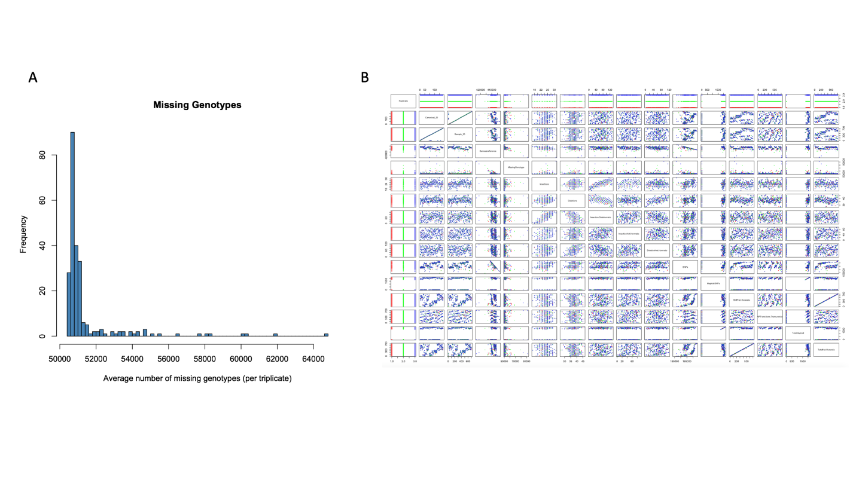
Figure S13. Quality control analysis of GSA call rate and GSA VCF statistics. (A) A histogram of the number of missing genotypes per sample for all GSA triplicate data. (B) All-vs-all scatter-plot analysis of GSA VCF statistics for all triplicate data.

Transitions and transversions
The GSA SNV assays were stratified by the type of nucleotide change, i.e., transition (purine to purine and pyrimidine to pyrimidine) or transversion (purine to pyrimidines and vice versa). Transversions performed poorer than transitions across the performance metrics of sensitivity, specificity, PPV, and concordance (Figure S14 A). Performance metrics of low-complexity regions are shown in Figure S14 B.
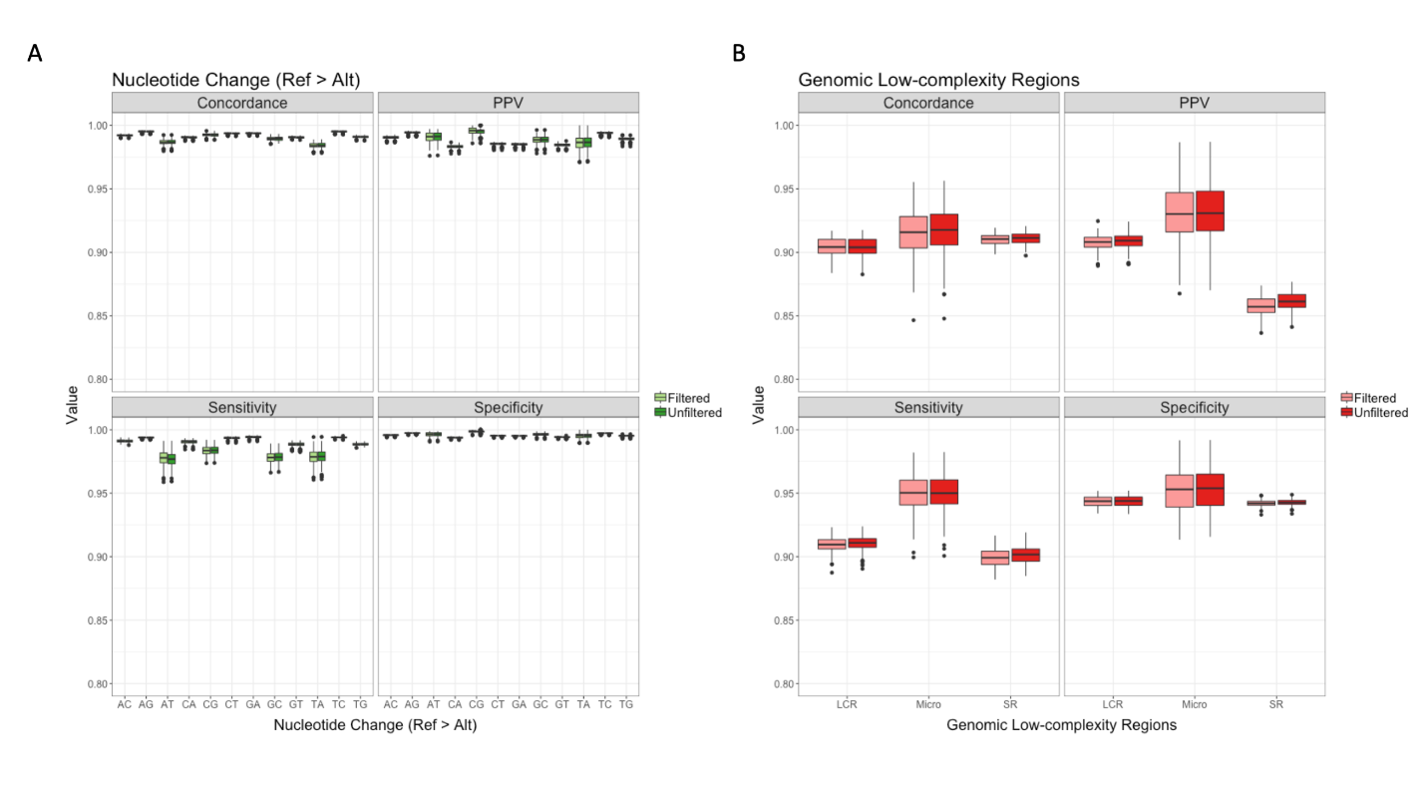
Figure S14. A box-plot analysis of performance metrics of GSA vs 1KG benchmark dataset when assays are classified according to (A) type of single-nucleotide change (transition (TNS), transversion (TVS)). All 12 possible nucleotide changes are shown along the x-axis. The first nucleotide is the reference allele, and the second nucleotide is the variant allele. Data filtered and samples removed for low-quality are shown in light green. (B) Interrogation of a low-complexity genomic regions. The data filtered and samples removed for low-quality are shown in light red.

Transitions and transversions with special focus on complementary transversions
Transitions interchange bases of similar shape, whereas transversions interchange bases of differing structure, i.e., one-ring pyrimidines (C, T) for two-ring purines (A, G) or vice versa (Figure S17). Given 4 nucleotide bases (A,C,G,T), there are a total of 16 possible interchanges (4x4). 8 transitions and 8 transversions. However, 4 “transitions” of the 8 possible transitions are unobserved due to self-interchange (e.g., A>A). This leaves 12 total interchanges: 4 transitions and 8 transversions (Figure S15). The 4 possible transitions are: A>G, G>A, C>T, and T>C. The 8 possible transversions are: A>C, C>A, A>T, T>A, C>G, G>C, G>T, T>G. Of the 8 possible transversions, half (4) are changes between complementary nucleotides (e.g., A>T) (Figure S15).
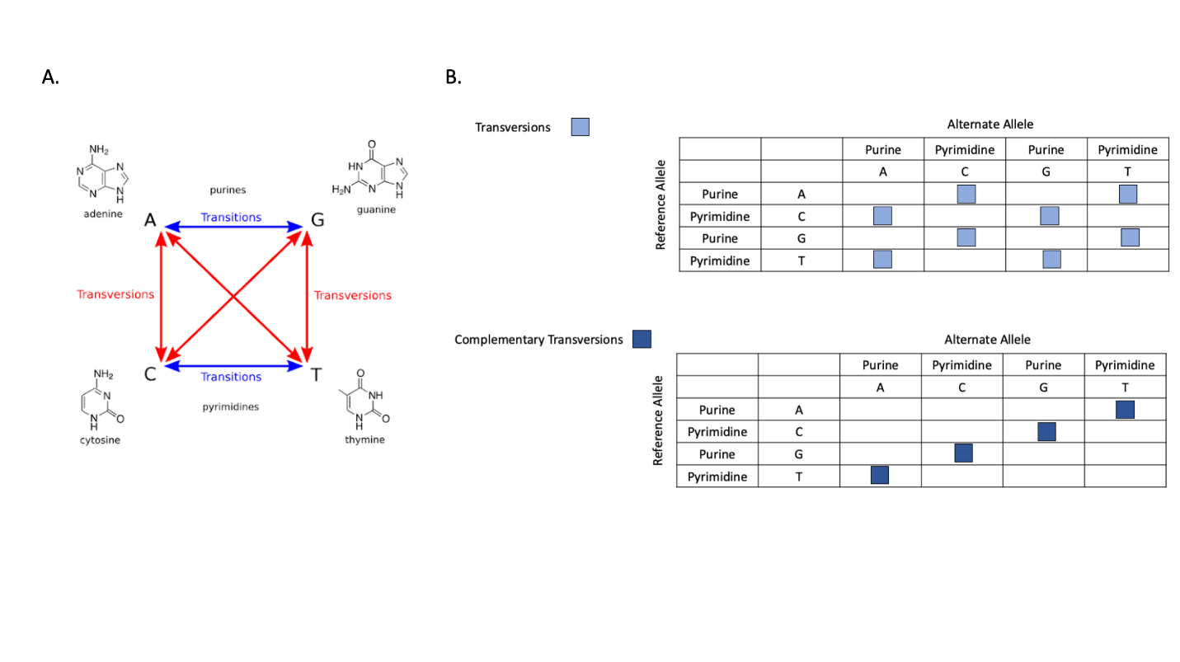
Figure S15. A schematic diagram showing the 12 possible transitions and transversions. (A) A schematic illustration of nucleotide substitutions leading to transitions (blue arrows) and transversions (red arrows). (B) Tabulated representation of all transversions (8) (top table) and complementary transversions (4) (bottom table). All transversions are shown as light blue squares in the top table, whereas complementary transversions are shown as dark blue squares in the bottom table.

Data submitted to NCBI
BioProject (PRJNA792997) was created at the National Center for Biotechnology Information (NCBI) for our study data. A total of 262 BioSample accession identifiers were created (Table S8) (Individual NA17281 did not consent to making genetic data publicly available and no data were submitted for this sample). The BAM files were submitted to the NCBI Sequence Read Archive (SRA) database via AWS S3 bucket and variation data for GSA and WGS were submitted to the NCBI dbSNP database (SFTP server).

Data were submitted to dbSNP database and will be publicly available when next dbSNP build (B156) is released. Our submitted data are accessible on NCBI FTP server: https://ftp.ncbi.nlm.nih.gov/snp/submission/SANFORD_IMAGENETICS/
Submitted variation data will receive a submitted SNP (ss) number and a reference SNP (rs) number. Variation that are assigned rs numbers are distributed as part of dbSNP once data are processed and released in the next build. Variation detected by GSA genotyping of 262 samples and by WGS genotyping of 260 samples were submitted to dbSNP (WGS variation data for HG00111 and HG00257 were not submitted to dbSNP database due to discordance between GSA and WGS data in our analyses).

SRA data are accessible on NCBI SRA database (https://www.ncbi.nlm.nih.gov/sra) via accession PRJNA792997 (261 samples’ submission id: SUB10951790; HG00111 submission id: SUB11086930 (accession id: SRR18019669)). All 262 samples’ BAM files’ sequence data were submitted to NCBI SRA database (Table S9).

Table S8. List of 262 BioSample accessions submitted to NCBI.
Accession | Sample Name | SPUID | Organism | Tax ID | Isolate | BioProject
SAMN24495081 | HG00096 | HG00096 | Homo sapiens | 9606 | HG00096 | PRJNA792997
SAMN24495082 | HG00099 | HG00099 | Homo sapiens | 9606 | HG00099 | PRJNA792997
SAMN24495083 | HG00101 | HG00101 | Homo sapiens | 9606 | HG00101 | PRJNA792997
SAMN24495084 | HG00102 | HG00102 | Homo sapiens | 9606 | HG00102 | PRJNA792997
SAMN24495085 | HG00103 | HG00103 | Homo sapiens | 9606 | HG00103 | PRJNA792997
SAMN24495086 | HG00106 | HG00106 | Homo sapiens | 9606 | HG00106 | PRJNA792997
SAMN24495087 | HG00108 | HG00108 | Homo sapiens | 9606 | HG00108 | PRJNA792997
SAMN24495088 | HG00110 | HG00110 | Homo sapiens | 9606 | HG00110 | PRJNA792997
SAMN24495089 | HG00111 | HG00111 | Homo sapiens | 9606 | HG00111 | PRJNA792997
SAMN24495090 | HG00116 | HG00116 | Homo sapiens | 9606 | HG00116 | PRJNA792997
SAMN24495091 | HG00118 | HG00118 | Homo sapiens | 9606 | HG00118 | PRJNA792997
SAMN24495092 | HG00120 | HG00120 | Homo sapiens | 9606 | HG00120 | PRJNA792997
SAMN24495093 | HG00122 | HG00122 | Homo sapiens | 9606 | HG00122 | PRJNA792997
SAMN24495094 | HG00126 | HG00126 | Homo sapiens | 9606 | HG00126 | PRJNA792997
SAMN24495095 | HG00133 | HG00133 | Homo sapiens | 9606 | HG00133 | PRJNA792997
SAMN24495096 | HG00174 | HG00174 | Homo sapiens | 9606 | HG00174 | PRJNA792997
SAMN24495097 | HG00185 | HG00185 | Homo sapiens | 9606 | HG00185 | PRJNA792997
SAMN24495098 | HG00188 | HG00188 | Homo sapiens | 9606 | HG00188 | PRJNA792997
SAMN24495099 | HG00253 | HG00253 | Homo sapiens | 9606 | HG00253 | PRJNA792997
SAMN24495100 | HG00257 | HG00257 | Homo sapiens | 9606 | HG00257 | PRJNA792997
SAMN24495101 | HG00263 | HG00263 | Homo sapiens | 9606 | HG00263 | PRJNA792997
SAMN24495102 | HG00265 | HG00265 | Homo sapiens | 9606 | HG00265 | PRJNA792997
SAMN24495103 | HG00266 | HG00266 | Homo sapiens | 9606 | HG00266 | PRJNA792997
SAMN24495104 | HG00268 | HG00268 | Homo sapiens | 9606 | HG00268 | PRJNA792997
SAMN24495105 | HG00276 | HG00276 | Homo sapiens | 9606 | HG00276 | PRJNA792997
SAMN24495106 | HG00332 | HG00332 | Homo sapiens | 9606 | HG00332 | PRJNA792997
SAMN24495107 | HG00345 | HG00345 | Homo sapiens | 9606 | HG00345 | PRJNA792997
SAMN24495108 | HG00366 | HG00366 | Homo sapiens | 9606 | HG00366 | PRJNA792997
SAMN24495109 | HG00403 | HG00403 | Homo sapiens | 9606 | HG00403 | PRJNA792997
SAMN24495110 | HG00419 | HG00419 | Homo sapiens | 9606 | HG00419 | PRJNA792997
SAMN24495111 | HG00452 | HG00452 | Homo sapiens | 9606 | HG00452 | PRJNA792997
SAMN24495112 | HG00759 | HG00759 | Homo sapiens | 9606 | HG00759 | PRJNA792997
SAMN24495113 | HG01051 | HG01051 | Homo sapiens | 9606 | HG01051 | PRJNA792997
SAMN24495114 | HG01083 | HG01083 | Homo sapiens | 9606 | HG01083 | PRJNA792997
SAMN24495115 | HG01089 | HG01089 | Homo sapiens | 9606 | HG01089 | PRJNA792997
SAMN24495116 | HG01112 | HG01112 | Homo sapiens | 9606 | HG01112 | PRJNA792997
SAMN24495117 | HG01170 | HG01170 | Homo sapiens | 9606 | HG01170 | PRJNA792997
SAMN24495118 | HG01398 | HG01398 | Homo sapiens | 9606 | HG01398 | PRJNA792997
SAMN24495119 | HG01441 | HG01441 | Homo sapiens | 9606 | HG01441 | PRJNA792997
SAMN24495120 | HG01455 | HG01455 | Homo sapiens | 9606 | HG01455 | PRJNA792997
SAMN24495121 | HG01500 | HG01500 | Homo sapiens | 9606 | HG01500 | PRJNA792997
SAMN24495122 | HG01530 | HG01530 | Homo sapiens | 9606 | HG01530 | PRJNA792997
SAMN24495123 | HG01565 | HG01565 | Homo sapiens | 9606 | HG01565 | PRJNA792997
SAMN24495124 | HG01583 | HG01583 | Homo sapiens | 9606 | HG01583 | PRJNA792997
SAMN24495125 | HG01595 | HG01595 | Homo sapiens | 9606 | HG01595 | PRJNA792997
SAMN24495126 | HG01605 | HG01605 | Homo sapiens | 9606 | HG01605 | PRJNA792997
SAMN24495127 | HG01620 | HG01620 | Homo sapiens | 9606 | HG01620 | PRJNA792997
SAMN24495128 | HG01879 | HG01879 | Homo sapiens | 9606 | HG01879 | PRJNA792997
SAMN24495129 | HG01941 | HG01941 | Homo sapiens | 9606 | HG01941 | PRJNA792997
SAMN24495130 | HG01944 | HG01944 | Homo sapiens | 9606 | HG01944 | PRJNA792997
SAMN24495131 | HG02012 | HG02012 | Homo sapiens | 9606 | HG02012 | PRJNA792997
SAMN24495132 | HG02032 | HG02032 | Homo sapiens | 9606 | HG02032 | PRJNA792997
SAMN24495133 | HG02052 | HG02052 | Homo sapiens | 9606 | HG02052 | PRJNA792997
SAMN24495134 | HG02271 | HG02271 | Homo sapiens | 9606 | HG02271 | PRJNA792997
SAMN24495135 | HG02304 | HG02304 | Homo sapiens | 9606 | HG02304 | PRJNA792997
SAMN24495136 | HG02360 | HG02360 | Homo sapiens | 9606 | HG02360 | PRJNA792997
SAMN24495137 | HG02568 | HG02568 | Homo sapiens | 9606 | HG02568 | PRJNA792997
SAMN24495138 | HG02628 | HG02628 | Homo sapiens | 9606 | HG02628 | PRJNA792997
SAMN24495139 | HG02651 | HG02651 | Homo sapiens | 9606 | HG02651 | PRJNA792997
SAMN24495140 | HG02684 | HG02684 | Homo sapiens | 9606 | HG02684 | PRJNA792997
SAMN24495141 | HG02922 | HG02922 | Homo sapiens | 9606 | HG02922 | PRJNA792997
SAMN24495142 | HG03006 | HG03006 | Homo sapiens | 9606 | HG03006 | PRJNA792997
SAMN24495143 | HG03052 | HG03052 | Homo sapiens | 9606 | HG03052 | PRJNA792997
SAMN24495144 | HG03267 | HG03267 | Homo sapiens | 9606 | HG03267 | PRJNA792997
SAMN24495145 | HG03279 | HG03279 | Homo sapiens | 9606 | HG03279 | PRJNA792997
SAMN24495146 | HG03366 | HG03366 | Homo sapiens | 9606 | HG03366 | PRJNA792997
SAMN24495147 | HG03369 | HG03369 | Homo sapiens | 9606 | HG03369 | PRJNA792997
SAMN24495148 | HG03401 | HG03401 | Homo sapiens | 9606 | HG03401 | PRJNA792997
SAMN24495149 | HG03464 | HG03464 | Homo sapiens | 9606 | HG03464 | PRJNA792997
SAMN24495150 | HG03472 | HG03472 | Homo sapiens | 9606 | HG03472 | PRJNA792997
SAMN24495151 | HG03514 | HG03514 | Homo sapiens | 9606 | HG03514 | PRJNA792997
SAMN24495152 | HG03575 | HG03575 | Homo sapiens | 9606 | HG03575 | PRJNA792997
SAMN24495153 | HG03642 | HG03642 | Homo sapiens | 9606 | HG03642 | PRJNA792997
SAMN24495154 | HG03681 | HG03681 | Homo sapiens | 9606 | HG03681 | PRJNA792997
SAMN24495155 | HG03685 | HG03685 | Homo sapiens | 9606 | HG03685 | PRJNA792997
SAMN24495156 | HG03686 | HG03686 | Homo sapiens | 9606 | HG03686 | PRJNA792997
SAMN24495157 | HG03687 | HG03687 | Homo sapiens | 9606 | HG03687 | PRJNA792997
SAMN24495158 | HG03694 | HG03694 | Homo sapiens | 9606 | HG03694 | PRJNA792997
SAMN24495159 | HG03705 | HG03705 | Homo sapiens | 9606 | HG03705 | PRJNA792997
SAMN24495160 | HG03713 | HG03713 | Homo sapiens | 9606 | HG03713 | PRJNA792997
SAMN24495161 | HG03742 | HG03742 | Homo sapiens | 9606 | HG03742 | PRJNA792997
SAMN24495162 | HG03788 | HG03788 | Homo sapiens | 9606 | HG03788 | PRJNA792997
SAMN24495163 | HG03790 | HG03790 | Homo sapiens | 9606 | HG03790 | PRJNA792997
SAMN24495164 | HG03848 | HG03848 | Homo sapiens | 9606 | HG03848 | PRJNA792997
SAMN24495165 | HG03854 | HG03854 | Homo sapiens | 9606 | HG03854 | PRJNA792997
SAMN24495166 | HG03871 | HG03871 | Homo sapiens | 9606 | HG03871 | PRJNA792997
SAMN24495167 | HG03885 | HG03885 | Homo sapiens | 9606 | HG03885 | PRJNA792997
SAMN24495168 | HG03896 | HG03896 | Homo sapiens | 9606 | HG03896 | PRJNA792997
SAMN24495169 | HG03967 | HG03967 | Homo sapiens | 9606 | HG03967 | PRJNA792997
SAMN24495170 | HG03974 | HG03974 | Homo sapiens | 9606 | HG03974 | PRJNA792997
SAMN24495171 | HG04060 | HG04060 | Homo sapiens | 9606 | HG04060 | PRJNA792997
SAMN24495172 | HG04094 | HG04094 | Homo sapiens | 9606 | HG04094 | PRJNA792997
SAMN24495173 | HG04131 | HG04131 | Homo sapiens | 9606 | HG04131 | PRJNA792997
SAMN24495174 | HG04219 | HG04219 | Homo sapiens | 9606 | HG04219 | PRJNA792997
SAMN24495175 | NA06989 | NA06989 | Homo sapiens | 9606 | NA06989 | PRJNA792997
SAMN24495176 | NA07045 | NA07045 | Homo sapiens | 9606 | NA07045 | PRJNA792997
SAMN24495177 | NA12156 | NA12156 | Homo sapiens | 9606 | NA12156 | PRJNA792997
SAMN24495178 | NA12878 | NA12878 | Homo sapiens | 9606 | NA12878 | PRJNA792997
SAMN24495180 | NA18486 | NA18486 | Homo sapiens | 9606 | NA18486 | PRJNA792997
SAMN24495181 | NA18488 | NA18488 | Homo sapiens | 9606 | NA18488 | PRJNA792997
SAMN24495182 | NA18508 | NA18508 | Homo sapiens | 9606 | NA18508 | PRJNA792997
SAMN24495183 | NA18511 | NA18511 | Homo sapiens | 9606 | NA18511 | PRJNA792997
SAMN24495184 | NA18525 | NA18525 | Homo sapiens | 9606 | NA18525 | PRJNA792997
SAMN24495185 | NA18543 | NA18543 | Homo sapiens | 9606 | NA18543 | PRJNA792997
SAMN24495186 | NA18544 | NA18544 | Homo sapiens | 9606 | NA18544 | PRJNA792997
SAMN24495187 | NA18552 | NA18552 | Homo sapiens | 9606 | NA18552 | PRJNA792997
SAMN24495188 | NA18559 | NA18559 | Homo sapiens | 9606 | NA18559 | PRJNA792997
SAMN24495189 | NA18572 | NA18572 | Homo sapiens | 9606 | NA18572 | PRJNA792997
SAMN24495190 | NA18606 | NA18606 | Homo sapiens | 9606 | NA18606 | PRJNA792997
SAMN24495191 | NA18856 | NA18856 | Homo sapiens | 9606 | NA18856 | PRJNA792997
SAMN24495192 | NA18861 | NA18861 | Homo sapiens | 9606 | NA18861 | PRJNA792997
SAMN24495193 | NA18915 | NA18915 | Homo sapiens | 9606 | NA18915 | PRJNA792997
SAMN24495194 | NA18916 | NA18916 | Homo sapiens | 9606 | NA18916 | PRJNA792997
SAMN24495195 | NA18933 | NA18933 | Homo sapiens | 9606 | NA18933 | PRJNA792997
SAMN24495196 | NA18939 | NA18939 | Homo sapiens | 9606 | NA18939 | PRJNA792997
SAMN24495197 | NA18944 | NA18944 | Homo sapiens | 9606 | NA18944 | PRJNA792997
SAMN24495198 | NA18948 | NA18948 | Homo sapiens | 9606 | NA18948 | PRJNA792997
SAMN24495199 | NA18953 | NA18953 | Homo sapiens | 9606 | NA18953 | PRJNA792997
SAMN24495200 | NA18959 | NA18959 | Homo sapiens | 9606 | NA18959 | PRJNA792997
SAMN24495201 | NA18965 | NA18965 | Homo sapiens | 9606 | NA18965 | PRJNA792997
SAMN24495202 | NA18966 | NA18966 | Homo sapiens | 9606 | NA18966 | PRJNA792997
SAMN24495203 | NA18970 | NA18970 | Homo sapiens | 9606 | NA18970 | PRJNA792997
SAMN24495204 | NA18971 | NA18971 | Homo sapiens | 9606 | NA18971 | PRJNA792997
SAMN24495205 | NA18974 | NA18974 | Homo sapiens | 9606 | NA18974 | PRJNA792997
SAMN24495206 | NA18983 | NA18983 | Homo sapiens | 9606 | NA18983 | PRJNA792997
SAMN24495207 | NA18990 | NA18990 | Homo sapiens | 9606 | NA18990 | PRJNA792997
SAMN24495208 | NA18994 | NA18994 | Homo sapiens | 9606 | NA18994 | PRJNA792997
SAMN24495209 | NA19017 | NA19017 | Homo sapiens | 9606 | NA19017 | PRJNA792997
SAMN24495210 | NA19019 | NA19019 | Homo sapiens | 9606 | NA19019 | PRJNA792997
SAMN24495211 | NA19023 | NA19023 | Homo sapiens | 9606 | NA19023 | PRJNA792997
SAMN24495212 | NA19024 | NA19024 | Homo sapiens | 9606 | NA19024 | PRJNA792997
SAMN24495213 | NA19026 | NA19026 | Homo sapiens | 9606 | NA19026 | PRJNA792997
SAMN24495214 | NA19031 | NA19031 | Homo sapiens | 9606 | NA19031 | PRJNA792997
SAMN24495215 | NA19036 | NA19036 | Homo sapiens | 9606 | NA19036 | PRJNA792997
SAMN24495216 | NA19037 | NA19037 | Homo sapiens | 9606 | NA19037 | PRJNA792997
SAMN24495217 | NA19041 | NA19041 | Homo sapiens | 9606 | NA19041 | PRJNA792997
SAMN24495218 | NA19042 | NA19042 | Homo sapiens | 9606 | NA19042 | PRJNA792997
SAMN24495219 | NA19043 | NA19043 | Homo sapiens | 9606 | NA19043 | PRJNA792997
SAMN24495220 | NA19056 | NA19056 | Homo sapiens | 9606 | NA19056 | PRJNA792997
SAMN24495221 | NA19070 | NA19070 | Homo sapiens | 9606 | NA19070 | PRJNA792997
SAMN24495222 | NA19072 | NA19072 | Homo sapiens | 9606 | NA19072 | PRJNA792997
SAMN24495223 | NA19076 | NA19076 | Homo sapiens | 9606 | NA19076 | PRJNA792997
SAMN24495224 | NA19102 | NA19102 | Homo sapiens | 9606 | NA19102 | PRJNA792997
SAMN24495225 | NA19119 | NA19119 | Homo sapiens | 9606 | NA19119 | PRJNA792997
SAMN24495226 | NA19130 | NA19130 | Homo sapiens | 9606 | NA19130 | PRJNA792997
SAMN24495227 | NA19131 | NA19131 | Homo sapiens | 9606 | NA19131 | PRJNA792997
SAMN24495228 | NA19147 | NA19147 | Homo sapiens | 9606 | NA19147 | PRJNA792997
SAMN24495229 | NA19159 | NA19159 | Homo sapiens | 9606 | NA19159 | PRJNA792997
SAMN24495230 | NA19160 | NA19160 | Homo sapiens | 9606 | NA19160 | PRJNA792997
SAMN24495231 | NA19189 | NA19189 | Homo sapiens | 9606 | NA19189 | PRJNA792997
SAMN24495232 | NA19209 | NA19209 | Homo sapiens | 9606 | NA19209 | PRJNA792997
SAMN24495233 | NA19238 | NA19238 | Homo sapiens | 9606 | NA19238 | PRJNA792997
SAMN24495234 | NA19239 | NA19239 | Homo sapiens | 9606 | NA19239 | PRJNA792997
SAMN24495235 | NA19248 | NA19248 | Homo sapiens | 9606 | NA19248 | PRJNA792997
SAMN24495236 | NA19308 | NA19308 | Homo sapiens | 9606 | NA19308 | PRJNA792997
SAMN24495237 | NA19314 | NA19314 | Homo sapiens | 9606 | NA19314 | PRJNA792997
SAMN24495238 | NA19319 | NA19319 | Homo sapiens | 9606 | NA19319 | PRJNA792997
SAMN24495239 | NA19320 | NA19320 | Homo sapiens | 9606 | NA19320 | PRJNA792997
SAMN24495240 | NA19321 | NA19321 | Homo sapiens | 9606 | NA19321 | PRJNA792997
SAMN24495241 | NA19323 | NA19323 | Homo sapiens | 9606 | NA19323 | PRJNA792997
SAMN24495242 | NA19324 | NA19324 | Homo sapiens | 9606 | NA19324 | PRJNA792997
SAMN24495243 | NA19327 | NA19327 | Homo sapiens | 9606 | NA19327 | PRJNA792997
SAMN24495244 | NA19347 | NA19347 | Homo sapiens | 9606 | NA19347 | PRJNA792997
SAMN24495245 | NA19350 | NA19350 | Homo sapiens | 9606 | NA19350 | PRJNA792997
SAMN24495246 | NA19355 | NA19355 | Homo sapiens | 9606 | NA19355 | PRJNA792997
SAMN24495247 | NA19374 | NA19374 | Homo sapiens | 9606 | NA19374 | PRJNA792997
SAMN24495248 | NA19376 | NA19376 | Homo sapiens | 9606 | NA19376 | PRJNA792997
SAMN24495249 | NA19380 | NA19380 | Homo sapiens | 9606 | NA19380 | PRJNA792997
SAMN24495250 | NA19390 | NA19390 | Homo sapiens | 9606 | NA19390 | PRJNA792997
SAMN24495251 | NA19395 | NA19395 | Homo sapiens | 9606 | NA19395 | PRJNA792997
SAMN24495252 | NA19399 | NA19399 | Homo sapiens | 9606 | NA19399 | PRJNA792997
SAMN24495253 | NA19403 | NA19403 | Homo sapiens | 9606 | NA19403 | PRJNA792997
SAMN24495254 | NA19429 | NA19429 | Homo sapiens | 9606 | NA19429 | PRJNA792997
SAMN24495255 | NA19434 | NA19434 | Homo sapiens | 9606 | NA19434 | PRJNA792997
SAMN24495256 | NA19435 | NA19435 | Homo sapiens | 9606 | NA19435 | PRJNA792997
SAMN24495257 | NA19436 | NA19436 | Homo sapiens | 9606 | NA19436 | PRJNA792997
SAMN24495258 | NA19437 | NA19437 | Homo sapiens | 9606 | NA19437 | PRJNA792997
SAMN24495259 | NA19440 | NA19440 | Homo sapiens | 9606 | NA19440 | PRJNA792997
SAMN24495260 | NA19443 | NA19443 | Homo sapiens | 9606 | NA19443 | PRJNA792997
SAMN24495261 | NA19445 | NA19445 | Homo sapiens | 9606 | NA19445 | PRJNA792997
SAMN24495262 | NA19452 | NA19452 | Homo sapiens | 9606 | NA19452 | PRJNA792997
SAMN24495263 | NA19457 | NA19457 | Homo sapiens | 9606 | NA19457 | PRJNA792997
SAMN24495264 | NA19466 | NA19466 | Homo sapiens | 9606 | NA19466 | PRJNA792997
SAMN24495265 | NA19468 | NA19468 | Homo sapiens | 9606 | NA19468 | PRJNA792997
SAMN24495266 | NA19471 | NA19471 | Homo sapiens | 9606 | NA19471 | PRJNA792997
SAMN24495267 | NA19472 | NA19472 | Homo sapiens | 9606 | NA19472 | PRJNA792997
SAMN24495268 | NA19473 | NA19473 | Homo sapiens | 9606 | NA19473 | PRJNA792997
SAMN24495269 | NA19475 | NA19475 | Homo sapiens | 9606 | NA19475 | PRJNA792997
SAMN24495270 | NA19625 | NA19625 | Homo sapiens | 9606 | NA19625 | PRJNA792997
SAMN24495271 | NA19648 | NA19648 | Homo sapiens | 9606 | NA19648 | PRJNA792997
SAMN24495272 | NA19658 | NA19658 | Homo sapiens | 9606 | NA19658 | PRJNA792997
SAMN24495273 | NA19682 | NA19682 | Homo sapiens | 9606 | NA19682 | PRJNA792997
SAMN24495274 | NA19700 | NA19700 | Homo sapiens | 9606 | NA19700 | PRJNA792997
SAMN24495275 | NA19701 | NA19701 | Homo sapiens | 9606 | NA19701 | PRJNA792997
SAMN24495276 | NA19704 | NA19704 | Homo sapiens | 9606 | NA19704 | PRJNA792997
SAMN24495277 | NA19713 | NA19713 | Homo sapiens | 9606 | NA19713 | PRJNA792997
SAMN24495278 | NA19764 | NA19764 | Homo sapiens | 9606 | NA19764 | PRJNA792997
SAMN24495279 | NA19780 | NA19780 | Homo sapiens | 9606 | NA19780 | PRJNA792997
SAMN24495280 | NA19789 | NA19789 | Homo sapiens | 9606 | NA19789 | PRJNA792997
SAMN24495281 | NA19795 | NA19795 | Homo sapiens | 9606 | NA19795 | PRJNA792997
SAMN24495282 | NA19834 | NA19834 | Homo sapiens | 9606 | NA19834 | PRJNA792997
SAMN24495283 | NA19835 | NA19835 | Homo sapiens | 9606 | NA19835 | PRJNA792997
SAMN24495284 | NA19909 | NA19909 | Homo sapiens | 9606 | NA19909 | PRJNA792997
SAMN24495285 | NA19921 | NA19921 | Homo sapiens | 9606 | NA19921 | PRJNA792997
SAMN24495286 | NA19984 | NA19984 | Homo sapiens | 9606 | NA19984 | PRJNA792997
SAMN24495287 | NA20126 | NA20126 | Homo sapiens | 9606 | NA20126 | PRJNA792997
SAMN24495288 | NA20274 | NA20274 | Homo sapiens | 9606 | NA20274 | PRJNA792997
SAMN24495289 | NA20276 | NA20276 | Homo sapiens | 9606 | NA20276 | PRJNA792997
SAMN24495290 | NA20278 | NA20278 | Homo sapiens | 9606 | NA20278 | PRJNA792997
SAMN24495291 | NA20287 | NA20287 | Homo sapiens | 9606 | NA20287 | PRJNA792997
SAMN24495292 | NA20289 | NA20289 | Homo sapiens | 9606 | NA20289 | PRJNA792997
SAMN24495293 | NA20291 | NA20291 | Homo sapiens | 9606 | NA20291 | PRJNA792997
SAMN24495294 | NA20294 | NA20294 | Homo sapiens | 9606 | NA20294 | PRJNA792997
SAMN24495295 | NA20296 | NA20296 | Homo sapiens | 9606 | NA20296 | PRJNA792997
SAMN24495296 | NA20299 | NA20299 | Homo sapiens | 9606 | NA20299 | PRJNA792997
SAMN24495297 | NA20320 | NA20320 | Homo sapiens | 9606 | NA20320 | PRJNA792997
SAMN24495298 | NA20321 | NA20321 | Homo sapiens | 9606 | NA20321 | PRJNA792997
SAMN24495299 | NA20332 | NA20332 | Homo sapiens | 9606 | NA20332 | PRJNA792997
SAMN24495300 | NA20339 | NA20339 | Homo sapiens | 9606 | NA20339 | PRJNA792997
SAMN24495301 | NA20342 | NA20342 | Homo sapiens | 9606 | NA20342 | PRJNA792997
SAMN24495302 | NA20346 | NA20346 | Homo sapiens | 9606 | NA20346 | PRJNA792997
SAMN24495303 | NA20348 | NA20348 | Homo sapiens | 9606 | NA20348 | PRJNA792997
SAMN24495304 | NA20351 | NA20351 | Homo sapiens | 9606 | NA20351 | PRJNA792997
SAMN24495305 | NA20355 | NA20355 | Homo sapiens | 9606 | NA20355 | PRJNA792997
SAMN24495306 | NA20356 | NA20356 | Homo sapiens | 9606 | NA20356 | PRJNA792997
SAMN24495307 | NA20412 | NA20412 | Homo sapiens | 9606 | NA20412 | PRJNA792997
SAMN24495308 | NA20502 | NA20502 | Homo sapiens | 9606 | NA20502 | PRJNA792997
SAMN24495309 | NA20509 | NA20509 | Homo sapiens | 9606 | NA20509 | PRJNA792997
SAMN24495310 | NA20510 | NA20510 | Homo sapiens | 9606 | NA20510 | PRJNA792997
SAMN24495311 | NA20511 | NA20511 | Homo sapiens | 9606 | NA20511 | PRJNA792997
SAMN24495312 | NA20513 | NA20513 | Homo sapiens | 9606 | NA20513 | PRJNA792997
SAMN24495313 | NA20515 | NA20515 | Homo sapiens | 9606 | NA20515 | PRJNA792997
SAMN24495314 | NA20516 | NA20516 | Homo sapiens | 9606 | NA20516 | PRJNA792997
SAMN24495315 | NA20519 | NA20519 | Homo sapiens | 9606 | NA20519 | PRJNA792997
SAMN24495316 | NA20520 | NA20520 | Homo sapiens | 9606 | NA20520 | PRJNA792997
SAMN24495317 | NA20524 | NA20524 | Homo sapiens | 9606 | NA20524 | PRJNA792997
SAMN24495318 | NA20525 | NA20525 | Homo sapiens | 9606 | NA20525 | PRJNA792997
SAMN24495319 | NA20532 | NA20532 | Homo sapiens | 9606 | NA20532 | PRJNA792997
SAMN24495320 | NA20763 | NA20763 | Homo sapiens | 9606 | NA20763 | PRJNA792997
SAMN24495321 | NA20767 | NA20767 | Homo sapiens | 9606 | NA20767 | PRJNA792997
SAMN24495322 | NA20812 | NA20812 | Homo sapiens | 9606 | NA20812 | PRJNA792997
SAMN24495323 | NA20814 | NA20814 | Homo sapiens | 9606 | NA20814 | PRJNA792997
SAMN24495324 | NA20822 | NA20822 | Homo sapiens | 9606 | NA20822 | PRJNA792997
SAMN24495325 | NA20845 | NA20845 | Homo sapiens | 9606 | NA20845 | PRJNA792997
SAMN24495326 | NA20846 | NA20846 | Homo sapiens | 9606 | NA20846 | PRJNA792997
SAMN24495327 | NA20863 | NA20863 | Homo sapiens | 9606 | NA20863 | PRJNA792997
SAMN24495328 | NA20864 | NA20864 | Homo sapiens | 9606 | NA20864 | PRJNA792997
SAMN24495329 | NA20867 | NA20867 | Homo sapiens | 9606 | NA20867 | PRJNA792997
SAMN24495330 | NA20887 | NA20887 | Homo sapiens | 9606 | NA20887 | PRJNA792997
SAMN24495331 | NA20889 | NA20889 | Homo sapiens | 9606 | NA20889 | PRJNA792997
SAMN24495332 | NA20890 | NA20890 | Homo sapiens | 9606 | NA20890 | PRJNA792997
SAMN24495333 | NA20901 | NA20901 | Homo sapiens | 9606 | NA20901 | PRJNA792997
SAMN24495334 | NA20904 | NA20904 | Homo sapiens | 9606 | NA20904 | PRJNA792997
SAMN24495335 | NA21090 | NA21090 | Homo sapiens | 9606 | NA21090 | PRJNA792997
SAMN24495336 | NA21093 | NA21093 | Homo sapiens | 9606 | NA21093 | PRJNA792997
SAMN24495337 | NA21105 | NA21105 | Homo sapiens | 9606 | NA21105 | PRJNA792997
SAMN24495338 | NA21118 | NA21118 | Homo sapiens | 9606 | NA21118 | PRJNA792997
SAMN24495339 | NA21128 | NA21128 | Homo sapiens | 9606 | NA21128 | PRJNA792997
SAMN24495340 | NA21135 | NA21135 | Homo sapiens | 9606 | NA21135 | PRJNA792997
SAMN24495341 | NA24143 | NA24143 | Homo sapiens | 9606 | NA24143 | PRJNA792997
SAMN24495342 | NA24149 | NA24149 | Homo sapiens | 9606 | NA24149 | PRJNA792997
SAMN24495343 | NA24385 | NA24385 | Homo sapiens | 9606 | NA24385 | PRJNA792997

Table S9. SRA accession numbers of submitted WGS BAM file data for 262 samples
Accession | Study | Bioproject_accession | Biosample_accession | Library_ID | Filename
SRR17635100 | SRP355248 | PRJNA792997 | SAMN24495081 | FD01114910 | HG00096.bam
SRR17635099 | SRP355248 | PRJNA792997 | SAMN24495082 | FD01114909 | HG00099.bam
SRR17634890 | SRP355248 | PRJNA792997 | SAMN24495083 | FD01114908 | HG00101.bam
SRR17634983 | SRP355248 | PRJNA792997 | SAMN24495084 | FD01114907 | HG00102.bam
SRR17634973 | SRP355248 | PRJNA792997 | SAMN24495085 | FD01114906 | HG00103.bam
SRR17634930 | SRP355248 | PRJNA792997 | SAMN24495086 | FD01114905 | HG00106.bam
SRR17634918 | SRP355248 | PRJNA792997 | SAMN24495087 | FD01114822 | HG00108.bam
SRR17634870 | SRP355248 | PRJNA792997 | SAMN24495088 | FD01114834 | HG00110.bam
SRR17634859 | SRP355248 | PRJNA792997 | SAMN24495090 | FD01114901 | HG00116.bam
SRR17634848 | SRP355248 | PRJNA792997 | SAMN24495091 | FD01114900 | HG00118.bam
SRR17635098 | SRP355248 | PRJNA792997 | SAMN24495092 | FD01114899 | HG00120.bam
SRR17635087 | SRP355248 | PRJNA792997 | SAMN24495093 | FD01114898 | HG00122.bam
SRR17635076 | SRP355248 | PRJNA792997 | SAMN24495094 | FD01114820 | HG00126.bam
SRR17635033 | SRP355248 | PRJNA792997 | SAMN24495095 | FD01114819 | HG00133.bam
SRR17635011 | SRP355248 | PRJNA792997 | SAMN24495096 | FD01114818 | HG00174.bam
SRR17634965 | SRP355248 | PRJNA792997 | SAMN24495097 | FD01114894 | HG00185.bam
SRR17635008 | SRP355248 | PRJNA792997 | SAMN24495098 | FD01114893 | HG00188.bam
SRR17634902 | SRP355248 | PRJNA792997 | SAMN24495099 | FD01114892 | HG00253.bam
SRR17634950 | SRP355248 | PRJNA792997 | SAMN24495100 | FD01114891 | HG00257.bam
SRR17634880 | SRP355248 | PRJNA792997 | SAMN24495101 | FD01114890 | HG00263.bam
SRR17634889 | SRP355248 | PRJNA792997 | SAMN24495102 | FD01114830 | HG00265.bam
SRR17635052 | SRP355248 | PRJNA792997 | SAMN24495103 | FD01114829 | HG00266.bam
SRR17635063 | SRP355248 | PRJNA792997 | SAMN24495104 | FD02929129 | HG00268.bam
SRR17634999 | SRP355248 | PRJNA792997 | SAMN24495105 | FD01114843 | HG00276.bam
SRR17635042 | SRP355248 | PRJNA792997 | SAMN24495106 | FD01114886 | HG00332.bam
SRR17634978 | SRP355248 | PRJNA792997 | SAMN24495107 | FD01114885 | HG00345.bam
SRR17634988 | SRP355248 | PRJNA792997 | SAMN24495108 | FD01114884 | HG00366.bam
SRR17634986 | SRP355248 | PRJNA792997 | SAMN24495109 | FD01114883 | HG00403.bam
SRR17634985 | SRP355248 | PRJNA792997 | SAMN24495110 | FD01114882 | HG00419.bam
SRR17634984 | SRP355248 | PRJNA792997 | SAMN24495111 | FD01114828 | HG00452.bam
SRR17634982 | SRP355248 | PRJNA792997 | SAMN24495112 | FD02929306 | HG00759.bam
SRR17634981 | SRP355248 | PRJNA792997 | SAMN24495113 | FD01114827 | HG01051.bam
SRR17634980 | SRP355248 | PRJNA792997 | SAMN24495114 | FD01115359 | HG01083.bam
SRR17634979 | SRP355248 | PRJNA792997 | SAMN24495115 | FD01114826 | HG01089.bam
SRR17634925 | SRP355248 | PRJNA792997 | SAMN24495116 | FD02929205 | HG01112.bam
SRR17634924 | SRP355248 | PRJNA792997 | SAMN24495117 | FD01114878 | HG01170.bam
SRR17634923 | SRP355248 | PRJNA792997 | SAMN24495118 | FD01114877 | HG01398.bam
SRR17634922 | SRP355248 | PRJNA792997 | SAMN24495119 | FD02929315 | HG01441.bam
SRR17634975 | SRP355248 | PRJNA792997 | SAMN24495120 | FD01115367 | HG01455.bam
SRR17634974 | SRP355248 | PRJNA792997 | SAMN24495121 | FD02929254 | HG01500.bam
SRR17634940 | SRP355248 | PRJNA792997 | SAMN24495122 | FD01115312 | HG01530.bam
SRR17634939 | SRP355248 | PRJNA792997 | SAMN24495123 | FD02929260 | HG01565.bam
SRR17634938 | SRP355248 | PRJNA792997 | SAMN24495124 | FD02929265 | HG01583.bam
SRR17634937 | SRP355248 | PRJNA792997 | SAMN24495125 | FD02929267 | HG01595.bam
SRR17634936 | SRP355248 | PRJNA792997 | SAMN24495126 | FD01115375 | HG01605.bam
SRR17634935 | SRP355248 | PRJNA792997 | SAMN24495127 | FD01114876 | HG01620.bam
SRR17634934 | SRP355248 | PRJNA792997 | SAMN24495128 | FD02929294 | HG01879.bam
SRR17634933 | SRP355248 | PRJNA792997 | SAMN24495129 | FD02929266 | HG01941.bam
SRR17634932 | SRP355248 | PRJNA792997 | SAMN24495130 | FD01115328 | HG01944.bam
SRR17634931 | SRP355248 | PRJNA792997 | SAMN24495131 | FD01114875 | HG02012.bam
SRR17634929 | SRP355248 | PRJNA792997 | SAMN24495132 | FD02929273 | HG02032.bam
SRR17634928 | SRP355248 | PRJNA792997 | SAMN24495133 | FD01114874 | HG02052.bam
SRR17634927 | SRP355248 | PRJNA792997 | SAMN24495134 | FD02929274 | HG02271.bam
SRR17634926 | SRP355248 | PRJNA792997 | SAMN24495135 | FD02929304 | HG02304.bam
SRR17634865 | SRP355248 | PRJNA792997 | SAMN24495136 | FD02929299 | HG02360.bam
SRR17634864 | SRP355248 | PRJNA792997 | SAMN24495137 | FD02929277 | HG02568.bam
SRR17634863 | SRP355248 | PRJNA792997 | SAMN24495138 | FD01114838 | HG02628.bam
SRR17634921 | SRP355248 | PRJNA792997 | SAMN24495139 | FD02929298 | HG02651.bam
SRR17634920 | SRP355248 | PRJNA792997 | SAMN24495140 | FD01114835 | HG02684.bam
SRR17634919 | SRP355248 | PRJNA792997 | SAMN24495141 | FD02929282 | HG02922.bam
SRR17634917 | SRP355248 | PRJNA792997 | SAMN24495142 | FD02929255 | HG03006.bam
SRR17634916 | SRP355248 | PRJNA792997 | SAMN24495143 | FD02929259 | HG03052.bam
SRR17634915 | SRP355248 | PRJNA792997 | SAMN24495144 | FD01114842 | HG03267.bam
SRR17634914 | SRP355248 | PRJNA792997 | SAMN24495145 | FD02929207 | HG03279.bam
SRR17634913 | SRP355248 | PRJNA792997 | SAMN24495146 | FD02929209 | HG03366.bam
SRR17634912 | SRP355248 | PRJNA792997 | SAMN24495147 | FD02929204 | HG03369.bam
SRR17634911 | SRP355248 | PRJNA792997 | SAMN24495148 | FD02929202 | HG03401.bam
SRR17634910 | SRP355248 | PRJNA792997 | SAMN24495149 | FD02929293 | HG03464.bam
SRR17634909 | SRP355248 | PRJNA792997 | SAMN24495150 | FD02929301 | HG03472.bam
SRR17634871 | SRP355248 | PRJNA792997 | SAMN24495151 | FD02929271 | HG03514.bam
SRR17634869 | SRP355248 | PRJNA792997 | SAMN24495152 | FD02929151 | HG03575.bam
SRR17634868 | SRP355248 | PRJNA792997 | SAMN24495153 | FD02929237 | HG03642.bam
SRR17634867 | SRP355248 | PRJNA792997 | SAMN24495154 | FD02929251 | HG03681.bam
SRR17634866 | SRP355248 | PRJNA792997 | SAMN24495155 | FD02929256 | HG03685.bam
SRR17634843 | SRP355248 | PRJNA792997 | SAMN24495156 | FD02929244 | HG03686.bam
SRR17634842 | SRP355248 | PRJNA792997 | SAMN24495157 | FD02929250 | HG03687.bam
SRR17634841 | SRP355248 | PRJNA792997 | SAMN24495158 | FD02929300 | HG03694.bam
SRR17634862 | SRP355248 | PRJNA792997 | SAMN24495159 | FD02929144 | HG03705.bam
SRR17634861 | SRP355248 | PRJNA792997 | SAMN24495160 | FD02929228 | HG03713.bam
SRR17634860 | SRP355248 | PRJNA792997 | SAMN24495161 | FD02929303 | HG03742.bam
SRR17634858 | SRP355248 | PRJNA792997 | SAMN24495162 | FD02929229 | HG03788.bam
SRR17634857 | SRP355248 | PRJNA792997 | SAMN24495163 | FD02929230 | HG03790.bam
SRR17634856 | SRP355248 | PRJNA792997 | SAMN24495164 | FD02929257 | HG03848.bam
SRR17634855 | SRP355248 | PRJNA792997 | SAMN24495165 | FD02929239 | HG03854.bam
SRR17634854 | SRP355248 | PRJNA792997 | SAMN24495166 | FD02929242 | HG03871.bam
SRR17634853 | SRP355248 | PRJNA792997 | SAMN24495167 | FD02929262 | HG03885.bam
SRR17634852 | SRP355248 | PRJNA792997 | SAMN24495168 | FD02929245 | HG03896.bam
SRR17634851 | SRP355248 | PRJNA792997 | SAMN24495169 | FD02929232 | HG03967.bam
SRR17634850 | SRP355248 | PRJNA792997 | SAMN24495170 | FD02929310 | HG03974.bam
SRR17634849 | SRP355248 | PRJNA792997 | SAMN24495171 | FD01114870 | HG04060.bam
SRR17634847 | SRP355248 | PRJNA792997 | SAMN24495172 | FD02929243 | HG04094.bam
SRR17634846 | SRP355248 | PRJNA792997 | SAMN24495173 | FD02929241 | HG04131.bam
SRR17634845 | SRP355248 | PRJNA792997 | SAMN24495174 | FD02929240 | HG04219.bam
SRR17634844 | SRP355248 | PRJNA792997 | SAMN24495175 | FD01114869 | NA06989.bam
SRR17634906 | SRP355248 | PRJNA792997 | SAMN24495176 | FD01114868 | NA07045.bam
SRR17634905 | SRP355248 | PRJNA792997 | SAMN24495177 | FD01114867 | NA12156.bam
SRR17634904 | SRP355248 | PRJNA792997 | SAMN24495178 | FD01114866 | NA12878.bam
SRR17634840 | SRP355248 | PRJNA792997 | SAMN24495180 | FD01114837 | NA18486.bam
SRR17634908 | SRP355248 | PRJNA792997 | SAMN24495181 | FD02929297 | NA18488.bam
SRR17634907 | SRP355248 | PRJNA792997 | SAMN24495182 | FD02929279 | NA18508.bam
SRR17635097 | SRP355248 | PRJNA792997 | SAMN24495183 | FD01115383 | NA18511.bam
SRR17635096 | SRP355248 | PRJNA792997 | SAMN24495184 | FD02929309 | NA18525.bam
SRR17635095 | SRP355248 | PRJNA792997 | SAMN24495185 | FD02929317 | NA18543.bam
SRR17635094 | SRP355248 | PRJNA792997 | SAMN24495186 | FD02929287 | NA18544.bam
SRR17635093 | SRP355248 | PRJNA792997 | SAMN24495187 | FD01114836 | NA18552.bam
SRR17635092 | SRP355248 | PRJNA792997 | SAMN24495188 | FD02929312 | NA18559.bam
SRR17635091 | SRP355248 | PRJNA792997 | SAMN24495189 | FD02929136 | NA18572.bam
SRR17635090 | SRP355248 | PRJNA792997 | SAMN24495190 | FD02929311 | NA18606.bam
SRR17635089 | SRP355248 | PRJNA792997 | SAMN24495191 | FD01114821 | NA18856.bam
SRR17635088 | SRP355248 | PRJNA792997 | SAMN24495192 | FD02929160 | NA18861.bam
SRR17635086 | SRP355248 | PRJNA792997 | SAMN24495193 | FD02929218 | NA18915.bam
SRR17635085 | SRP355248 | PRJNA792997 | SAMN24495194 | FD02929236 | NA18916.bam
SRR17635084 | SRP355248 | PRJNA792997 | SAMN24495195 | FD01114862 | NA18933.bam
SRR17635083 | SRP355248 | PRJNA792997 | SAMN24495196 | FD02929270 | NA18939.bam
SRR17635082 | SRP355248 | PRJNA792997 | SAMN24495197 | FD02929263 | NA18944.bam
SRR17635081 | SRP355248 | PRJNA792997 | SAMN24495198 | FD02929258 | NA18948.bam
SRR17635080 | SRP355248 | PRJNA792997 | SAMN24495199 | FD02929288 | NA18953.bam
SRR17635079 | SRP355248 | PRJNA792997 | SAMN24495200 | FD02929220 | NA18959.bam
SRR17635078 | SRP355248 | PRJNA792997 | SAMN24495201 | FD02929261 | NA18965.bam
SRR17635077 | SRP355248 | PRJNA792997 | SAMN24495202 | FD02929231 | NA18966.bam
SRR17635075 | SRP355248 | PRJNA792997 | SAMN24495203 | FD02929247 | NA18970.bam
SRR17635074 | SRP355248 | PRJNA792997 | SAMN24495204 | FD01114861 | NA18971.bam
SRR17635073 | SRP355248 | PRJNA792997 | SAMN24495205 | FD02929210 | NA18974.bam
SRR17635072 | SRP355248 | PRJNA792997 | SAMN24495206 | FD02929219 | NA18983.bam
SRR17635071 | SRP355248 | PRJNA792997 | SAMN24495207 | FD02929208 | NA18990.bam
SRR17635070 | SRP355248 | PRJNA792997 | SAMN24495208 | FD02929249 | NA18994.bam
SRR17635069 | SRP355248 | PRJNA792997 | SAMN24495209 | FD02929217 | NA19017.bam
SRR17635036 | SRP355248 | PRJNA792997 | SAMN24495210 | FD02929212 | NA19019.bam
SRR17635035 | SRP355248 | PRJNA792997 | SAMN24495211 | FD02929139 | NA19023.bam
SRR17635034 | SRP355248 | PRJNA792997 | SAMN24495212 | FD02929269 | NA19024.bam
SRR17635032 | SRP355248 | PRJNA792997 | SAMN24495213 | FD02929215 | NA19026.bam
SRR17635031 | SRP355248 | PRJNA792997 | SAMN24495214 | FD02929193 | NA19031.bam
SRR17635030 | SRP355248 | PRJNA792997 | SAMN24495215 | FD02929191 | NA19036.bam
SRR17635029 | SRP355248 | PRJNA792997 | SAMN24495216 | FD02929176 | NA19037.bam
SRR17635028 | SRP355248 | PRJNA792997 | SAMN24495217 | FD02929201 | NA19041.bam
SRR17635027 | SRP355248 | PRJNA792997 | SAMN24495218 | FD02929188 | NA19042.bam
SRR17635026 | SRP355248 | PRJNA792997 | SAMN24495219 | FD02929199 | NA19043.bam
SRR17635025 | SRP355248 | PRJNA792997 | SAMN24495220 | FD02929216 | NA19056.bam
SRR17635024 | SRP355248 | PRJNA792997 | SAMN24495221 | FD02929189 | NA19070.bam
SRR17635023 | SRP355248 | PRJNA792997 | SAMN24495222 | FD02929221 | NA19072.bam
SRR17635012 | SRP355248 | PRJNA792997 | SAMN24495223 | FD02929238 | NA19076.bam
SRR17635013 | SRP355248 | PRJNA792997 | SAMN24495224 | FD02929272 | NA19102.bam
SRR17635014 | SRP355248 | PRJNA792997 | SAMN24495225 | FD02929246 | NA19119.bam
SRR17635015 | SRP355248 | PRJNA792997 | SAMN24495226 | FD02929291 | NA19130.bam
SRR17635016 | SRP355248 | PRJNA792997 | SAMN24495227 | FD02929224 | NA19131.bam
SRR17635017 | SRP355248 | PRJNA792997 | SAMN24495228 | FD02929164 | NA19147.bam
SRR17635018 | SRP355248 | PRJNA792997 | SAMN24495229 | FD02929134 | NA19159.bam
SRR17635019 | SRP355248 | PRJNA792997 | SAMN24495230 | FD02929227 | NA19160.bam
SRR17635021 | SRP355248 | PRJNA792997 | SAMN24495231 | FD02929313 | NA19189.bam
SRR17635022 | SRP355248 | PRJNA792997 | SAMN24495232 | FD02929234 | NA19209.bam
SRR17634966 | SRP355248 | PRJNA792997 | SAMN24495233 | FD01114854 | NA19238.bam
SRR17634967 | SRP355248 | PRJNA792997 | SAMN24495234 | FD01114853 | NA19239.bam
SRR17634968 | SRP355248 | PRJNA792997 | SAMN24495235 | FD01114860 | NA19248.bam
SRR17634969 | SRP355248 | PRJNA792997 | SAMN24495236 | FD02929150 | NA19308.bam
SRR17634970 | SRP355248 | PRJNA792997 | SAMN24495237 | FD02929132 | NA19314.bam
SRR17634971 | SRP355248 | PRJNA792997 | SAMN24495238 | FD02929135 | NA19319.bam
SRR17634972 | SRP355248 | PRJNA792997 | SAMN24495239 | FD02929275 | NA19320.bam
SRR17635005 | SRP355248 | PRJNA792997 | SAMN24495240 | FD02929141 | NA19321.bam
SRR17635006 | SRP355248 | PRJNA792997 | SAMN24495241 | FD02929130 | NA19323.bam
SRR17635007 | SRP355248 | PRJNA792997 | SAMN24495242 | FD02929140 | NA19324.bam
SRR17635009 | SRP355248 | PRJNA792997 | SAMN24495243 | FD02929194 | NA19327.bam
SRR17635010 | SRP355248 | PRJNA792997 | SAMN24495244 | FD02929131 | NA19347.bam
SRR17634964 | SRP355248 | PRJNA792997 | SAMN24495245 | FD02929190 | NA19350.bam
SRR17635020 | SRP355248 | PRJNA792997 | SAMN24495246 | FD02929175 | NA19355.bam
SRR17634963 | SRP355248 | PRJNA792997 | SAMN24495247 | FD02929187 | NA19374.bam
SRR17634962 | SRP355248 | PRJNA792997 | SAMN24495248 | FD02929172 | NA19376.bam
SRR17634961 | SRP355248 | PRJNA792997 | SAMN24495249 | FD02929127 | NA19380.bam
SRR17634960 | SRP355248 | PRJNA792997 | SAMN24495250 | FD02929137 | NA19390.bam
SRR17634959 | SRP355248 | PRJNA792997 | SAMN24495251 | FD02929196 | NA19395.bam
SRR17634958 | SRP355248 | PRJNA792997 | SAMN24495252 | FD02929292 | NA19399.bam
SRR17634901 | SRP355248 | PRJNA792997 | SAMN24495253 | FD02929195 | NA19403.bam
SRR17634900 | SRP355248 | PRJNA792997 | SAMN24495254 | FD02929278 | NA19429.bam
SRR17634899 | SRP355248 | PRJNA792997 | SAMN24495255 | FD02929142 | NA19434.bam
SRR17634957 | SRP355248 | PRJNA792997 | SAMN24495256 | FD02929295 | NA19435.bam
SRR17634956 | SRP355248 | PRJNA792997 | SAMN24495257 | FD02929149 | NA19436.bam
SRR17634955 | SRP355248 | PRJNA792997 | SAMN24495258 | FD01115352 | NA19437.bam
SRR17634954 | SRP355248 | PRJNA792997 | SAMN24495259 | FD02929222 | NA19440.bam
SRR17634953 | SRP355248 | PRJNA792997 | SAMN24495260 | FD02929289 | NA19443.bam
SRR17634952 | SRP355248 | PRJNA792997 | SAMN24495261 | FD02929197 | NA19445.bam
SRR17634951 | SRP355248 | PRJNA792997 | SAMN24495262 | FD02929198 | NA19452.bam
SRR17634949 | SRP355248 | PRJNA792997 | SAMN24495263 | FD02929290 | NA19457.bam
SRR17634948 | SRP355248 | PRJNA792997 | SAMN24495264 | FD02929186 | NA19466.bam
SRR17634947 | SRP355248 | PRJNA792997 | SAMN24495265 | FD02929169 | NA19468.bam
SRR17634946 | SRP355248 | PRJNA792997 | SAMN24495266 | FD02929285 | NA19471.bam
SRR17634945 | SRP355248 | PRJNA792997 | SAMN24495267 | FD02929316 | NA19472.bam
SRR17634944 | SRP355248 | PRJNA792997 | SAMN24495268 | FD02929280 | NA19473.bam
SRR17634943 | SRP355248 | PRJNA792997 | SAMN24495269 | FD02929305 | NA19475.bam
SRR17634942 | SRP355248 | PRJNA792997 | SAMN24495270 | FD02929179 | NA19625.bam
SRR17634941 | SRP355248 | PRJNA792997 | SAMN24495271 | FD02929264 | NA19648.bam
SRR17634903 | SRP355248 | PRJNA792997 | SAMN24495272 | FD02929308 | NA19658.bam
SRR17634879 | SRP355248 | PRJNA792997 | SAMN24495273 | FD02929203 | NA19682.bam
SRR17634878 | SRP355248 | PRJNA792997 | SAMN24495274 | FD02929157 | NA19700.bam
SRR17634898 | SRP355248 | PRJNA792997 | SAMN24495275 | FD02929159 | NA19701.bam
SRR17634897 | SRP355248 | PRJNA792997 | SAMN24495276 | FD02929162 | NA19704.bam
SRR17634896 | SRP355248 | PRJNA792997 | SAMN24495277 | FD02929178 | NA19713.bam
SRR17634895 | SRP355248 | PRJNA792997 | SAMN24495278 | FD01114859 | NA19764.bam
SRR17634894 | SRP355248 | PRJNA792997 | SAMN24495279 | FD02929296 | NA19780.bam
SRR17634893 | SRP355248 | PRJNA792997 | SAMN24495280 | FD02929283 | NA19789.bam
SRR17634892 | SRP355248 | PRJNA792997 | SAMN24495281 | FD02929284 | NA19795.bam
SRR17634891 | SRP355248 | PRJNA792997 | SAMN24495282 | FD02929226 | NA19834.bam
SRR17634888 | SRP355248 | PRJNA792997 | SAMN24495283 | FD02929138 | NA19835.bam
SRR17634887 | SRP355248 | PRJNA792997 | SAMN24495284 | FD02929181 | NA19909.bam
SRR17634886 | SRP355248 | PRJNA792997 | SAMN24495285 | FD02929184 | NA19921.bam
SRR17634885 | SRP355248 | PRJNA792997 | SAMN24495286 | FD02929281 | NA19984.bam
SRR17634884 | SRP355248 | PRJNA792997 | SAMN24495287 | FD01115304 | NA20126.bam
SRR17634883 | SRP355248 | PRJNA792997 | SAMN24495288 | FD02929163 | NA20274.bam
SRR17634882 | SRP355248 | PRJNA792997 | SAMN24495289 | FD02929319 | NA20276.bam
SRR17634881 | SRP355248 | PRJNA792997 | SAMN24495290 | FD02929302 | NA20278.bam
SRR17634877 | SRP355248 | PRJNA792997 | SAMN24495291 | FD02929147 | NA20287.bam
SRR17634876 | SRP355248 | PRJNA792997 | SAMN24495292 | FD01115320 | NA20289.bam
SRR17635051 | SRP355248 | PRJNA792997 | SAMN24495293 | FD02929320 | NA20291.bam
SRR17634875 | SRP355248 | PRJNA792997 | SAMN24495294 | FD02929177 | NA20294.bam
SRR17634874 | SRP355248 | PRJNA792997 | SAMN24495295 | FD02929307 | NA20296.bam
SRR17634873 | SRP355248 | PRJNA792997 | SAMN24495296 | FD01115303 | NA20299.bam
SRR17634872 | SRP355248 | PRJNA792997 | SAMN24495297 | FD02929126 | NA20320.bam
SRR17635068 | SRP355248 | PRJNA792997 | SAMN24495298 | FD02929276 | NA20321.bam
SRR17635067 | SRP355248 | PRJNA792997 | SAMN24495299 | FD02929161 | NA20332.bam
SRR17635066 | SRP355248 | PRJNA792997 | SAMN24495300 | FD02929158 | NA20339.bam
SRR17635065 | SRP355248 | PRJNA792997 | SAMN24495301 | FD02929171 | NA20342.bam
SRR17635064 | SRP355248 | PRJNA792997 | SAMN24495302 | FD02929173 | NA20346.bam
SRR17635062 | SRP355248 | PRJNA792997 | SAMN24495303 | FD02929167 | NA20348.bam
SRR17635061 | SRP355248 | PRJNA792997 | SAMN24495304 | FD02929166 | NA20351.bam
SRR17635060 | SRP355248 | PRJNA792997 | SAMN24495305 | FD02929155 | NA20355.bam
SRR17635059 | SRP355248 | PRJNA792997 | SAMN24495306 | FD02929170 | NA20356.bam
SRR17635058 | SRP355248 | PRJNA792997 | SAMN24495307 | FD02929174 | NA20412.bam
SRR17635057 | SRP355248 | PRJNA792997 | SAMN24495308 | FD02929286 | NA20502.bam
SRR17635056 | SRP355248 | PRJNA792997 | SAMN24495309 | FD01115344 | NA20509.bam
SRR17635055 | SRP355248 | PRJNA792997 | SAMN24495310 | FD02929168 | NA20510.bam
SRR17635054 | SRP355248 | PRJNA792997 | SAMN24495311 | FD02929128 | NA20511.bam
SRR17635053 | SRP355248 | PRJNA792997 | SAMN24495312 | FD02929148 | NA20513.bam
SRR17634998 | SRP355248 | PRJNA792997 | SAMN24495313 | FD02929318 | NA20515.bam
SRR17634997 | SRP355248 | PRJNA792997 | SAMN24495314 | FD01114858 | NA20516.bam
SRR17635050 | SRP355248 | PRJNA792997 | SAMN24495315 | FD02929145 | NA20519.bam
SRR17635049 | SRP355248 | PRJNA792997 | SAMN24495316 | FD02929165 | NA20520.bam
SRR17635048 | SRP355248 | PRJNA792997 | SAMN24495317 | FD02929146 | NA20524.bam
SRR17635047 | SRP355248 | PRJNA792997 | SAMN24495318 | FD02929143 | NA20525.bam
SRR17635046 | SRP355248 | PRJNA792997 | SAMN24495319 | FD02929154 | NA20532.bam
SRR17635045 | SRP355248 | PRJNA792997 | SAMN24495320 | FD02929156 | NA20763.bam
SRR17635044 | SRP355248 | PRJNA792997 | SAMN24495321 | FD02929211 | NA20767.bam
SRR17635043 | SRP355248 | PRJNA792997 | SAMN24495322 | FD01115360 | NA20812.bam
SRR17635041 | SRP355248 | PRJNA792997 | SAMN24495323 | FD02929153 | NA20814.bam
SRR17635040 | SRP355248 | PRJNA792997 | SAMN24495324 | FD01115296 | NA20822.bam
SRR17635039 | SRP355248 | PRJNA792997 | SAMN24495325 | FD02929233 | NA20845.bam
SRR17635038 | SRP355248 | PRJNA792997 | SAMN24495326 | FD02929133 | NA20846.bam
SRR17635037 | SRP355248 | PRJNA792997 | SAMN24495327 | FD02929206 | NA20863.bam
SRR17635004 | SRP355248 | PRJNA792997 | SAMN24495328 | FD02929152 | NA20864.bam
SRR17635003 | SRP355248 | PRJNA792997 | SAMN24495329 | FD02929235 | NA20867.bam
SRR17635002 | SRP355248 | PRJNA792997 | SAMN24495330 | FD02929225 | NA20887.bam
SRR17635001 | SRP355248 | PRJNA792997 | SAMN24495331 | FD02929314 | NA20889.bam
SRR17635000 | SRP355248 | PRJNA792997 | SAMN24495332 | FD02929253 | NA20890.bam
SRR17634977 | SRP355248 | PRJNA792997 | SAMN24495333 | FD02929252 | NA20901.bam
SRR17634976 | SRP355248 | PRJNA792997 | SAMN24495334 | FD02929248 | NA20904.bam
SRR17634996 | SRP355248 | PRJNA792997 | SAMN24495335 | FD02929200 | NA21090.bam
SRR17634995 | SRP355248 | PRJNA792997 | SAMN24495336 | FD02929185 | NA21093.bam
SRR17634994 | SRP355248 | PRJNA792997 | SAMN24495337 | FD02929214 | NA21105.bam
SRR17634993 | SRP355248 | PRJNA792997 | SAMN24495338 | FD02929180 | NA21118.bam
SRR17634992 | SRP355248 | PRJNA792997 | SAMN24495339 | FD02929183 | NA21128.bam
SRR17634991 | SRP355248 | PRJNA792997 | SAMN24495340 | FD02929182 | NA21135.bam
SRR17634990 | SRP355248 | PRJNA792997 | SAMN24495341 | FD01114846 | NA24143.bam
SRR17634989 | SRP355248 | PRJNA792997 | SAMN24495342 | FD01114845 | NA24149.bam
SRR17634987 | SRP355248 | PRJNA792997 | SAMN24495343 | FD01114844 | NA24385.bam
SRR18019669 | SRP355248 | PRJNA792997 | SAMN24495089 | FD01114902 | HG00111.bam

References

1. Biesecker LG, Mullikin JC, Facio FM, Turner C, Cherukuri PF, Blakesley RW, et al. The ClinSeq Project: piloting large-scale genome sequencing for research in genomic medicine. Genome Res. 2009;19(9):1665-74.
2. Genomes Project C, Abecasis GR, Altshuler D, Auton A, Brooks LD, Durbin RM, et al. A map of human genome variation from population-scale sequencing. Nature. 2010;467(7319):1061-73.
3. Genomes Project C, Abecasis GR, Auton A, Brooks LD, DePristo MA, Durbin RM, et al. An integrated map of genetic variation from 1,092 human genomes. Nature. 2012;491(7422):56-65.
4. Genomes Project C, Auton A, Brooks LD, Durbin RM, Garrison EP, Kang HM, et al. A global reference for human genetic variation. Nature. 2015;526(7571):68-74.
5. Lee S, Abecasis GR, Boehnke M, Lin X. Rare-variant association analysis: study designs and statistical tests. Am J Hum Genet. 2014;95(1):5-23.
6. Reich D, Price AL, Patterson N. Principal component analysis of genetic data. Nature Genetics. 2008;40(5):491-2.
7. Jun G, Flickinger M, Hetrick KN, Romm JM, Doheny KF, Abecasis GR, et al. Detecting and estimating contamination of human DNA samples in sequencing and array-based genotype data. Am J Hum Genet. 2012;91(5):839-48.
8. Zook JM, Chapman B, Wang J, Mittelman D, Hofmann O, Hide W, et al. Integrating human sequence data sets provides a resource of benchmark SNP and indel genotype calls. Nature Biotechnology. 2014;32(3):246-51.
9. Belsare S, Levy-Sakin M, Mostovoy Y, Durinck S, Chaudhuri S, Xiao M, et al. Evaluating the quality of the 1000 genomes project data. BMC Genomics. 2019;20(1):620.
10. Wall JD, Tang LF, Zerbe B, Kvale MN, Kwok P-Y, Schaefer C, et al. Estimating genotype error rates from high-coverage next-generation sequence data. Genome Res. 2014;24(11):1734-9.

*We extended the 7. Jun G, Flickinger M, Hetrick KN, Romm JM, Doheny KF, Abecasis GR, et al. Detecting and estimating contamination of human DNA samples in sequencing and array-based genotype data. Am J Hum Genet. 2012;91(5):839-48. methodology not only to include the sites that are called as homozygous, but also to include sites that have missing genotypes. The purpose of including genotype sites that are missed by the Illumina genotyping software. This effect is due to ambiguous signal intensity to confidently call one of three possible genotypes (AA, or AB, or BB).

