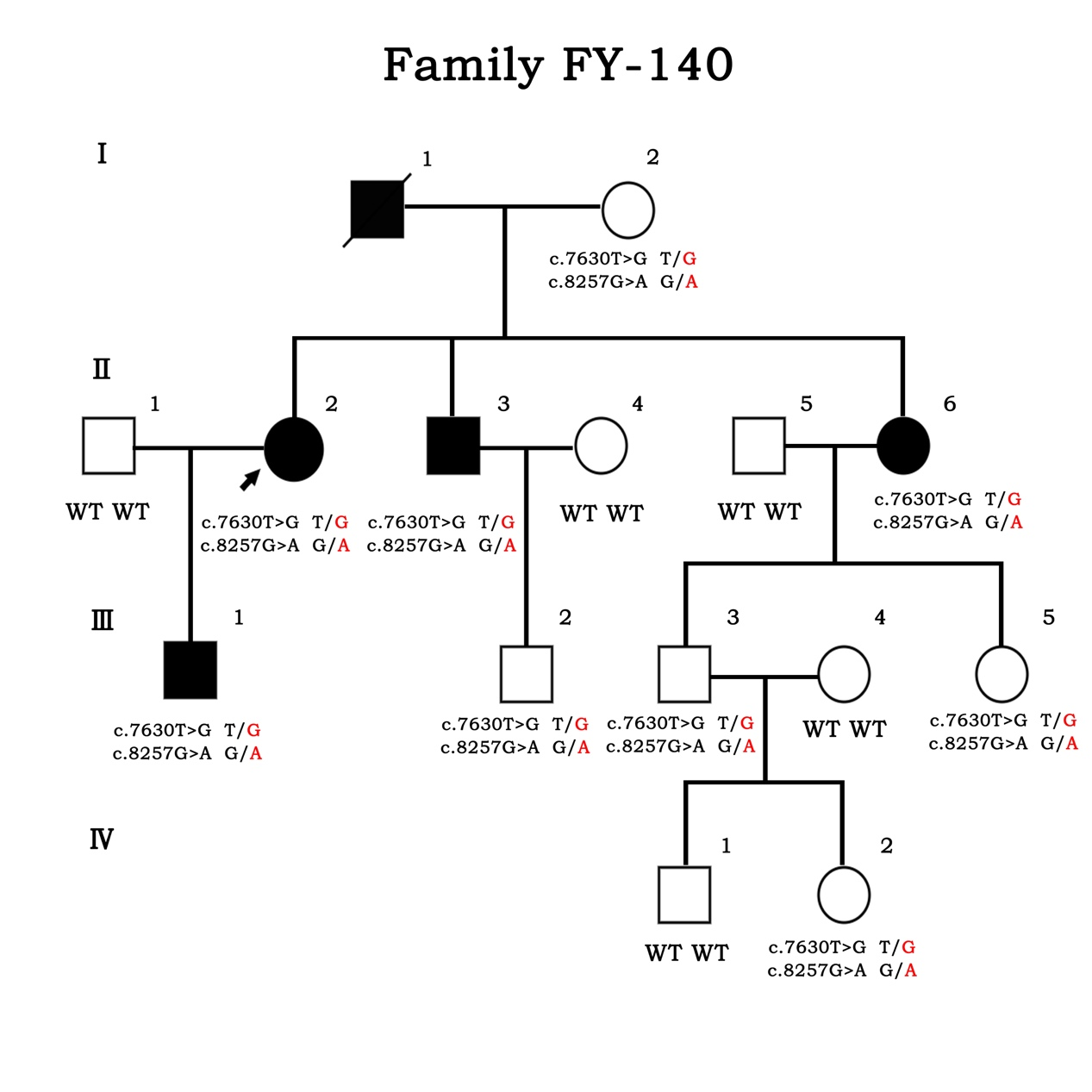
Figure S1. Pedigree diagram of the four generations of FY-140 with variants in CDH23. (c.7630T>G, p. Leu2544Val and c.8257G>A p. Ala2753Thr)

