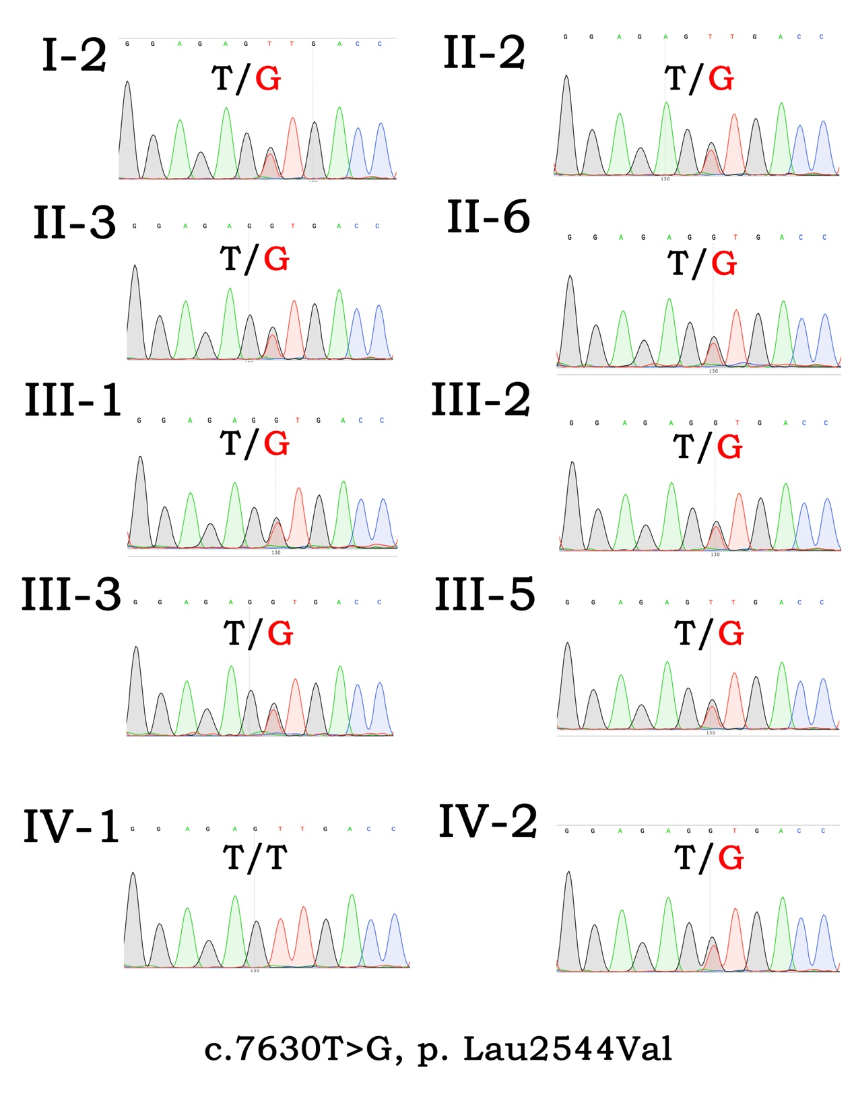
Figure.S2 Sanger sequencing of c.7630T>G, p. Leu2544Val in Family FY‐140.

