Supplemental
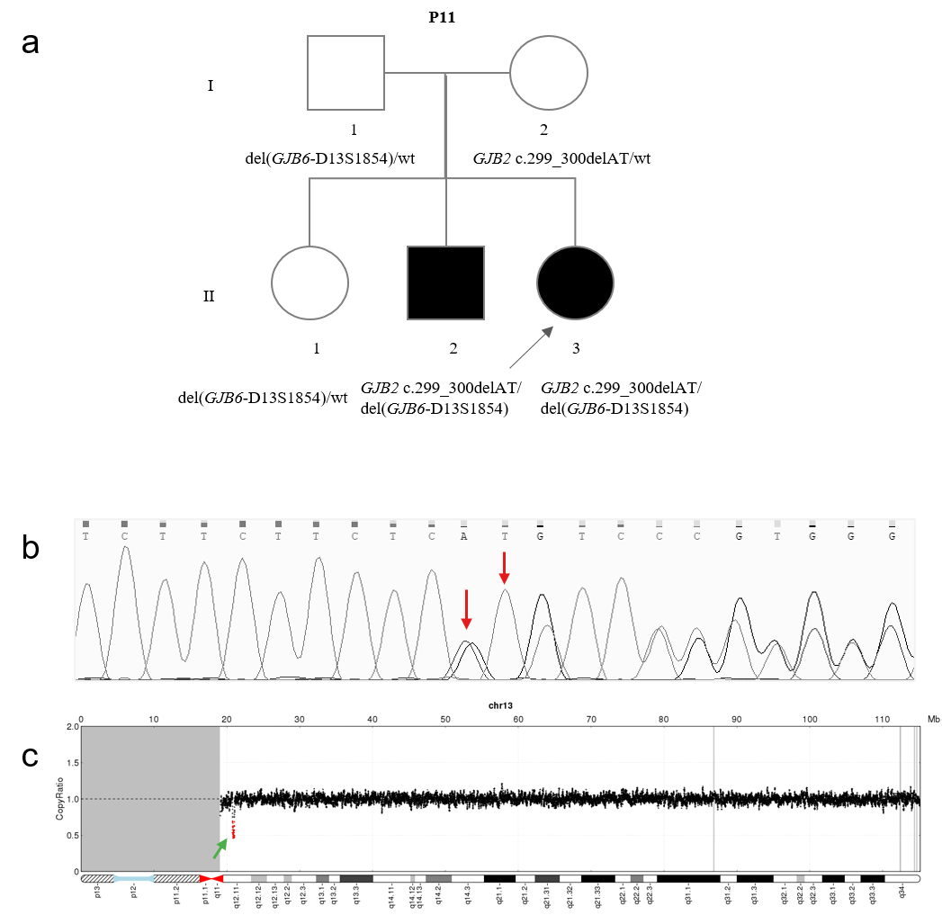

Figure S1 Pedigree with GJB6 deletion
(a) Pedigree information. Black and white symbols each represent affected and normal individuals. The proband had one hearing loss brother and a normal hearing sister, we tested all individuals and confirmed the co-segregation of the family, the affected brother carried compound heterozygous variants, the unaffected sister carried heterozygote variant (b) Sanger confirmation testing result of c.299_300delAT of GJB2, the red arrow indicates this variant. (c) The del(GJB6-D13S1854) (seq[GRCh37] del(13q12.11q12.11) chr13:g.20797693-21034825) is represented by a green arrow identified by low-pass genome sequencing. del, deletion, wt, wild type.

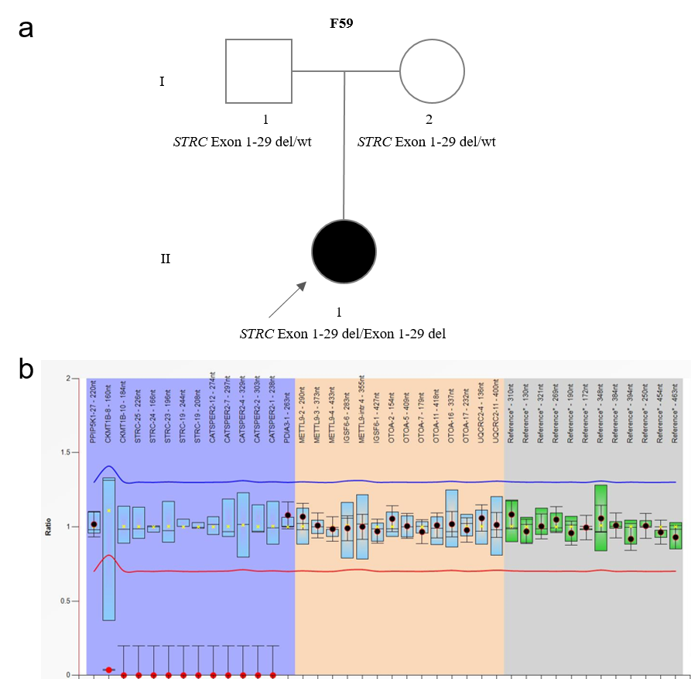

Figure S2 Pedigree with STRC homozygous deletion
(a) Pedigree information. Black and white symbols each represent affected and normal individuals. (b) MLPA result of STRC. The red dot with 0 copy ratio indicated homozygous deletion of STRC. del, deletion, wt, wild type

