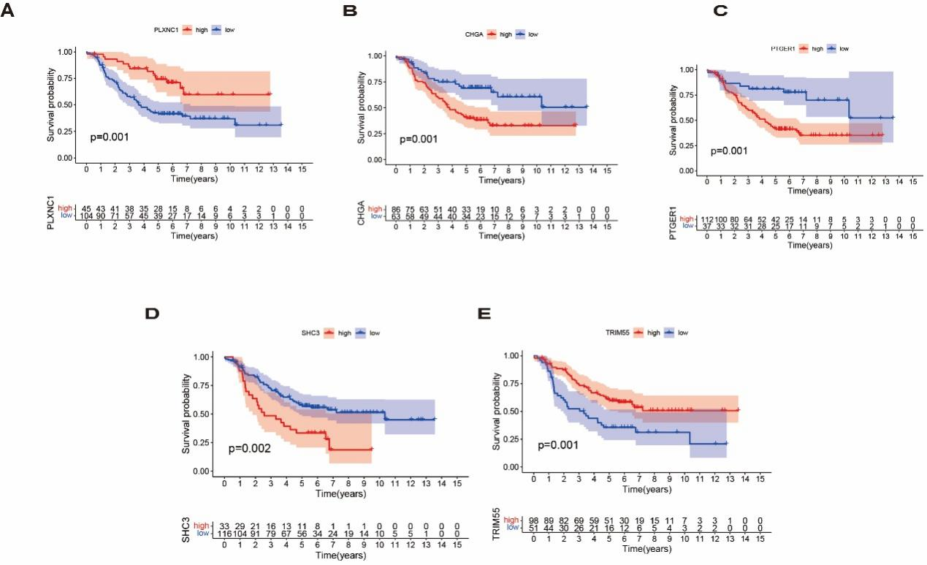
Additional Fig. S1 The correlation between the prognostic genes and overall survival. The Kaplan-Meier analysis of (A) PLXNC1, (B) CHGA, (C) PTGER1, (D) SHC3, (E) TRIM55 in the high- or low-risk groups
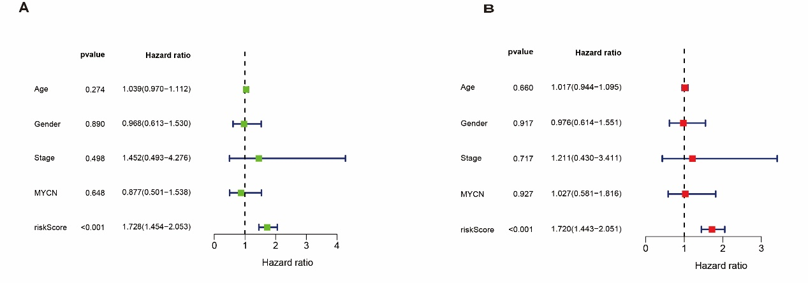
Additional Fig. S2 Identification of the independent prognosis factor in the risk model. The independence of the risk model was assessed by (A) univariate and (B) multivariate Cox regression analysis.

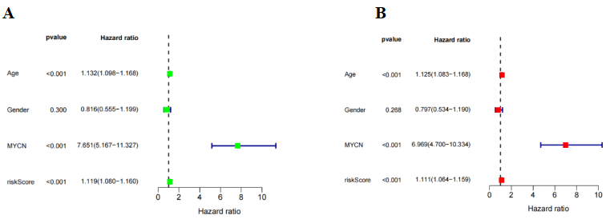

Additional Fig. S3 Identification of the independent prognosis factor in the GSE49711 dataset. The independence of the risk model was assessed by (A) univariate and (B) multivariate Cox regression analysis.
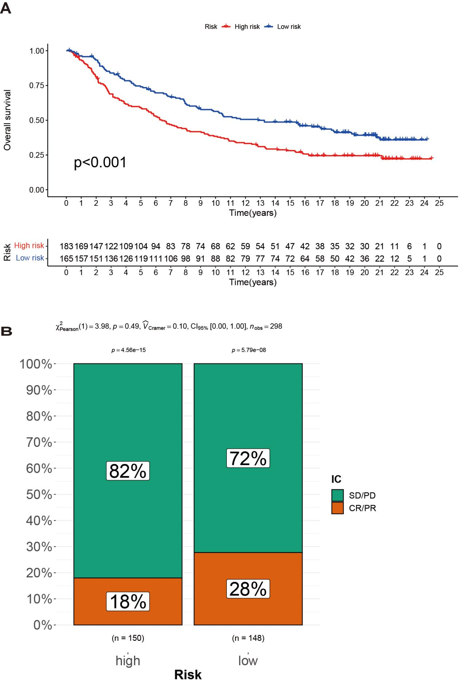

Additional Fig. S4 Immune signature predicts immunotherapy benefit. (A) The Kaplan-Meier analysis for overall survival (OS) of patients based on the risk stratification in the IMvigor210 cohort. (B) Rate of clinical response (CR/PR and SD/PD) to immunotherapy in high- or low-risk groups.

