Additional file 1. Quality assessment including risk of bias and concerns regarding applicability of included studies.

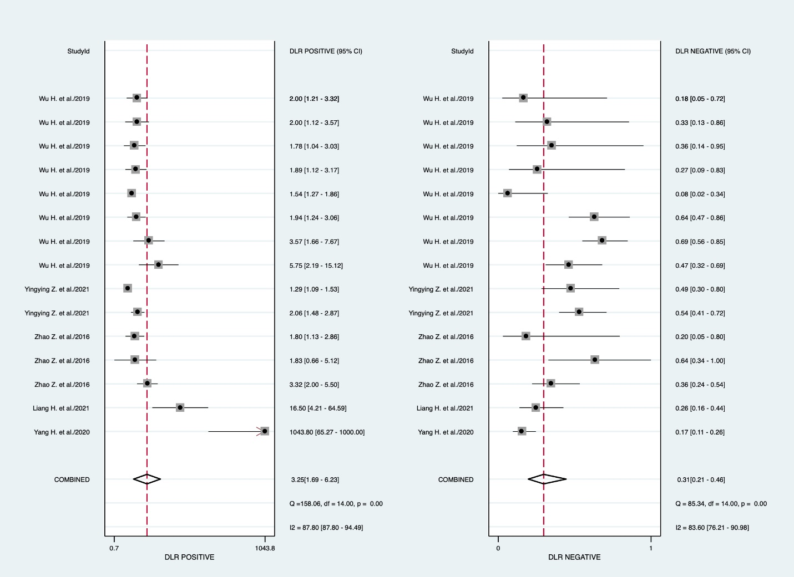
Additional file 2. The pooled positive likelihood ratio (a) and the pooled negative likelihood ratio (b) of circRNA for diabetes mellitus detection.
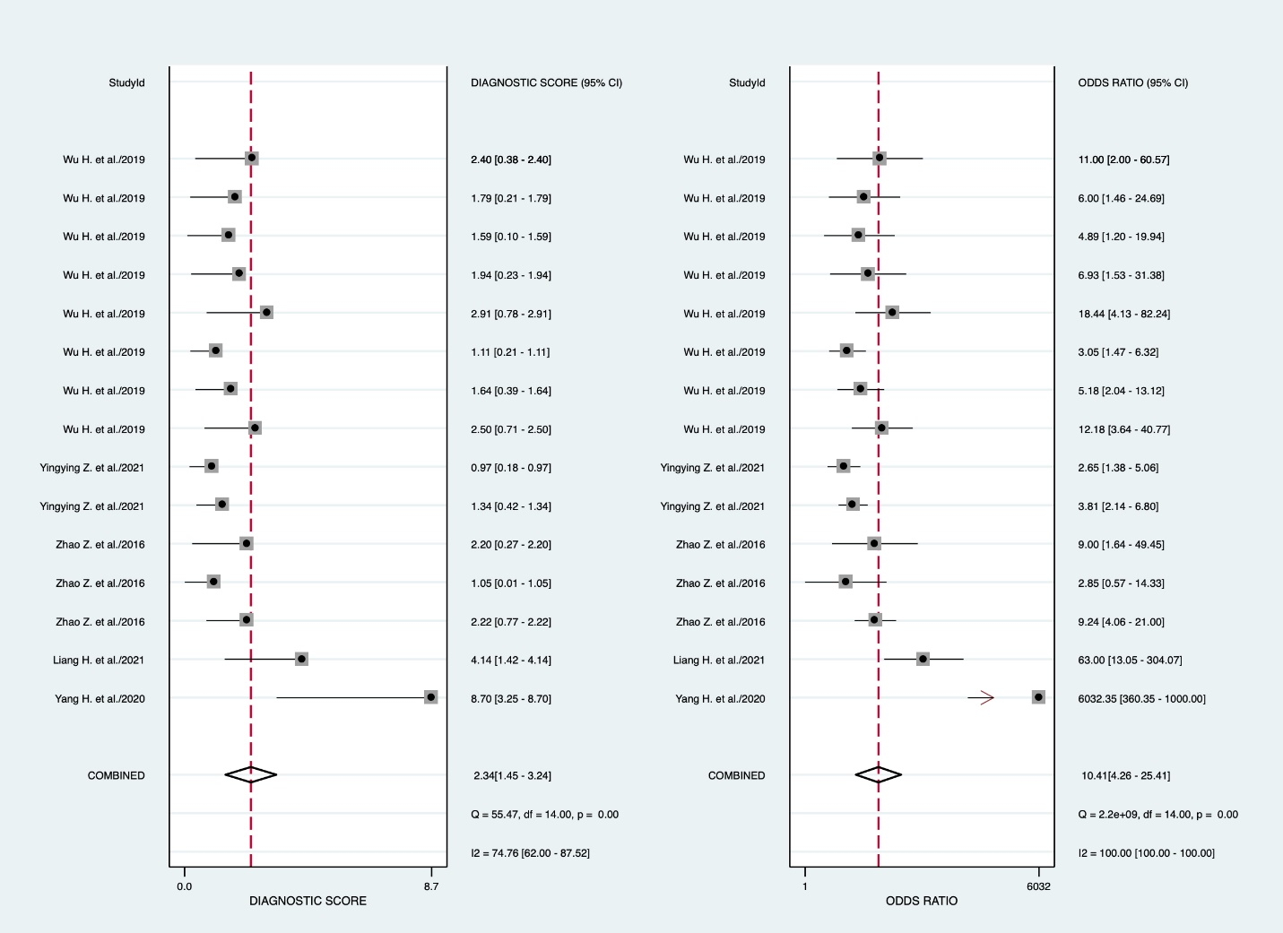
Additional file 3. The pooled diagnostic score (a) and the pooled diagnostic odds ratio (b) of circRNA for diabetes mellitus detection.

