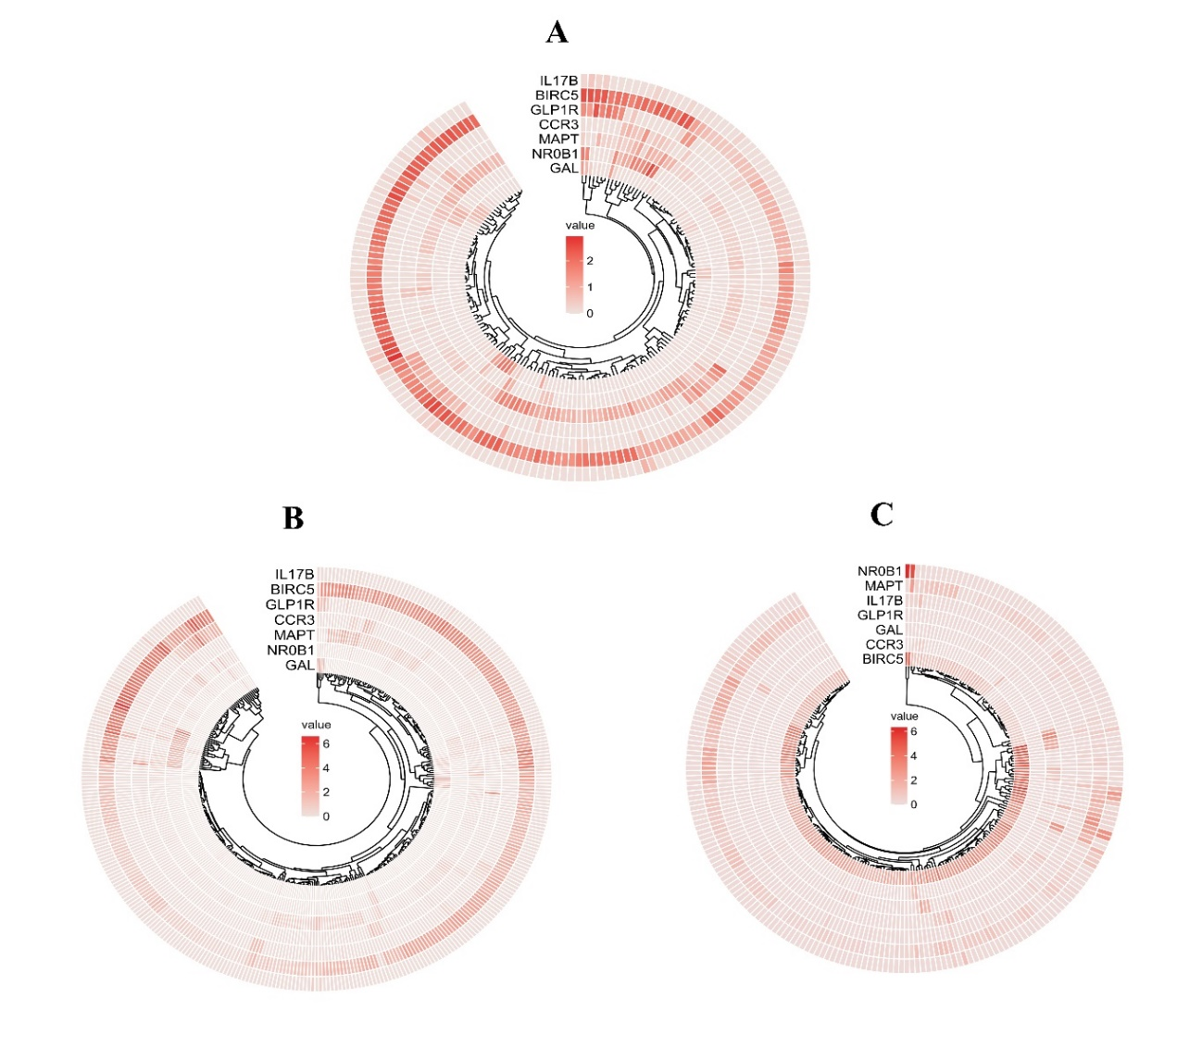
Figure S2 | Heat map results of seven IRSS genes expression levels.(A) The expression of seven IRSS genes in the TCGA test set. (B) The expression of seven IRSS genes in the TCGA sum set. (C) The expression of seven IRSS genes in the ICGC validation set.

