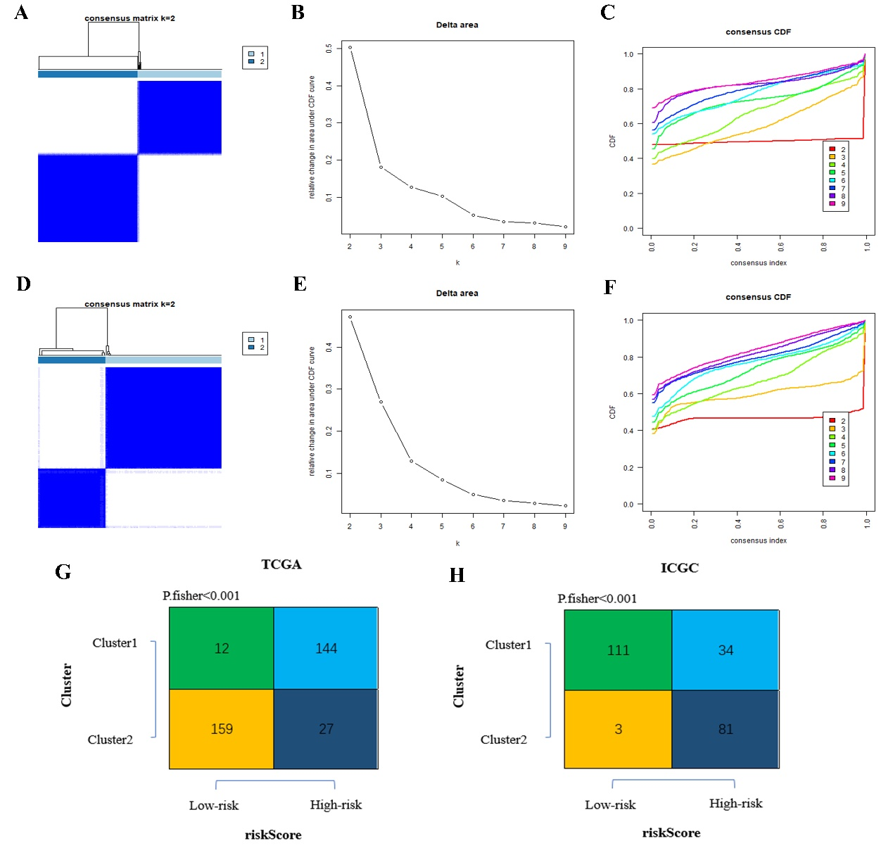
Figure S4 | Identification of consensus clusters by prognostic genes. (A) Consensus cluster matrix for k=2 in TCGA dataset. (B) Relative change in area under CDF curve for k=2 to 10 in TCGA dataset. (C) Consensus clustering cumulative distribution function (CDF) for k=2 to 10 in TCGA dataset. (D) Consensus cluster matrix for k=2 in ICGC dataset. (E) Relative change in area under CDF curve for k=2 to 10 in ICGC dataset. (F) Consensus clustering cumulative distribution function (CDF) for k=2 to 10 in ICGC dataset. (G) Contingency table showing the consistency between clustered groups and risk groups in TCGA. (H) Contingency table showing the consistency between clustered groups and risk groups in ICGC.

