The result of quantitative repeatability:

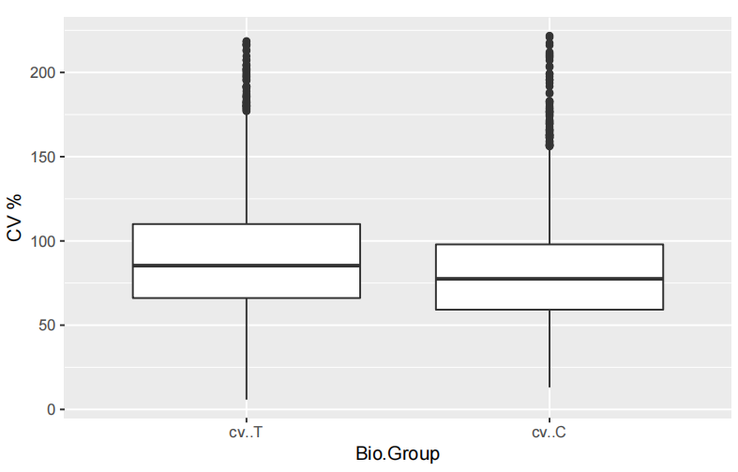
Figure S1 Distribution of quantitative coefficient of variation between biological repeats. T, spinal tuberculosis; C, control group；CV, coefficient of variation.

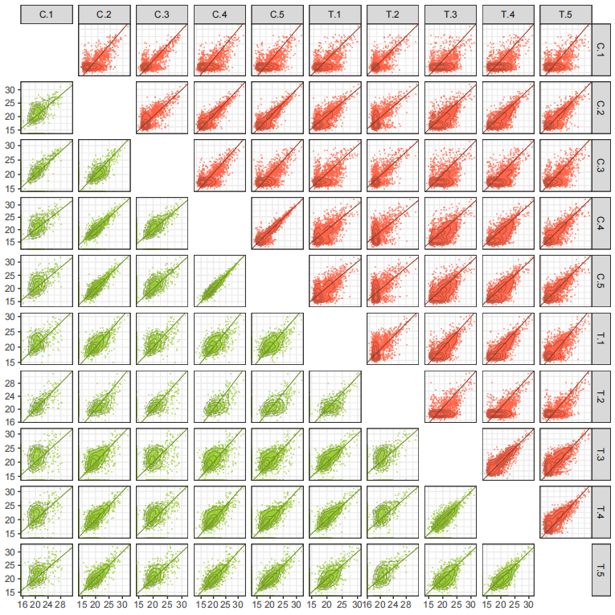
Figure S2 The quantitative correlation analysis between samples. T, spinal tuberculosis; C, control group.

