Figure S1. MR effect size for PCOS on GST.
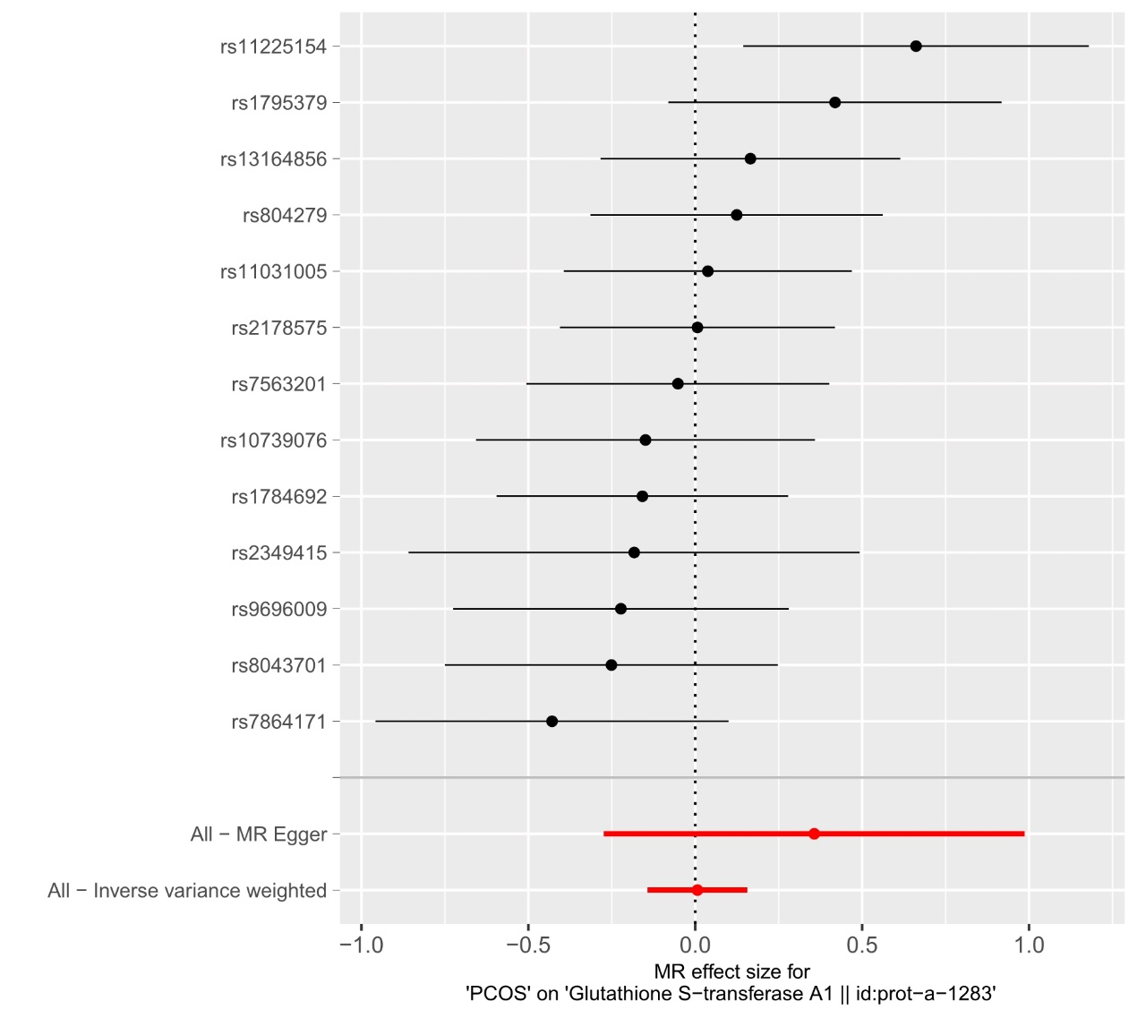
PCOS, Polycystic ovary syndrome; GST, glutathione S-transferase.

