Figure S7. leave-one-out regression analysis of PCOS on GPX
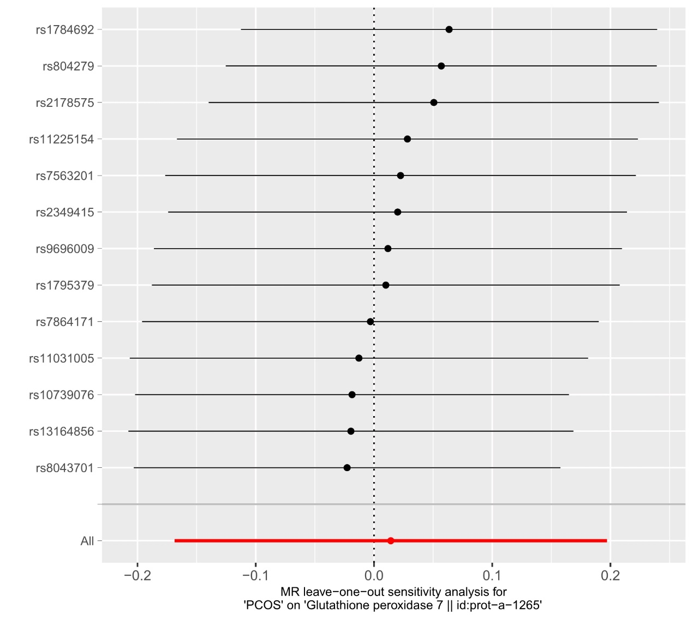
PCOS, Polycystic ovary syndrome; GPX, glutathione peroxidase.

