Figure S11. leave-one-out regression analysis of PCOS on CAT
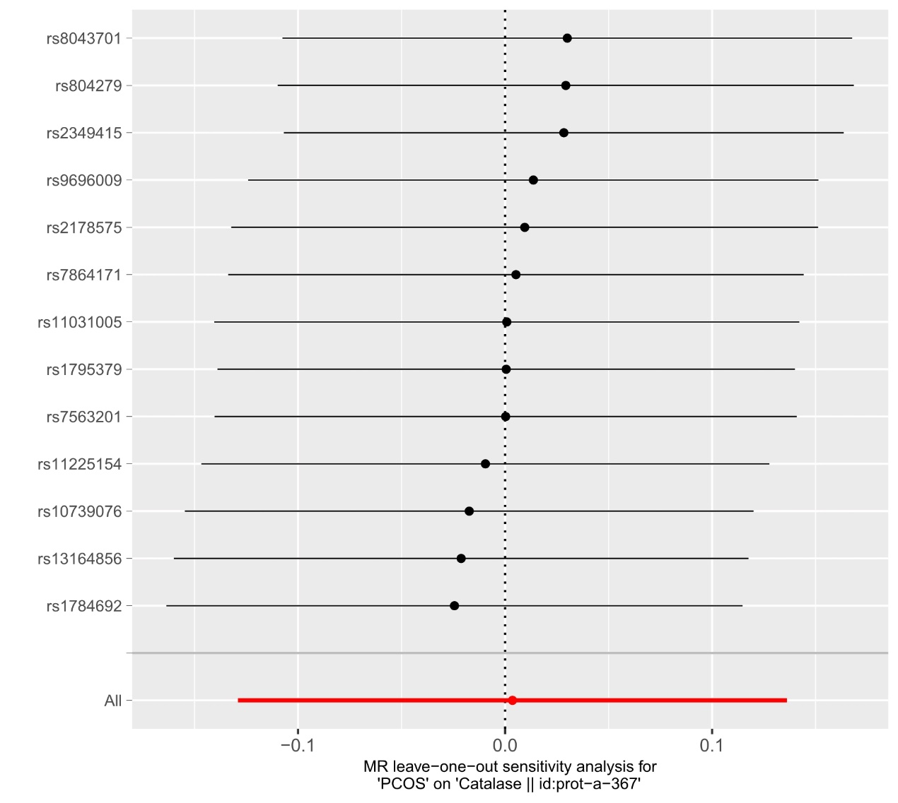
PCOS, Polycystic ovary syndrome; CAT, catalase.

