Figure S9. MR effect size for PCOS on CAT
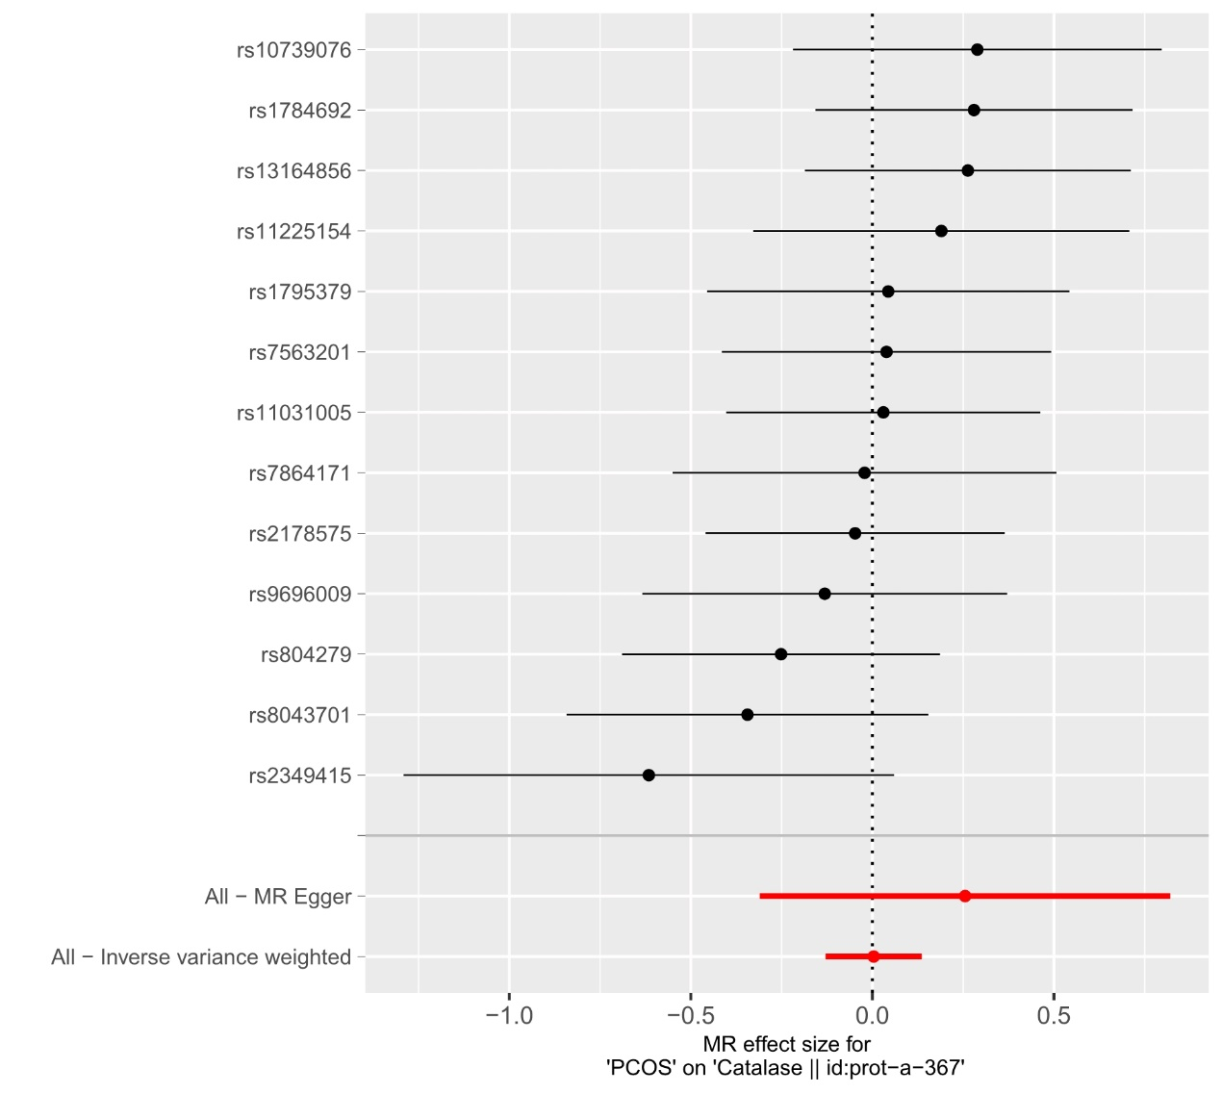
PCOS, Polycystic ovary syndrome; CAT, catalase.

