Fig2
miRNA mimics or inhibitors were transfected into HGC-27 cells. WB was used to detect expression levels of Bcl-2, Bax, Caspase-3, E-cadherin, N-cadherin, Snail, and β-actin.

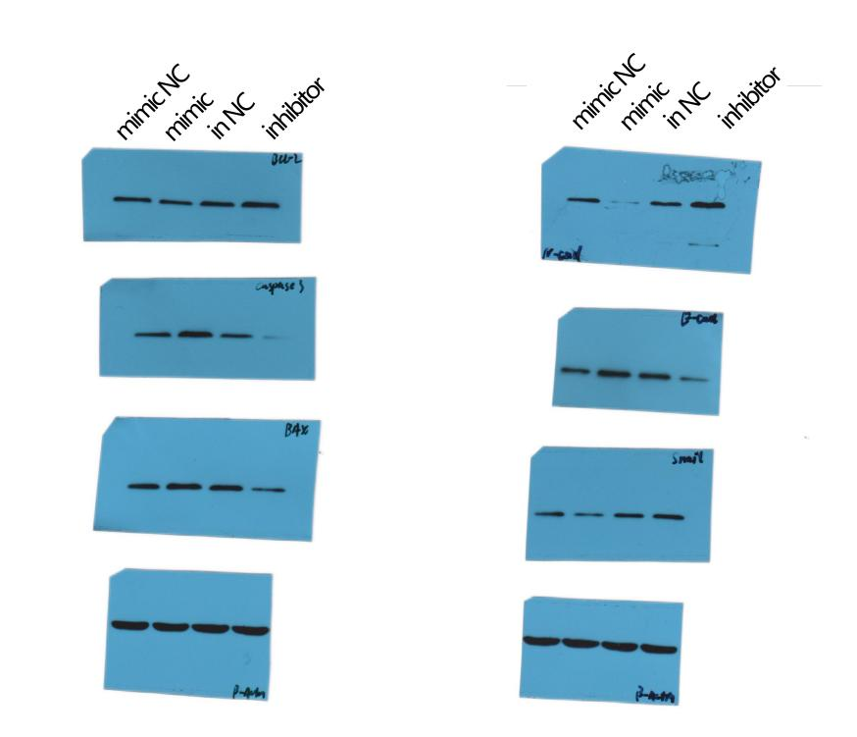

miRNA mimics or inhibitors were transfected into AGS cells. WB was used to detect expression levels of Bcl-2, Bax, Caspase-3, E-cadherin, N-cadherin, Snail, and β-actin.

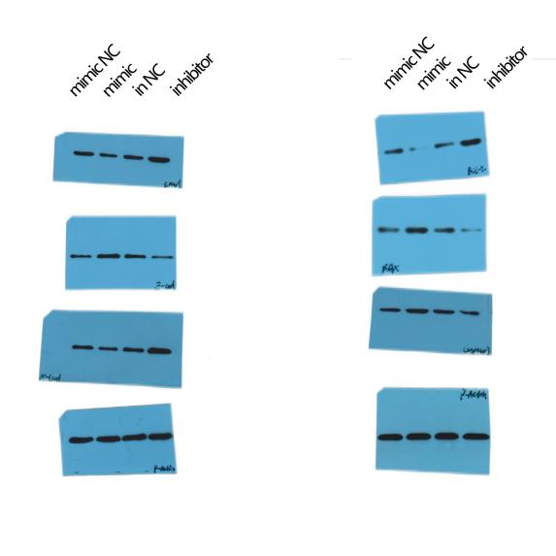

Fig 3

miRNA mimics and NC were transfected into HGC-27 cells. WB was used to detect expression levels of ARMC8. (On the left is HGC-27，the right is AGS）

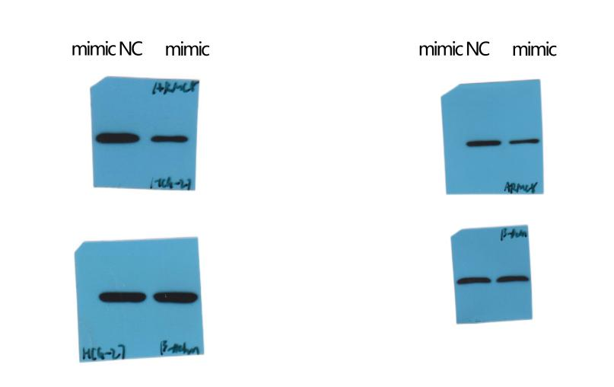

Expression levels of ARMC8 by WB in three cells: GES-1, HGC-27, and AGS
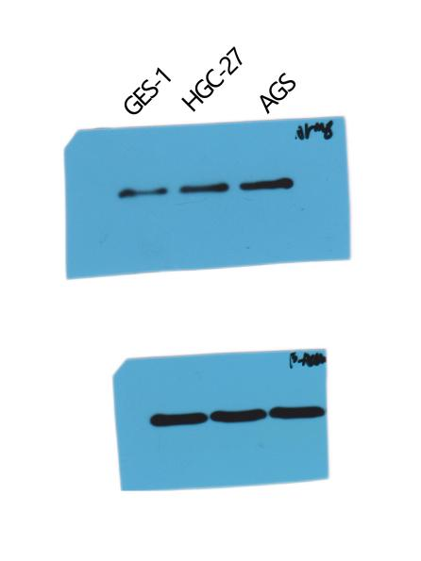

Fig 4
After transfected GC cells with miR-455-3p mimics or miR-455-3p mimics plus the ARMC8 expression vector, WB was used to detect expression levels of ARMC8. (On the left is HGC-27, the right is AGS）

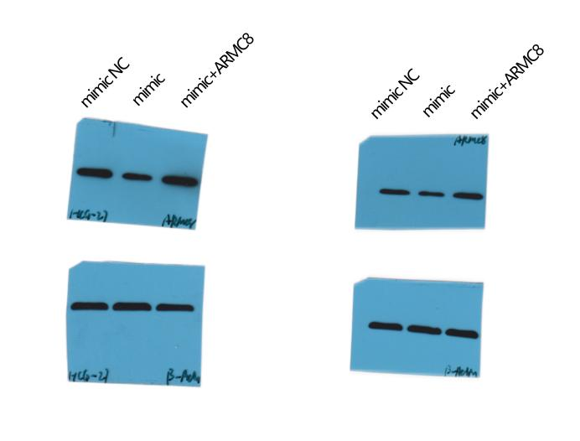

After transfected GC cells with miR-455-3p mimics or miR-455-3p mimics plus the ARMC8 expression vector, WB was used to detect expression levels of E-cadherin, N-cadherin, Snail, and β-actin. (On the left is HGC-27, the right is AGS）

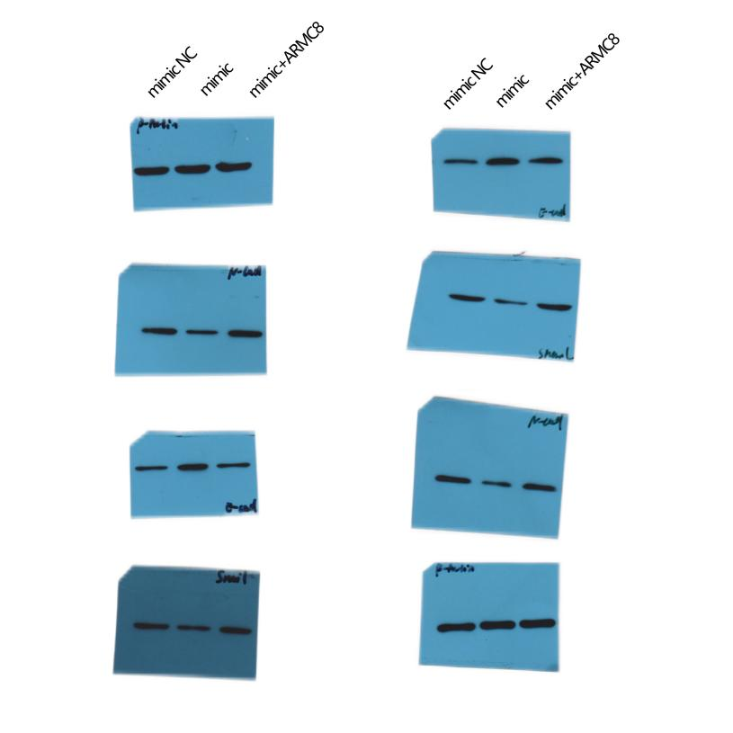

Fig 6

After transfected GC cells with miR-455-3p mimics or miR-455-3p mimics plus the ARMC8 expression vector, WB was used to detect expression levels of β-catenin, cyclinD1, C-myc, and β-actin. (On the left is HGC-27, the right is AGS）

