Supplementary material 3.
Title: Original graphs of PCR product on agarose gels
Legend: original graphs of PCR product of NM_000175.5：c.633+3A>G and WT in GPI
The original images are presented below:
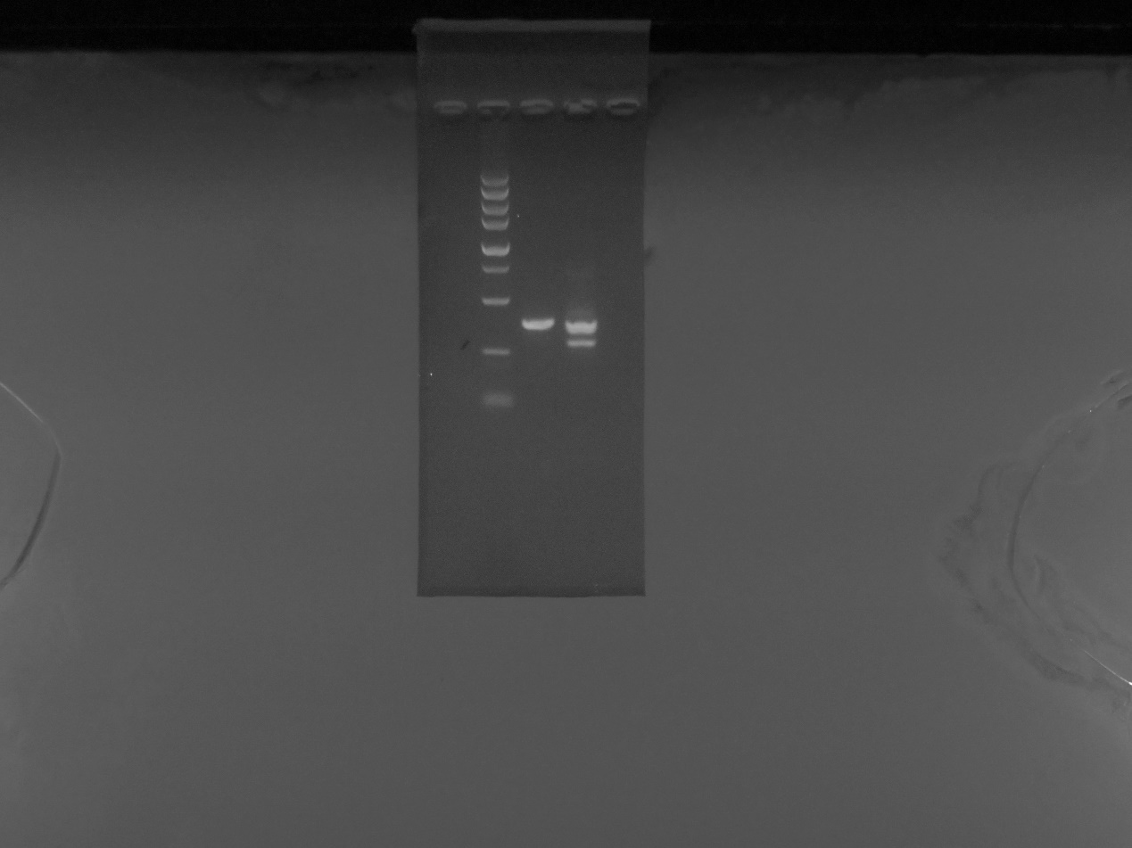
Supplementary Figure 1. Original graphs of PCR product on agarose gels
A)original graphs of PCR product of NM_000175.5：c.633+3A>G and WT in GPI gene

