Supplementary Figure S1. Scatter plots for summary-level Mendelian Randomization. (a) Scatter plots from genetically predicted AF on HF with initial instrument P-value threshold at 5×＜10⁻⁸; (b) Scatter plots from genetically predicted AF on HF with tightening instrument P-value threshold at 5×＜10⁻¹⁵;(c) Scatter plots from genetically predicted HF on AF with initial instrument P-value threshold at 5×10⁻⁸;(d) Scatter plots from genetically predicted HF on AF with tightening instrument P-value threshold at 5×10⁻¹⁵.
(a) AF à HF with P＜5×10⁻⁸
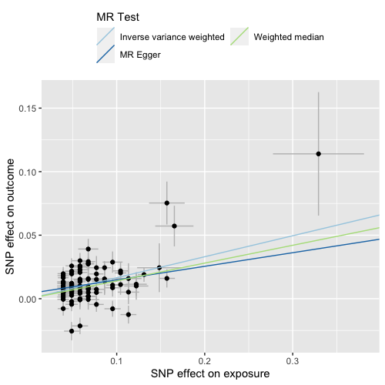

(b) AF à HF with P＜5×10⁻¹⁵
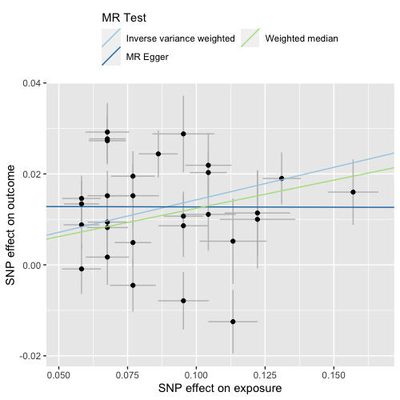

(c) HF à AF with P＜5×10⁻⁸
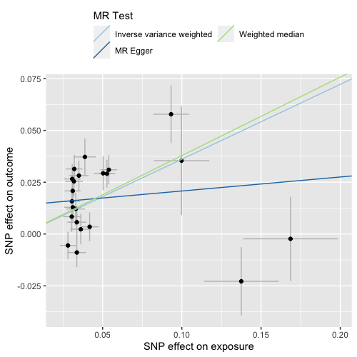

(d) HF à AF with P＜5×10⁻¹⁵
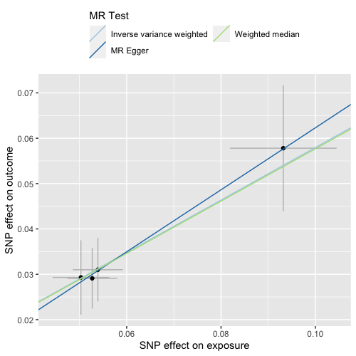

Supplementary Figure S2. Leave-one-out plots for summary-level Mendelian randomization. (a) leave-one-out plots from genetically predicted AF on HF with initial instrument P-value threshold at 5×＜10⁻⁸; (b) leave-one-out plots from genetically predicted AF on HF with tightening instrument P-value threshold at 5×＜10⁻¹⁵;(c) leave-one-out plots from genetically predicted HF on AF with initial instrument P-value threshold at 5×10⁻⁸;(d) leave-one-out plots from genetically predicted HF on AF with tightening instrument P-value threshold at 5×＜10⁻¹⁵.
(a) AF à HF with P＜5×10⁻⁸
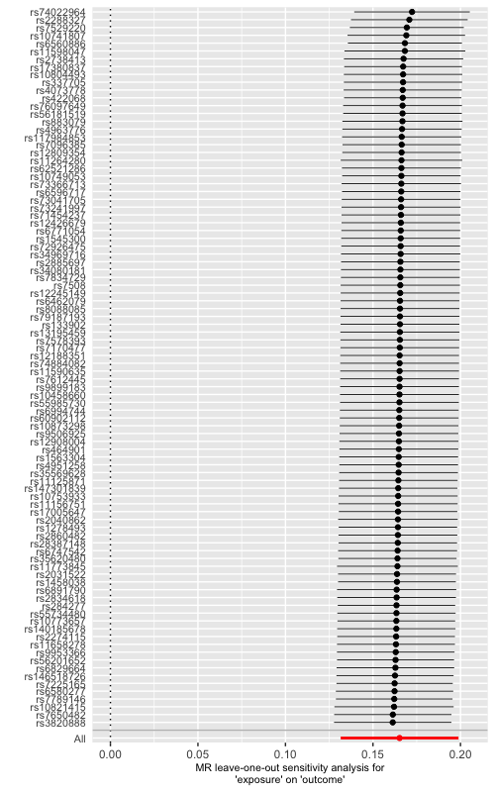

(b) AF à HF with P＜5×10⁻¹⁵
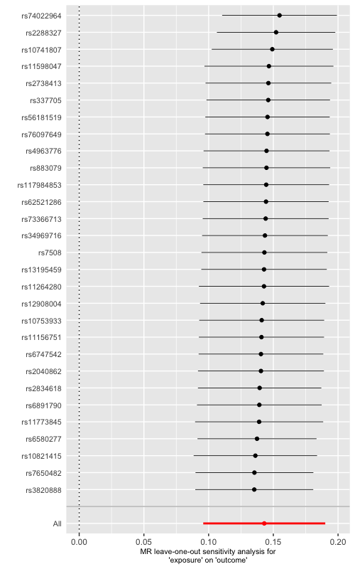

(c) HF à AF with P＜5×10⁻⁸
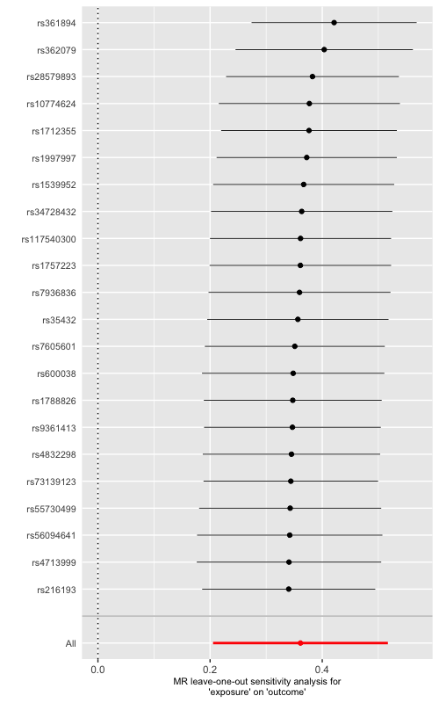

(d) HF à AF with P＜5×10⁻¹⁵
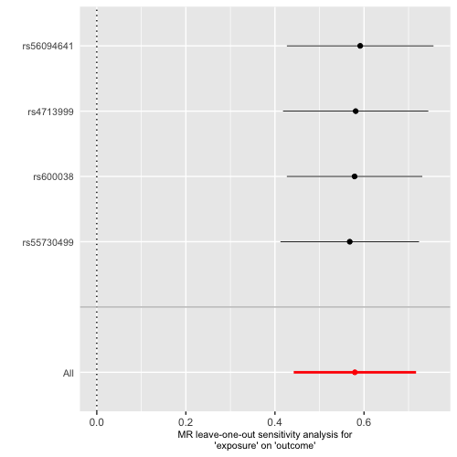

Supplementary Figure S3. Funnel plots for summary-level Mendelian randomization. (a) funnel plots from genetically predicted AF on HF with initial instrument P-value threshold at 5×＜10⁻⁸; (b) funnel plots from genetically predicted AF on HF with tightening instrument P-value threshold at 5×＜10⁻¹⁵;(c) funnel plots from genetically predicted HF on AF with initial instrument P-value threshold at 5×＜10⁻⁸;(d) funnel plots from genetically predicted HF on AF with tightening instrument P-value threshold at 5×＜10⁻¹⁵.
(a) AF à HF with P＜5×10⁻⁸
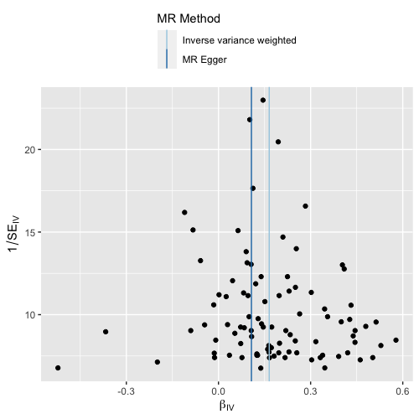

(b) AF à HF with P＜5×10⁻¹⁵
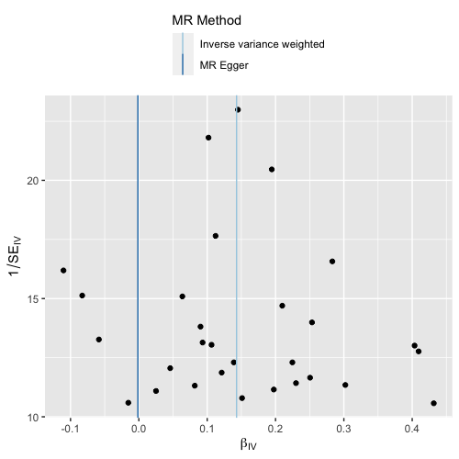

(c) HF à AF with P＜5×10⁻⁸
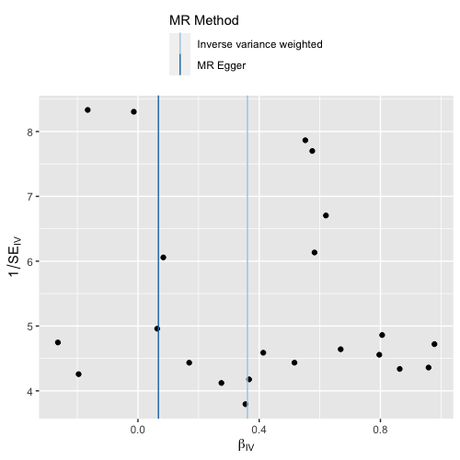

(d) HF à AF with P＜5×10⁻¹⁵
