Insights into the genetics of menopausal vasomotor symptoms: genome-wide analyses of routinely-collected primary care health records
Katherine S. Ruth¹*, Robin N. Beaumont¹, Jonathan M. Locke¹, Jessica Tyrrell¹, Carolyn J. Crandall², Gareth Hawkes¹, Timothy M. Frayling¹, Julia K. Prague^{3,4}, Kashyap A. Patel^{3,4}, Andrew R. Wood¹, Michael N. Weedon¹, Anna Murray¹
¹Genetics of Complex Traits, University of Exeter Medical School, University of Exeter, Exeter, EX2 5DW, UK.
²Division of General Internal Medicine and Health Services Research, David Geffen School of Medicine at University of California, Los Angeles, CA 90024, USA.
³Exeter Centre of Excellence for Diabetes Research, University of Exeter, Exeter, EX2 5DW, UK.
⁴Macleod Diabetes and Endocrinology Centre, Royal Devon and Exeter National Health Service Foundation Trust, Exeter, EX2 5DW, UK.
*Correspondence to Katherine S. Ruth (K.S.Ruth@exeter.ac.uk)

Contents:
p2 Supplementary Methods
p5 Supplementary Results
p6 References
p7 Supplementary Figures
Supplementary Methods
Phenotype definitions
Vasomotor symptoms derived from primary care records
We identified Read v2 and CTV3 codes containing the full and partial words “flush”, “flash”, “meno”, “sweat”, “vaso” in the term descriptions, to account for the two clinical coding systems used in the UK Biobank linked primary care data. This resulted in the identification of 970 code and term descriptions which were manually reviewed along with their frequency of use in females in UK Biobank, resulting in the identification of 11 Read v2 and 22 CTV3 codes that were considered to be of direct relevance for vasomotor menopausal symptoms (VMS) (Supplementary Table 1). We used primary care data linked to UK Biobank to identify women with one or more clinical events containing codes for VMS. Such clinical events are coded from interactions with health care professionals in general practice including consultations, diagnoses, history, symptoms, procedures, laboratory tests and secondary care interactions reported back to general practice.
Proxy phenotype definitions
For secondary analyses we derived proxy phenotypes for VMS based on self-reported hormone replacement therapy use. These proxy phenotypes included the binary phenotype “Ever taken HRT” in postmenopausal women (n=72,535 cases and n=80,617 controls), and the quantitative traits “Age started HRT”, “Age ended HRT” and “Time taken HRT” in up to 85,488 women (Supplementary Table 2). We derived phenotypes based on the most recent study visit with non-missing information as described below. In the phenotype calculations, ages were rounded to ages in years.
HRT ever
We included women who answered “Yes” to “2724: Have you had your menopause (periods stopped)?”. Cases (used HRT) answered “Yes” to “2814: Have you ever used hormone-replacement therapy (HRT)?” while controls answered “No”. Women were excluded if they provided conflicting information at separate UK Biobank visits.
HRT before and after 2002
The year in which the woman started HRT was calculated from year of birth plus the age at which HRT was started. Women using HRT before 2002 were those who were ‘HRT ever’ cases and who started taking HRT before or during 2002, while those using HRT after 2002 were ‘HRT ever’ cases who started taking HRT after 2002. Controls were as described for ‘HRT ever’.
Age started HRT
We included women who gave an age for “3536: How old were you when you first used HRT?” that was younger than their age at the respective study visit and who answered “Yes” to “2814: Have you ever used hormone-replacement therapy (HRT)?”.
Age ended HRT
We included women who gave an age for “3546: How old were you when you last used HRT?” that was younger than their age at the respective study visit and who answered “Yes” to “2814: Ever used hormone-replacement therapy (HRT)?”.
Length of time that HRT was taken
We calculated the difference between age starting and ending HRT in women with this information available who answered “Yes” to “2814: Have you ever used hormone-replacement therapy (HRT)?”, provided that the age ending HRT was after that starting HRT.
Calculation of proportion of women using HRT
To calculate the proportion of women taking HRT, we identified women who stated that they were postmenopausal at baseline and thus ‘at risk’ of taking HRT in 2006−2010. To compare the proportion of women using HRT before and after 2002, we used year of birth to identify which of these postmenopausal women turned 50 (the average age of menopause in the UK) before and after 2002 (i.e. born before 1952 or in/after 1952) to minimise the effect of differences in age distribution in the cohort on temporal trends in HRT use. We then used the variables that we calculated for using HRT pre and post 2002 to find the proportion of women who both turned 50 and used HRT before 2002 and the proportion of women who both turned 50 and used HRT after 2002.
Genome-wide association study analyses
Age used for adjustment of statistical analyses
Statistical analyses were adjusted for the age of the woman which was calculated at the study visit used to define the phenotype.
Fisher’s exact test of the associations for HRT use
Since mixed linear models can result in inflation of test statistics at low allele frequencies, for genome-wide significant signals identified for case−control phenotypes we carried out a Fisher’s exact test to confirm that the distribution of the effect allele was significantly different in cases and controls. We calculated the total number of effect and other alleles in the case and control groups for the genetic signals and tested the null hypothesis of no difference in the distribution using a Fisher’s exact chi squared test carried out in Stata-MP v14. We considered genome-wide significant associations to be confirmed if P<5×10⁻⁸.
Matched case−control sensitivity analyses
To ensure that different age distributions of the cases and controls did not affect the effect estimates for HRT use, we generated effect estimates from case−control matched analyses. For the phenotypes ever used HRT, used HRT before 2002 and used HRT after 2002, cases and controls were 1:1 matched on age and year of birth using “ccmatch” in Stata-MP v16. This produced 51,628 age matched case/control pairs for ever used HRT, 44,431 for used HRT before 2002 and 5,615 for used HRT after 2002. Effect estimates were generated for the genetic variants of interest using case-control matched logistic regression (“clogit”) in Stata including the covariates genotyping chip and release of genotype data, recruitment centre, age and the first five genetic principal components.
Exome-wide analyses
Gene burden association testing of rare variants was performed using exome sequencing data available in ~200,000 people from UK Biobank (1). Detailed sequencing methodology is provided by Szustakowski et al.(1) Briefly, exomes were captured with the IDT xGen Exome Research Panel v1.0 which targeted 39Mbp of the human genome with coverage exceeding on average 20x on 95.6% of sites. The OQFE protocol was used for mapping and variant calling to the GRCh38 reference. Variants included in our analyses had individual and variant missingness <10%, Hardy Weinberg Equilibrium p-value >10⁻¹⁵, minimum read depth of 7 for SNPs and 10 for indels, and at least one sample per site passed the allele balance threshold > 15% for SNPs and 20% for indels.
Supplementary Results
In silico functional and expression analyses
Analyses of variants in linkage disequilibrium (LD) with our lead genetic variant (rs34867104) in Variant Effect Predictor (2) did not find any non-synonymous variants strongly correlated with the GWAS signal (LD r²>0.8). Further in silico analyses using GTEx, PsychENCODE, Intropolis and goDMC found little evidence for an effect on gene expression, regulation or splicing. Two variants in strong LD with rs34867104 (r²>0.8) were expression quantitative trait loci (eQTLs) for TACR3 in brain in PsychENCODE; alleles raising TACR3 expression (FDR=3×10⁻²) were associated with lower odds of VMS (P<3×10⁻²⁰; Supplementary Table 10), an apparently opposite effect to that expected from the clinical studies of NK3R antagonism. However, these variants were not the top eQTL for TACR3 in the region and the strongest eQTL for TACR3 in brain (rs3846440, chr4:104840863, FDR=8×10⁻²⁴) was only weakly correlated with the lead GWAS signal for VMS (LD r²<0.01 with rs34867104), and is likely to represent a distinct causal variant for gene expression. The VMS lowering allele of the lead variant for VMS (rs34867104) was associated with lower levels of methylation at a probe overlapping the promoter region of TACR3 (P=2×10⁻¹¹⁸) in goDMC suggesting higher expression, though this was not the top variant associated with methylation of this probe (top variant P<1×10⁻³⁰⁰). The contradictory expression, methylation and clinical study evidence suggests a complex biological mechanism resulting in VMS.
Genome-wide analyses of HRT phenotypes
We carried out genome-wide analyses of HRT use in UK Biobank as a proxy phenotype for VMS (Supplementary Figure 2). Our GWAS included up to 153,152 women for the binary phenotype “Ever taken HRT”, derived to include postmenopausal women only (Supplementary Methods and Supplementary Table 2). In addition, we analysed the quantitative traits “Age started HRT”, “Age ended HRT” and “Time taken HRT”. In total we observed 21 signal−trait pairs at P<5×10⁻⁸ across the four phenotypes that following confirmation by Fisher’s exact test (binary traits; Supplementary Methods), resolved to 15 independent genetic signals across phenotypes on the basis of distance and linkage disequilibrium (Supplementary Table 7).

References
1. Szustakowski JD, Balasubramanian S, Kvikstad E, Khalid S, Bronson PG, Sasson A, et al. Advancing human genetics research and drug discovery through exome sequencing of the UK Biobank. Nat Genet. 2021;53(7):942–8.
2. McLaren W, Gil L, Hunt SE, Riat HS, Ritchie GRS, Thormann A, et al. The Ensembl Variant Effect Predictor. Genome Biol. 2016;17(1):1–14.

Supplementary Figures
Supplementary Figure 1. Quantile-quantile and Manhattan plots for the GWAS of VMS in UK Biobank. The plots include all variants with imputation quality>0.3 and MAF>0.001
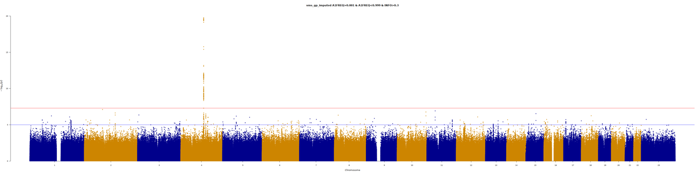

Lambda-GC=1.00
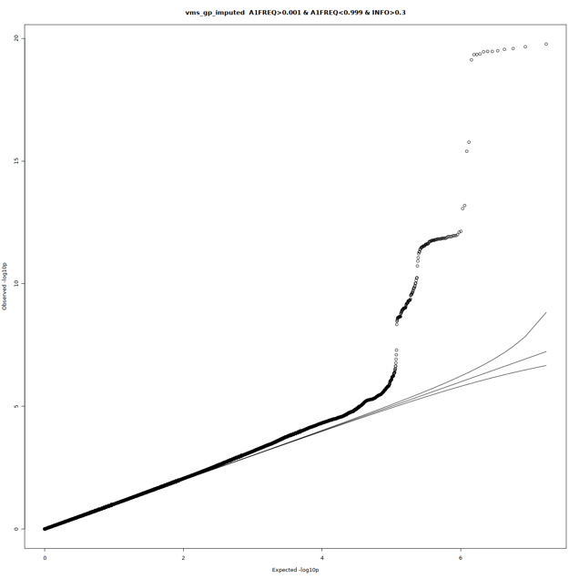
Supplementary Figure 2. Quantile-quantile and Manhattan plots of the GWASs of HRT use. The plots include all variants with imputation quality>0.3 and MAF>0.001. (a) HRT ever. Of the five signals identified as P<5E-08 in our GWAS, only the top SNP (rs34867104) on chromosome 4 had Fisher’s exact P<5E-08; (b) HRT start age; (c) HRT end age; (d) Time taken HRT
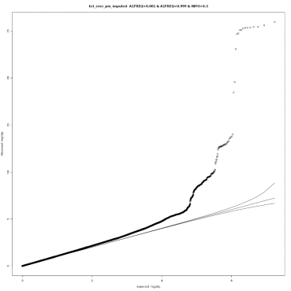
(a)
Lambda-GC=1.09.
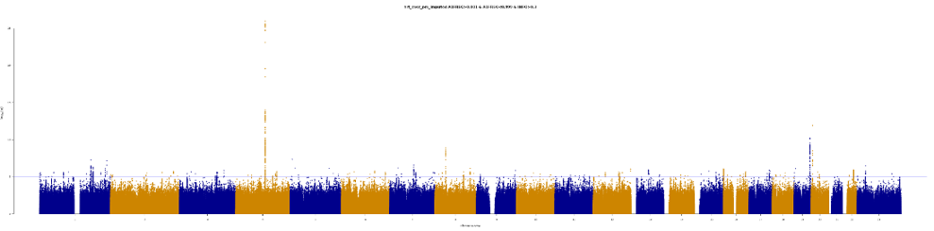

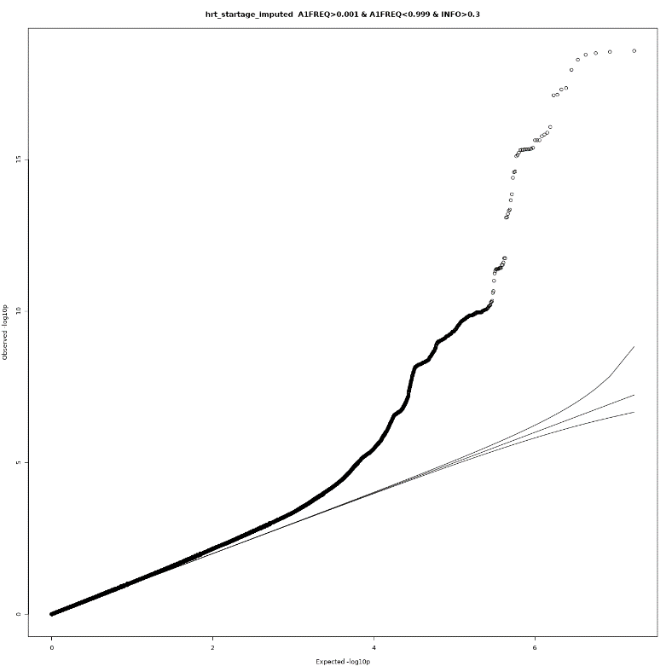
(b)
Lambda-GC=1.05
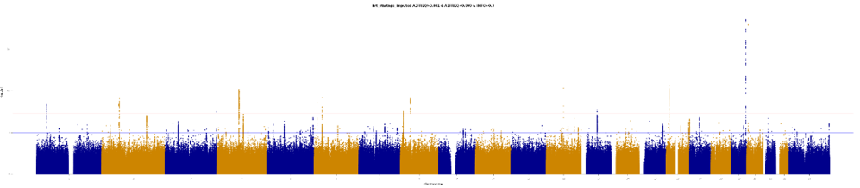

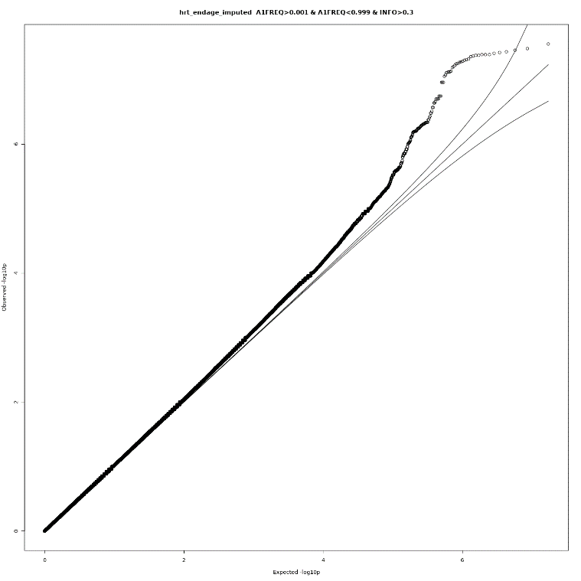
(c)
Lambda-GC=1.05
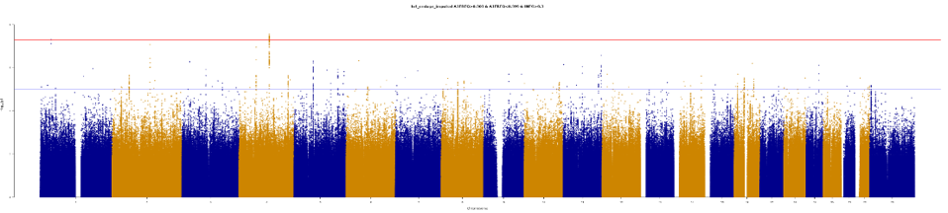

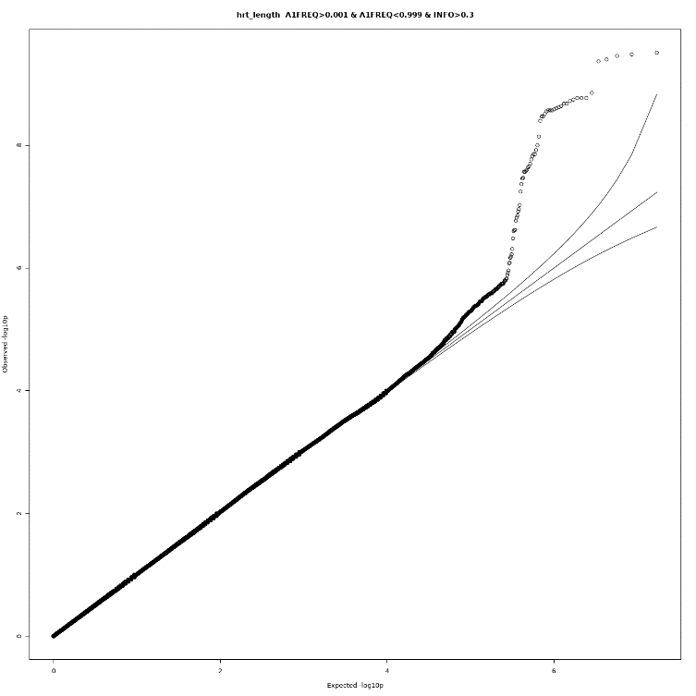
(d) Lambda-GC=1.00
