Supplementary file: PCR-SSP detection of HLA-DRB1*11 and HLA-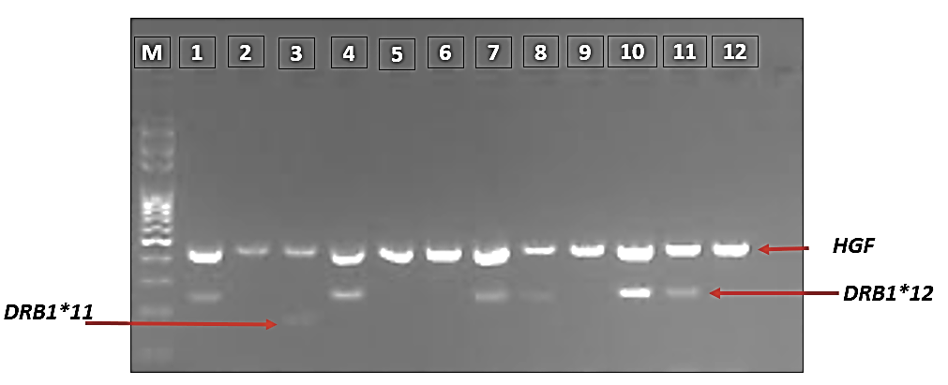DRB1*12 alleles

Image 1: PCR-SSP detection of HLA-DRB1*11 and HLA- DRB1*12 alleles

Image 2: PCR-SSP detection of HLA-DRB1*11 and HLA- DRB1*12 alleles

Image 3: PCR-SSP detection of HLA-DRB1*11 and HLA- DRB1*12 alleles

Image 4: PCR-SSP detection of HLA-DRB1*11 and HLA- DRB1*12 alleles

Image 5: PCR-SSP detection of HLA-DRB1*11 and HLA- DRB1*12 alleles

