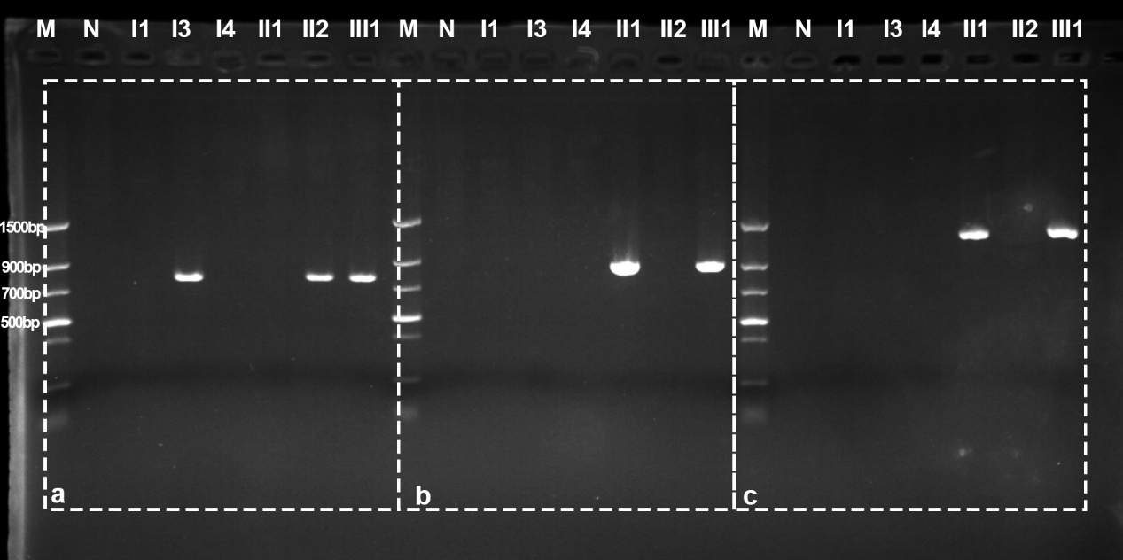

Supplementary Figure 1：This is the original figure of Figure 3 in the manuscript. a. A 800-bp PCR product was amplified by gap-PCR using primers F1 and R1 in I3, II2 and III1. No PCR product was observed from I1, I4, II1 or the control. M: marker, N: normal individual. b. A 900-bp PCR product was amplified by gap-PCR using primers F2 and R2 in II1 and III1. No PCR product was observed from I1, I3, I4, II2 or the control. c. A 1300-bp PCR product was amplified by gap-PCR using primers F3 and R3 in II1 and III1. No PCR product was observed from I1, I3, I4, II2 or the control.

