Supplementary Figure 1 - Western blot showing induction of the Cas9 protein by doxycycline (top image) in K562 cells transfected with the dCas9-KRAB construct after treated with 1 ug/ml of doxycycline for 48h. The bottom image show the a blot for beta actin to control for efficiency of protein loading. The image was acquired using the FluorChem E imagining system and ProteinSimple version:3.1.0 software.
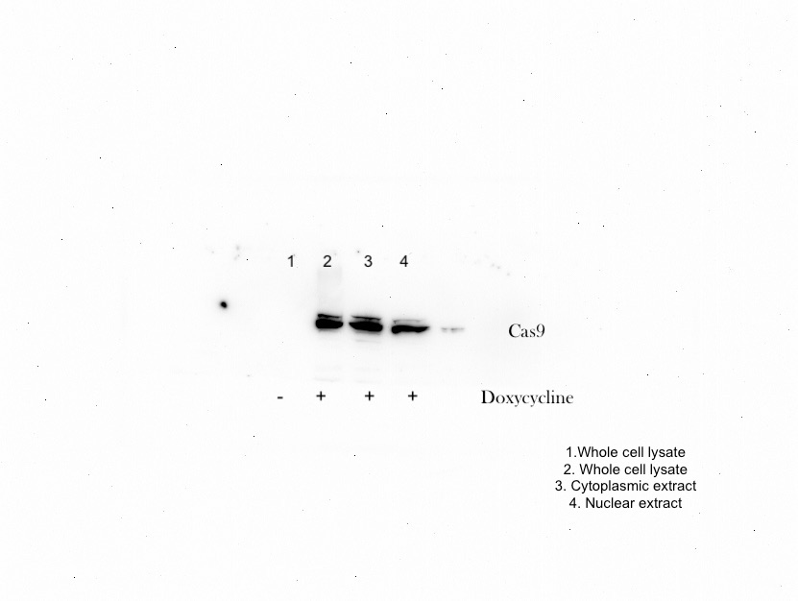
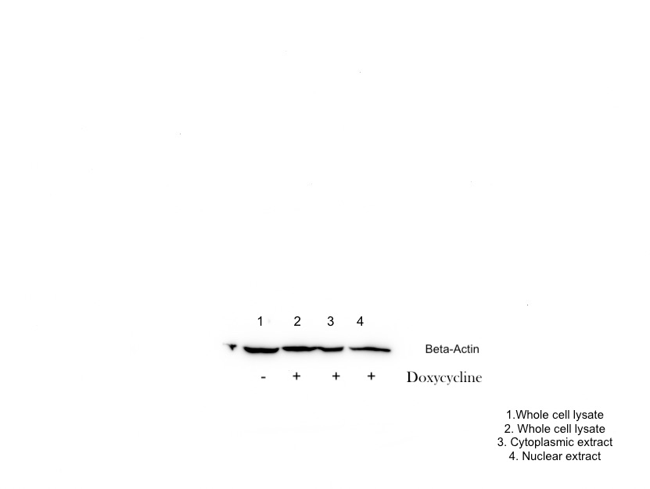

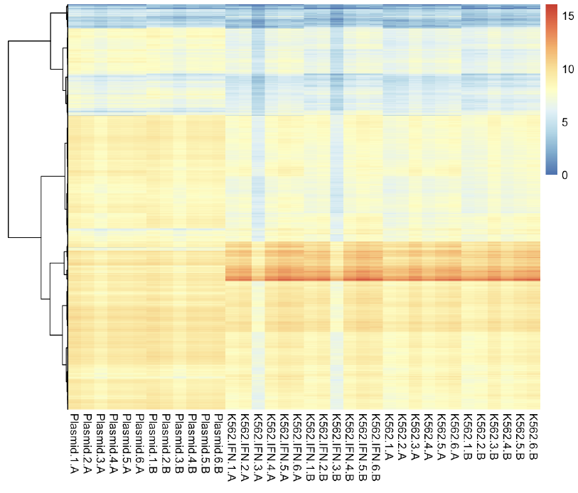
Supplementary Figure 2 – Heat map showing gene expression levels for each replicate experiment, comparing empty plasmid and reporter vectors (with and without IFNγ stimulation).

